REPORT ON CLUB PEER BUDDY SESSION
Club Name: NexaSoul
Domain: Frontend Development
Session: Club Peer Buddy Session
Date: 11 September 2026
Venue: C3 Block, Room 704
Scheduled Time: 2:30 PM – 3:20 PM
Organised As Per: Timetable and instructions received from the Office of Academic Affairs (OAA), Chandigarh University
1. Introduction
NexaSoul, the Frontend Development Club of Chandigarh University, conducted its scheduled Club Peer Buddy Session on 11 September 2026 as per the timetable and instructions received from the Office of Academic Affairs (OAA), Chandigarh University.
The primary topic of the session was “Importance of Full Stack Development.” The session was organised to introduce students to the concept of full stack development and explain the importance of understanding both frontend and backend technologies in modern software development.
The session was conducted at C3 Block, Room 704, from 2:30 PM to 3:20 PM. The designated club representatives interacted with students and discussed the role of full stack development, its components, practical applications, and the skills required to develop complete web applications.
2. Resource Persons
The following representatives from NexaSoul were assigned to conduct the Peer Buddy Session:
Name | UID | Mobile Number | Assigned Timing
GARVIT BHUTANI | 24BCS12030 | 7219143239 | 2:30 PM – 3:20 PM
SURAJ | 24BCS11025 | 9501158082 | 2:30 PM – 3:20 PM
Both resource persons reported for the assigned activity and remained available for student interaction.

3. Session Objectives
The major objectives of the session were:
- To introduce students to the concept of Full Stack Development.
- To explain the role of frontend and backend development.
- To create awareness about databases and server-side technologies.
- To explain how different technologies work together to build complete applications.
- To highlight the importance of full stack skills in modern software development.
- To encourage students to develop both frontend and backend skills.
- To motivate students to work on complete, functional projects.
Student Attendance and Participation
A total of 10 students participated in the Peer Buddy Session. The attendance recorded during the session was as follows:
S. No. | Student Name | UID
1 | Khushi | 26BDA10106
2 | Yashita | 26BDA10149
3 | Snehal Sinha | 26BDA10128
4 | Tanishka Iyer | 26BDA10096
5 | Karish | 25BAI70367
6 | Varun | 25BAI70294
7 | Kohana Kalra | 25BAI70129
8 | Avni | 25BAI70386
9 | Kashish | 25BAI70382
10 | Drishti Gulati | 25BAI70816
Total Student Count: 10
The students participated in the session and were provided with information regarding full stack development, its components, and its relevance to modern software development.
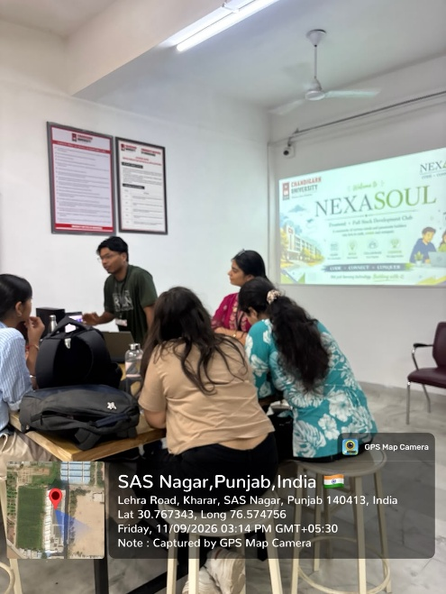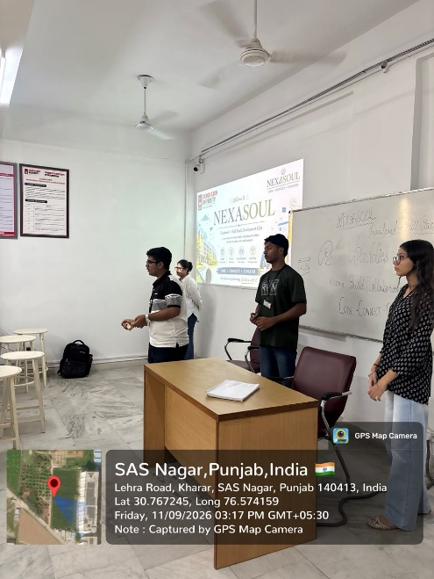
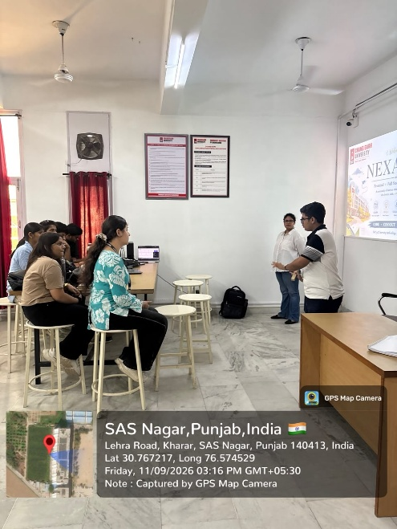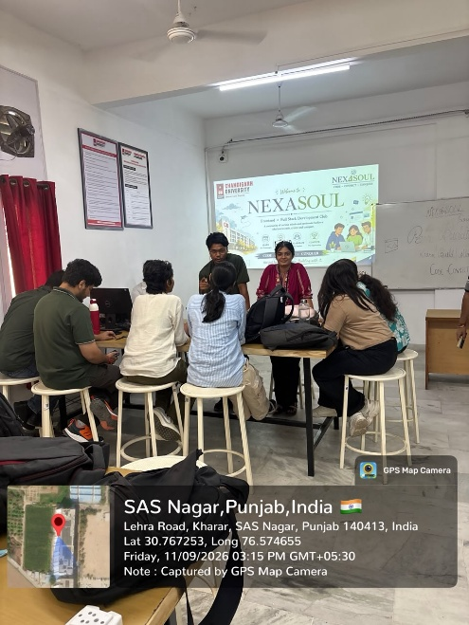
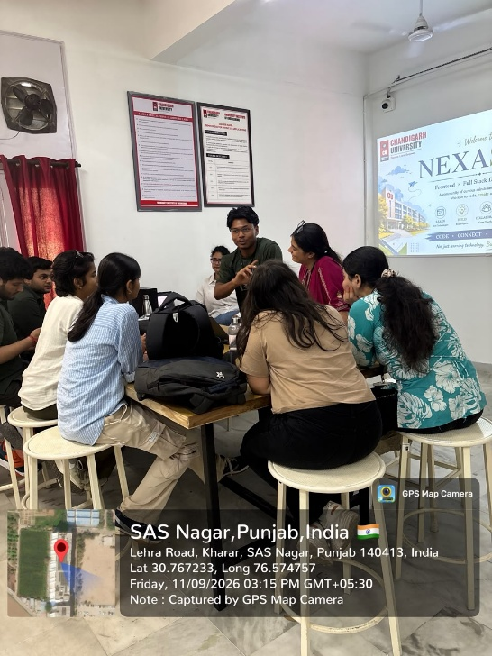
4. Student Interaction
The session was conducted in an interactive format, allowing students to discuss their understanding of web development and full stack technologies.
The interaction focused on:
- Difference between frontend and backend development.
- Role of databases in web applications.
- Importance of APIs.
- Technologies used in full stack development.
- How frontend and backend communicate.
- Project ideas that can be developed using full stack technologies.
- Skills required to begin learning full stack development.
Students were encouraged to ask questions and discuss their current level of technical knowledge and areas they wanted to explore further.

5. Key Observations
The session highlighted that understanding only one part of application development may limit a student's understanding of how complete software systems function.
The discussion demonstrated the importance of learning how different components work together. A student who understands frontend interfaces, backend logic, databases, and APIs can develop a clearer understanding of the complete lifecycle of a web application.
The session also emphasised that students can gradually expand their skill set by starting with the technologies they already understand and then progressing towards backend development, databases, APIs, and deployment.
6. Major Outcomes
The major outcomes of the session were:
- Students were introduced to the concept of Full Stack Development.
- The roles of frontend and backend development were explained.
- Students gained awareness about databases and APIs.
- The importance of frontend-backend integration was discussed.
- Students understood the benefits of developing end-to-end projects.
- Different areas of full stack development were introduced.
- Students were encouraged to expand their technical skills beyond a single development layer.
7. Conclusion
The NexaSoul Club Peer Buddy Session held on 11 September 2026 focused on the “Importance of Full Stack Development.” The session provided students with an overview of frontend development, backend development, databases, APIs, and the importance of integrating these components to build complete web applications.
Through discussion and student interaction, the session encouraged students to expand their technical knowledge and gradually develop full stack capabilities. The session also highlighted the value of practical project development and understanding the complete workflow involved in building modern web applications.

