REPORT ON CLUB PEER BUDDY SESSION
Club Name: NexaSoul
Domain: Frontend Development
Session: Club Peer Buddy Session
Date: 16 September 2026
Venue: C1 Block, Room 711
Scheduled Time: 3:35 PM – 4:25 PM
Organised As Per: Timetable and instructions received from the Office of Academic Affairs (OAA), Chandigarh University
1. Introduction
NexaSoul, the Frontend Development Club of Chandigarh University, conducted its scheduled Club Peer Buddy Session on 16 September 2026 as per the timetable and instructions received from the Office of Academic Affairs (OAA), Chandigarh University.
The primary focus of the session was “Club SOPs and Core Team Interview.” The session was organised to familiarise students with the standard operating procedures followed within the club and to provide an opportunity for selected/interested students to participate in the Core Team Interview process.
The session was conducted at C1 Block, Room 711, from 3:35 PM to 4:25 PM. The club representatives interacted with the students and discussed the organisational structure, working procedures, responsibilities, and expectations associated with being an active member of NexaSoul.
2. Resource Persons
The following representatives from NexaSoul were assigned to conduct the Peer Buddy Session:
Name | UID | Mobile Number | Assigned Timing
Ayush Negi | 24BCS10743 | 7876710340 | 3:35 PM – 4:10 PM
Sumanshu Jindal | 24BCS11091 | 9815713417 | 3:35 PM – 4:10 PM
Both resource persons reported for the assigned activity and remained available for student interaction.

3. Session Objectives
The major objectives of the session were:
- To introduce students to the Standard Operating Procedures (SOPs) of NexaSoul.
- To explain the expected conduct, responsibilities, and working practices within the club.
- To familiarise students with the organisational workflow of the club.
- To explain the importance of communication, coordination, discipline, and accountability.
- To conduct the Core Team Interview process.
- To provide students with an opportunity to demonstrate their interest and suitability for core team responsibilities.
- To encourage responsible and active participation in club activities.
4. Introduction to Club SOPs
The session included an orientation on the Standard Operating Procedures (SOPs) followed by NexaSoul.
Students were introduced to the importance of following defined procedures while carrying out club activities. The discussion focused on maintaining proper coordination, communication, task responsibility, discipline, and professional conduct during club activities and events.
The representatives explained that SOPs help maintain consistency in the execution of activities and ensure that responsibilities are clearly understood by members and team members.
Students were encouraged to follow the established workflow of the club while carrying out assigned responsibilities and communicating with other members.
5. Core Team Interview
A Core Team Interview was conducted as part of the session. The interview provided an opportunity for participating students to interact with the club representatives and discuss their interest in taking up responsibilities within NexaSoul.
The interaction focused on understanding students' interest in club activities, their willingness to take responsibility, and their approach towards working as part of a team.
The interview process also provided students with an opportunity to understand the expectations associated with core team responsibilities and the level of commitment required for effective participation in club activities.
6. Attendance and Student Participation
A total of 9 students were recorded as participants in the session.
S. No. | Student Name | UID
1 | Anupom Chakraborty | 24BAI71019
2 | Akshaj Singh | 25BCS11808
3 | Kohana Kalra | 25BAI70129
4 | Aditi Tomar | 24BCS12652
5 | Garvit Bhutani | 24BCS12030
6 | Saweta Kumari | 25BCS12188
7 | Kaushiki | 25BCS11118
8 | Aarit | 25BCS10003
9 | Mehul | 25BCS10594
Total Student Count: 9
The participating students were involved in the discussion regarding club SOPs and the Core Team Interview process.
8. Student Interaction
The session was conducted in an interactive format, allowing participating students to discuss their understanding of the club's working procedures and responsibilities.
Students were encouraged to ask questions regarding the SOPs and core team roles. The Core Team Interview further provided an opportunity for individual interaction and discussion with the club representatives.
The interaction helped students gain a clearer understanding of the expectations associated with active involvement in the club and the responsibilities that accompany core team positions.
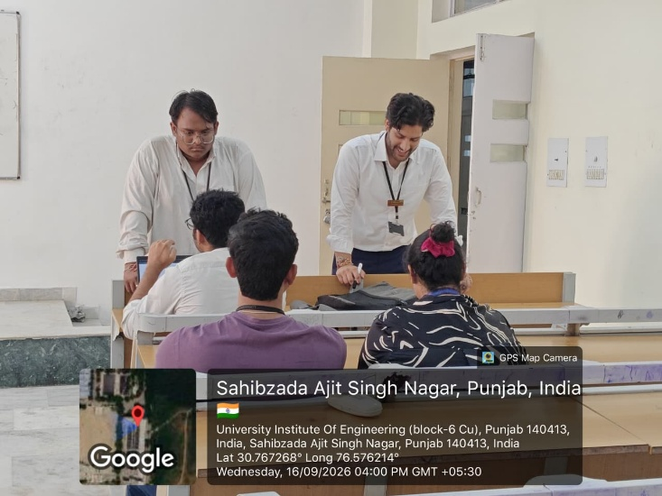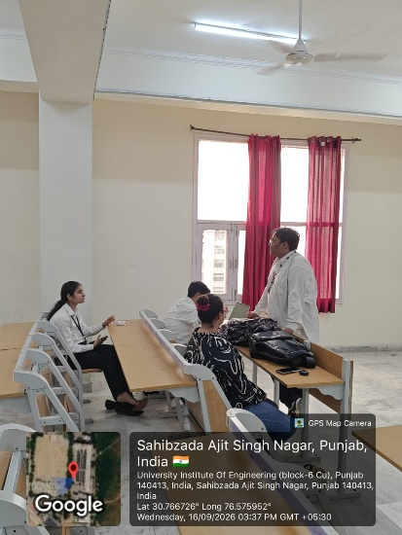
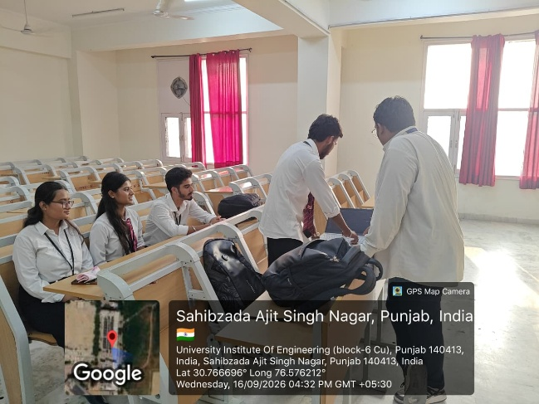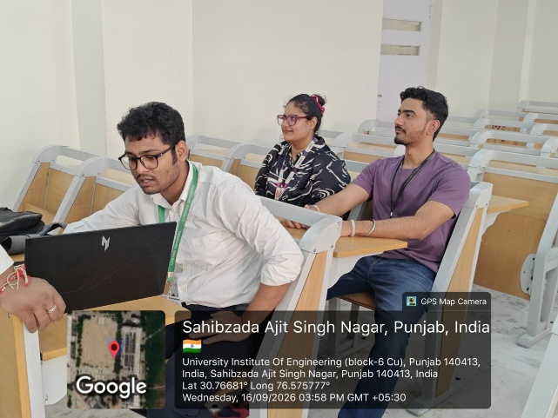
10. Major Outcomes
The major outcomes of the session were:
- Students were introduced to the SOPs followed by NexaSoul.
- The importance of discipline, communication, coordination, and accountability was discussed.
- Students were familiarised with expectations related to club responsibilities.
- The Core Team Interview process was conducted.
- Students received an opportunity for direct interaction with club representatives.
- The session encouraged students to take greater responsibility in club activities.
- A total of 9 students participated in the session.

12. Conclusion
The NexaSoul Club Peer Buddy Session held on 16 September 2026 focused on “Club SOPs and Core Team Interview.” The session provided students with an understanding of the club's standard operating procedures, working expectations, responsibilities, and organisational practices.
The session also incorporated the Core Team Interview, providing participating students with an opportunity to interact with club representatives and discuss their interest in taking up responsibilities within NexaSoul.
A total of 9 students participated in the session. Overall, the session contributed towards creating greater clarity regarding club procedures, responsibilities, teamwork, and participation in the organisational activities of NexaSoul.

