REPORT ON CLUB PEER BUDDY SESSION
Club Name: NexaSoul
Domain: Frontend Development
Session: Club Peer Buddy Session
Date: 19 August 2026
Venue: C1 Block, Room 711
Scheduled Time: 3:35 PM – 4:25 PM
Organised As Per: Timetable and instructions received from the Office of Academic Affairs (OAA), Chandigarh University

1. Introduction
NexaSoul, the Frontend Development Club of Chandigarh University, conducted its scheduled Club Peer Buddy Session on 19 August 2026 as per the timetable and instructions received from the Office of Academic Affairs (OAA), Chandigarh University.
The primary focus of the session was Membership Drive and Awareness Campaign. The session was organised to introduce students to NexaSoul, create awareness about the club's objectives and activities, and encourage students to participate in the club's technical and co-curricular initiatives.
The session was scheduled at C1 Block, Room 711, from 3:35 PM to 4:25 PM. The designated club representatives were present for the assigned activity and interacted with students regarding NexaSoul, its Frontend Development domain, membership opportunities, and upcoming activities.

2. Resource Persons
The following representatives from NexaSoul were assigned to conduct the Peer Buddy Session:
Name | UID | Mobile Number | Assigned Timing
Ayush Negi | 24BCS10743 | 7876710340 | 3:35 PM – 4:10 PM
Sumanshu Jindal | 24BCS11091 | 9815713417 | 3:35 PM – 4:10 PM
Both resource persons reported for the assigned activity and remained available for student interaction.

3. Session Objectives
The major objectives of the session were:
- To create awareness about NexaSoul – Frontend Development Club.
- To introduce students to the purpose and activities of the club.
- To conduct a membership drive among interested students.
- To explain the opportunities available through club participation.
- To encourage students to participate in technical workshops, events, projects, and competitions.
- To provide students with direct interaction with club representatives.
- To motivate students to explore frontend development and related technical activities.

4. Membership Drive
As part of the session, NexaSoul conducted a membership drive to encourage students to become members of the club. Students were informed about the purpose of club membership and the opportunities associated with being an active member.
The representatives explained that students can participate in various technical and co-curricular activities organised by the club. These activities provide opportunities for students to develop practical skills, work on projects, participate in competitions, attend workshops, and collaborate with other students.
The membership drive was also intended to encourage students who are interested in frontend development to become part of the club's technical community and participate in future initiatives.

5. Awareness Campaign
The awareness campaign focused on introducing students to NexaSoul and its role as a Frontend Development Club.
During the session, students were made aware of the club's activities and the different opportunities available through participation. The representatives explained the importance of practical learning, peer interaction, technical development, and participation in co-curricular activities.
Students were also encouraged to explore the club's activities irrespective of their existing level of technical knowledge. The session provided an opportunity for students to interact directly with the representatives and understand how they could participate in NexaSoul's future activities.

6. Student Interaction
The session included interaction between the NexaSoul representatives and students regarding club membership, activities, and participation opportunities.
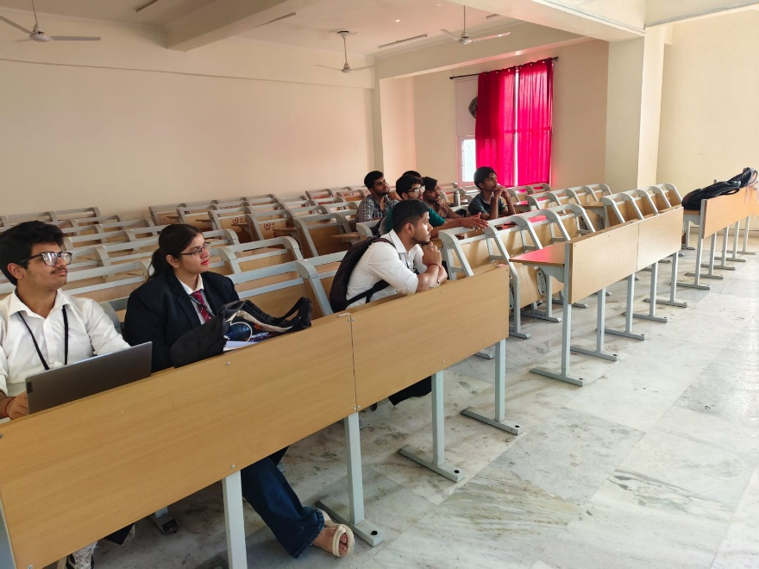
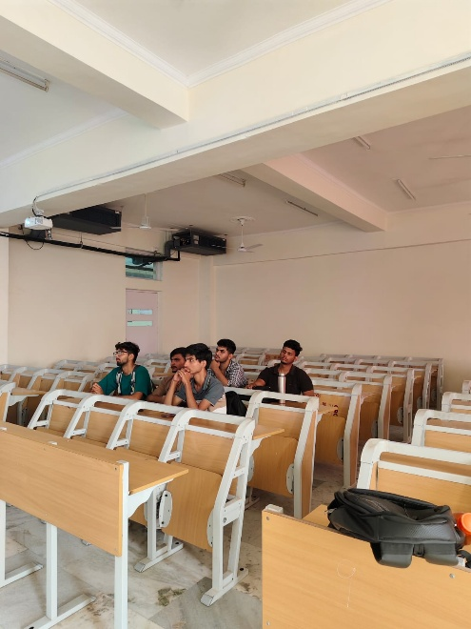
The interaction focused on:
- Understanding the role and purpose of NexaSoul.
- Learning about the Frontend Development domain.
- Understanding the membership drive.
- Learning about technical events and workshops.
- Exploring opportunities for participation in club activities.
- Clarifying students' queries regarding club involvement.
The direct interaction helped communicate information about the club and encouraged students to consider becoming active participants in NexaSoul activities.

7. Key Observations and Outcomes
The session provided an opportunity for NexaSoul to directly communicate its objectives and activities to students. The membership drive helped create awareness regarding the availability of technical and co-curricular opportunities through the club.
The awareness campaign also highlighted the importance of direct student interaction in communicating information about club activities and encouraging participation.
The major outcomes of the session included:
- Students were introduced to NexaSoul and its Frontend Development domain.
- Awareness regarding club activities and opportunities was promoted.
- Students were informed about the membership drive.
- Students were encouraged to participate in future technical activities.
- Direct interaction between club representatives and students was facilitated.
- The session promoted technical engagement and peer-based learning.

8. Conclusion
The NexaSoul Club Peer Buddy Session held on 19 August 2026 was organised with the primary focus of conducting a Membership Drive and Awareness Campaign. The session provided an opportunity to introduce students to NexaSoul, its Frontend Development domain, activities, and available opportunities.
Through direct interaction with students, the club representatives communicated the importance of technical participation, peer learning, and involvement in co-curricular activities. The session also served as a platform to encourage interested students to become members of NexaSoul and participate actively in its upcoming initiatives.

