REPORT ON CLUB PEER BUDDY SESSION
Club Name: NexaSoul
Domain: Frontend Development
Session: Core Team Hiring
Date: 23 September 2026
Venue: C1 Block, Room 711
Scheduled Time: 3:30 PM – 4:10 PM
Organised As Per: Timetable and instructions received from the Office of Academic Affairs (OAA), Chandigarh University
1. Introduction
NexaSoul conducted its scheduled Club Peer Buddy Session on 23 September 2026 with the agenda “Core Team Hiring.” The session focused on introducing students to the NexaSoul Core Team structure, available roles, responsibilities, and the selection process.
2. Resource Persons
Name | UID | Mobile Number | Timing
Sumanshu Jindal | 24BCS11091 | 9815713417 | 3:30–4:10 PM
Darshna Parihar | 24BCS12956 | 7300304978 | 3:30–4:10 PM
3. Session Objectives
- To introduce students to the NexaSoul Core Team.
- To explain available roles and responsibilities.
- To discuss the core team selection process.
- To understand students' skills and interests.
- To encourage leadership, teamwork, and active participation.
4. Student Attendance
A total of 5 students participated in the session. The attendance list has been retained from the previous report. NEXASOUL_11SEP2026
S. No. | Student Name | UID
1 | Khushi | 26BDA10106
2 | Yashita | 26BDA10149
3 | Snehal Sinha | 26BDA10128
4 | Tanishka Iyer | 26BDA10096
5 | Karish | 25BAI70367
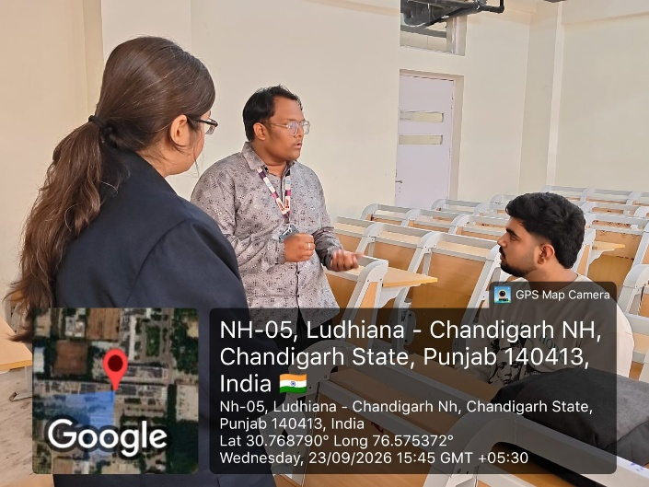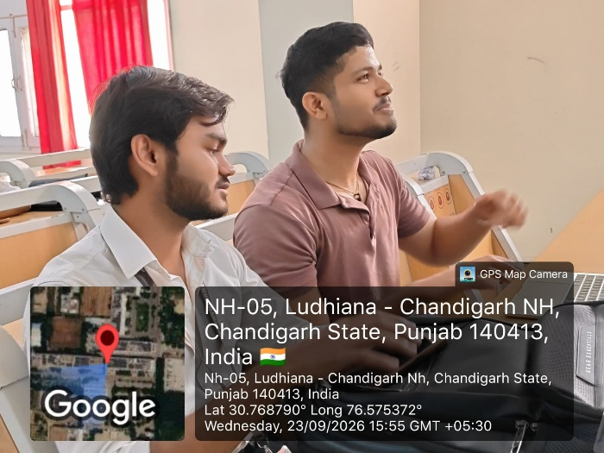
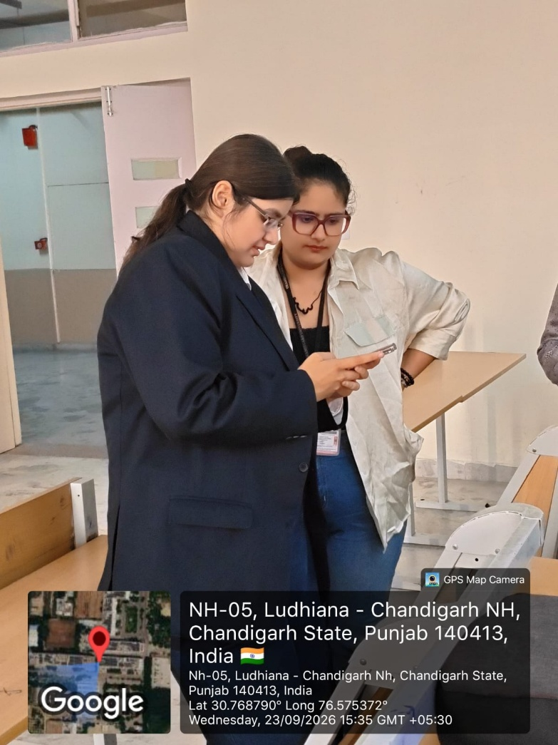
5. Student Interaction
Students were briefed about:
- Core team roles and responsibilities.
- Hiring and selection process.
- Technical and non-technical opportunities.
- Leadership and coordination responsibilities.
- Ways to contribute to NexaSoul activities.
6. Major Outcomes
- Students understood the NexaSoul Core Team structure.
- Different roles and responsibilities were explained.
- The hiring process was discussed.
- Students identified roles according to their skills and interests.
- Leadership and teamwork were encouraged.
7. Conclusion
The NexaSoul Core Team Hiring Session held on 23 September 2026 successfully introduced students to core team opportunities, responsibilities, and the selection process. The interactive session encouraged students to actively contribute to the club and take up leadership responsibilities.

