REPORT ON CLUB PEER BUDDY SESSION
Club Name: NexaSoul
Domain: Frontend Development
Session: Club Peer Buddy Session
Date: 23 September 2026
Venue: C1 Block, Room 711
Time: 3:30 PM – 4:10 PM
Agenda: AI Automation Tools to Automate Your Website
1. Introduction
NexaSoul conducted a Club Peer Buddy Session on 23 September 2026 focusing on “AI Automation Tools to Automate Your Website.” The session introduced students to AI-powered tools and their applications in automating website development and improving productivity.
2. Resource Person
Name | UID | Mobile Number | Timing
Manas Gupta | 25BCS11571 | 9568391020 | 3:30–4:10 PM
3. Session Objectives
- To introduce students to AI automation tools.
- To explain AI-based website automation.
- To demonstrate automation of website development tasks.
- To improve development productivity using AI.
- To encourage students to explore AI-assisted workflows.

4. Student Attendance
A total of 4 students participated in the session:
S. No. | Student Name | UID
1 | Aarit | 25BCS10003
2 | Saweta | 25BCS12188
3 | Avni Chugh | 25BAI70386
4 | Kohana Kalra | 25BAI70129
Total Student Count: 4
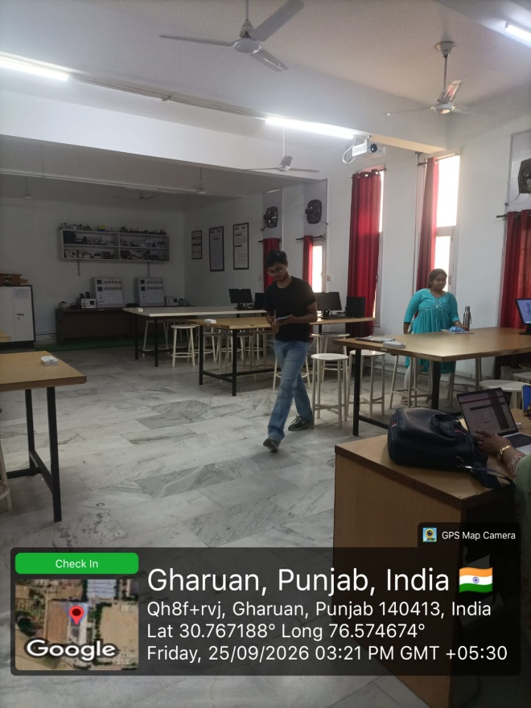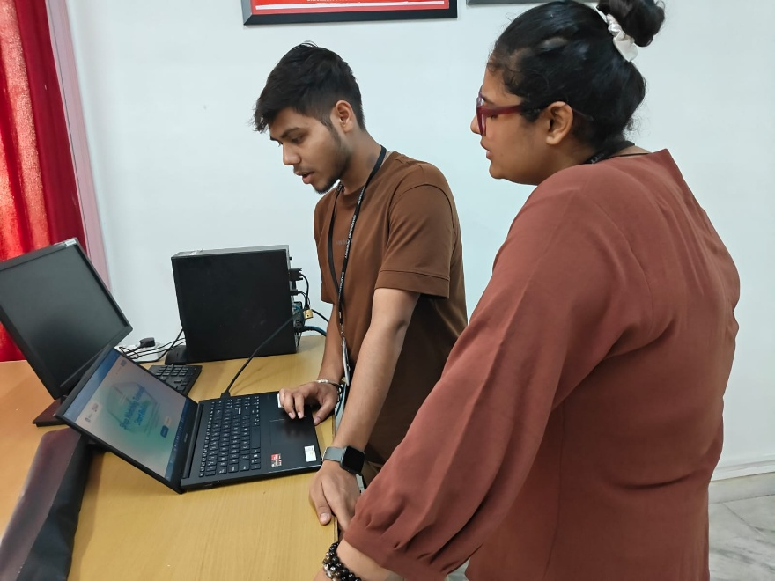

5. Student Interaction
The discussion focused on:
- AI tools for website development.
- Automating repetitive development tasks.
- AI-assisted code and content generation.
- Improving website development workflows.
- Practical applications of AI automation.
6. Major Outcomes
- Students were introduced to AI-powered website automation.
- Different applications of AI automation were discussed.
- Students understood how AI can improve development productivity.
- Practical use cases were explained.
- Students were encouraged to explore AI-assisted development.
7. Conclusion
The session successfully introduced students to AI automation tools for website development and highlighted how AI can simplify repetitive tasks and improve development efficiency. The session encouraged students to incorporate AI tools into their development and learning workflows.

