REPORT ON CLUB PEER BUDDY SESSION
Club Name: NexaSoul
Domain: Frontend Development
Session: Club Peer Buddy Session
Date: 30 September 2026
Venue: C1 Block, Room 711
Time: 3:30 PM – 4:10 PM
Agenda: Integrate Frontend and Backend in Project
1. Introduction
NexaSoul conducted a scheduled Club Peer Buddy Session on 30 September 2026 with the agenda “Integrate Frontend and Backend in Project.” The session was planned to explain how frontend and backend components communicate and work together to build functional web applications.
2. Resource Persons
Name | UID | Mobile Number | Timing
Sumanshu Jindal | 24BCS11091 | 9815713417 | 3:30–4:10 PM
Ayush Negi | 24BCS10743 | 7876710340 | 3:30–4:10 PM
3. Session Objectives
- To explain frontend and backend integration.
- To introduce API-based communication.
- To explain data exchange between frontend and backend.
- To discuss the workflow of full stack projects.
- To encourage students to build integrated applications.
4. Student Attendance
Total Student Count: 0
No students attended the scheduled Peer Buddy Session.
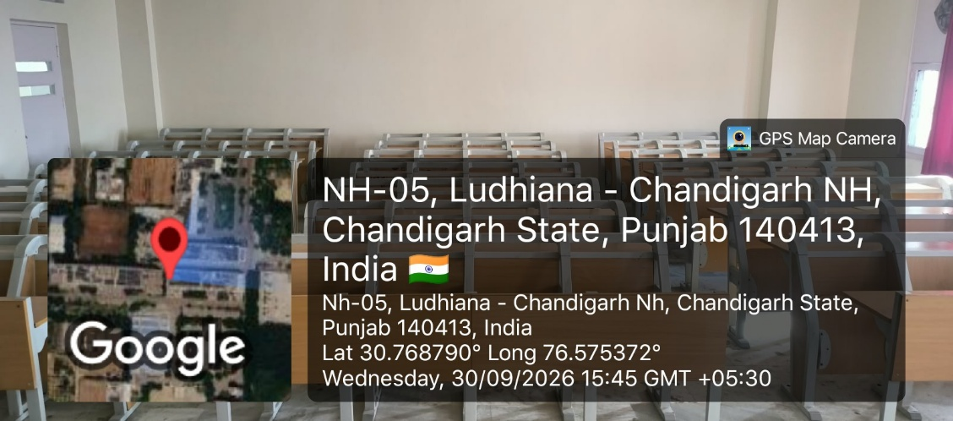
5. Planned Session Discussion
The session was planned to cover:
- Connecting frontend applications with backend services.
- API communication between frontend and backend.
- Sending and receiving data.
- Integrating backend functionality into frontend projects.
- Basic workflow of a full stack application.
6. Major Observation
The session was scheduled on the same day as a NexaSoul event at B1 Seminar Hall. Most students were engaged in and available at the event, which resulted in zero student attendance for the scheduled Peer Buddy Session.
7. Conclusion
The NexaSoul Club Peer Buddy Session scheduled for 30 September 2026 focused on frontend and backend integration in projects. Although the session had zero student attendance due to the ongoing NexaSoul event at B1 Seminar Hall, the designated resource persons were available for the scheduled activity.

