REPORT ON CLUB PEER BUDDY SESSION
Club Name: NexaSoul
Domain: Frontend Development
Session: Club Peer Buddy Session
Date: 9 September 2026
Venue: C1 Block, Room 711
Scheduled Time: 3:35 PM – 4:25 PM
Organised As Per: Timetable and instructions received from the Office of Academic Affairs (OAA), Chandigarh University

1. Introduction
NexaSoul, the Frontend Development Club of Chandigarh University, conducted its scheduled Club Peer Buddy Session on 9 September 2026 as per the timetable and instructions received from the Office of Academic Affairs (OAA), Chandigarh University.
The primary topic of the session was “Importance of Competitions and Hackathons.” The session was organised to create awareness among students about the role of technical competitions and hackathons in developing practical skills, problem-solving abilities, teamwork, creativity, and exposure to real-world development challenges.
The session was conducted at C1 Block, Room 711, from 3:35 PM to 4:25 PM. The designated club representatives interacted with students and discussed the importance of actively participating in technical competitions and hackathons.

2. Resource Persons
The following representatives from NexaSoul were assigned to conduct the Peer Buddy Session:
Name | UID | Mobile Number | Assigned Timing
Ayush Negi | 24BCS10743 | 7876710340 | 3:35 PM – 4:10 PM
Sumanshu Jindal | 24BCS11091 | 9815713417 | 3:35 PM – 4:10 PM
Both resource persons reported for the assigned activity and remained available for student interaction.

3. Session Objectives
The major objectives of the session were:
- To explain the importance of technical competitions and hackathons.
- To encourage students to participate in competitive programming and development events.
- To highlight the practical learning opportunities provided by hackathons.
- To develop awareness about teamwork and collaborative problem-solving.
- To encourage students to apply classroom knowledge to practical problems.
- To promote innovation, creativity, and technical skill development.
- To motivate students to participate in inter-college and university-level competitions.

4. Student Interaction
The session was conducted in an interactive format. Students were encouraged to discuss their understanding of technical competitions and hackathons and share their previous experiences, if any.
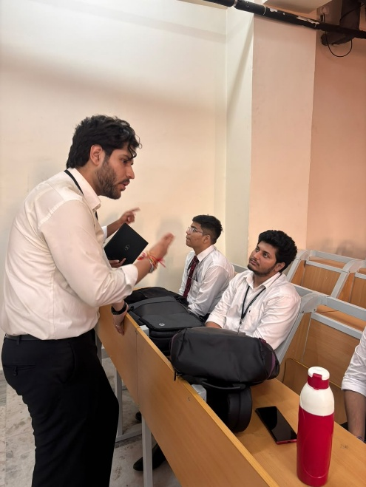\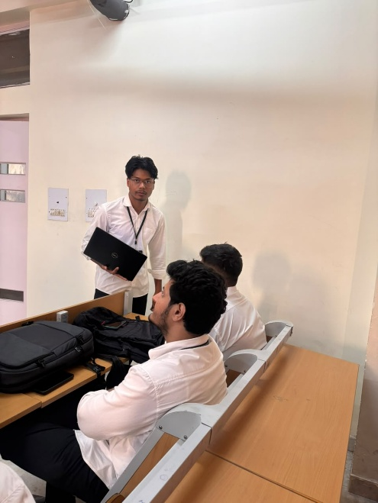
The interaction focused on:
- Students' familiarity with hackathons and competitions.
- How to identify suitable competitions.
- Preparation required before participating.
- Team formation and role distribution.
- Project development during hackathons.
- Importance of presenting and documenting projects.
- Learning from participation regardless of the final result.
Students were encouraged to actively explore upcoming technical opportunities and participate in events relevant to their interests and skill levels.

5. Key Observations
The session highlighted that participation in competitions and hackathons can complement classroom learning by providing students with practical development environments.
The discussion also emphasised that students can benefit from participation even when they do not achieve a winning position. Working on problems under time constraints, collaborating with teammates, receiving feedback, and completing a project can contribute to practical learning and skill development.
The session further reinforced the importance of starting with manageable competitions and gradually participating in more challenging events as students gain experience.

6. Conclusion
The NexaSoul Club Peer Buddy Session held on 9 September 2026 focused on the “Importance of Competitions and Hackathons.” The session provided students with an understanding of how technical competitions and hackathons can complement academic learning through practical problem-solving, teamwork, innovation, time management, and project development.
Through discussion and student interaction, the session encouraged students to explore technical competitions and hackathons as opportunities for practical learning and skill development. The session also highlighted the importance of consistent participation, collaboration, and learning from competitive experiences.

