Twenty-metre optical paths in sub-19 cm rings: chord-skip toroidal multipass cells built from catalogue mirrors for drone-borne methane sensing
Draft v3 for internal review (simulation results) — 2 July 2026 — not for distribution
Sumant Varanasi¹, [co-authors — confirm], and Thomas Benoy^{2,*}
¹Indian Institute of Technology Delhi – Abu Dhabi, UAE ²Aston Institute of Photonic Technologies, Aston University, UK *t.benoy@aston.ac.uk
Abstract
Toroidal multipass cells fold long absorption paths into compact, mechanically robust volumes, but published designs demonstrate at most ~10 m of optical path in the 100–200 mm diameter class and typically require custom diamond-turned optics. We present a family of ring-geometry multipass cells that reach a verified 20.4–24.8 m optical path length within a 180 mm assembly envelope — and 20.6 m within 159 mm — using 13–16 catalogue 25.4 mm concave mirrors (≈US$1000 of optics) and a sub-kilogram optical head. Three design principles enable this: (i) a chord-skip ring geometry whose near-diameter chords deliver up to 143 mm of path per reflection at 7–13° incidence; (ii) an engineered dual-plane re-entrance condition in which the machined ring radius acts as the closure-tuning parameter (≈1.2 rad of accumulated transverse phase per millimetre), with a number-theoretic constellation rule that guarantees fringe-safe spot separation on every mirror; and (iii) mode-matched injection through a single 1.3 mm coupling hole, which makes hole losses negligible so that cell transmission equals R^(n−1) exactly in mirror reflectivity R — 86.7 % for the headline 20.4 m design at R = 0.999. Designs are verified with an exact three-dimensional ray tracer including astigmatic Gaussian-beam propagation, cross-validated against an independent ray tracer to sub-micrometre agreement, and toleranced by Monte-Carlo analysis: at research-grade build tolerances the headline design completes all 144 traversals in 100 % of trials, the ±1 % catalogue tolerance on mirror focal length is absorbed by a linear 0.72 mm-per-percent trim of the ring radius, and a plain aluminium ring holds alignment over ±26 K. An exhaustive search over the full catalogue space additionally establishes the architecture's boundaries: a 141 mm minimum feasible envelope, and a ≈25 m verified path ceiling set by spot-constellation crowding on the 25.4 mm aperture rather than by the photon budget.
1. Introduction
Tunable diode laser absorption spectroscopy (TDLAS) of the methane 2ν3 band near 1654 nm requires tens of metres of absorption path for sub-ppm sensitivity, while drone deployment restricts the sensor head to roughly a 19 cm envelope and about a kilogram of payload. Multipass cells reconcile these demands by folding the path between mirrors. The classical two-mirror Herriott cell [11–13] achieves this with re-entrant elliptical patterns; its densest variants reach 54.6 m in a 17 cm astigmatic cell [9] and 26.4 m in a 12 cm dense-pattern cell [10], at the cost of custom mirror pairs and critical two-mirror alignment. Ring-geometry (toroidal/circular) cells trade some packing density for one-piece mechanical robustness: demonstrated paths are 2.2–4.1 m in the monolithic toroidal cell of Tuzson et al. [1, 2], >12 m in a 145 mm circular paraboloid [3], 10 m at <200 g in the segmented cell of Graf et al. [4], and 10 m (30 m theoretical) from multi-layer patterns on a 100 mm ring [7]; mask-based fringe suppression [5], double-row geometries at larger diameter [6], and cryogenic toroidal cavities [8] extend the family. Across this literature, demonstrated toroidal-class paths in drone-compatible envelopes cluster at or below ~10 m, and every design relies on custom optics.
This work asks a deliberately constrained question: how much verified optical path can a ring cell deliver inside a 190 mm envelope using only catalogue mirrors — Thorlabs CM254-series 25.4 mm concave mirrors (16 focal lengths, ≈US$74 each) — with 8–16 mirrors, a single 1.3 mm coupling hole, and a 1.3 mm collimated input? The chord-skip parameter is the entry point: in our early design-space exploration, moving from adjacent-mirror propagation to a skip of s = 4 on a 9-mirror ring raised the path length by 67 % while cutting the incidence angle from 67.5° to 10°, and a companion catalogue study showed 12.7 mm mirrors saturate near 12 m — fixing the present 25.4 mm, N = 8–16 design space. Our contributions are: (1) the chord-skip parametrisation itself, with s ≈ N/2 giving near-diameter chords at near-normal incidence; (2) an engineered — rather than searched-for — re-entrance condition, tuned by the machined ring radius against catalogue-locked curvatures, with an exact constellation criterion guaranteeing fringe-safe spot patterns before any ray is traced; (3) mode-matched single-hole coupling that renders the hole lossless; and (4) a fully verified design menu (13.6 m in 143 mm to 24.8 m in 180 mm), each design passing an eight-item physical check matrix in exact ray tracing, cross-validated independently, Monte-Carlo toleranced, and accompanied by machining-level build specifications and a drone mass budget.
2. Cell architecture and design principles
2.1 Chord-skip ring geometry
N identical concave mirrors of curvature radius R and clear-aperture radius 11.4 mm face inward from a ring of radius R_ring, one every 360°/N. A beam injected through a hole in mirror M0 advances by s mirrors per reflection (the chord skip, gcd(N, s) = 1). Each chord has length L = 2 R_ring sin(πs/N) and the incidence angle on every mirror is θ_i = π/2 − πs/N. For s ≈ N/2 the chords approach the ring diameter while θ_i falls to 6–13°: a 72 mm-radius ring yields 140+ mm of path per reflection — the geometric core of the result. The assembly envelope is 2(R_ring + 18 mm), the allowance covering substrate and housing wall.
2.2 Re-entrance: dual-plane phase closure
In the paraxial unit cell (one chord plus one mirror) the transverse ray oscillation advances by a phase θ per bounce, with cos θ_t = 1 − L/(R cos θ_i) tangentially and cos θ_s = 1 − L cos θ_i /R sagittally (the off-axis astigmatic split). The beam exits through the entrance hole after n = kN reflections when both accumulated phases return to their launch value; zero-crossing launches close at phase 0 or π, giving four closure-mode combinations per geometry. The single machinable parameter R_ring moves both accumulated phases along a nearly fixed direction (≈1.2 rad per millimetre here), so a candidate is closable only if its signed phase residuals lie near that line; the residual is absorbed by the launch amplitudes through their weak aberration-mediated phase pull. Re-entrance thus becomes an engineered property: the ring is machined to the radius that closes the pattern for the delivered mirror lot, and the verified designs re-cross the hole centre to within 10⁻⁶–10⁻⁴ mm.
2.3 Constellation rule: fringe-safe spot patterns
At closure the n = kN spots sample a Lissajous curve at unit-fraction phase steps. Three exact geometric rules follow: k must be odd (for even k the tangential π-slot coincides with a sagittal near-return and a spot lands in the coupling hole); gcd(M, k) = 1 in both planes with M = round(nθ/2π) (otherwise the k spots per mirror collapse into clusters); and — decisive in practice — every mirror carries the same k-point pattern at a different phase origin along the curve, so the worst spot pair must be evaluated over all N mirrors, not only the launch mirror, which overestimates usable separation by up to 3×. The minimum pair distance and pattern extent are computed exactly per candidate, sizing the required amplitude and rejecting self-crowding patterns before ray tracing. Spot-overlap fringes — the dominant practical noise source in this cell class [5, 7] — are thereby excluded by construction: every design keeps every spot pair on every mirror at least the sum of the local 1/e² radii plus 0.36–0.42 mm apart.
2.4 Mode-matched single-hole coupling
A 1.3 mm waist placed at the hole is badly mismatched to the cell eigenmode (mirror-plane radius w = √(M²λL/π sin θ) ≈ 0.3–0.45 mm here); the beam then breathes to ~3× its injected size, spots overlap, and the hole clips 13.5 % of the power at entry and again at exit. Instead, a small lens focuses the 1.3 mm collimated input so the in-cell waist (0.20–0.33 mm) sits near mid-chord: the beam rides the eigenmode at 0.21–0.42 mm for the entire path, the radius at the hole is ~0.3–0.37 mm, and the 1.3 mm hole transmits ≈100 % both ways. Cell transmission is then exactly T(R) = R^(n−1). At closure the round-trip ABCD map is the identity, so the exit beam reproduces the injected Gaussian and leaves through the same hole, separated from the input axis by 2θ_i (22.5° for N = 16), placing laser and detector side by side behind M0 with no beamsplitter.
3. Numerical methods
Designs were generated and verified with our open simulation platform: an exact 3-D ray tracer on toroidal/spherical surfaces (analytic normals, Newton-iterated intersections, per-bounce aperture tests), astigmatic Gaussian propagation via per-plane complex-q ABCD transfer with the actual per-bounce incidence angles and an M² factor, loss budget, per-plane stability, and spot diagnostics; earlier iterations of the platform added Sobol design-space sampling and machine-learning surrogates used in the exploratory phase. The search runs in two stages: Stage A enumerates the catalogue space (16 curvatures × N = 8–16 × coprime skips × a fine ring-radius grid × odd k) against packing, envelope, stability, closure-residual and constellation criteria; Stage B ray-traces survivors, sweeps the ring radius in 20 µm steps to locate the ~20 µm-wide closure valley, and polishes six launch/geometry parameters by Nelder-Mead. A design is accepted only if the final trace passes all eight checks of Table 2. The tracer was cross-validated against the independent open-source ray tracer Optiland [15]: over 64 bounces of the headline design the two agree to 0.000 µm RMS in spot position, 0.01° in incidence angle, and 0.8 µm in chord length.
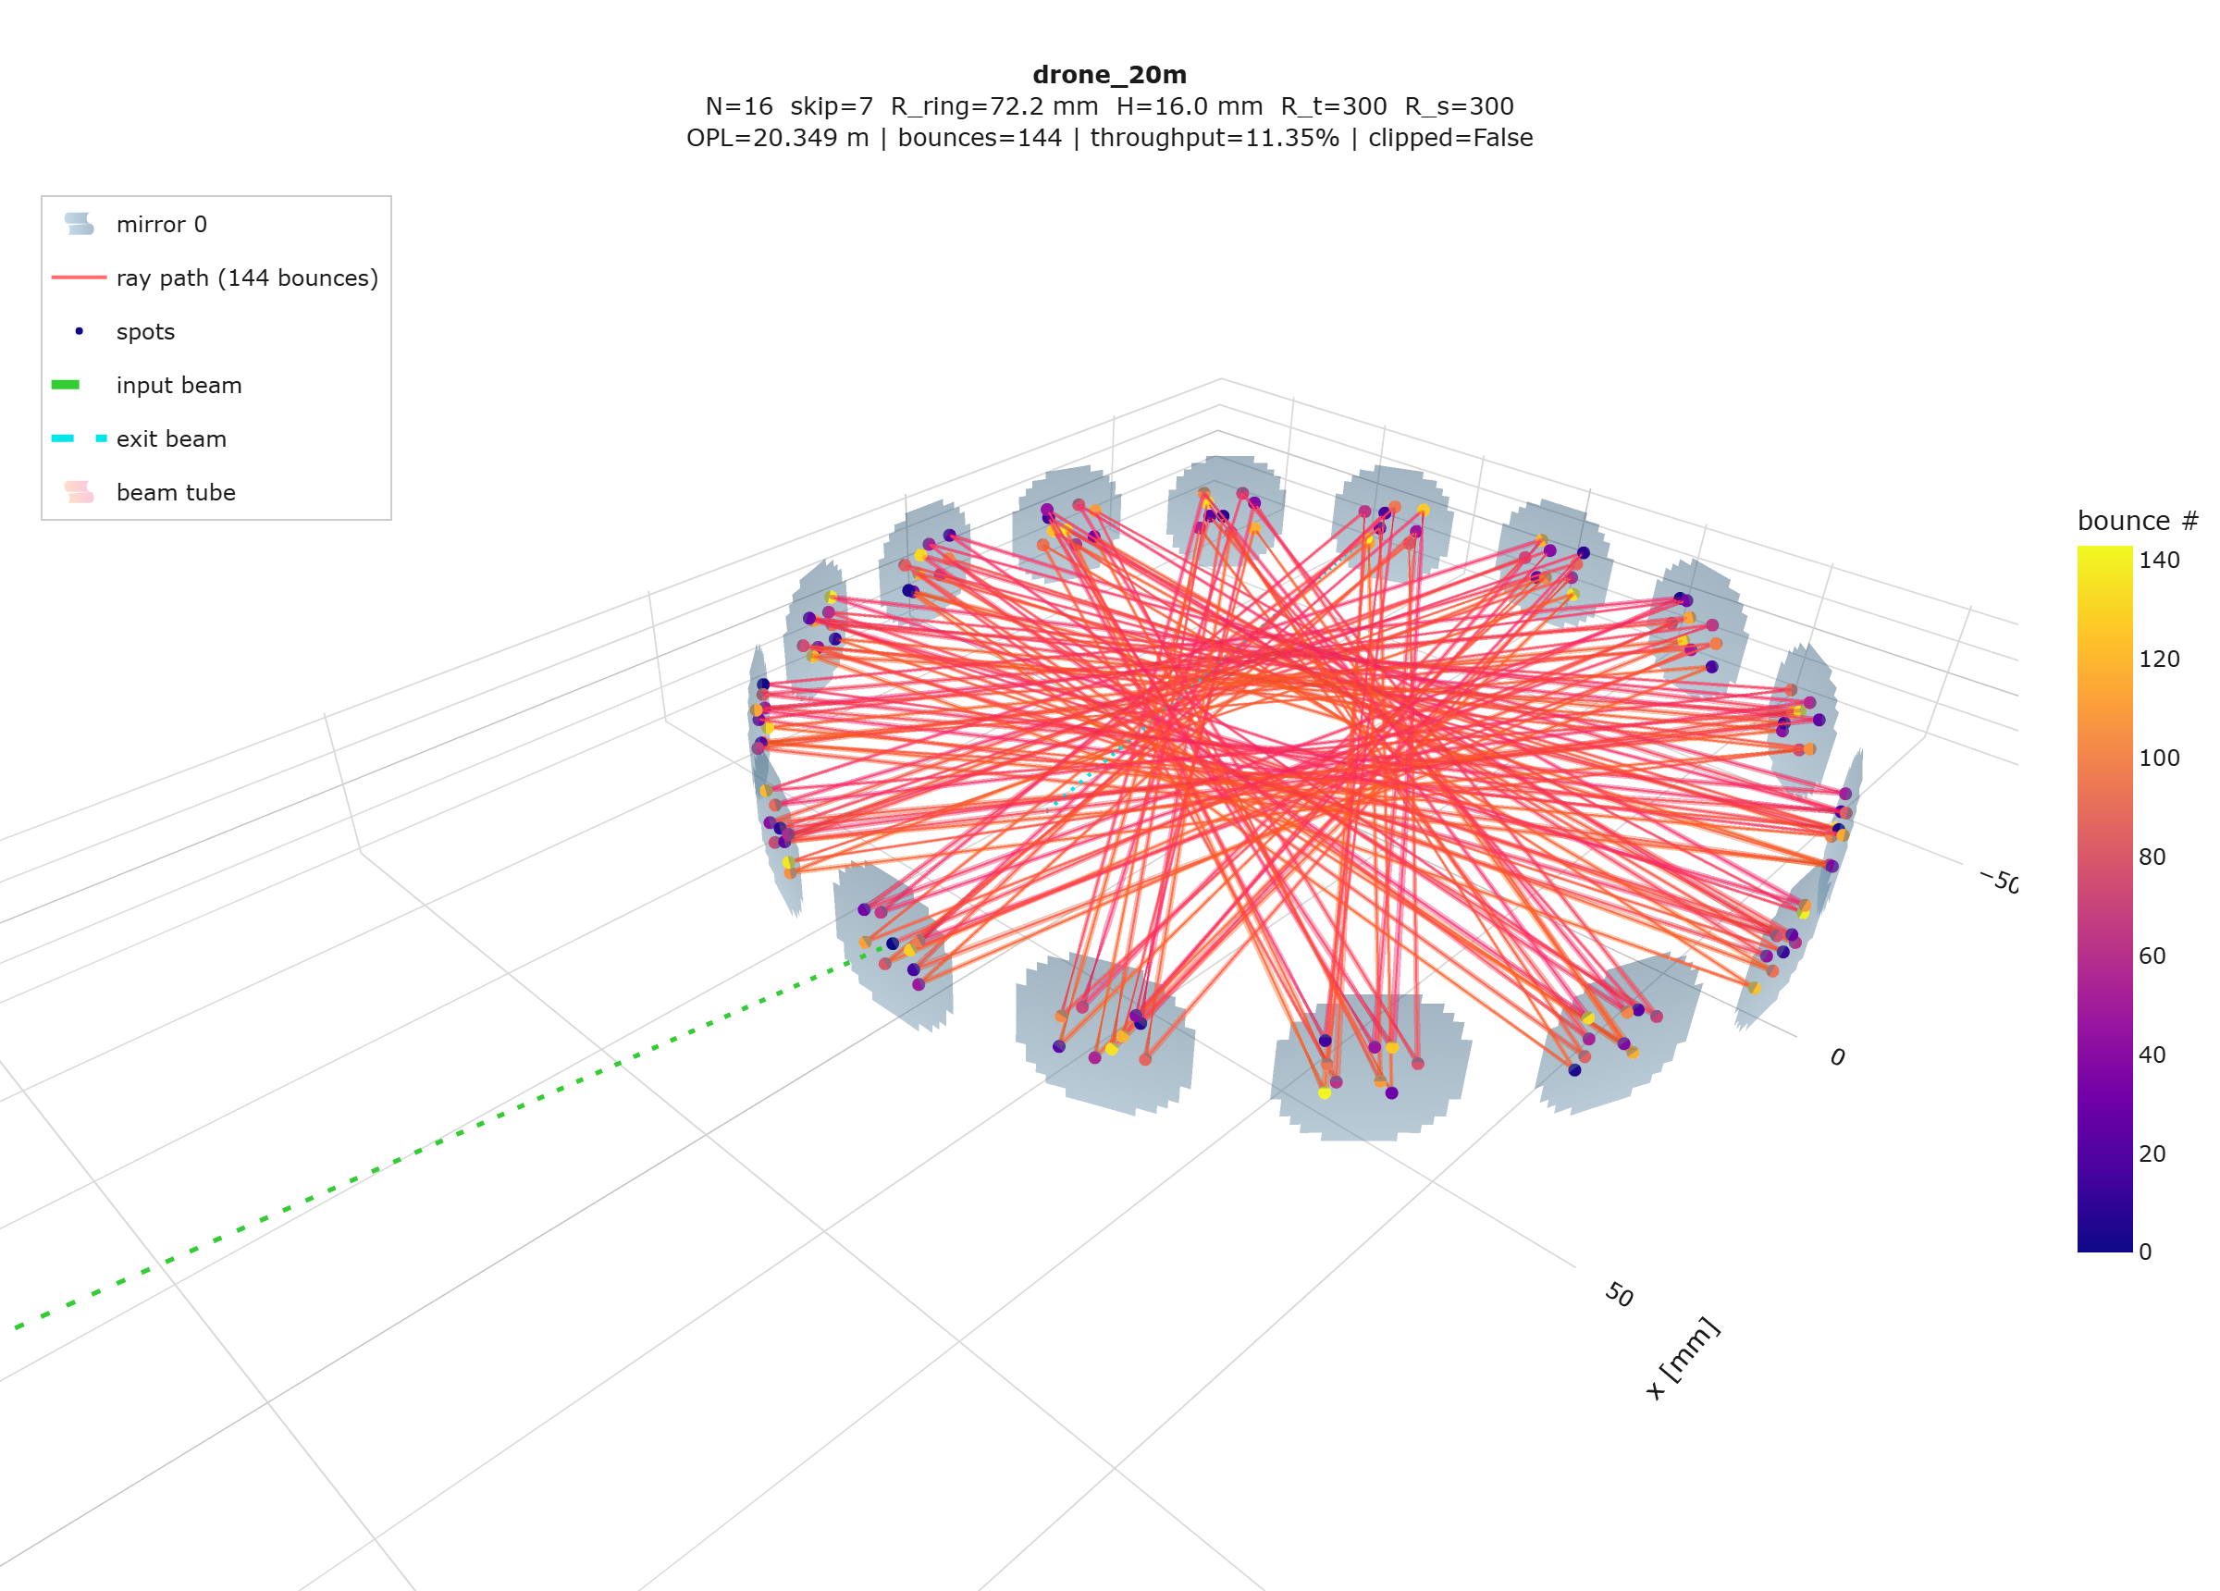
Fig. 1. Exact traced beam path of the headline design: 16 catalogue mirrors on a 72.155 mm ring, 144 chords (20.38 m), coloured by bounce order; the input beam (green) enters through the 1.3 mm hole in M0 and the closed pattern exits through the same hole.
4. Results
4.1 Verified design menu
Table 1. Verified design menu. Every row passes the full check matrix in the exact ray trace. Transmission T = R^(chords−1) exactly (hole losses ≈ 0); quoted at R = 0.999 with sensitivity to coating in brackets (R = 0.985 / 0.97). Envelope = 2(R_ring + 18 mm).
design | mirrors | R_ring [mm] | chords | OPL [m] | T @0.999 (0.985/0.97) | env. × height [mm]
max OPL | 16 × CM254-200 (R 400) | 71.758 | 176 | 24.77 | 83.9 % (7.1/0.5) | 180 × 22
mid Pareto | 14 × CM254-100 (R 200) | 67.849 | 182 | 22.25 | 83.4 % (6.5/0.4) | 172 × 26
headline 20 m | 16 × CM254-150 (R 300) | 72.155 | 144 | 20.38 | 86.7 % (11.5/1.3) | 180 × 16
mid | 12 × CM254-075 (R 150) | 67.489 | 156 | 20.34 | 85.6 % (9.6/0.9) | 171 × 22
compact 20 m | 13 × CM254-050 (R 100) | 61.519 | 169 | 20.64 | 84.5 % (7.9/0.6) | 159 × 18
compact max-T | 13 × CM254-150 (R 300) | 62.087 | 143 | 16.60 | 86.8 % (11.7/1.3) | 160 × 20
small | 12 × CM254-250 (R 500) | 53.486 | 132 | 13.64 | 87.7 % (13.8/1.9) | 143 × 16

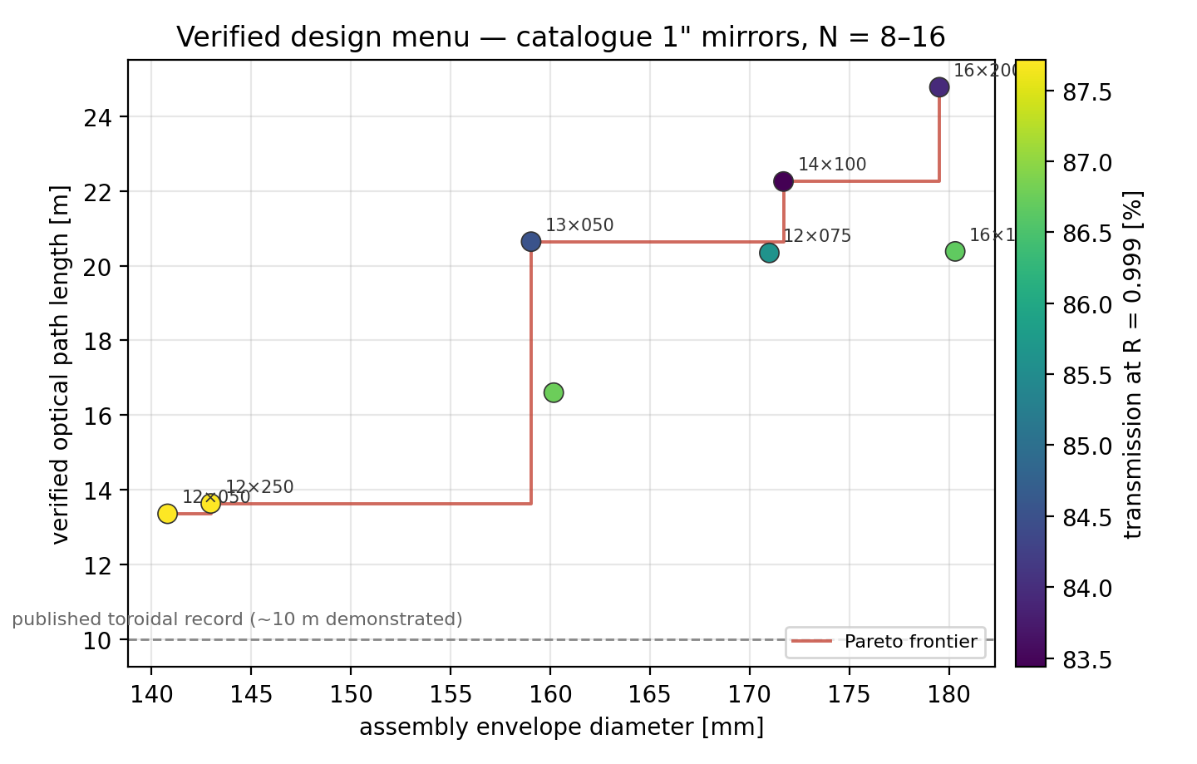
Fig. 2. The verified design menu as an envelope–path map (marker colour = transmission at R = 0.999). The Pareto frontier is populated entirely by catalogue-mirror designs; the dashed line marks the ~10 m demonstrated record of published toroidal cells in this size class.
At R = 0.999 — the reflectivity class of enhanced/dielectric coatings, adopted as the project baseline (a protected-gold build at R ≈ 0.985 is quoted in brackets; the coating is a procurement decision, not a design change) — all designs transmit 83–88 %, and the long-path corners become unambiguously preferred since 30–40 extra reflections cost only ~3 % of signal. Two boundaries of the architecture were established by exhaustive search (0.05 mm ring-radius grid, up to 240 bounces, k ≤ 15 spots per mirror). Downward: the smallest feasible envelope is 141 mm (13.4 m); the best near-miss — 18.0 m in 140 mm — fails only by an intermediate spot grazing the coupling hole by 0.56 mm, and re-slotting the hole within the constellation is an open lever; below 105 mm, eight 25.4 mm mirrors no longer pack. Upward: the verified path ceiling is ≈25 m — the 26–32 m corner never closes because 15-spot-per-mirror constellations self-crowd under the exact worst-pair rule. The ceiling is thus set by spot geometry on the 11.4 mm clear aperture, not by the photon budget, and larger-aperture mirrors (at the cost of packing) are the identified route past it.
4.2 The headline design
The 20.38 m design uses sixteen CM254-150 mirrors (R = 300 mm) on a ring machined to R_ring = 72.155 mm (envelope 180 mm, inner height 16 mm, sampled volume 0.26 L). The beam enters at 11.25° mean incidence, completes 144 chords of mean 141.5 mm, deposits 9 spots on each mirror with a worst-pair separation of 0.99 mm against summed beam radii of ~0.64 mm, keeps 4.9 mm of aperture margin, and re-crosses the hole plane within 6 nm of the entrance point at the designed bounce; all eight intermediate visits to M0 clear the hole by at least 1.46 mm beyond the local beam radius. Mode matching sets a 0.326 mm waist 102 mm past the hole (radius at the hole 0.365 mm; hole transmission 100.0 %). Transmission is R^143 = 86.7 % at R = 0.999: a 10 mW DFB source delivers ≈8.7 mW to the detector, so the photon budget is not the limiting factor at any realistic coating.
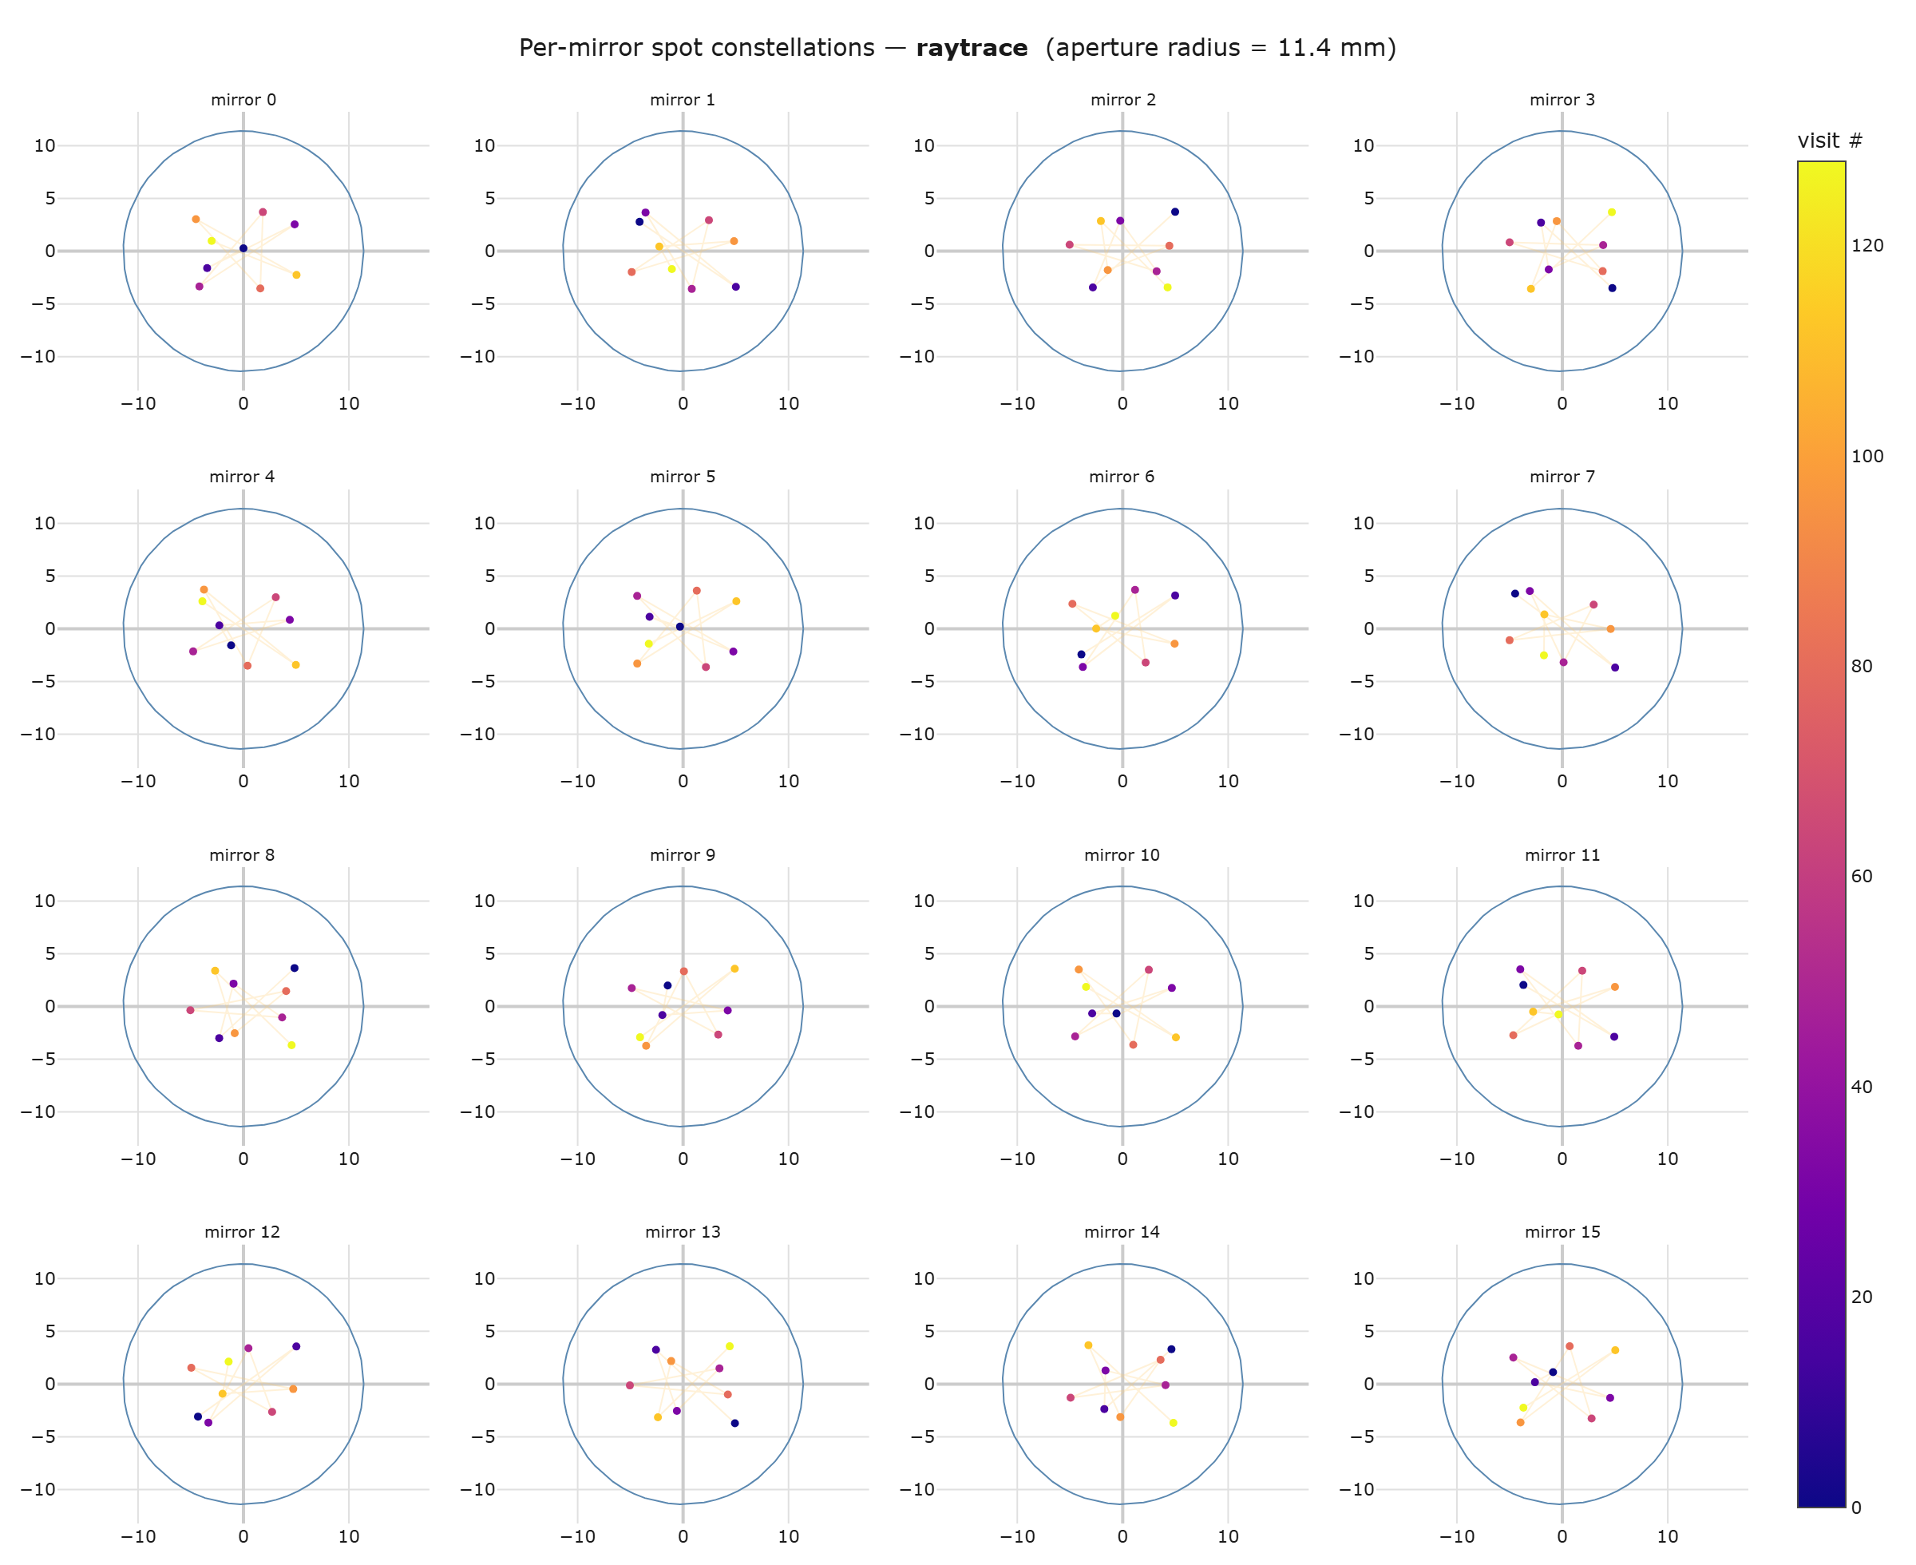
Fig. 3. Per-mirror spot constellations of the headline design (ray-traced): each of the 16 mirrors carries the same 9-point pattern at a different phase origin; the worst pair over all mirrors is the verified fringe-safety quantity. M0 additionally shows the entrance/exit hole.
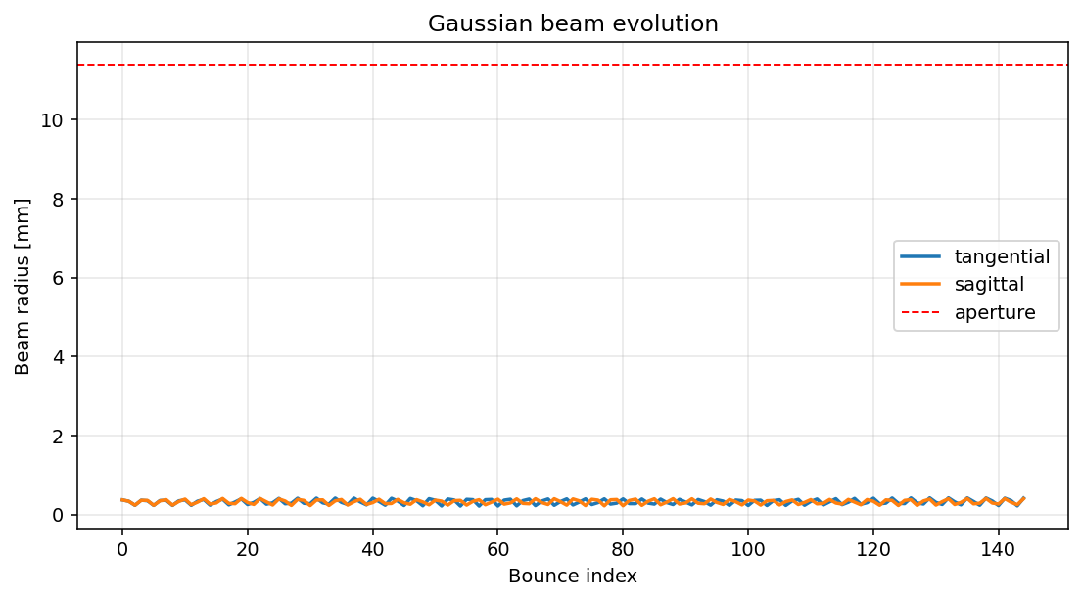
Fig. 4. Tangential and sagittal 1/e² beam radii at each bounce under mode-matched injection: the beam rides the cell eigenmode at 0.21–0.42 mm for all 144 chords, an order of magnitude below the 11.4 mm clear aperture.
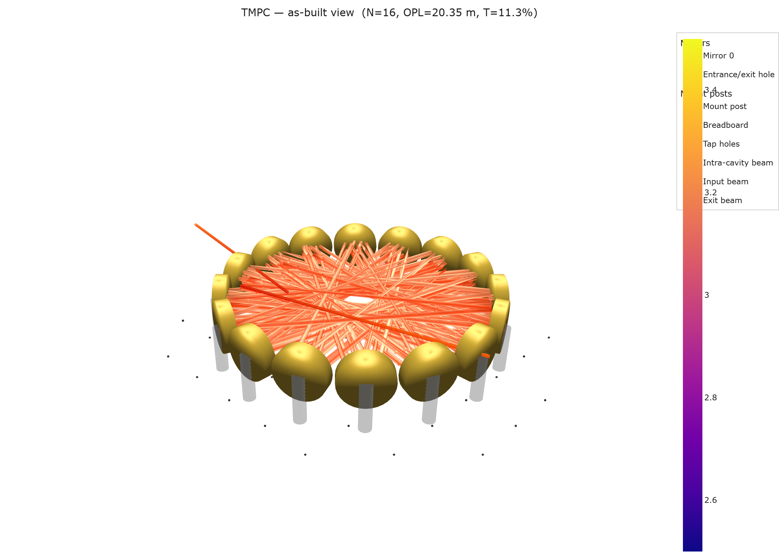
Fig. 5. As-built rendering of the headline design: sixteen 25.4 mm mirrors in a one-piece machined ring; laser collimator, mode-matching lens and detector all mount behind M0, the exit beam leaving 22.5° from the injection axis.
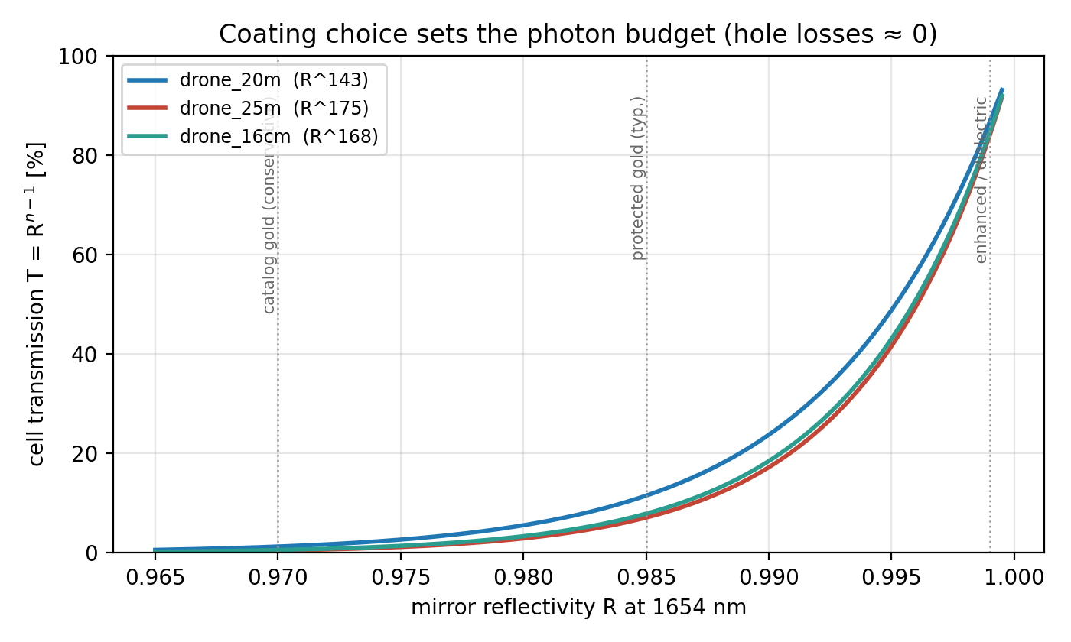
Fig. 6. Coating choice sets the photon budget: with the coupling hole rendered lossless by mode matching, transmission is exactly R to the power (chords − 1) for every design. Vertical guides mark conservative catalogue gold, typical protected gold, and enhanced/dielectric coatings.
4.3 Drone integration: mass and power budget
Table 2 gives a CAD-level mass estimate for the complete airborne sensor head. Mirror substrates are 25.4 mm × 6.35 mm glass (≈8 g each); the one-piece aluminium ring (14 mm radial section, pocketed) and two 1.5 mm lids dominate the optical-head mass and admit ~30 % lightweighting by skeletonising; injection optics comprise the fibre collimator, mode-matching lens and InGaAs photodiode on a common plate behind M0. With a compact DFB driver/DAQ stack the full payload is ≈1.0–1.2 kg, within the payload class of standard commercial multirotor platforms, and the 0.26 L sampled volume exchanges in well under a second at modest flow. Power is dominated by the laser TEC and electronics at a few watts; the cell itself is passive.
Table 2. Mass budget (CAD-level estimates, headline vs compact design).
item | drone_20m (Ø180) | drone_16cm (Ø159)
mirror substrates | 16 × 8 g = 128 g | 13 × 8 g = 104 g
Al ring (pocketed) + lids | ≈ 450–600 g | ≈ 380–500 g
injection optics + detector plate | ≈ 80 g | ≈ 80 g
optical head subtotal | ≈ 0.66–0.81 kg | ≈ 0.56–0.68 kg
DFB laser + driver + DAQ | ≈ 0.30–0.40 kg | ≈ 0.30–0.40 kg
total payload | ≈ 1.0–1.2 kg | ≈ 0.9–1.1 kg

5. Tolerance and engineering analysis
Each design was subjected to 300–400 Monte-Carlo trials with independent per-mirror perturbations at research-grade magnitudes (tilt σ = 0.5 mrad per axis; decentre σ = 50 µm lateral, 100 µm axial; curvature σ = 1 mm; ring radius σ = 0.1 mm; launch σ = 50 µm and 0.5 mrad). No trial in any design clipped or lost the beam, and all completed the full traversal count; geometric quantities in Table 3 are coating-independent. One-at-a-time sensitivity identifies the dominant error source per design: mirror-pocket tilt for the R ≥ 300 mm designs (3.3 mrad of exit drift per 0.5 mrad tilt σ, curvature error negligible), and ring radius / curvature for the compact R = 100 mm design (tilt negligible). The one-piece machined ring, whose pocket angles are cut in a single CNC operation, targets precisely the dominant term; the compact design additionally wants ~2× tighter machining or use of its thermal trim at first alignment.
Table 3. Monte-Carlo results at research-grade tolerances (mean ± σ; p95 in brackets).
metric | drone_20m | drone_25m | drone_16cm
trials clipping / losing beam | 0/400 | 0/300 | 0/300
OPL [m] | 20.35 ± 0.03 | 24.74 ± 0.03 | 20.61 ± 0.03
exit pointing drift [mrad] | 4.2 ± 2.6 (9.4) | 5.0 ± 3.3 (11.2) | 38 ± 23 (89)
spot-pattern walk p95 [mm] | 0.89 | 1.43 | 2.95
hole clearance available [mm] | 1.46 | 3.40 | 1.65

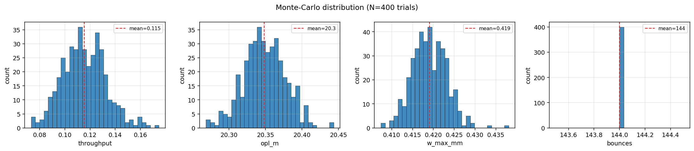
Fig. 7. Monte-Carlo distributions for the headline design at research-grade tolerances (400 trials): traversal count is invariant at 144; OPL and exit drift remain within operational bounds in every trial.
Systematic errors are compensated rather than tolerated. Catalogue mirrors carry a ±1 % focal-length tolerance, typically biased across a delivered lot; re-optimising only the ring radius restores the complete check matrix across the entire band with a strictly linear trim — 0.72 mm per percent of curvature error for the 180 mm designs, 0.62 mm for the compact one. The assembly rule is therefore: measure the delivered curvatures, machine the ring to the interpolated radius, walk in the final micrometres with the temperature trim. Temperature acts through the same mechanism (aluminium scales R_ring by 23.6 ppm/K against an essentially fixed glass curvature): with the launch frozen, the headline design passes every check over ±26 K on plain aluminium (±20 K for the 24.8 m design, ±8 K for the compact one), an invar ring holds ≥±30 K for all three, and a small ring heater doubles as the closure fine-adjustment actuator. All designs also pass every check up to M² = 1.3, beyond typical fibre-coupled DFB sources.
Table 4. Systematic-error compensation and robustness.
design | ROC ±1 % → ring trim | thermal window (Al) | thermal window (invar) | M² tested
drone_20m | ±0.72 mm (linear) | ±26 K | ≥±30 K | 1.3 pass
drone_25m | ±0.72 mm (linear) | ±20 K | ≥±30 K | 1.3 pass
drone_16cm | ±0.62 mm (linear) | ±8 K | ≥±30 K | 1.3 pass

6. Discussion
Table 5. Position against published compact multipass cells (demonstrated values unless noted).
cell | diameter | OPL | optics | notes
Tuzson 2013 [1] | ~100 mm | 4.1 m | monolithic diamond-turned | first monolithic toroidal
Graf 2018 [4] | <200 g | 10 m | segmented diamond-turned | interference-free
Chang 2020 [7] | 100 mm | 10 m (30 m theory) | ring surface | multi-layer patterns
Dong 2016 [9] | 170×65×55 mm | 54.6 m | 2 custom spherical | densest; critical alignment
this work, compact | 159 mm | 20.6 m | 13 × catalogue $74 | 84.5 % T @0.999
this work, headline | 180 mm | 20.4 m | 16 × catalogue $74 | 86.7 % T @0.999
this work, max OPL | 180 mm | 24.8 m | 16 × catalogue $74 | 83.9 % T @0.999

Within the toroidal class the verified paths roughly double the demonstrated state of the art at comparable diameter, using catalogue optics and a single machined part; the astigmatic-Herriott record [9] remains denser but at custom-optics and alignment cost the one-piece ring eliminates. Three limitations bound the claims: the results are simulation-verified rather than experimentally demonstrated (the verification chain — exact tracing, independent cross-validation, Monte-Carlo tolerancing, systematic-error compensation — is designed to de-risk the build, and machining-level specification sheets accompany each design); coating reflectivity enters as an external parameter, quoted parametrically throughout; and surface-figure error and scatter are not yet modelled, meriting measurement on the assembled cell.
7. Conclusion
Chord-skip ring geometry, engineered dual-plane re-entrance tuned by the machined ring radius, an exact constellation criterion, and mode-matched single-hole coupling together turn catalogue 1-inch mirrors into verified 20–25 m multipass cells inside drone-compatible 143–180 mm envelopes, transmitting ~84–88 % at R = 0.999 on a ≈1 kg payload. Next steps: fabricate the headline design, measure transmission and fringe floor against the simulated budgets, and integrate a 1654 nm DFB source for airborne methane sensing.
Data and code availability
Simulation platform, search harness, all design specifications, and scripts reproducing every figure, table and this document: github.com/Sumant-varanasi/toroidal-cell (_CURRENT/, presets drone_20m, drone_25m, drone_16cm). Acknowledgements and author list to be completed; per the project brief, intellectual property resides with Aston University.
References
[1] B. Tuzson, M. Mangold, H. Looser, A. Manninen, and L. Emmenegger, “Compact multipass optical cell for laser spectroscopy,” Opt. Lett. 38(3), 257–259 (2013).
[2] A. Manninen, B. Tuzson, H. Looser, Y. Bonetti, and L. Emmenegger, “Versatile multipass cell for laser spectroscopic trace gas analysis,” Appl. Phys. B 109, 461–466 (2012).
[3] M. Mangold, B. Tuzson, M. Hundt, J. Jágerská, H. Looser, and L. Emmenegger, “Circular paraboloid reflection cell for laser spectroscopic trace gas analysis,” J. Opt. Soc. Am. A 33(5), 913–919 (2016).
[4] M. Graf, L. Emmenegger, and B. Tuzson, “Compact, circular, and optically stable multipass cell for mobile laser absorption spectroscopy,” Opt. Lett. 43(11), 2434–2437 (2018).
[5] M. Graf et al., coherent-field modelling and absorption-mask fringe suppression in toroidal multipass cells (2017). [verify]
[6] K. Sun et al., double-row circular multipass cell reaching 74.7 m (2018). [verify]
[7] J. Chang et al., “Multi-layer beam patterns from a single toroidal ring surface,” Opt. Lett. 45 (2020). [verify]
[8] Y. Kilinc et al. (CREMA collaboration), cryogenic toroidal multipass cavities at 6.8 µm with >15 m path (2026). [verify]
[9] L. Dong et al., ultra-compact dense-spot-pattern multipass cell, 54.6 m in 220 mL (2016). [verify]
[10] K. Liu et al., dense-pattern multipass cell, 26.4 m (2015). [verify]
[11] D. R. Herriott, H. Kogelnik, and R. Kompfner, “Off-axis paths in spherical mirror interferometers,” Appl. Opt. 3(4), 523–526 (1964).
[12] D. R. Herriott and H. J. Schulte, “Folded optical delay lines,” Appl. Opt. 4(8), 883–889 (1965).
[13] J. B. McManus, P. L. Kebabian, and M. S. Zahniser, “Astigmatic mirror multipass absorption cells for long-path-length spectroscopy,” Appl. Opt. 34(18), 3336–3348 (1995).
[14] Thorlabs Inc., CM254-xxx-M01 concave mirror series, product datasheets (2026).
[15] H. Kramer, Optiland: open-source sequential ray tracing in Python, github.com/HarrisonKramer/optiland.

