SOA MatadarRaja API List

Base url = <http://api.aoinfotech.com/api>

1. Search voters

https://api.aoinfotech.com/api/SearchVoters?pageindex=0&pagesize=10&Search_Data=Onk tupe

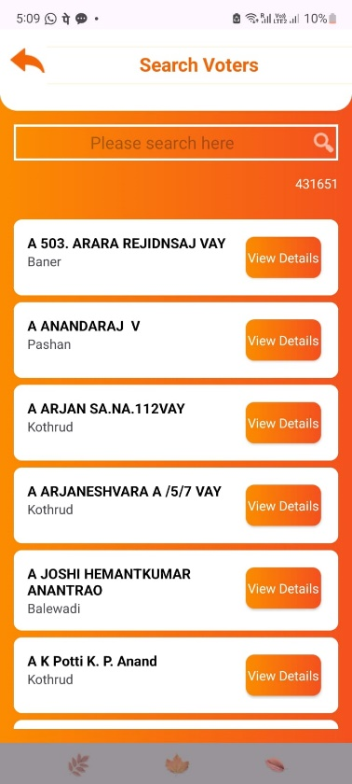

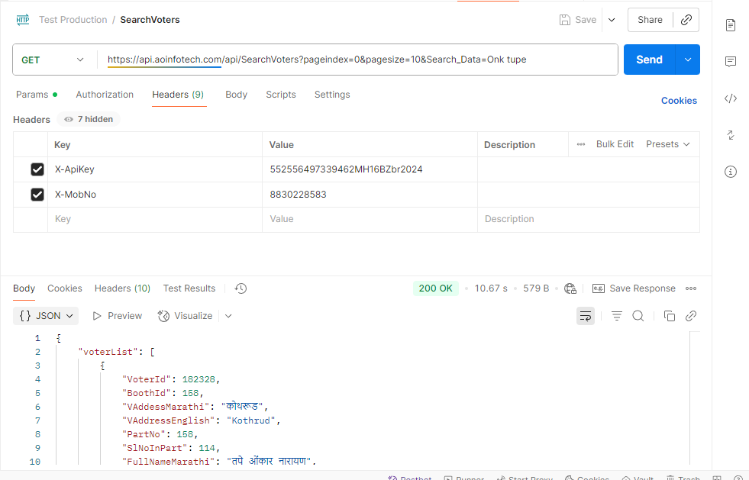

1. Voter details

https://api.aoinfotech.com/api/GetVoterDetails?voterid=1001

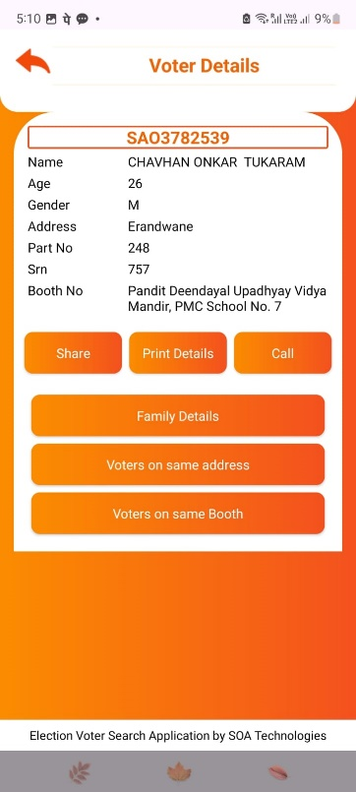

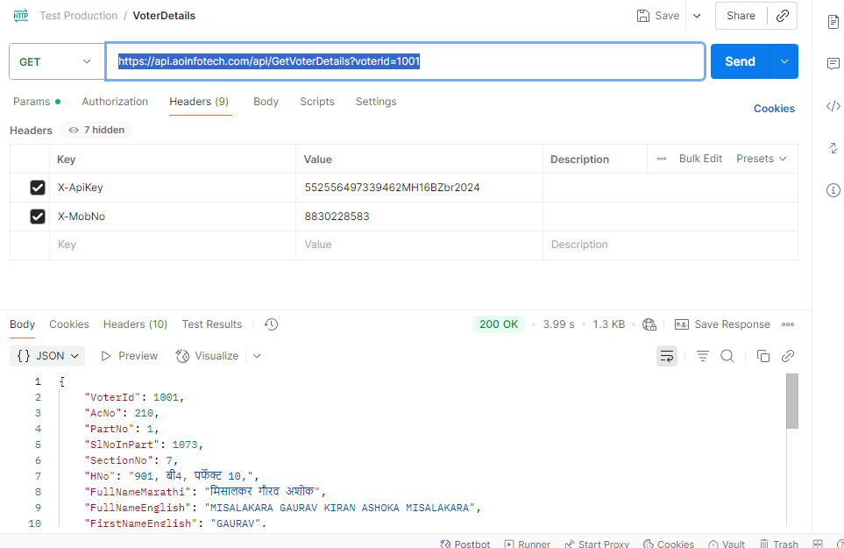

1. Family voters

<https://api.aoinfotech.com/api/GetFamilyVoters?pageindex=0&pagesize=10&voterId=186939>

1. Voters on same address

<https://api.aoinfotech.com/api/GetVotersWithSameAddress?pageindex=0&pagesize=10&voterId=186939&Search_Data=>

1. Voters on same booth

[https://api.aoinfotech.com/api/GetVotersOnSameBooth?pageindex=0&pagesize=10&voterId=186939&Search_Data=](https://api.aoinfotech.com/api/GetVotersWithSameAddress?pageindex=0&pagesize=10&voterId=186939&Search_Data=)

1. Advanced Search

<http://api.aoinfotech.com/api/AdvanceSearchVoters?pageindex=0&pagesize=10&FirstName=%E0%A4%AE%E0%A5%81%E0%A4%95%E0%A5%8D%E0%A4%A4%E0%A4%AC%E0%A4%BE%E0%A4%88&MiddleName=%E0%A4%AC%E0%A4%AC%E0%A4%A8&Lastname=%E0%A4%AC%E0%A4%B0%E0%A4%BE%E0%A4%9F%E0%A5%87&FromAge=20&ToAge=100&MobileNo=&PartNo=372&EpicNo=DRD1961952&HouseNo=Mu%20Chawl>

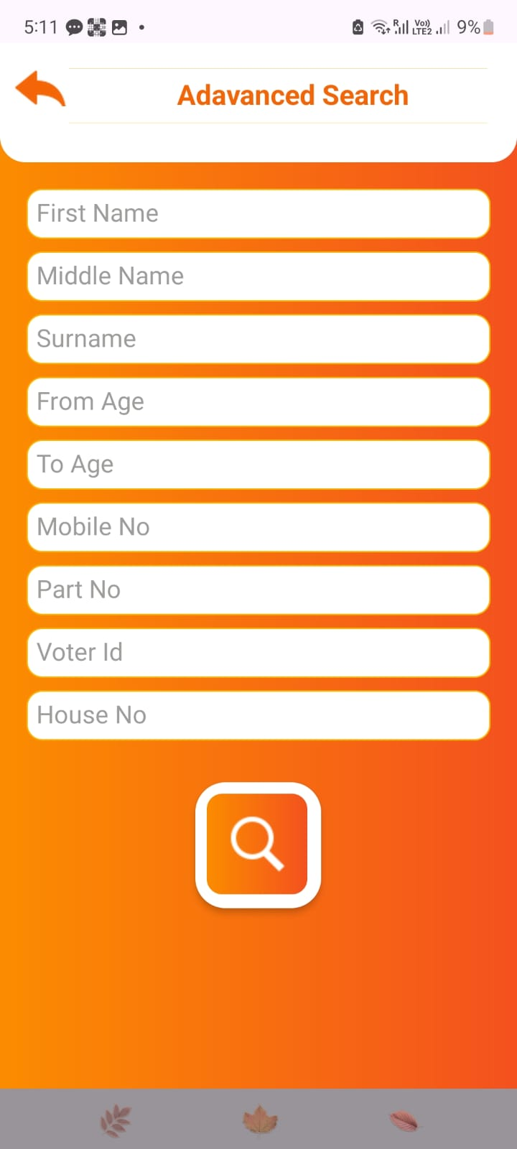

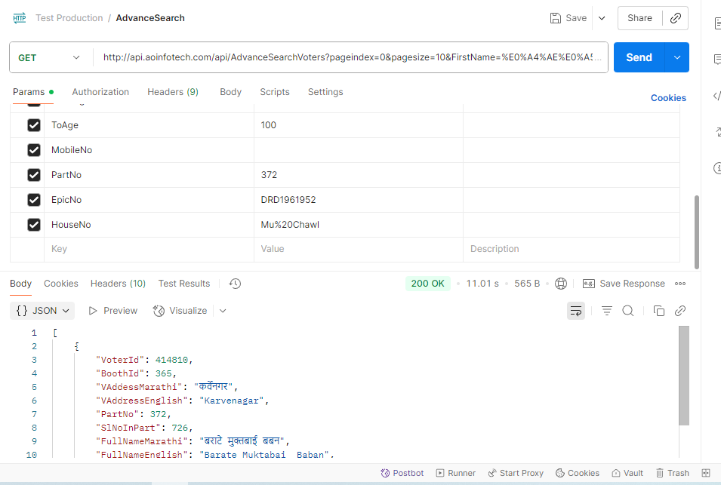

1. Apis for Charts

We need the counts

1. http://api.aoinfotech.com/api/GetTownWiseVoterCount?pageindex=0&pagesize=10&Search_Data=
2. http://api.aoinfotech.com/api/GetBoothWiseVoterCount?pageindex=0&pagesize=10&Search_Data=
3. http://api.aoinfotech.com/api/GetSurnameWiseVoterCount?pageindex=0&pagesize=10&Search_Data=
4. http://api.aoinfotech.com/api/GetGenderWiseVoterCount?pageindex=0&pagesize=10&Search_Data=
5. http://api.aoinfotech.com/api/GetAgeWiseVoterCount?pageindex=0&pagesize=10&Search_Data=

Voter search after each chart

1. http://api.aoinfotech.com/api/GetVotersByTown?pageindex=0&pagesize=10&TownName=Kothrud&Search_Data=
2. http://api.aoinfotech.com/api/GetVotersByBoothId?pageindex=0&pagesize=10&BoothId=10&Search_Data=
3. http://api.aoinfotech.com/api/GetVotersBySurname?pageindex=0&pagesize=10&Surname=Tupe&Search_Data=
4. http://api.aoinfotech.com/api/GetVotersByGender?pageindex=0&pagesize=10&Gender=M&Search_Data=
5. <http://api.aoinfotech.com/api/GetVotersByAge?pageindex=0&pagesize=10&AgeGroup=26TO35&Search_Data=>

Part no wise graph apis are pending