https://www.genalyte.com/about-us/our-technology/

The Maverick Detection System

The Maverick Detection System is a full-fledged commercial Lab-On-chip architecture designed by Genalyte. It performs real-time detection of macromolecules in biologically functionalized crude samples using silicon photonic biosensors lithographically printed on disposable silicon chips. These biosensors are functionalized individually using unique probe molecules and are individually cross-examined, making highly multiplexed analysis possible. As the sample flows over the chip, the probes on the sensors attract and bind with their corresponding molecules. This binding results in a localized change in effective index on the sensor surface and this change is directly proportional to the concentration of the analyte.

The constant monitoring of the effective index change enables real-time detection without the need for a tag, label, or reporter molecule. The results are available usually in 15 minutes depending on the type of assay performed.

Each sensor is placed next to the linear waveguide on the chip’s surface that directs light from a laser on to a photodetector. As light propagates in the straight waveguide each ring-resonator will trap a single wavelength, creating a peak in the wavelength spectrum received at the photodetector also called as FSR or Free-Spectral-Range. The collection of biological complexes on the sensor surface causes the effective index of the resonator to change, which in turn causes a longer wavelength of light to be trapped and the FSR to shift. The degree of shift of of the FSR is directly proportional to the total mass of molecules per unit surface area. The figure below shows the approximate size of the glitch for different detections limits. Each chip contains almost 128 separate micro-ring resonators for multiplexed detection.

Genalyte Announced CE Mark For Maverick (TM) Detection System And Signs On First European Distributors

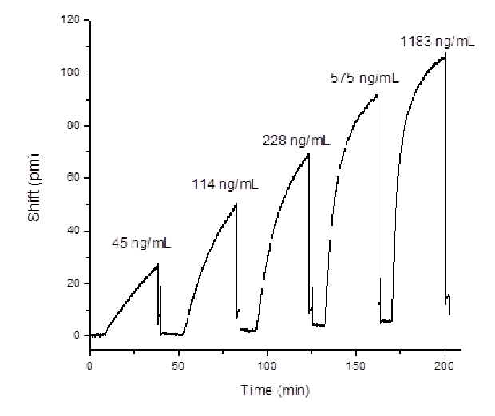

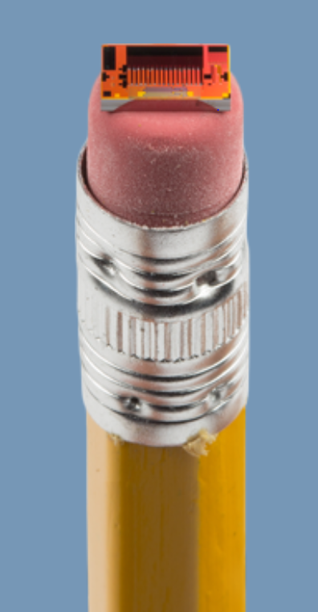

Challenges : <https://www.darkdaily.com/real-time-in-vitro-diagnostic-results-at-the-point-of-care-possible-one-san-diego-based-ivd-developer-says-yes/>

Detail: <https://www.youtube.com/watch?v=Dn2WHGuCc5o>

Epic Systems

Corning (Corning, New York, NY, USA) came up with a label free detection equipment based on Resonant Waveguide Grating Biosensor System called Corning® Epic®. They have used a microarray which contains up to 384 wells for multiplexed detection. These are used to immobilize proteins, peptides, small molecules and DNA. After these molecules have been immobilized, a baseline test is established. Then the analyte is passed over the chip and once this is done the analyte material binds to these proteins and peptides. When the test is performed in comparison to the baseline it is observed that there is a change in wavelength of the reflected wave. Three second whole microplate read time

(i) Immobilization step: This is the chemical conjugation of the receptor-containing glycoprotein to pre-activated plates.

(ii) Wash step: Following the wash and equilibration on the ligand buffer, the chip is tested to establish a baseline reading.

(iii) HA binding step: The ligand (rHA) is passed on the chip and the wavelength of reflected light is measured in the portion of the well containing immobilized fetuin and an internal control sensor located in a portion of the well that has no capacity to immobilize fetuin.

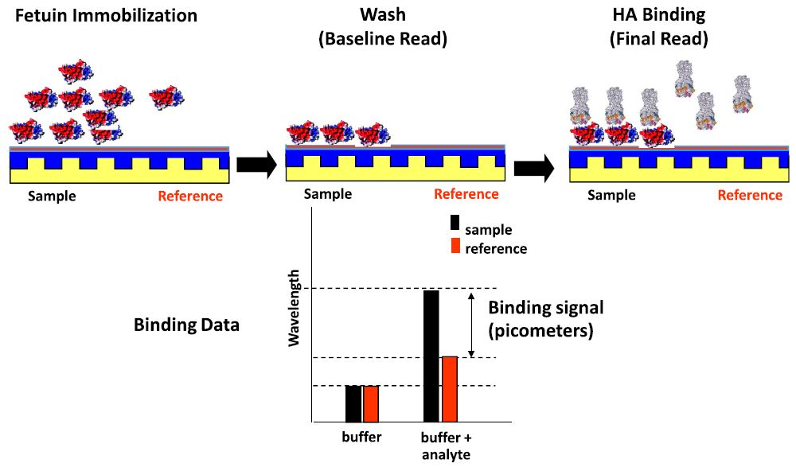

There is need for highly sensitive counter-screening (Counter-screening is used to eliminate compounds that possess undesirable properties) across different targets within hit follow up to ensure potential lead compounds were more fully characterized prior to decisions regarding their progress.

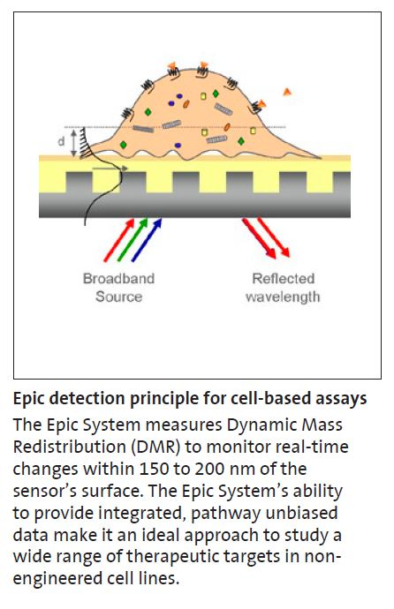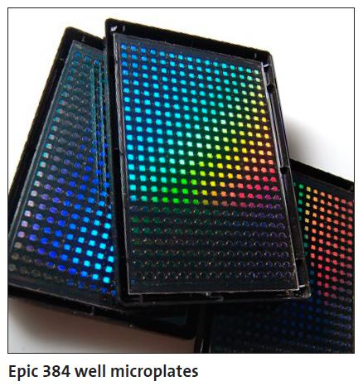Axela DOT

The dotLab® mX System, is a highly flexible and easy to use assay platform appropriate for protein biomarker research and the investigation of new diagnostic tests. Diffractive Optics Technology or DOT combines multiplex immunoassay (a procedure for detecting or measuring specific proteins or other substances through their properties as antigens or antibodies) formats with real time measurements thereby giving more informative immunoassays compared to traditional end-point techniques.

Diffractive optics technology brings together two technologies: grating-based light diffraction and immobilized capture surfaces. This combination gives us a very simple and sensitive technique for the detection of molecular binding without the use of fluorescent labels. Capture molecules, such as antibodies, are immobilized in an ordered pattern of lines that form a diffraction grating on the surface of the dotLab® Sensor (prism shaped). When illuminated by a laser, a series of discrete diffraction beams is generated. When the sample is passed over the fiber gratings, the biomolecules, such as an antigen bind to the protein receptors, increasing the height of the surface pattern, producing a phase shift in the reflected beams. This in turn increases the diffraction signal intensity that is detected in real time by a photodiode detector below the sensor.

Obtain results in less than an hour. Small sample requirements (3.5 μL of serum).

