Preliminary Report: Adaptive Downscaling Network (ADN)
This preliminary experiment evaluates an Adaptive Downscaling Network (ADN) for x4 image downscaling. The model generates learned low-resolution images and evaluates reconstruction quality using PSNR and SSIM. This is a pilot run for progress review, not final publication-level training.

1. Dataset Requirement from the Paper
The paper states in the Experimental Setup / Datasets section that DIV2K contains 900 HR images split into 800 training, 50 validation, and 50 test images. Training uses random HR patches with flipping augmentation.
Split | Images
Training | 800
Validation | 50
Test | 50

Benchmark Dataset | Images
Set5 | 5
Set14 | 14
BSD100 | 100
Urban100 | 100
DIV2K validation | 50

2. Dataset Folder Structure
C:\Users\suman\Documents\Codex\ADN-run\ADN\
datasets\
DIV2K\
DIV2K_train_HR\
DIV2K_valid_HR\
benchmark\
Set5\HR\
Set14\HR\
BSD100\HR\
Urban100\HR\
Only HR images are required. The ADN code generates LR images itself, so benchmark LR folders are ignored.

3. Architecture Followed
The code follows the main ADN pipeline: HR image -> Feature Extractor -> ARM/CBAM -> KGM -> OEM -> Adaptive Resampling -> LR image -> Bicubic reconstruction -> MSE + SSIM loss.
Component | Code Module
Feature extractor | adn/models/feature_extractor.py
ARM / CBAM attention | adn/models/attention.py
Kernel Generation Module | adn/models/kernel_offset.py
Offset Estimation Module | adn/models/kernel_offset.py
Adaptive resampling | adn/models/resampler.py
Hybrid MSE + SSIM loss | adn/losses/losses.py
Bicubic reconstructor | adn/models/reconstructor.py

4. Commands Used
Pilot training command:
.\.venv\Scripts\python.exe -m scripts.train --config configs/adn_x4.yaml --work-dir experiments/adn_x4_pilot --opts train.total_iters=1000 train.log_interval=50 train.val_interval=500 train.save_interval=500 data.batch_size=4 data.patch_size=128 data.num_workers=2 data.val_max_images=5 train.amp=false
Track progress:
Get-Content .\experiments\adn_x4_pilot\train.log -Wait
Generate final test images and metrics:
.\.venv\Scripts\python.exe -m scripts.test --config configs/adn_x4.yaml --checkpoint experiments/adn_x4_pilot/checkpoints/best.pth --save-dir results/adn_x4_pilot --opts data.val_max_images=5

5. Preliminary Training Configuration
Setting | Value
Scale factor | x4
Device | CPU
Real training images | 800 DIV2K HR images
Virtual training samples | 16000 because repeat = 20
Batch size | 4
Total iterations | 1000
Total HR patches used | 4000 patches
Patch size | 128 x 128
Validation limit | 5 images per dataset
Loss | 0.55 MSE + 0.45 SSIM
Optimizer | Adam
Model parameters | 1.864 M

6. Preliminary Results
Dataset | Images Used | PSNR | SSIM | NIQE
Set5 | 5 | 28.5357 | 0.8310 | 8.8941
Set14 | 5 | 23.6859 | 0.5972 | 10.4907
BSD100 | 5 | 25.8428 | 0.7160 | NaN
Urban100 | 5 | 23.0494 | 0.7051 | 15.7026
DIV2K validation | 5 | 30.9613 | 0.8404 | 4.2420

7. Comparison With Known Methods
Baseline values are x4 PSNR / SSIM values reported in the ADN paper. The final row is this preliminary pilot run.
Method | Set5 | Set14 | BSD100 | Urban100 | DIV2K Val
Bicubic | 25.94 / 0.7714 | 23.10 / 0.6641 | 23.32 / 0.6403 | 20.45 / 0.6341 | 26.01 / 0.7694
DPID | 24.72 / 0.7368 | 23.36 / 0.6436 | 24.00 / 0.6256 | 20.98 / 0.6159 | 26.20 / 0.7551
IDCL | 24.62 / 0.7358 | 23.26 / 0.6438 | 23.91 / 0.6244 | 20.83 / 0.6156 | 26.14 / 0.7552
ADN Paper | 26.87 / 0.7814 | 24.45 / 0.6808 | 24.70 / 0.6521 | 21.84 / 0.6488 | 27.36 / 0.7923
ADN Pilot Run | 28.54 / 0.8310 | 23.69 / 0.5972 | 25.84 / 0.7160 | 23.05 / 0.7051 | 30.96 / 0.8404

Note: The pilot run used only 5 validation/test images per dataset, so these numbers are preliminary and should not be treated as final publication-level results.

8. Example Output Images
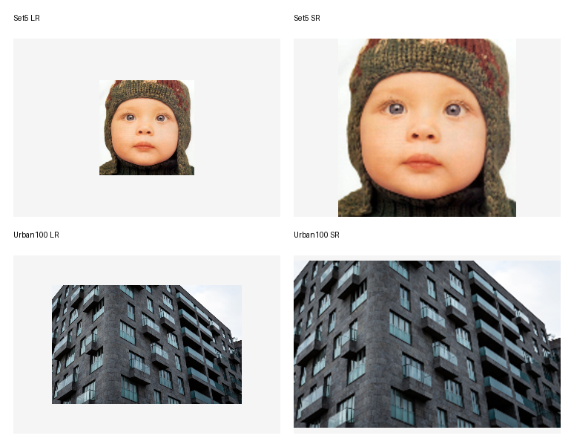
Generated outputs are available in results/adn_x4_pilot with LR and SR images for Set5, Set14, BSD100, Urban100, and DIV2K.

9. Conclusion
A preliminary ADN x4 training run was completed successfully on CPU for 1000 iterations. The model was trained using DIV2K HR patches and evaluated on Set5, Set14, BSD100, Urban100, and DIV2K validation with a 5-image limit per dataset. The run generated quantitative PSNR/SSIM metrics and LR/SR output images. The next stage is longer training and complete benchmark evaluation for publication-quality results.

