Maulana Abul Kalam Azad
University Of Technology


MAKAUT WB

NAME: TRIDIB MONDAL
DEPARTMENT: Department of IT
COURSE: BCA
Section: B
SUBJECT: DBMS
SEMESTER: 6th SEMESTER
REG. NO: 223001010804
ROLL. NO: 30001222203

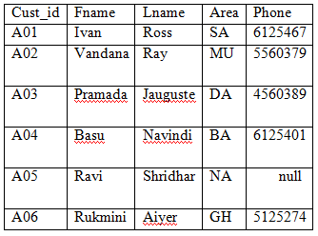  Customer Table | Write SQL query to perform the following:  - Create the table and insert data as given.  - Display all the customer details in the following way:  ‘Ivan Ross stays in SA and his phone number is 6125467.’  - Display the cust_id who have stays in the area either SA or BA or GH.  - Display the details of those customers who have an A in their area name.

CREATE TABLE Customer (
cust_id VARCHAR(50),
cust_fname VARCHAR(50),
cust_lname VARCHAR(50),
area VARCHAR(50),
phone VARCHAR(15)
);

INSERT INTO Customer VALUES
('A01', 'Ivan', 'Ross', 'SA', '6125467'),
('A02', 'Vandana', 'Ray', 'MU', '6125467'),
('A03', 'Pramada', 'Jauguste', 'DA', '6543210'),
('A04', 'Basu', 'Navindi', 'BA', '6125467'),
('A05', 'Ravi', 'Shridhar', 'NA', NULL),
('A06', 'Rukmini', 'Aiyer', 'GH', '6125467');

Display: ‘Ivan Ross stays in SA and his phone number is 6125467.
SELECT CONCAT(cust_fname, ' ' ,cust_lname, ' stays in ', area, ' and his phone number is ', phone, '.') AS detail
FROM Customer;
OUTPUT:
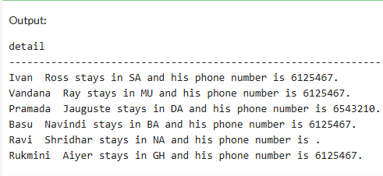

Display cust_id who stay in SA, BA, or GH
SELECT cust_id
FROM Customer
WHERE area IN ('SA', 'BA', 'GH');
OUTPUT:
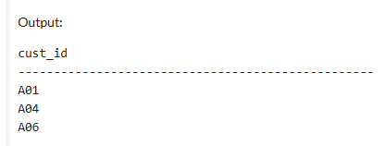

Customers whose area name contains an 'A'
SELECT *
FROM Customer
WHERE area LIKE '%A%';
OUTPUT:
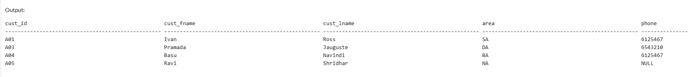

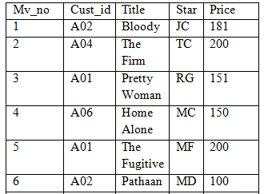  Movie Table | Write SQL query to perform the following:  - Create the table and insert data as given.  - Display the movie titles, whose price is greater than 100 but less than 200.  - Display the movie name, their original prices and the prices after 10% increment. Give alias name to the incremented price column.  - Display the movie titles, whose price is within 100 and the movie titles are of exactly 7 characters.

CREATE TABLE Movie (
Mv_no INT,
Cust_id VARCHAR(10),
Title VARCHAR(50),
Star VARCHAR(10),
Price INT
);

INSERT INTO Movie (Mv_no, Cust_id, Title, Star, Price) VALUES
(1, 'A02', 'Bloody', 'JC', 181),
(2, 'A04', 'The Firm', 'TC', 200),
(3, 'A01', 'Pretty Woman', 'RG', 151),
(4, 'A06', 'Home Alone', 'MC', 150),
(5, 'A01', 'The Fugitive', 'MF', 200),
(6, 'A02', 'Pathaan', 'MD', 100);

SELECT Title
FROM Movie
WHERE Price > 100 AND Price < 200;

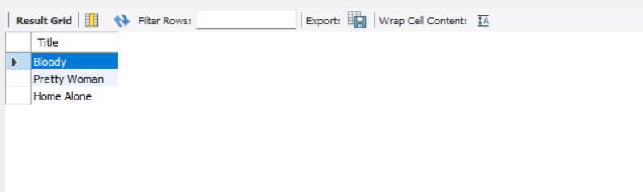

SELECT Title,
Price AS Original_Price,
Price * 1.10 AS Increased_Price
FROM Movie;

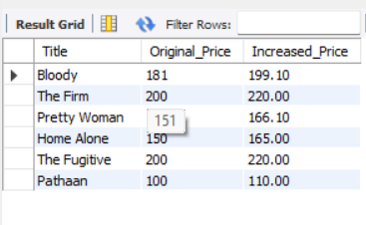

SELECT Title
FROM Movie
WHERE Price = 100 AND LENGTH(Title) = 7;
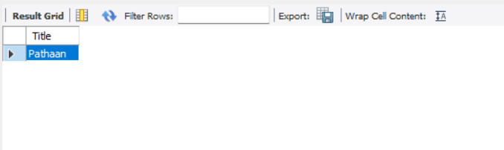

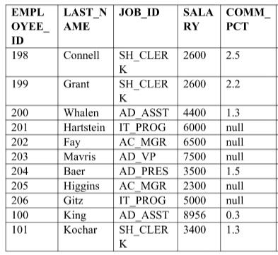  Employee Table | Write SQL query to perform the following:  - Create the table and insert data as given.  - Display last_name, salary and annual compensation of all employees, plus a onetime bonus of Rs 100. Give an alias name to the column displaying annual compensation.  - Display the Last_Name and Salary of all employees whose salary is between 4000 and 7000.  - Display the details of those employees who do not get commission.

CREATE TABLE Employee (
emp_id INT,
last_name VARCHAR(50),
job_id VARCHAR(50),
salary DECIMAL(10,2),
commission DECIMAL(10,2)
);

INSERT INTO Employee VALUES
(198, 'Connell', 'SH_CLERK', 2600, 2.5),
(199, 'Grant', 'SH_CLERK', 2600, 2.2),
(200, 'Whalen', 'AD_ASST', 4400, 1.3),
(201, 'Hartstein', 'IT_PROG', 6000, NULL),
(202, 'Fay', 'AC_MGR', 6500, NULL),
(203, 'Mavris', 'AD_VP', 7500, NULL),
(204, 'Baer', 'AD_PRES', 3500, 1.5),
(205, 'Higgins', 'AC_MGR', 2300, NULL),
(206, 'Gitz', 'IT_PROG', 5000, NULL),
(100, 'King', 'AD_ASST', 8956, 0.3),
(101, 'Kochar', 'SH_CLERK', 3400, 1.3);

last_name, salary, and annual compensation with Rs 100 bonus

SELECT last_name, salary, commission, ((salary * 12)*( commission/100) + 100) AS annual_compensation
FROM Employee;
OUTPUT:
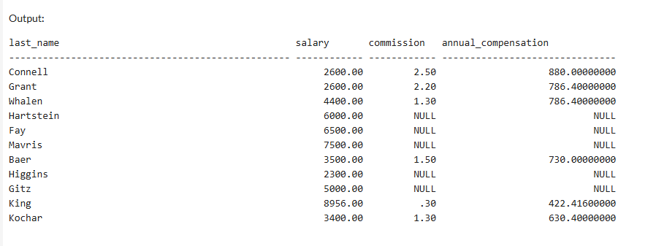

Last_Name and Salary where salary is between 4000 and 7000

SELECT last_name, salary
FROM Employee
WHERE salary BETWEEN 4000 AND 7000;
OUTPUT :
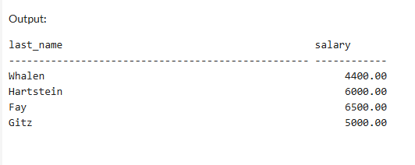

Employees who do not get commission

SELECT *
FROM Employee
WHERE commission IS NULL;
OUTPUT :
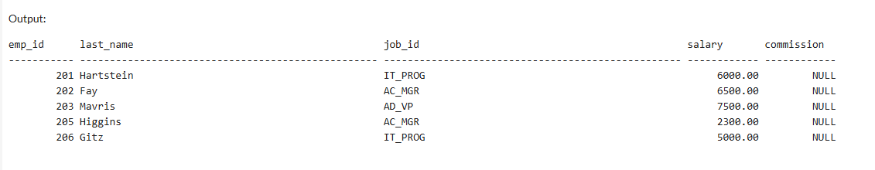

4.

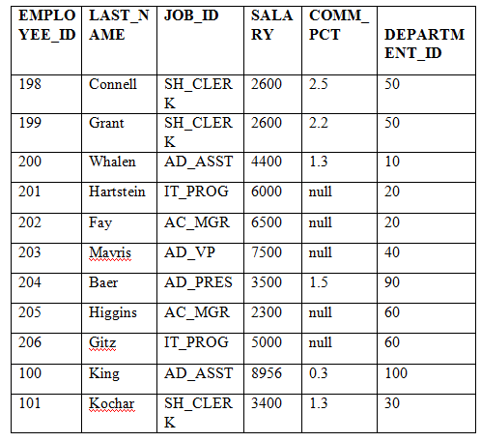  Employee Table | Write SQL query to perform the following:  - Create the table and insert data as given.  - Display last_name, salary and salary increase of Rs300. Give the new column name as ‘Increased Salary’.  - Display the Last_Name and Salary of all employees whose salary is between 4000 and 7000.  - Update the job_id’s of the employees who earn more than 5000 to Grade A. Display the table EMPLOYEE after updating.

CREATE TABLE Employee (
emp_id INT,
last_name VARCHAR(50),
job_id VARCHAR(20),
salary INT,
comm_pct DECIMAL(10,2),
dep_id INT
);

INSERT INTO Employee VALUES
(198, 'Connell', 'SH_CLERK', 2600, 2.5, 50),
(199, 'Grant', 'SH_CLERK', 2600, 2.2, 50),
(200, 'Whalen', 'AD_ASST', 4400, 1.3, 10),
(201, 'Hartstein', 'IT_PROG', 6000, NULL, 20),
(202, 'Fay', 'AC_MGR', 6500, NULL, 20),
(203, 'Mavris', 'AD_VP', 7500, NULL, 40),
(204, 'Baer', 'AD_PRES', 3500, 1.5, 90),
(205, 'Higgins', 'AC_MGR', 2300, NULL, 60),
(206, 'Gitz', 'IT_PROG', 5000, NULL, 60),
(100, 'King', 'AD_ASST', 8956, 0.3, 100),
(101, 'Kochar', 'SH_CLERK', 3400, 1.3, 30);

Display last name, salary, and increased salary (Rs 300)

SELECT last_name, salary, (salary + 300) AS Increased_Salary
FROM Employee;
OUTPUT :
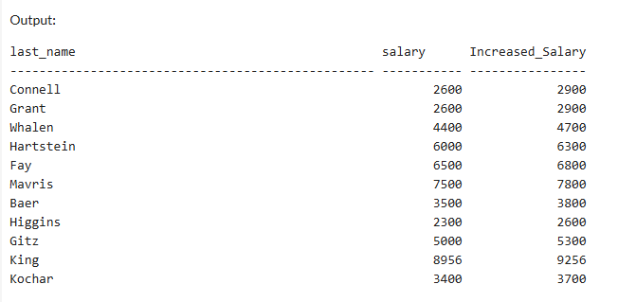

Display last name and salary between 4000 and 7000

SELECT last_name, salary
FROM Employee
WHERE salary BETWEEN 4000 AND 7000;
OUTPUT :
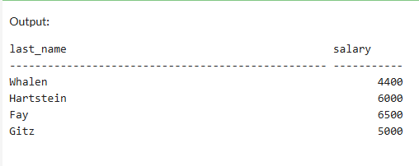

Update job_id to 'Grade A' for salary > 5000

UPDATE Employee
SET job_id = 'Grade A'
WHERE salary > 5000;

SELECT * FROM Employee;
OUTPUT :
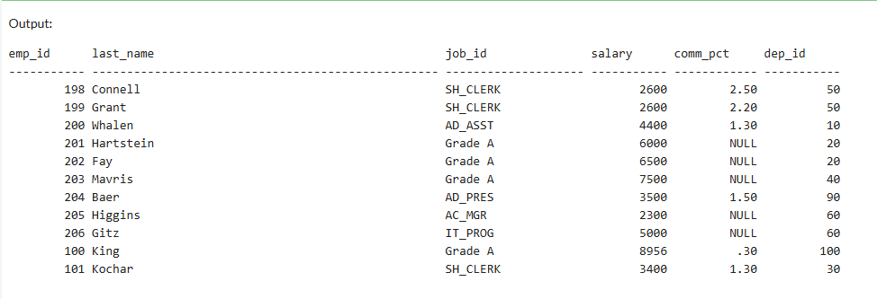

5.

  Employee Table | Write SQL query to perform the following:  - Create the table and insert data as given.  - Find the length of the last names of the employees getting commission  - Display the Last_Name and Jo_id and Salary of all employees whose salary is between 4000 and 7000.  - Display the Last Name of all employees in LOWER CASE , those who work in department no 20 or 50 or 60.

CREATE TABLE Employee (
emp_id INT,
last_name VARCHAR(50),
job_id VARCHAR(20),
salary INT,
commission DECIMAL(10,2),
dep_id INT
);

INSERT INTO Employee VALUES

(198, 'Connell', 'SH_CLERK', 2600, 2.5, 50),
(199, 'Grant', 'SH_CLERK', 2600, 2.2, 50),
(200, 'Whalen', 'AD_ASST', 4400, 1.3, 10),
(201, 'Hartstein', 'IT_PROG', 6000, NULL, 20),
(202, 'Fay', 'AC_MGR', 6500, NULL, 20),
(203, 'Mavris', 'AD_VP', 7500, NULL, 40),
(204, 'Baer', 'AD_PRES', 3500, 1.5, 90),
(205, 'Higgins', 'AC_MGR', 2300, NULL, 60),
(206, 'Gitz', 'IT_PROG', 5000, NULL, 60),
(100, 'King', 'AD_ASST', 8956, 0.3, 100),
(101, 'Kochar', 'SH_CLERK', 3400, 1.3, 30);

Find the length of last names of employees getting commission:

SELECT last_name, LEN(last_name) AS Name_Length
FROM Employee
WHERE commission IS NOT NULL;
OUTPUT :

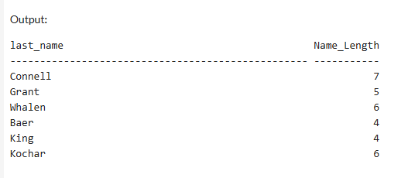

Display last name, job_id, and salary for employees with salary between 4000 and 7000:

SELECT last_name, job_id, salary
FROM Employee
WHERE salary BETWEEN 4000 AND 7000;
OUTPUT :
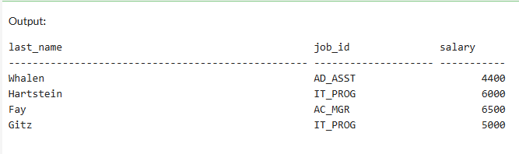

Display last names in lowercase who work in dept no 20 or 50 or 60:
ALTER TABLE Employee ADD department_no INT;

SELECT LOWER(last_name) AS lower_name
FROM Employee
WHERE dep_id IN (20, 50, 60);
OUTPUT :
