- Why distributed databases are essential?

Scalability

To handle increased loads increased, in distributed databases, more systems can be added instead of upgrading the single database.

Reliability and Redundancy

In distributed database system, the data is distributed across multiple locations providing data redundancy, reducing the risk of data losses.

High Availability and Fault Tolerance

In distributed database system, if any system fails down, another system will be available to serve the client request.

Performance

In distributed database system, as the data is distributed across multiple locations, Queries can be processed across multiple nodes. Reducing the workload and maintaining the work balance

Maintainability

In distributed database system, the database system is available to every location. Which is easier to maintain

- What are the distribution design issues?

Scalability

If the distributed database system is not able to scale up its resources such as data users, that is be an issue of distributed database system.

Transparency

The users must be unaware of their data physical location, data replication or any failures.

Lack of failure handling

In distributed database system if any of the system fails down, that is be an issue needs to be resolved.

Security concerns

As the data is distributed across multiple locations, it is vulnerable to security threats such as unauthorized accesses. This can compromise the confidentiality, integrity, and availability of information.

Openness

distributed database system should be extensible so that they can be integrated to new extension of distributed system.

Heterogeneity

Distributed system often involves different hardware, OSes and network protocols. They need to communicate with each other. So, a standard need to be maintained and agreed upon.

- What are the different distribution design issues?

- What do you mean by data security?

Data security is the practice of protecting digital data from unauthorized access, corruption, or theft.

Objectives of Data Security is to maintain

• Confidentiality
Ensures that data is only accessible to authorized.

• Integrity
Ensures that data is accurate and has not been tampered with or altered in an unauthorized way.

• Availability
Ensures that authorized users can access the data all the time, without disruptions.

- Explain Briefly about DDBMS Architecture.

There are 3 types of Architecture for DDBMS

- Client server Architecture

- A client Server architecture has number of clients and. Servers connected to a network.

- A client sends a query to one of the. Server and the earliest available server respond to the client’s request.

- A client server architecture is simple to implement and execute due to centralized server system.

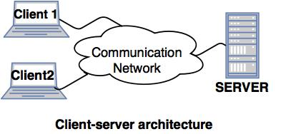

- Collaborating server architecture.

- It is designed to run a single query to multiple servers.

- It breaks single query into multiple small queries and the result is sent to the client.

- Collaborating server architecture has a collection of database servers. Each server is available for executing the current transactions across the database.

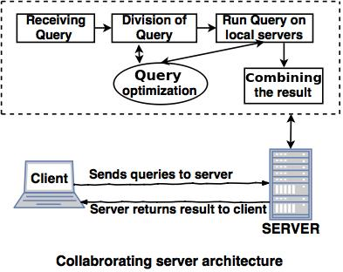

- Middleware Architecture

- Middleware architecture are designed in such a way that single queries executed on multiple servers.

- This System needs only one server, which is capable of managing queries and transactions from multiple servers.

- Milwaukee architecture uses local servers to handle queries and transactions.

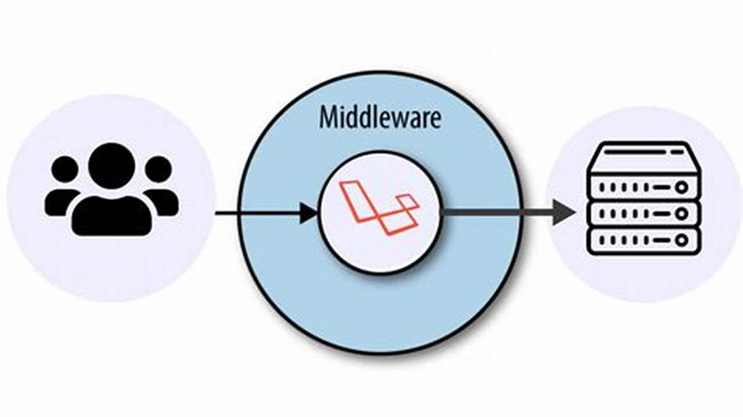

https://youtu.be/vuApQk27Jus?si=9co2-o3ApaC02w53

- Explain about Architectural Models for DDBMS.

Architectural Models for Distributed Database Management Systems (DDBMS)

Deals with the organization of components across network of computers and their interrelationship.

- Client-Server Architecture

- The most important and widely used distributed system architecture.

- A centralized architecture where, client and server roles are assigned and changeable

- Clients initiate communication as it requests data or services. and servers respond to the requests made by the client.

- Peer to peer model

- A decentralized architecture where all nodes (peers) have equal roles and responsibilities.

- Each node can act both as a client and a server.

- Nodes share data directly with each other without centralized control.

- Explain about DBMS Standardization? Give Examples.
DBMS Standardization refers to the process of developing and adopting common rules, protocols, languages, and interfaces for different Database Management Systems (DBMS). The goal is to ensure that different systems can work together, share data, and support cross-platform compatibility.

📘 Examples of DBMS Standardization in Practice:
Standardized Area | Example
Query Language | SQL (used in MySQL, Oracle, SQL Server, PostgreSQL)
API/Connectivity | JDBC
Schema Design | ER Model for relational databases
Data Types | Common types like INT, VARCHAR, DATE, etc., supported everywhere

8. What are the distribution design issues? Explain with examples.

9. Explain briefly about Fragmentation with suitable examples.
- Data fragmentation allows us to break a single object (database or table) into two or more fragments that means subrelations. Fragmentation of a relation ‘R’ consists of breaking it into number of fragments R₁, R₂, ..., Rₙ such that it is always possible to reconstruct the original relation ‘R’ from the fragments.

📌 Example:
- Let’s say we have a relation:

- EMPLOYEE(RollNo, Name, Department, Country)

• Horizontal Fragmentation:

- Break based on rows:

- Fragment 1 (R1):

Employees in India
SELECT * FROM EMPLOYEE WHERE Country = 'India'

- Fragment 2 (R2):
Employees not in India
SELECT * FROM EMPLOYEE WHERE Country != 'India'

- Reconstruction:
- R = R1 UNION R2

10. Explain allocation model.

In a Distributed Database Management System (DDBMS), the allocation model Describe the process of dividing where to locate data.

Types of Allocation Models:

🔹 1. Centralized Allocation
- Consist off single database and DBMS stored at one site with users distributed across the network
🔹 2. Partitioned (or Non-Replicated) Allocation
- Database is partitioned into disjoint fragments, each fragment assigned to one site.
🔹 3. Replicated Allocation
- With replicated data allocation, copies of one or more database fragments are stored at different sites.

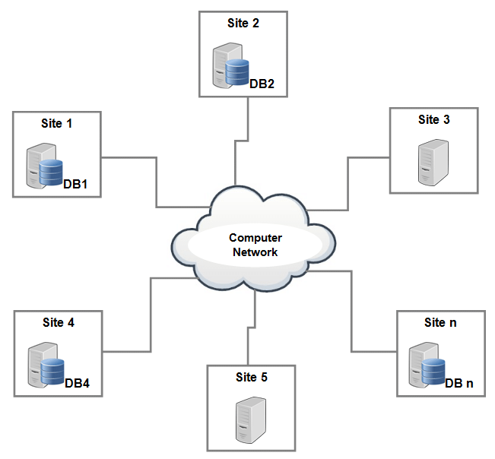
https://youtu.be/84yEQokh0xQ?si=PayJN3DLb1Hciam1

11. Explain views in centralized DBMSs with examples.

A view in a centralized DBMS is a virtual table that does not store data physically.
View is the result set of a stored query.

Features
Views are read-only or updatable

Advantages
To restrict the data access
Views are used make complex queries easy
To provide data independence

https://youtu.be/QngqhdLd1SE?si=e_RIhrFvszq0R-f9

12. Write down briefly about the advantages and disadvantages of DDBMS.
The advantages of DDBMS.
Reliability

In distributed database system, the data is distributed across multiple locations providing data redundancy, reducing the risk of data losses.

High Availability and Fault Tolerance

In distributed database system, if any system fails down, another system will be available to serve the client request.

Performance

In distributed database system, as the data is distributed across multiple locations, Queries can be processed across multiple nodes. Reducing the workload and maintaining the work balance

Maintainability

In distributed database system, the database system is available to every location. Which is easier to maintain

The advantages and disadvantages of DDBMS.
- Managing and coordinating data across multiple nodes can be complex.
- Maintaining multiple database systems and networks is costly and expensive.

13. What are the features of DDBMS? Explain.

- Local autonomy

Data is physically stored across multiple. Location. And can be accessed locally optimizing performance and resource utilization.

- Reliability (No reliance on central site)

In distributed database system, if one database system fails down or stops working, another system will override the task.

- Availability
If any database system fails down, the other database system will be available to serve the client request.

- Performance

Performance is achieved by distributed device system by distributing database systems over multiple locations.

- Scalability

New database systems can be added without affecting the other distributed database systems.

- Maintainability

In the distributed database system, The database system is available to every destributed location which makes it easier to maintain

14. Discuss different levels of a distributed transparency system.

Distribution transparency is the property of distributed database by the virtue of which the internal details of the distributions are hidden from the users.

- Location Transparency

- The user is aware of the database fragments, but the users not aware of the physical location the data have been stored. Means the data where it is actually stored is hidden from the user.

- The location transparency ensures that users can query on any tables or fragments of a table as? If it were stored locally in the user site

🔹 2. Fragmentation Transparency
- Fragmentation transparency is the highest level of transparency. In fragmentation transparency, the user does not need to know the databases partitioned. Therefore, neither fragment names nor fragment location are specified prior to database access.

🔹 3. Replication Transparency

It makes user unaware of the existence of multiple copies of data at different site.
- Replication Of databases are hidden from the user
- Replication increase availability and reliability of the system

- Replication transparency ensures that the users is not involved in the management of copies of same data.

15. Discuss different database types.

Centralized DB
Centralized database is maintained at one site
If Centralized system fails entire system is halted
In Centralised databases provide higher security as a central server manages all the data and resources
It comforts the users to access the stored data from different location through several applications. These applications contains the authentication process to let users access the data securely.

Distributed DB
Distributed database is maintained at number of different sites.
If any database system fails down, the other database system continues work with other sites.
More reliable.
Requires less time in accessing the data because the data is retrieved from nearest database file
Distributed DB is divided into two sub parts, i. homogeneous database and ii. heterogeneous database.
- Cloud database

This is the type of database where data is stored in cloud and executes the queries over the cloud computing platform.
It provides users with various cloud services like SAAS, PAAS LAAS etc, for accessing database.

- Relational database

- Relational database stores data in rows (tuple's) and columns (attributes) together it forms a table.
- A relational database uses SQL for storing, updating and maintaining the data
- Example of relational database are MySQL, oracle, etc.

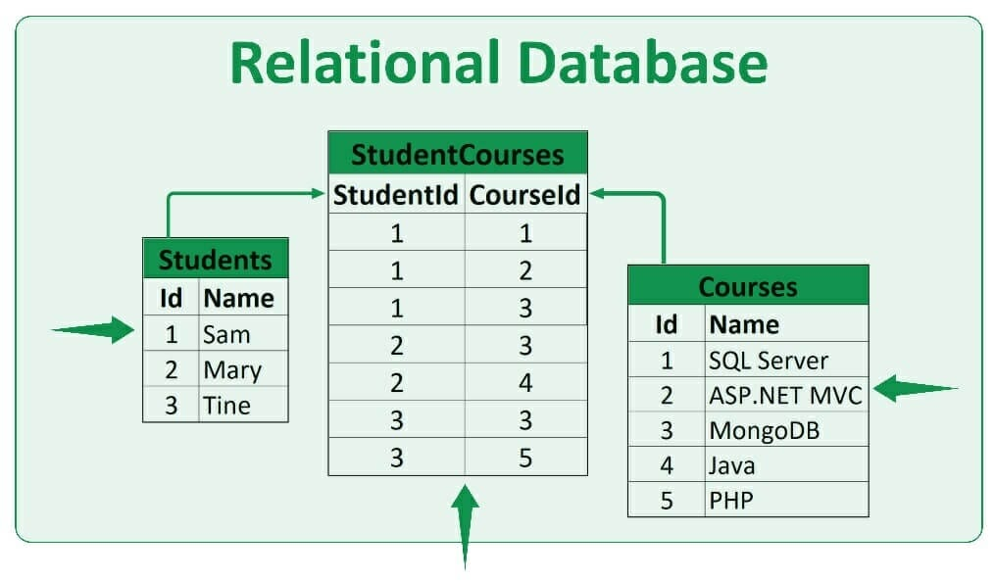

- NoSQL database

- NoSQL database is a type of unstructured database that is used for storing a wide range of data sets.
- Example – MongoDB

- Object oriented database

- This type of database uses. Object oriented data model approach for storing data in the database system.

- The data is represented and stored in the form. In the form of objects used in object-oriented programming language

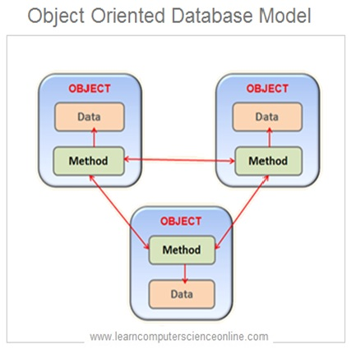

- Hierarchical database

- The hierarchical database is a type of database that stores data in hierarchical manner (parent child relationship).
- It organizes data in a tree like structure

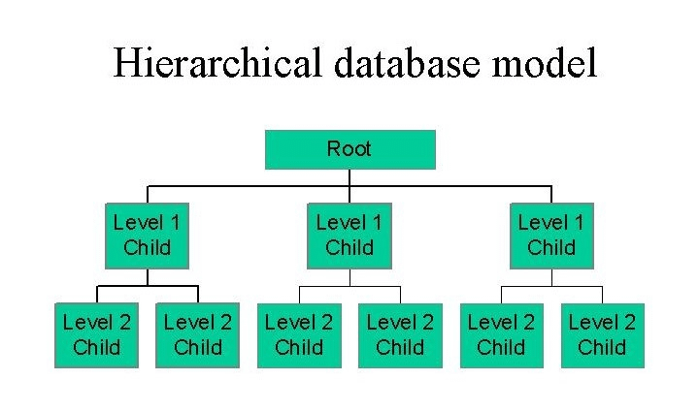

- Each parent record can have multiple child records, but each child record in the tree will contain only one parent

- Network database

- It is the database that typically follows a network data model.
- In Network database, the representation of data is in the form of nodes connected via links between them.

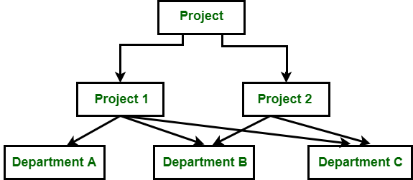

https://youtu.be/cLhzbmhNiEQ?si=oLZU1SXs3zypSSCc

16. Write down a comparative analysis between Centralised DBMS and Distributed DBMS.

Centralized DBMS | Distributed DBMS
Centralized DBMS, database is maintained at one site | In distributed DBMS, database is maintained at number of different sites.
If Centralized system fails entire system is halted | If any database system fails down, the other database system continues work with other sites.
Less reliable | More reliable.
Requires time. For accessing the data because multiple users access the same database file | Requires less time in accessing the data because the data is retrieved from nearest database file
Has more data consistency | Can have data replication and there can be some data inconsistency
In Central Dbms. The databases provide higher security as a central server manages all the data and resources | Distributed DBMS offers less security as the databases are distributed across multiple different locations.
E.g. – client-server model | Example – peer to peer model

17. Discuss peer-to-peer architecture for DDBMS.

Peer to peer model does not distinguish between client and server instead, each node can either be a client or server, depending on whether the node is requesting or providing the services.

Each node is considered as peer

Pattern of communication between the peers depends entirely on application requirements.

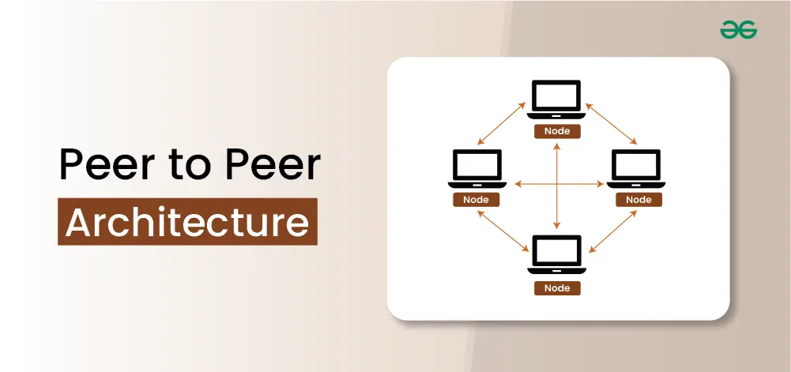

18. Explain multi-DBMS architecture.

Multi-DBMS architecture refers to database systems that involve multiple database management systems working together to manage and integrate data from multiple autonomous databases that may be distributed and heterogeneous.
Advantages
- Autonomy for participating organizations
- Incremental growth - new databases can be added.
- Location transparency for users
- Heterogeneity support - works with different DBMS products

19. What are the advantages and disadvantages of the client-server model?

Advantages of the client-server model?

- Centralized management - client-server model is a centralized system. Therefore, we can back up the data easily.

- Improved performance - The network has a dedicated server that improves the overall performance for the whole system.

- Higher security - Security is better in client server model. Because a single network manages all the shared resources

- High speed - speed of sharing data or resources is high

- Extendable/Scalability - The network is scalable/extendable so that we can extend the network by adding new devices.

disadvantages of the client-server model

- client-server model is expensive as it requires this server with large memory.

- Client server model has a network operating system(server) to provide resources to the client but the cost of network operating system is high.

- It requires a dedicated network administrator to manage all the resources

20. What are the different factors of DDBMS architecture? Discuss.

Scalability
The distributed database system should allow easy to scale up its resources such as data users.

Transparency
The users should be unaware of their data physical location, data replication or any failures.

Security
As the data is distributed across multiple locations, Data must be protected during storage and transmission.

Reliability
If one system fails down for some time, another system should overwrite and complete the task

Availability
The system should be accessible to users at all times, even in the case of failures or maintenance.

21. What are the different properties of autonomy? Discuss.
🔹 1. Design Autonomy
- Individual DBMSs are free to use data models and transaction management technique that they prefer.
🔹 2. Communication Autonomy
- Each of the individual DBMS’s is free to make its own decision as to what type of information it wants to provide to other DBMS’s or software that controls their global execution.

🔹 3. Execution Autonomy
- Each D B M S can execute the transaction that has submitted to it in any way that it wants to

https://www.youtube.com/watch?v=zp_YakRYBS0

22. Explain the failures in DDBMS.
i. Managing and co-ordinating data across multiple nodes can be complex.
ii. Maintaining multiple database systems(servers) and networks is costly and expensive
- Distributed databases rely heavily on network connectivity. A failure in the network can isolate nodes, preventing coordination and data access.

- Replicating data across multiple nodes introduces chances of inconsistency or replication lag

- In ddbms, data is placed across many locations and travels over networks, it is vulnerable points for unauthorized access, interception

23. Explain briefly about network partitioning.

Network partitioning is a critical issue in distributed systems, where communication between distributed databases is interrupted, where the network gets split into individual segments, and nodes within each segment can’t communicate with nodes in other segments.

📘 Example:
Imagine a distributed database with three servers:
- Server A (USA)
- Server B (Europe)
- Server C (Asia)
If a network failure occurs between USA and Europe, then:
- Server A can’t talk to Server B or C.
- Server B and C may still talk to each other.
This is a partitioned network.

24. Explain general architecture of a parallel database system & shared memory architecture.

Parallel database architecture uses multiple processors and storage devices working together in parallel.

- It processes queries is faster and more efficiently
- It improves speed scalability and performance for large databases
- Types of parallel database architecture
  - Shared memory architecture.
  - Shared disk architecture.
  - Shared nothing architecture

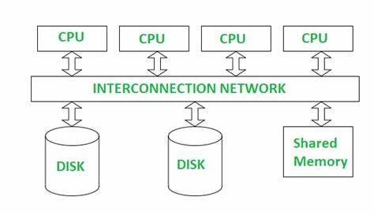

Shared memory architecture
In shared memory architecture multiple processors (CPU) share a single central memory (RAM).

Processors are attached to a global shared memory via. Communication channel.

All processes can access the same data in memory, and they work together on tasks
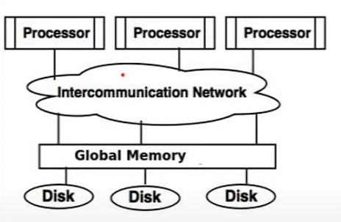

https://youtu.be/I_8P67Mda0Y?si=eKa2vxROjO28j9XX

Nepal Sir
1. Which of the following is an advantage of distributed database -
a. high latency
b. single point of failure
c. improved re-availability
d. centralized control

2. What does data fragmentation referred to in distributed database -
a. deleting data from different sites
b. combining data from multiple source
c. breaking a database into smaller pieces for storage at different sites
d. encrypting data for security

3. Which is not a type of data fragmentation -
a. horizontal fragmentation
b. vertical fragmentation
c. diagonal fragmentation
d. mixed fragmentation

4. In distributed database what is data replication -
a. Encrypting at one site
b. duplicating data at multiple sites
c. deleting data automatically
d. compressing data

5. Which of the following is true about distributed query processing -
a. it is always slower than centralized query processing
b. it involves processing a query over data located at multiple sites
c. it cannot be optimized

d. it requires only local database access
6. What is the major challenge in distributed transaction management -
a. formatting data
b. ensuring atomicity and consistency across multiple sites
c. increasing redundancy
d. minimizing query cost

7. Which of the following is a drawback of data replication in distributed DB –
a. increased performance
b. better data availability
c. increased storage cost and synchronization overhead
d. simplified access control
8. Consider the SQL query "select* from Emp group by Dept_no." Which of the
following is true—
a. One row output
b. Error
c. Zero row output
d. Can't say

9. Locking all data items before beginning of transaction is part of—
a. Basic 2PL protocol
b. Strict 2PL protocol
c. Rigorous 2PL protocol
d. Conservative 2PL protocol

10. In which of the following schedule, all the instructions of transaction execute
constitutively—
a. Serial schedule
b. Serializable schedule
c. Recordable schedule
d. Cascade less schedule

11. Transitive dependency is not allowed in—
a. 1NF
b. 2NF
c. 3NF
d. All of these

12. In public key encryption is a process where data is encrypted using—
a. Receivers public key
b. Sender public key
c. Global public key
d. A user generated public key

SAQ Marks: 1
- What does ACID stand’s for in transaction management?
ACID stands for Atomicity, Consistency, Isolation, and Durability

A – Atomicity
A transaction must be treated as an indivisible unit.
Which either completes in full or does not happen at all.

C – Consistency
• Transactions must transform the database from one valid state to another, maintaining predefined rules and constraints.

Isolation – Ensures that concurrent transactions do not interfere with each other.

D – Durability – Once a transaction is committed, its changes must be permanently saved, even in the case of system failures.

- Which type of joint returns all rows when there is a match in one of the tables?

Full Outer Join returns all rows when there is a match in one of the tables.

A Full Outer Join in SQL is used to combine rows from two or more tables based on a related column between them.

Visual Representation of SQL Full Outer Join

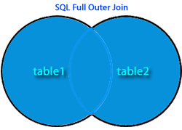

- What is the purpose of normalization?

Normalization in databases is used to:
- Eliminate data redundancy
- Reduce data inconsistencies
- Improve data integrity
- Simplify data maintenance and updates

- Which indexing method uses a balance-tree structure?

The B-tree indexing method uses a balanced-tree structure

- What is the default isolation level in most RDBMS system?
The default isolation level in most Relational Database Management Systems (RDBMS) is Read Committed.

- Which protocol ensure serializability in distributed data-base?

The protocol that ensures serializability in a distributed database is:

Two-Phase Locking (2PL)

- What is the key idea of CAP-Theorem?
The CAP theorem is a fundamental principle in distributed database systems that states a system can only achieve two out of the following three properties simultaneously:

- Consistency: All nodes see the same data at the same time.
- Availability: Every request receives a response, even if it’s not the latest data.
- P – Partition Tolerance: The system continues to operate despite of network failures or partitioning.

- What type of data base is MongoDB?
MongoDB is a NoSQL database

- In which normal form is a relation if it has no transitive dependency?

If a relation has no transitive dependency, it is in:

Third Normal Form (3NF)

- What is the function of Data Dictionary?

A Data Dictionary is a centralized repository that stores metadata—data about the data—in a database system.
5 Marks question: -
1. Define a Distributed DB system. How it is different from a centralized database
system.

Distributed DBMS
In distributed DBMS, database is maintained at number of different sites.
If any database system fails down, the other database system continues work with other sites.
More reliable.
Requires less time in accessing the data because the data is retrieved from nearest database file
Can have data replication and there can be some data inconsistency
Distributed DBMS offers less security as the databases are distributed across multiple different locations.

Example – peer to peer model

Centralized DBMS | Distributed DBMS
Centralized DBMS, database is maintained at one site | In distributed DBMS, database is maintained at number of different sites.
If Centralized system fails entire system is halted | If any database system fails down, the other database system continues work with other sites.
Less reliable | More reliable.
Requires time. For accessing the data because multiple users access the same database file | Requires less time in accessing the data because the data is retrieved from nearest database file
Has more data consistency | Can have data replication and there can be some data inconsistency
In Central Dbms. The databases provide higher security as a central server manages all the data and resources | Distributed DBMS offers less security as the databases are distributed across multiple different locations.
E.g. – client-server model | Example – peer to peer model

- What is data fragmentation? Explain its types.

Data fragmentation allows us to break a single object (database or table) into two or more fragments that means sub relations. Fragmentation of a relation ‘R’ consists of breaking it into number of fragments R₁, R₂, ..., Rₙ such that it is always possible to reconstruct the original relation ‘R’ from the fragments.

📌 Example:
Let’s say we have a relation:

EMPLOYEE(RollNo, Name, Department, Country)

• Horizontal Fragmentation:

Break based on rows:

Fragment 1 (R1):

Employees in India
SELECT * FROM EMPLOYEE WHERE Country = 'India'

Fragment 2 (R2):
Employees not in India
SELECT * FROM EMPLOYEE WHERE Country != 'India'

Reconstruction:
R = R1 UNION R2

There are two main types of data fragmentation:
- Horizontal Fragmentation: Dividing a table into fragments based on rows. Each fragment contains a subset of the total rows.
- Vertical Fragmentation: Dividing a table into fragments based on columns. Each fragment contains a subset of the total columns.

- What are the different types of transparency in distributed DBS?

Distribution transparency is the property of distributed database by the virtue of which the internal details of the distributions are hidden from the users.

Location Transparency

- The user is aware of the database fragments, but the users not aware of the physical location the data have been stored. Means the data where it is actually stored is hidden from the user.

- The location transparency ensures that users can query on any tables or fragments of a table as? If it were stored locally in the user site

🔹 2. Fragmentation Transparency
- Fragmentation transparency is the highest level of transparency. In fragmentation transparency, the user does not need to know the databases partitioned. Therefore, neither fragment names nor fragment location are specified prior to database access.

🔹 3. Replication Transparency

It makes user unaware of the existence of multiple copies of data at different site.
- Replication Of databases are hidden from the user
- Replication increase availability and reliability of the system

- Replication transparency ensures that the users is not involved in the management of copies of same data.

- Write a short note on ACID properties.

ACID stands for Atomicity, Consistency, Isolation, and Durability

A – Atomicity
A transaction must be treated as an indivisible unit.
Which either completes in full or does not happen at all.

C – Consistency
• Transactions must transform the database from one valid state to another, maintaining predefined rules and constraints.

Isolation – Ensures that concurrent transactions do not interfere with each other.

D – Durability – Once a transaction is committed, its changes must be permanently saved, even in the case of system failures.

- Explain the concept of concurrency control in database.

Concurrency control in a database ensures that multiple transactions can execute simultaneously without causing inconsistencies or conflicts in the data.

It maintains the ACID properties (Atomicity, Consistency, Isolation, Durability) while allowing efficient multi-user access.

Without proper concurrency control, several problems can arise, leading to data inconsistencies and loss of data integrity.

- Explain the concept of Normalization and its importance.

Normalization is a database design technique to organize data efficiently to minimize redundancy and improve data integrity by structuring tables systematically.

It eliminates undesirable characteristics such as insertion, update, and deletion anomalies within a database.

The process involves dividing large tables into smaller tables and establishing relationships between them.

The process of normalization is based on set of rules called "normal forms
First Normal Form (1NF),
Second Normal Form (2NF),
and Third Normal Form (3NF),
followed by Boyce-Codd Normal Form (BCNF)

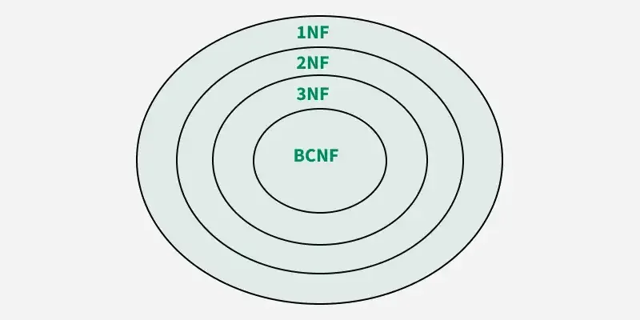

- Explain the types of distributed data base.

Homogeneous Distributed Database: all nodes use the same database software and schema.

Heterogeneous Distributed Database: All the nodes may use different database software and schema requiring translation coordination.

Replicated Distributed Database: Data is duplicated across multiple nodes for redundancy and availability.

Partitioned Distributed Database: Data is divided into fragments and stored on different nodes.

Federated Distributed Database: Integrates multiple autonomous databases, providing a unified view.

• Peer-to-Peer Distributed Database – All nodes are equal, meaning each can serve as both a client and a server.

- Explain the concept of two-phase commit protocol.

The Two-Phase Commit (2PC) Protocol is a distributed transaction protocol used ensure the atomicity of transactions across multiple databases.

It ensures that either all participants commit a transaction or none do, preventing partial updates that could lead to inconsistencies.

Atomicity, as part of the ACID properties, means A transaction must be treated as an indivisible unit.
Which either completes in full or does not happen at all.

Phase 1: The Prepare Phase
- Coordinator sends "Prepare" message: The coordinator sends a "PREPARE" message to all participating nodes. This message asks each participant if they are ready to commit their portion of the transaction.
- Participants execute and vote:
Each participant writes the transaction to a local log.
- Each participant receives the "PREPARE" message.
- Each participant node checks if it's ready to commit and sends a response back to the coordinator.
- If the participant successfully prepares its work and is ready to commit, it sends a "YES" (or "VOTE_COMMIT") message back to the coordinator.

- If for any reason (e.g., insufficient resources, a local error) the participant cannot commit, it aborts its local transaction, and sends a "NO" (or "VOTE_ABORT") message to the coordinator.
- If any participant node votes "no", the transaction is aborted.

Phase 2: Commit or Abort

- If all participant nodes vote "yes", the coordinator sends a "commit" message to all participants.

If "COMMIT" message received: Each participant commits its local transaction, making the changes permanent on the resources.
- Each participant node commits the transaction and sends a confirmation to the coordinator.
If any participant voted "NO", or a failure occurs before the commit, the coordinator sends an "ABORT" message.

If "ABORT" message received: Each participant aborts (rolls back) its local transaction, undoing any temporary changes and releasing all locks.
- If any participant node fails during this phase, the coordinator will instruct all participants to roll back the transaction.

15 Marks question: -
1. Explain the architecture of distributed database system. Discuss its components &
how they interact with each other. (5+10)
In distributed DBMS, database is maintained at number of different sites.
Architectural Models for Distributed Database Management Systems (DDBMS)

Deals with the organization of components across network of computers and their interrelationship.

Client-Server Architecture

- The most important and widely used distributed system architecture.

- A centralized architecture where, client and server roles are assigned and changeable

- Clients initiate communication as it requests data or services. and servers respond to the requests made by the client.

Peer to peer model

- A decentralized architecture where all nodes (peers) have equal roles and responsibilities.

- Each node can act both as a client and a server.

- Nodes share data directly with each other without centralized control.

Components of Distributed Database System

- Distributed Database: In DDBMS, database is distributed across multiple physical locations.
DBMSs can be homogeneous or heterogeneous.
- Data Fragmentation
Dividing a single database into logical units called fragments and distributed across multiple physical locations.
- Data Replication
Replication of data is stored at multiple sites for fault tolerance and to improve availability and reliability.

- Data Allocation: Deciding where to place data fragments at different site.

- Communication Network:
  - A communication network connects the different nodes in the distributed database system.
  - It facilitates data exchange and query processing among the nodes.

Interaction Among Components

  - i. User Request: When a user submits a query

  - ii. Query Parsing: the query processor interprets it

  - iii. Site Selection: and consults the global directory to determine where the relevant data fragments are located or stored.

The query processor may decompose the query into sub-queries that are sent to the appropriate DBMS at different nodes.

- iv. Data Retrieval: The DDBMS retrieves the required data from the selected sites and combines the results.

v. Data Update: If the query is an update, the DDBMS updates the data at the selected sites, ensuring that data consistency is maintained.

- Transaction Management: The transaction manager manages transactions across multiple sites, ensuring that either the transactions are completed successfully or rolled back in case of failure.

2. Design a distributed database system schema for a multinational ecommerce
company. Explain your choice regarding data fragmentation, replication, and
allocation. (9+6)

Schema Design
Entities & Attributes:
- Customer
  - CustomerID (PK)
  - Name, Email
  - Phone
  - shipping_address
  - Country
- Products:
- product_id (PK)
- name
- description
- price
- category
- supplier_id
- Orders:

- order_id (PK)
- customer_id (FK to Customers)
- order_date
- total_amount
- shipping_address

- Order_Items:

- order_item_id (PK)
- order_id (FK to Orders)
- product_id (FK to Products)
- quantity
- unit_price

- Inventories:
  - inventory_id (PK)
  - product_id (FK to Products)
  - location_region
  - quantity_available

- Payment:
- payment_id (PK)
- order_id (FK to Orders)
- payment_date
- amount
- payment_method
- status

  - Fragmentation Strategy:

i. Customers Table: Horizontal Fragment the Customers table by region based on the customer's address. Each region will have its own fragment of the Customers table.

ii. Vertical Fragmentation: Fragment the Products table into two tables: Product Info (product_id, name, description) and Product Pricing (product_id, price).
iii. Payments Table:
- Derived Horizontal Fragmentation: Payments will be fragmented based on order_id to co-locate with its corresponding Orders fragment.

3. Explain the significance of NoSQL DB in Distributed environment. Compare them
with traditional relational distributed database. (9+6)

significance of NoSQL DB in Distributed environment

• Scalability – Supports horizontal scaling, NoSQL databases are designed to scale horizontally by adding more nodes to the cluster

• High Availability – In a distributed environment, the failure of a single component should not bring down the entire system. NoSQL databases use replication and partitioning, ensuring fault tolerance means data is available even in the case of failures.

• Schema Flexibility: NoSQL databases do not enforce a fixed schema, NoSQL allows schema-less structures, making it easy to handle dynamic and unstructured data.

• Schema-less Design – Unlike relational databases, NoSQL databases do not require a fixed schema, making them adaptable to evolving data structures.

• Performance Optimization – Optimized for fast read/write operations

• Handling Big Data: NoSQL databases are well-suited for handling large amounts of unstructured data

Comparison: NoSQL vs. Traditional Relational Distributed Databases

Feature | NoSQL Databases | Relational Distributed Databases
Scalability | Horizontal scaling (adding nodes) | Vertical scaling (upgrading hardware)
Data Structure | Supports unstructured data | Supports structured data
Performance | Optimized for high-speed read/write operations | Slower due to complex transactions
Schema | Dynamic schema, flexible data models | Fixed schema
Query Language | SQL (Structured Query Language) | MongoDB Query Language
Transaction Support | Supports simple transactions, eventual consistency | Supports complex transactions with ACID compliance
Use Cases | Big data, IoT, real-time analytics, AI | Banking, ERP, traditional business applications
Query Language | No universal query language, varies by database type | Uses SQL for structured queries
Cost | More cost-effective due to horizontal scaling | Can be expensive due to vertical scaling
Complexity | Simpler | Complex

4. Discuss the role of Distributed DBS in modern cloud-based application. How do
system like google spanner & amazon Aurora tackle distrusted database challenges.
(7+8)

The Role of Distributed Databases in Modern Cloud-Based Applications

• Scalability – Cloud applications handle massive amounts of data, and distributed databases enable horizontal scaling by adding more nodes.

• Flexibility: Distributed databases can support a variety of data models and consistency levels, making them suitable for a wide range of applications.

• High Availability: Distributed databases can ensure data is always available, even in the event of node failures.

• Fault Tolerance – If a node fails, others nodes will overwrite the tasks, ensuring data integrity and system resilience.

• Cost Efficiency – Cloud providers offer pay-as-you-go models, reducing costs.

• Optimized Data Access & Reduced Latency: Data can be stored closer to users, reducing latency and improving performance

• Resilience to Disasters: By replicating data across multiple physical locations, distributed databases provide resilience to disasters.

• Handling Diverse Data Types: Cloud applications deal with a mix of structured, semi-structured, and unstructured data. Distributed databases handle this diversity, offering flexible schemas and various data models.

5. Explain 5th Normal Form with an example. What is fill replication? What are its
advantages? What is multi database system? What is critical section? What is live
lock? What is super key give an example. (3+2+2+2+2+2+2)

The Fifth Normal Form (5NF), is the highest level of normalization.
5NF, ensures that a table is decomposed into smaller tables that can be joined back without losing data, eliminating redundancy caused by join dependencies.

Full replication is a data replication strategy in distributed database systems where every piece of data in the database is replicated to multiple nodes in a distributed system.

🔹 Advantages of Full Replication:
High Availability: If any single node fails, the data remains available on the other replicated nodes.

Fault Tolerance – If any single node fails, the data remains available on the other replicated nodes ensuring fault tolerance.

multi database system
A multi database system is an environment where multiple autonomous databases, possibly of different types or locations work together and are accessed as a single unified system.

critical section
A Critical Section is a part of a program that accesses shared resources (like shared variables, files, or hardware devices) and must not be executed by more than one process at a time.
Critical sections are typically used in concurrent programming to prevent data corruption and ensure thread safety.

Live Lock
A Live Lock occurs when two or more processes continuously change state in response to each other without making progress.

Super Key
A Super Key is any set of one or more attributes that uniquely identifies a tuple (row) in a relation.

🔹 Example:
Consider a relation Employee(EmpID, Name, Email):
- {EmpID} is a super key.
- {EmpID, Email} is also a super key.
- {EmpID, Name} is also a super key.

6. Explain a schema to solve the naming problem to access and object in distributed
database system. Explain semi joint and bloom joint in mechanism. Suppose that we
decompose the schema 𝑅 = (𝐴,𝐵,𝐶,𝐷,𝐸) ×(𝐴,𝐵,𝐶) & (𝐴,𝐷,𝐸) show that this
decomposition is a losses joint decomposition if the following set of functional set F of
functional decencies holds 𝐴 ∅ 𝐵𝐶 , 𝐶𝐷 ∅ 𝐸 , 𝐵 ∅ 𝐷, 𝐸 ∅ 𝐴. (5+5+5)

