1. Image Accustion

How Aliasing effect is related to image accusation?

1. **Image acquisition** is the first step in digital image processing. It involves capturing an image using a sensor (e.g., camera or scanner) and converting it into a digital form that can be processed by a computer.

**Aliasing in image acquisition refers to the distortion or artifacts that occur when an image is sampled at a lower resolution than actually needed to accurately capture its fine details. High-frequency details are not sampled properly due to a low sampling rate. this causes visual distortions like unwanted patterns as high-frequency components are to be misinterpreted leading to visible artifacts and distortion in the digital image.**

1. Quantization

How quantization relates to image compression

Quantization is a fundamental and critical step in **lossy image compression**. It works by reducing the amount of data required to store an image while maintaining reasonable visual quality.

**Quantization** is the process of **mapping a continuous or large range of values** into a **smaller and finite set of discrete levels**.

**Relation to Image Compression:**

1. **Reduces Data Size:**
   * Reduces the amount of data required to store an image while maintaining reasonable visual quality.
2. **Enables Lossy Compression:**
   * Less important details (often negligible to the human eye) are discarded.
   * This makes quantization inherently **lossy**, but it greatly reduces file size.
3. Intensity level slicing:

How many type of intensity level slicing are three? Describe using graph if possible

**Intensity level slicing** is an image enhancement technique used in image processing to highlight specific intensity ranges within an image.

here are **two primary types** of intensity level slicing:

* + 1. **Binary Slicing** – In this method, pixels within a specified intensity range are set to a high value (white), while all other pixels are set to a low value (black). This results in a binary image.
    2. **Gray-Level Slicing** – In this method, all pixels within the specified intensity range are mapped to high value while all other intensities outside the range are mapped to a low value.

1. Log transformation in image enhancement.

**Log transformation** is an image enhancement technique used to **enhance low-intensity pixel values** in an image while compressing higher **intensity pixel values** of an image, making hidden details visible.

It works by **nonlinearly stretching low intensities** by applying the log transformation, this transformation expands the **dark pixel range** and reduces the **bright pixel range.**

1. Compare log transformation with contrast strectching

| **Feature** | **Log Transformation** | **Contrast Stretching** |
| --- | --- | --- |
| **Meaning** | Log transformation is an image enhancement technique used to enhance low-intensity pixel values in an image while compressing higher intensity pixel values of an image, making hidden details visible. | Contrast stretching is a linear technique used in image processing to enhance the **contrast** of an image by expanding the range of pixel intensities. |
| **Type** | Non-linear | Linear (default) |
| **Goal** | Enhance details in **dark areas** | Improve overall **contrast** of an image |
| Function type | Logarithmic scaling | Linear scaling |
| Best Suited For | Great for high dynamic range images | Better for low-contrast images |

1. 1d numerical problem on first order derivative. (l02.pdf last part)
2. Numerical on edge detection for a given 4/4 matrix-> finding horizontal/vertical/diagonal edge using given filter.

### 7/8 marks

1. Fundamental steps involving image processing

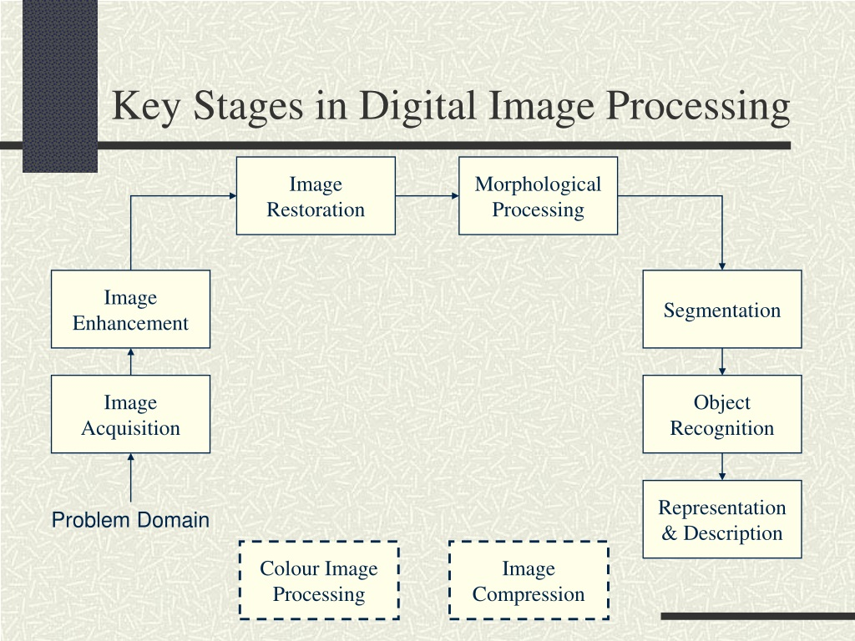

1️⃣ **Image Acquisition**

**Image acquisition** is the first step in digital image processing. It involves capturing an image using a sensor (e.g., camera or scanner) and converting it into a digital form that can be processed by a computer.

2️⃣ Image Enhancement:

The process of manipulating an image so that the result is more suitable than the original for specific applications.

3️⃣ Image Restoration:

The process of improving the appearance of an image.

It uses mathematical or probabilistic models of image degradation to reverse or compensate for known degradations that occurred during image acquisition and try to reconstruct the original image.

4️⃣ Morphological Processing

Morphological processing deals with the Set of operations for extracting image components that are useful in the representation and description of shape.

5️⃣ Image Segmentation:

Image Segmentation procedures partition a digital image into multiple segments or "objects". The more accurate the segmentation, it will be more meaningful and easier to analyze.

6️⃣ **Feature Extraction**

**Feature Extraction** is the process of assigning a label to an object based on its description.

7️⃣ Representation and Description:

the segmented regions need to be represented in a form suitable for computer processing.

Description involves extracting quantitative information from these regions.

8️⃣ Image Compression:

Reducing the amount of data required to represent an image without significant loss of information and maintaining quality.

1. colour image processing

It includes the use of colour of the image to extract the features of interest in the image

1. Significance of segmentation in DIP. Common segmentation methods and their application.

* Segmentation refers to the process of partitioning an image into multiple regions.
* Image segmentation is used to locate objects and boundaries in images

*Significance of Segmentation in Digital Image Processing (DIP)*

1. • Object **Identification** & Detection

Segmentation helps identify objects, boundaries, and structures within an image, enabling object detection, classification, and recognition

1. • Enhanced **Image Analysis**: It helps computers perceive visual data(image) in a similar way to human vision, making image processing more efficient.
2. • **Simplifies Image Representation:** Reduces complexity by transforming the image into a more meaningful and easier-to-analyze form.
3. • **Feature Extraction:** Allows extraction of meaningful features (shape, texture, color) from specific segments.
4. • **Image Compression: Acts as a preprocessing step for tasks like image compression.**

*Common segmentation methods and their application.*

**1. Thresholding**

* **Method**: Divides an image into segments by converting grayscale image to binary image, based on pixel intensity values.

**Types**-

* 1. Global Thresholding
  2. Variable Thresholding
  3. Regional Thresholding
  4. Adaptive Thresholding
* 2. Edge-Based Segmentation

• Method: Detects object boundaries by identifying edges in image intensity, using operators like Sobel, Canny, or Laplacian.

* 3. Region-Based Segmentation
* **Concept:** This approach segments an image by grouping pixels that have similar properties (color, texture, intensity).
* 4. Clustering-Based Segmentation

Uses clustering algorithms (e.g., K-means) and groups pixels into clusters based on their similarity

**in feature space (e.g., RGB values, intensity, texture features).**

* 5. Watershed Segmentation

• Method: Treats an image as a topographic surface and segments regions based on gradients.

6. Deep Learning-Based Segmentation

• Uses neural networks particularly Convolutional Neural Networks (CNNs) for pixel-wise classification.

1. How the affine transformation matrix effects on scaling, rotaion, and sharpening of an image?

* An affine transformation is a fundamental concept in digital image processing.
* The **affine transformation matrix** plays a crucial role in modifying images through scaling, rotation, and sharpening.
* An **affine transformation** is a linear mapping method that preserves **parallel lines, but not necessarily lengths and angles.**
* **The power of affine transformations lies in their ability to combine multiple operations (like scaling, rotation, and translation) into a single matrix multiplication, simplifying computations.**
* It is represented by a **2×3 matrix** (for 2D images)

1. Scaling:

* Scaling involves changing the size of an image, either enlarging (zooming in) or shrinking (zooming out).
* This is achieved by multiplying the x and y coordinates by scaling factors.
* Scaling can be **uniform** or **non-uniform**.

1. **Rotation**

* **Rotation involves turning an image around a specific point by a certain angle.**
* This is accomplished **by applying trigonometric functions to pixel coordinates.**

1. **- Sharpening:**

* **Sharpening is NOT a geometric transformation and therefore is NOT directly affected by the affine transformation matrix.**
* **sharpening is achieved through convolution filters.**

1. What is shearing transformation how it effects image’s geometry

Shearing transformation is a **geometric transformation that alters the shape of an image by shifting its points along a specific axis, creating a skewed effect.**

**shearing preserves parallelism**

Shearing Transformation Affects Image Geometry

**• Horizontal Shearing**:

In X-shearing, the x-coordinate of each pixel is shifted by an amount proportional to its y-coordinate. The y-coordinate remains unchanged.

(Vertical Shearing):

In Y-shearing, the y-coordinate of each pixel is shifted by an amount proportional to its x-coordinate. The x-coordinate remains unchanged.

1. How spatial filters are processed? Explain using a example of low pass filter. How it effects the quality of the image?

* A spatial filter is a technique in image processing that modifies the pixels of an image based on the values of their neighboring pixels.
* The processing is done by applying a "kernelover each pixel in the image.

A **low-pass filter (LPF)** is a type of filter used in **image processing** that **removes high-frequency components** from an image while **preserving low-frequency components**.

**Effects on Image Quality**

* **Reduces noise**: Helps remove unwanted variations.
* **Blurs fine details**: Can make edges less sharp.
* **Improves smoothness**: Creates a more uniform appearance.

1. Math from contrast stretching
2. Purpose of histogram equalization in DIP.

Histogram equalization is a technique in **Digital Image Processing (DIP)** used to enhance the contrast of digital images.

🔍 Purpose of Histogram Equalization:

* 1. Enhance Image Contrast:

It redistributes the intensity values of pixels, improving the visibility of details in dark or bright regions.

* 1. Improve Visual Quality:
* Enhances features for better performance in tasks like edge detection, segmentation, and object recognition.
  + 1. **Facilitating Image Analysis**: Enhanced contrast can improve the performance of image analysis algorithms, such as edge detection, segmentation, and object recognition
    2. **Utilization of Dynamic Range:**

 It ensures that the full dynamic range of pixel values is utilized which leads to a more visually appealing image.

* + 1. **Standardizing Image Appearance**: Histogram equalization can help standardize the appearance of images taken under different lighting conditions, making them more uniform for further analysis or processing.

1. Numerical from histogram matching.
2. Primary use of Hough transformation. Why polar form is better than y = mx + c

The **Hough Transform** is primarily used for **detecting geometric shapes** in images like lines, circles, and ellipses.

It is used in:

* **Edge Detection**
* **Object Recognition**

**Why Polar Form is Better than y = mx + c**

polar form is better than y = mx + c because:

**• Handles Vertical Lines:**

* For a perfectly vertical line, the slope m becomes **infinite**, y = mx + c becomes undefined for vertical lines, whereas the polar form Every line, including vertical lines, can be uniquely represented by a finite pair, as it does not rely on the slope.
* **Uniform Hough Space:** The polar form allows a **more uniform distribution** of lines in the Hough space, making the voting process in the Hough accumulator more stable and efficient.
* **Better Parameterization**: The polar coordinates allows more uniform distribution of parameters, which lead to better performance in detecting lines
* **Reduced Complexity**: The polar form simplifies the representation of lines, making it easier to process.

1. Numerical problem from Hough transform
2. Region growing algorithm explained in detail

The Region growing is a region-based image segmentation technique.

Region growing is a procedure that group pixels or sub bridges into larger regions based on similarity criteria.

Logic behind region growing algorithm is a principle of similarity.

Principle of similarity states that the region is coherent. if all the pixels of the region are homogeneous.

Major steps of region growing algorithm are

* 1. Selection of the initial seed
  2. Seed growing criterion
  3. Termination of the segmentation process
* It starts with one or more **seed points** and iteratively adds similar neighboring pixels to form coherent regions until no more pixels can be added .

1. Numerical from split and merge algorithm

All the Cas, there will be SAQ instead of MCq



**Maulana Abul Kalam Azad University of Technology, West Bengal**

Internal Class Test - May-2025

|  |  |
| --- | --- |
| **Program: BCA** | **SEM: VI** |
| **Course Name: Digital Image Processing** | **Course Code: BCAD 601A** |
| **FM: 25** | **Time: 1 Hrs.** |

|  |  |  |  |
| --- | --- | --- | --- |
| **Attempt all questions** | | | |
| 1 | i | An 8-bit grayscale image (uncompressed) has dimensions of 256 × 256 pixels. Calculate the total size of the image in kilobytes (KB).  An **8-bit grayscale image** means each pixel uses **8 bits = 1 byte**.  Total number of pixels 256 × 256 = 65,536 pixels  convert to **kilobytes (KB)**:   * 65,536÷1024=64KB | 2 |
|  | ii | An image has an original size of 1024 × 1024 pixels.  If the image is downsampled by a factor of 4 in both dimensions,  how many pixels will the downsampled image contain?  If an image of **1024 × 1024 pixels** is **downsampled by a factor of 4** in **both dimensions**, then:   * New width = 1024 ÷ 4 = **256** * New height = 1024 ÷ 4 = **256**   So, the total number of pixels in the downsampled image is:  **256 × 256 = 65,536 pixels** | 2 |
|  | iii | If an image is quantized using 4 bits per pixel,  how many intensity levels are possible?  Quantisation: 4 bits per pixel  The number of intensity level is  2^4 = 16 | 2 |
|  | iv | What do you mean by city-block distance?  City-block distance, also known as **Manhattan distance**, | 2 |
|  |  | It is a way of measuring distance between two points in a grid-based system.  D=∣x1​−x2​∣+∣y1​−y2​∣   |  |  |  | | --- | --- | --- | | v | What is contrast stretching? | 2 | |  |
|  |  | Contrast stretching is a linear technique used in image processing to enhance the **contrast** of an image by expanding the range of pixel intensities. |  |
|  |  | Linear (default) |
|  |  | Improve overall **contrast** of an image |
|  |  | Linear scaling |
|  |  | Better for low-contrast images |  |

|  |  |  |
| --- | --- | --- |
| 2 | i | Using the Hough Transform, draw a line based on the given points:  (−4, −12), (−2, −5), (−1, 2), (0, 2), (2, 9), (4, 16). |
|  | ii | Discuss the Region Growing algorithm for image segmentation with a suitable example.  The Region growing is a region-based image segmentation technique.  Region growing is a procedure that group pixels or sub bridges into larger regions based on similarity criteria.  Logic behind region growing algorithm is a principle of similarity.  Principle of similarity states that the region is coherent. if all the pixels of the region are homogeneous.  Major steps of region growing algorithm are   * 1. Selection of the initial seed   2. Seed growing criterion   3. Termination of the segmentation process * It starts with one or more **seed points** and iteratively adds similar neighboring pixels to form coherent regions until no more pixels can be added . |
|  | iii | Apply the Split and Merge algorithm to the given matrix for image segmentation.   |  |  |  |  |  |  |  |  | | --- | --- | --- | --- | --- | --- | --- | --- | | **6** | **5** | **0** | **1** | **2** | **2** | **1** | **3** | | **6** | **6** | **1** | **2** | **1** | **0** | **0** | **1** | | **7** | **5** | **3** | **2** | **1** | **3** | **0** | **2** | | **5** | **7** | **1** | **0** | **0** | **2** | **1** | **0** | | **4** | **6** | **1** | **1** | **5** | **5** | **6** | **6** | | **7** | **7** | **0** | **2** | **6** | **7** | **6** | **5** | | **7** | **6** | **7** | **5** | **7** | **7** | **7** | **6** | | **5** | **6** | **5** | **6** | **6** | **6** | **6** | **5** | |

**Instructions for Class Test:**

* Write your answers on **A4-sized paper only**. You may use **both sides of the page**.
* **Do not write the questions** on the answer sheet; only mention the **question number** when answering.
* At the **top of the first page**, include the following details:  
   **Name / Program Name / Course Name / Course Code / Semester / University Roll No. / University Registration No. / Date of Examination**
* You must **upload a scanned copy of your answer script within one hour** after completing the test.

**Upload link:** <https://docs.google.com/forms/d/e/1FAIpQLSeAAXU57kecYp3990B2EtSqW5cJ6xHQgCaixZgksfDxr_kObQ/viewform?usp=header>

* Additionally, you are required to **submit the hard copy of your answer script by 8th May 2025**.