

**LAB REPORT – 2**

**Computer & Networks**

**List Of Topologies:**

* **Bus topology**
* **Mesh topology**
* **Ring topology**
* **Star topology**
* **Hybrid topology**

**Goals: -**

* To check by assigning the packet
* To check my removing the wire on one side
* And by removing on other side
* By checking ping with ip address of one pc from another Pc
* And observing Realtime & simulation mode
* And to write observation

**1.Bus Topology**

**Intro: -**

In Bus topology data transmitted through the cable. because data reaches each node, the node checks the destination IP address to work out if it matches their address. If the address does not match with the node, the node does nothing more. But if the addresses of nodes match to address contained within data then they process on knowledge. In the bus, communication between nodes is done through a foremost network cable.

Bus Topology is one of the easiest way to connect computers, but it is also depends on the central wire if it does not work the total topology will stop working.

**Arranging of Pc’s and switches:**

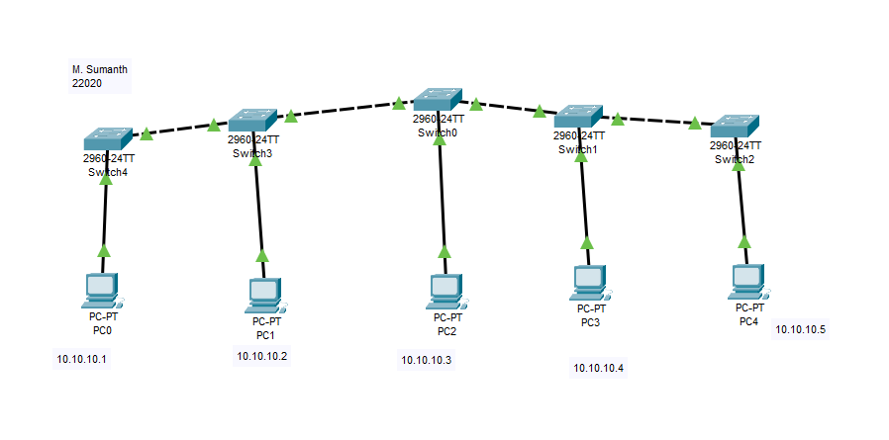

Now, we must configure connection by sending a packet through one pc to another.

**After running packet:**

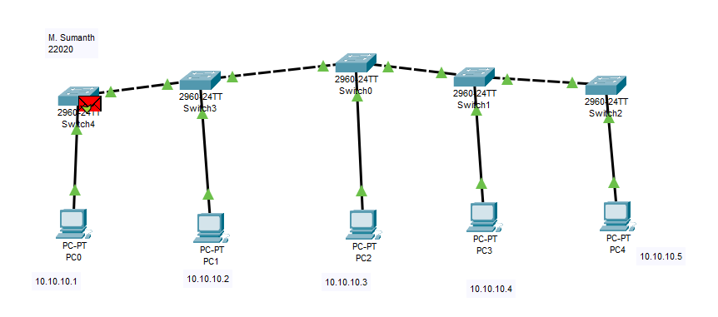

After a Successful running of the packet then we have to check Realtime and simulation mode, In the simulation mode we can see that detailed info of the packages from travelling from switches to pc and from each other.

**Realtime mode:**

RealTime shows the packets that has travelled from one Pc to another Pc is successful or failed.

If there is a valid connection between the Pc’s it shows Successful or else if connection is interrupted it shows failed.

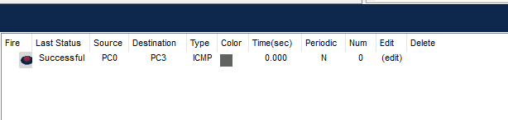

**Simulation mode (detailed info of travelling of packets):**

If provides the detailed information about the packet from which it travels from one switch to another switch and provides the detailed info about time taken from switch to switch and packet which is at present device.

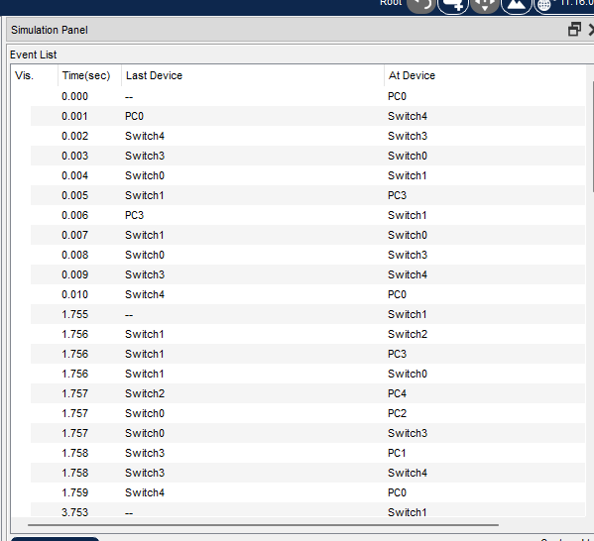



**Ping:**

By using Ping, we can check the connection from the one pc to another pc by using IP address and it display the time taken to connect and show no of packets have been transferred, received and lost while transferring.

In Some cases, due to some network issues the packets which was will be lost.

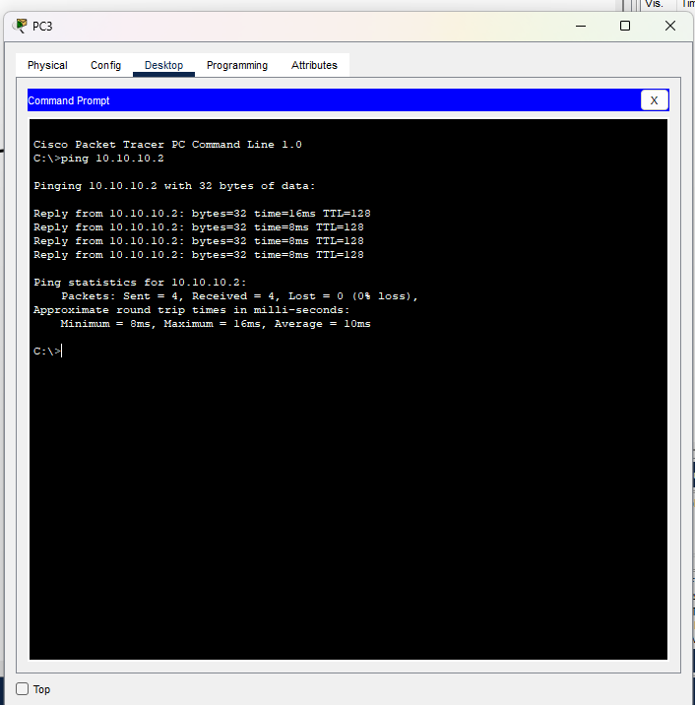

**Removing the Internal connections:**

In Bus topology it is not possible to remove the wire between the pc and switch because there is a single connection between pc and switch and they are not interconnected among each other like other topologies.

**Observation:**

A bus topology network involves a combination of visual inspection and monitoring network performance to ensure that it functions correctly and reliably. If issues are detected, troubleshooting may be required to address them and maintain the network's integrity. If the centre cable or switch fails total topology fails..

**2.Mesh Topology**

**Intro:**

In mesh, all the computers are interconnected to every other during a network. Each computer not only sends its own signals but also relays data from other computers. The nodes are connected to every other completely via a dedicated link during which information is travel from nodes to nodes and there are N(N-1)/2 links in mesh if there are N nodes. Every node features a point-to-point connection to the opposite node. The connections within the mesh are often wired or wireless.

**Arrangements of Pc’s and Switches:**

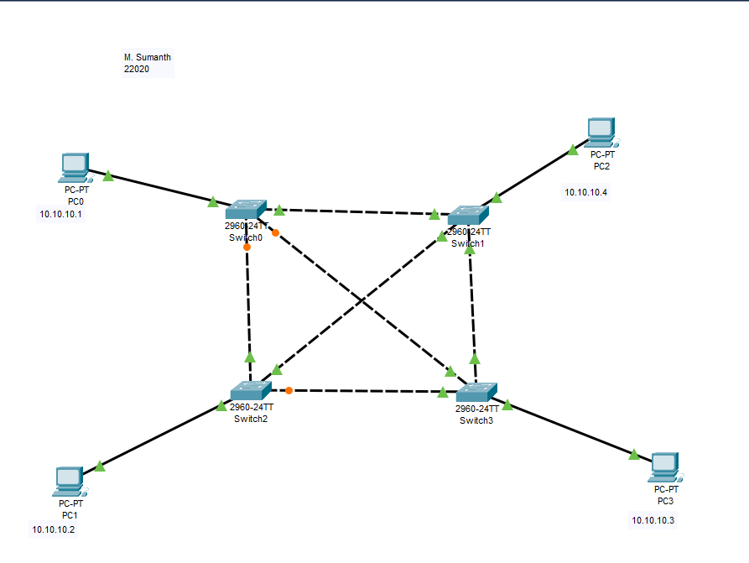

**After running Packets:**

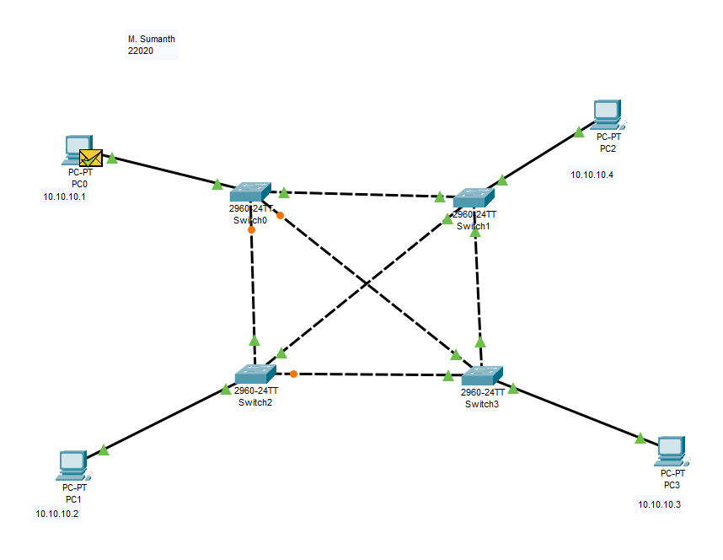

After a Successful running of the packet then we have to check Realtime and simulation mode, In the simulation mode we can see that detailed info of the packages from travelling from switches to pc and from each other.

**Real Time:**

RealTime shows the packets that has travelled from one Pc to another Pc is successful or failed.

If there is a valid connection between the Pc’s it shows Successful or else if connection is interrupted it shows failed.

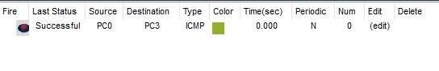

**Simulation:**

If provides the detailed information about the packet from which it travels from one switch to another switch and provides the detailed info about time taken from switch to switch and packet which is at present device

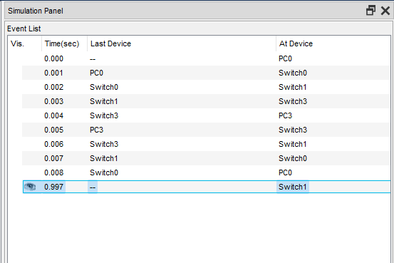

**Ping:**

By using Ping we can check the connection from the one pc to another pc by using IP address and it display the time taken to connect and also show no of packets have been transferred, received and lost while transferring.

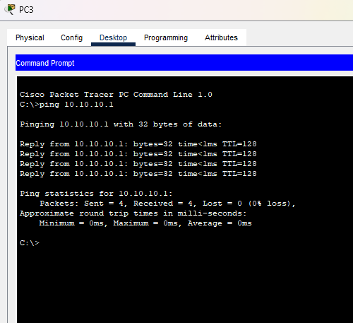

**Removing the Internal connections:**

In the Mesh Topology everything is interconnected with wire each other. So, when we the connection of one wire and we run the packet, it runs successfully because it chooses another way to transfer the packet.

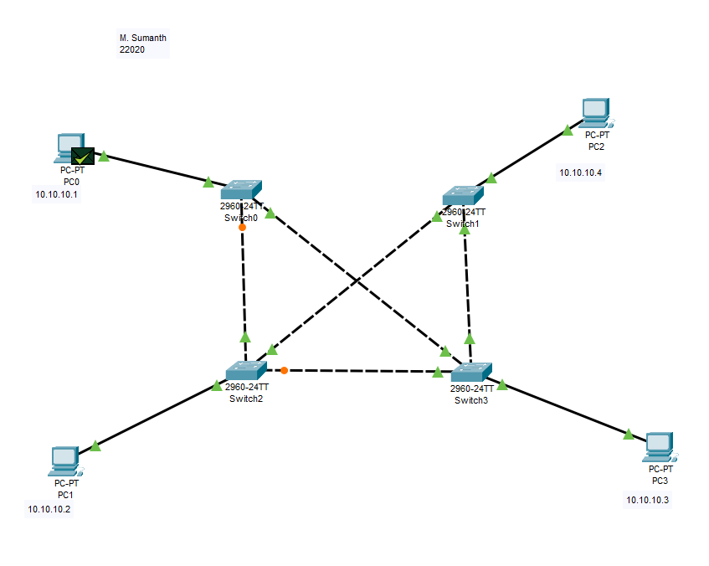

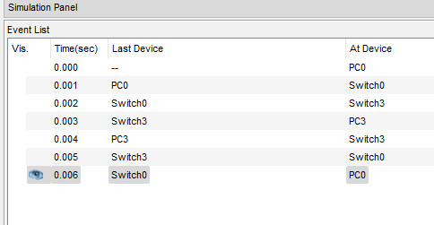

**Observation:**

In a mesh topology, on the basis of the availability of connection between nodes, all devices decide the route of the data flow and work as a router. If a break occurs in a segment of cable, the traffic load of the network is redistributed between all nodes, which maintains the availability of the network.It is a type of network topology that offers redundant links across the network, but it is rarely used due to work involved in having a network and significant cost, as the network components are directly connected to every other component. Furthermore, for installing partial mesh topologies, the mesh network setup is ideal as it balances the need for redundancy as well as cost.

**3. Ring Topology**

**Intro:**

Ring topology is a network topology in which all the devices in the network are connected in a circular fashion. Each device in the ring topology is connected to two other devices, one on either side of it. The data is transmitted in a single direction, either clockwise or counterclockwise, around the ring. This type of topology is commonly used in local area networks (LANs) and wide area networks (WANs).

**Arrangement of Pc’s and Switches:**

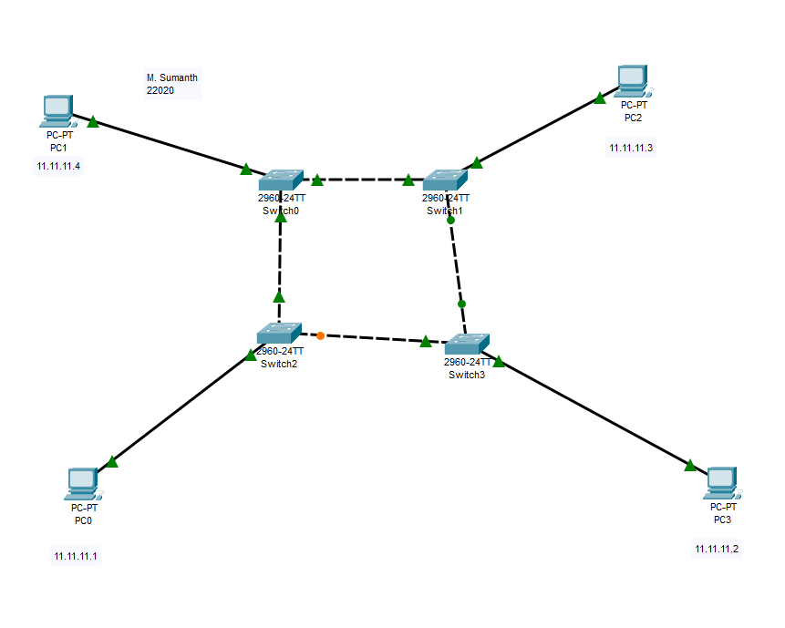

Now, we must configure connection by sending a packet through one pc to another.

**After running packet:**

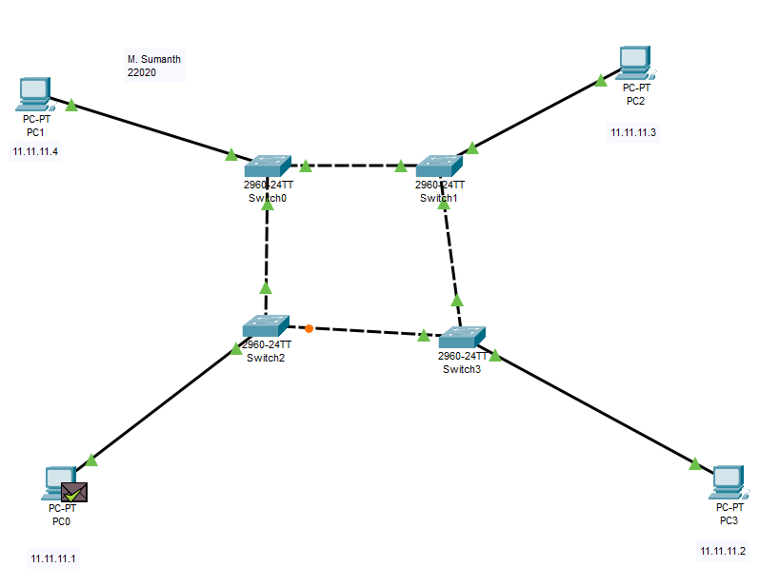

After a Successful running of the packet then we have to check Realtime and simulation mode, In the simulation mode we can see that detailed info of the packages from travelling from switches to pc and from each other.

**Realtime mode:**

RealTime shows the packets that has travelled from one Pc to another Pc is successful or failed. If there is a valid connection between the Pc’s it shows Successful or else if connection is interrupted it shows failed.

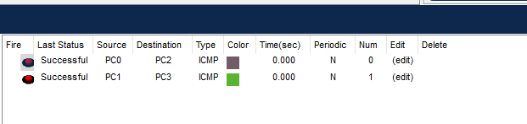

**Simulation mode (detailed info of travelling of packets):**

If provides the detailed information about the packet from which it travels from one switch to another switch and provides the detailed info about time taken from switch to switch and packet which is at present device.

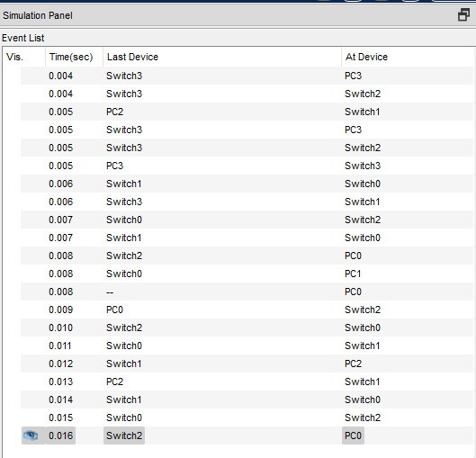

**Ping:**

By using Ping, we can check the connection from the one pc to another pc by using IP address and it display the time taken to connect and show no of packets have been transferred, received and lost while transferring.

In Some cases, due to some network issues the packets which was will be lost.

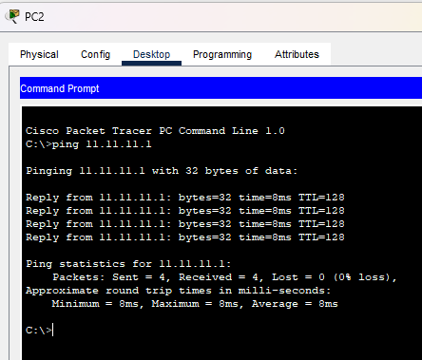

**Removing the Internal connections:**

In Ring topology we can remove the connections between the switches which makes a way for a packet to go from another switches.

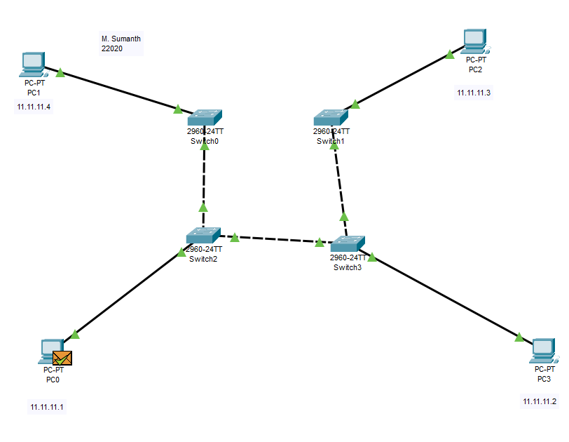



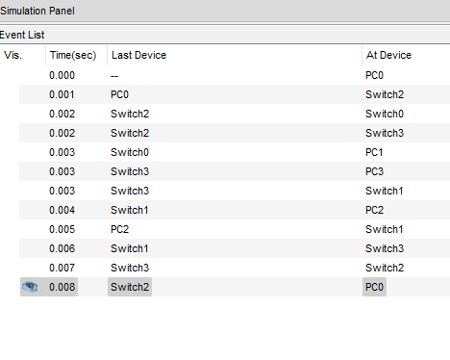

**Observation:**

One of the main advantages of ring topology is the high data transmission rate. In a ring topology, data is transmitted in a single direction, which reduces the chances of collisions and increases the overall speed of data transmission. This makes ring topology ideal for networks that require high-speed data transfer, such as video conferencing and online gaming. if one device fails, the rest of the devices can still communicate with each other by bypassing the failed device. This means that the network can continue to function, albeit at a reduced capacity, even if one device fails.

**4. Star Topology**

**Intro:**

Star Topology A star may be a topology for a Local Area Network (LAN) during which all nodes are individually connected to a central connection point, sort of a hub or a switch. A star takes more cable than e.g., a bus, but the benefit is that if a cable fails, just one node is going to be brought down. Each device within the network is connected to a central device called a hub. If one device wants to send data to another device, it’s to first send the info to the hub then the hub transmits that data to the designated device.

**Arranging of Pc’s and Switches and Hub:**

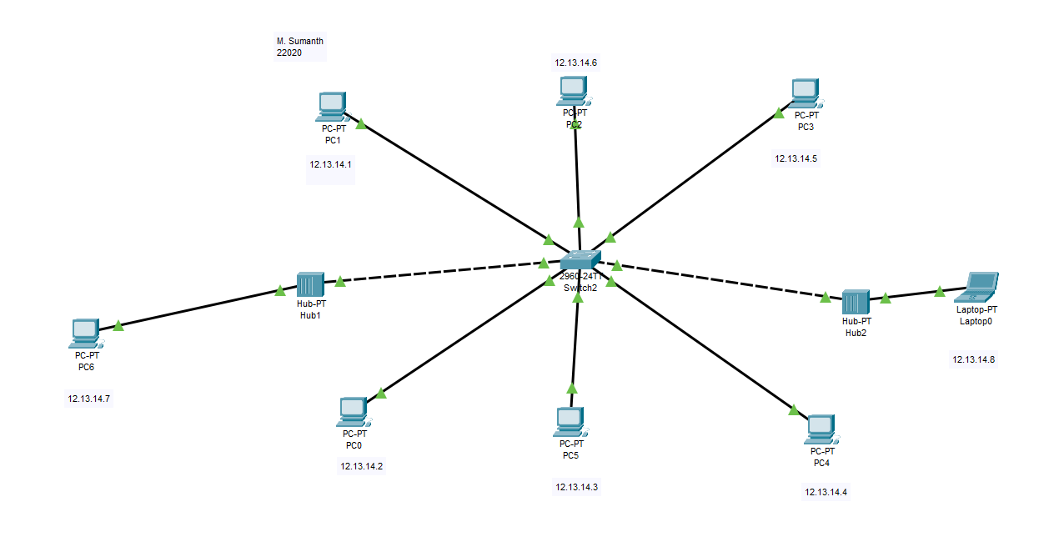

Now, we must configure connection by sending a packet through one pc to another.

**After running packet:**

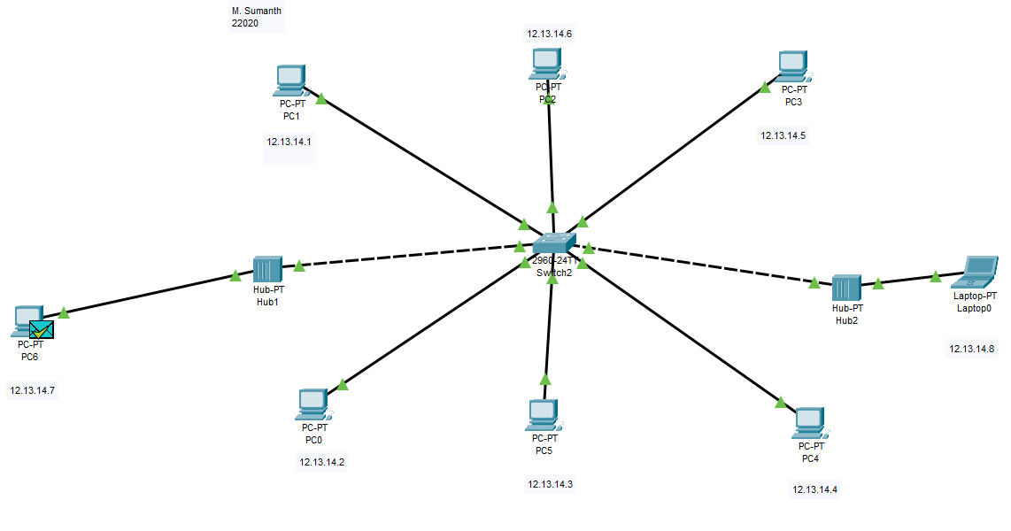

After a Successful running of the packet then we have to check Realtime and simulation mode, In the simulation mode we can see that detailed info of the packages from travelling from switches to pc and from each other.

**Realtime mode:**

RealTime shows the packets that has travelled from one Pc to another Pc is successful or failed.

If there is a valid connection between the Pc’s it shows Successful or else if connection is interrupted it shows failed.

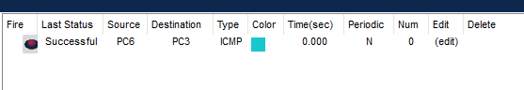

**Simulation mode (detailed info of travelling of packets):**

If provides the detailed information about the packet from which it travels from one switch to another switch and provides the detailed info about time taken from switch to switch and packet which is at present device.

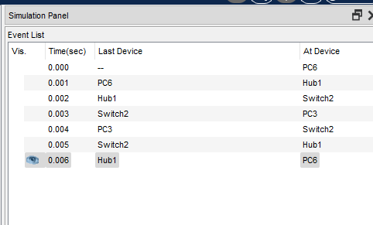

**Ping:**

By using Ping, we can check the connection from the one pc to another pc by using IP address and it display the time taken to connect and show no of packets have been transferred, received and lost while transferring.

In Some cases, due to some network issues the packets which was will be lost.

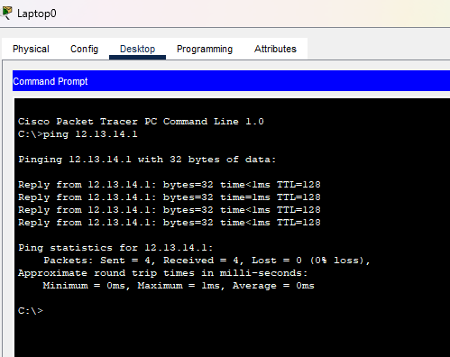

**Removing the Internal connections:**

If you remove the wire connecting a single device to the central hub or switch, that particular device will lose its network connection. It will no longer be able to communicate with other devices on the network until the wire is reconnected or an alternative connection is established.

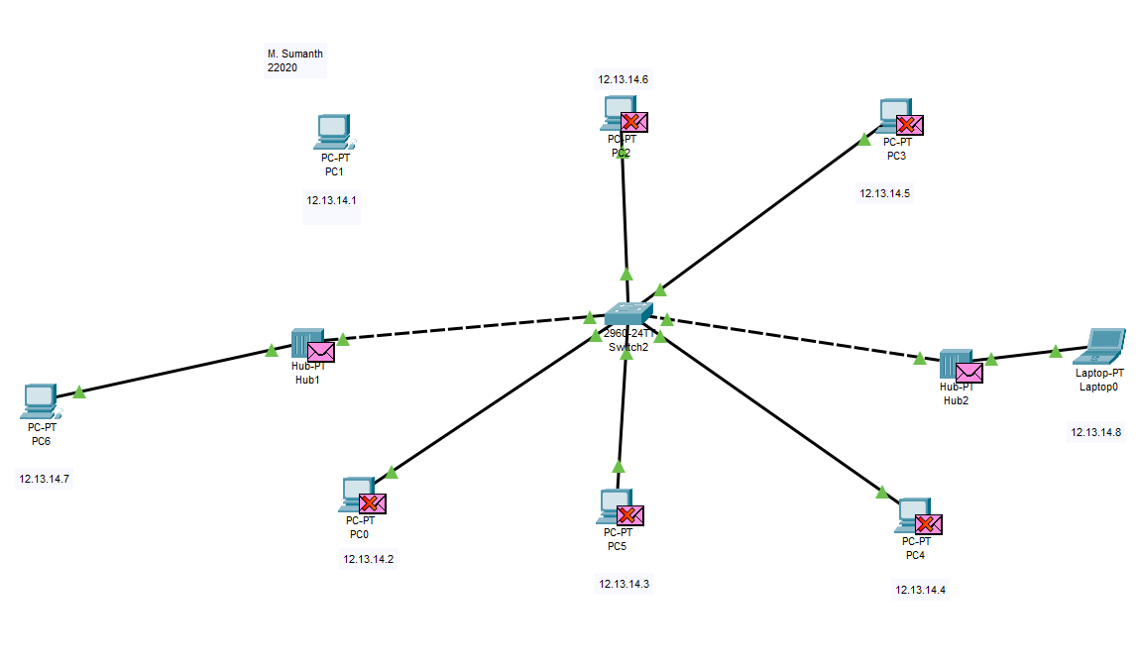

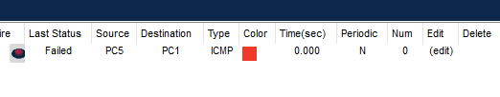

In Above it has failed because of no connection.

**Observation:**

the consequences of removing a wire in a star topology network depend on the specific wire you remove and the network's overall design. It can result in the loss of connectivity for a single device or, in more severe cases, the entire network. Care should be taken when making changes to the network topology to avoid disruptions and ensure proper functioning.

**5.Hybrid Topology**

**Intro:**

The arrangement of a network that comprises nodes and connecting lines via sender and receiver is referred to as network topology. The combination of two or more topologies in a computer network is called Hybrid Topology. These combined topologies can be a combination of bus topology, mesh topology, ring topology, star topology, and tree topology.

**Arrangements of Pc’s and Switches:**

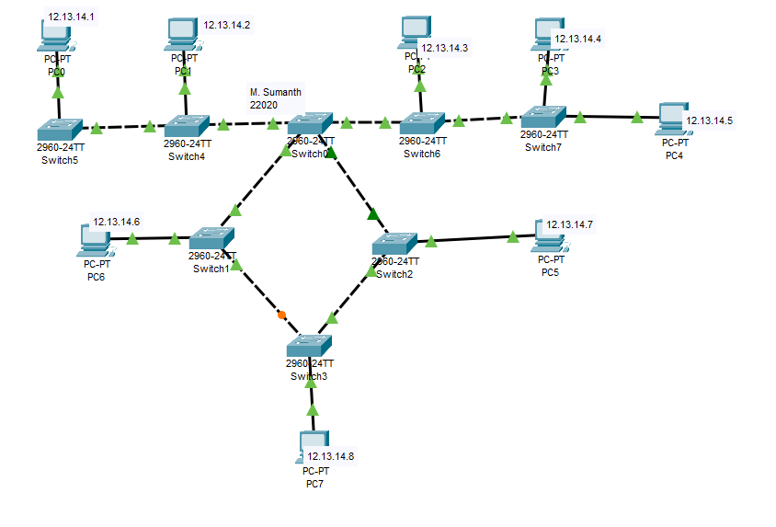

**After running Packets:**

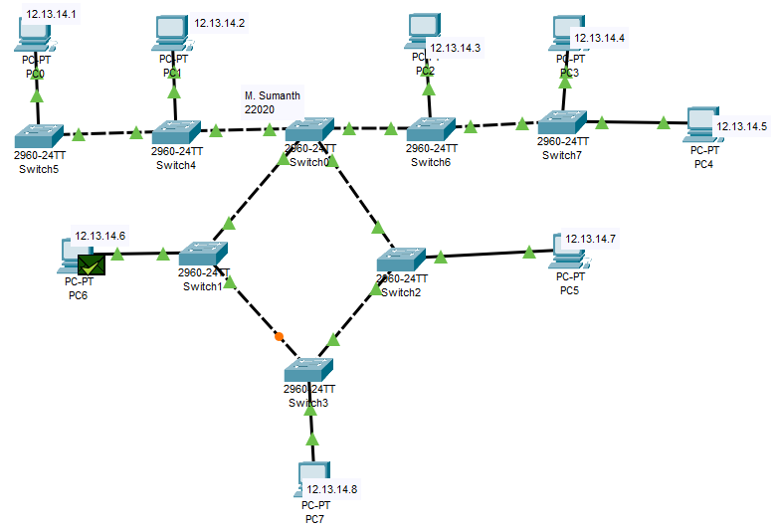

After a Successful running of the packet then we have to check Realtime and simulation mode, In the simulation mode we can see that detailed info of the packages from travelling from switches to pc and from each other.

**Real Time:**

RealTime shows the packets that has travelled from one Pc to another Pc is successful or failed. If there is a valid connection between the Pc’s it shows Successful or else if connection is interrupted it shows failed.



**Simulation:**

If provides the detailed information about the packet from which it travels from one switch to another switch and provides the detailed info about time taken from switch to switch and packet which is at present device

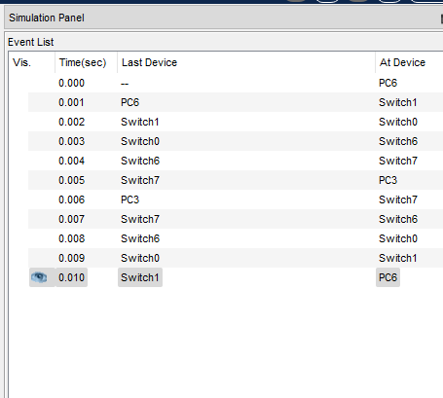

**Ping:**

By using Ping we can check the connection from the one pc to another pc by using IP address and it display the time taken to connect and also show no of packets have been transferred, received and lost while transferring.

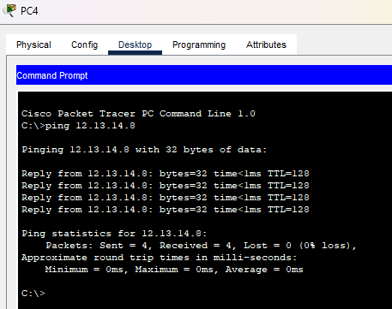

**Removing the Internal connections:**

If you remove a wire that connects a segment of one topology to another, you will effectively isolate those segments from each other. For example, if you have a hybrid topology with a star and ring combination, removing a wire that connects a device in the star topology to the ring topology will isolate the star segment from the ring segment. Devices on one side of the removed wire will not be able to communicate with devices on the other side.

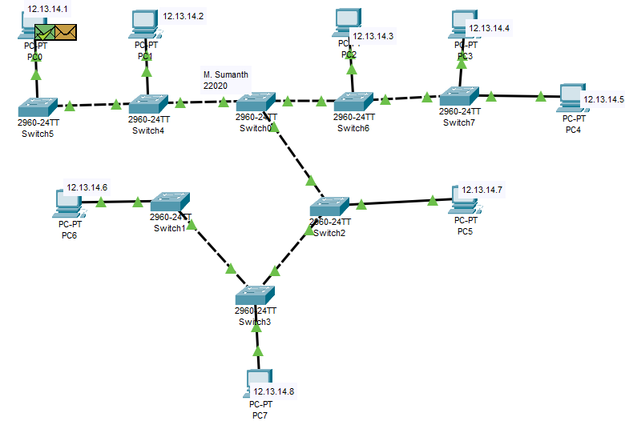

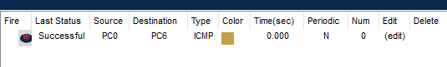

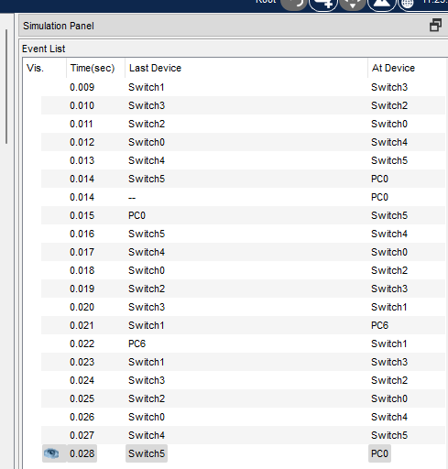

**Observation:**

Hybrid Topology helps in keeping the full diversity of the computer network and it is helpful when we require more than one topology in the system. that the removal of a wire in hybrid topology is done in a controlled and planned manner to minimize disruptions and maintain network integrity.