**API Detection Rules:**

Modern applications use a lot of different frameworks, so stacktraces in method hotspots and exceptions can become quite long. APIs allow you to spot a component and the respective ownership that is responsible for a hotspot or degradation faster. API detection rules look at a stacktrace frame and classify it based on classes (Java, .NET and PHP) or files (Node.js, PHP and GO) depending on the technology.

**Request naming rule**

You can use request naming rules to adjust how your requests are tracked and to define service entry and endpoints in your customer-facing workflow. With such end-to-end tracing, you can easily recognize and monitor important business transactions that are critical to the success of your digital business.

1. Go to **Services** or **Services Classic** (latest Dynatrace) and select the service you want to configure.
2. Select **More** (**…**) > **Settings**.
3. On the **Service settings** page, go to the **Request naming rules** (or **Web request naming rules**) and select **Add rule**.

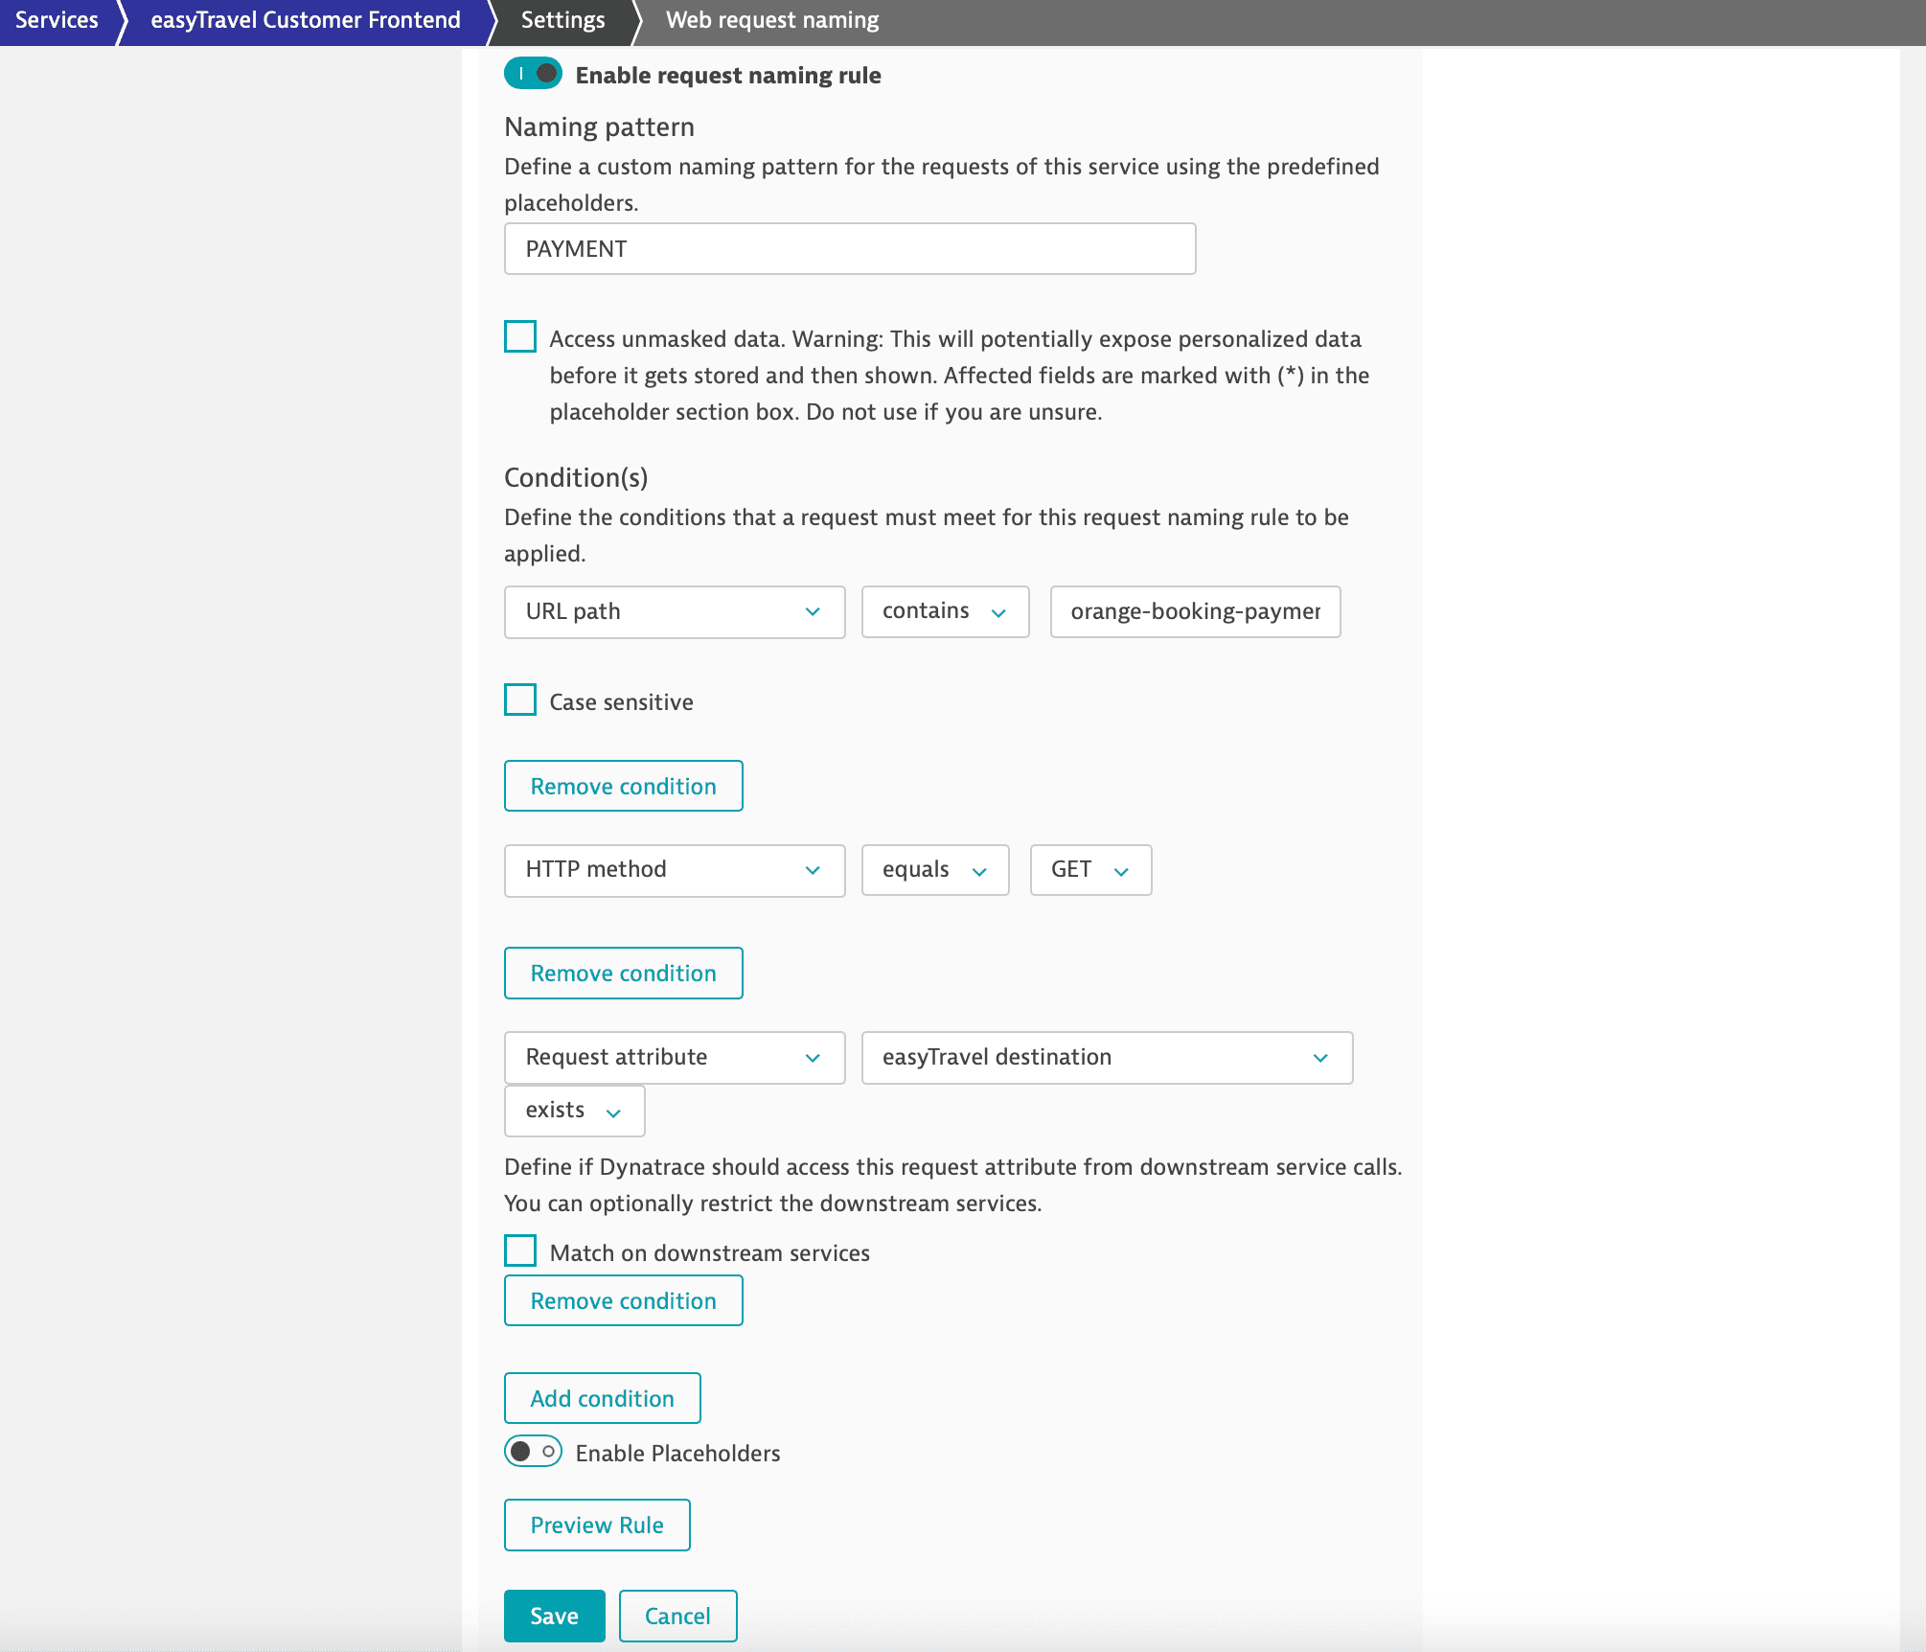

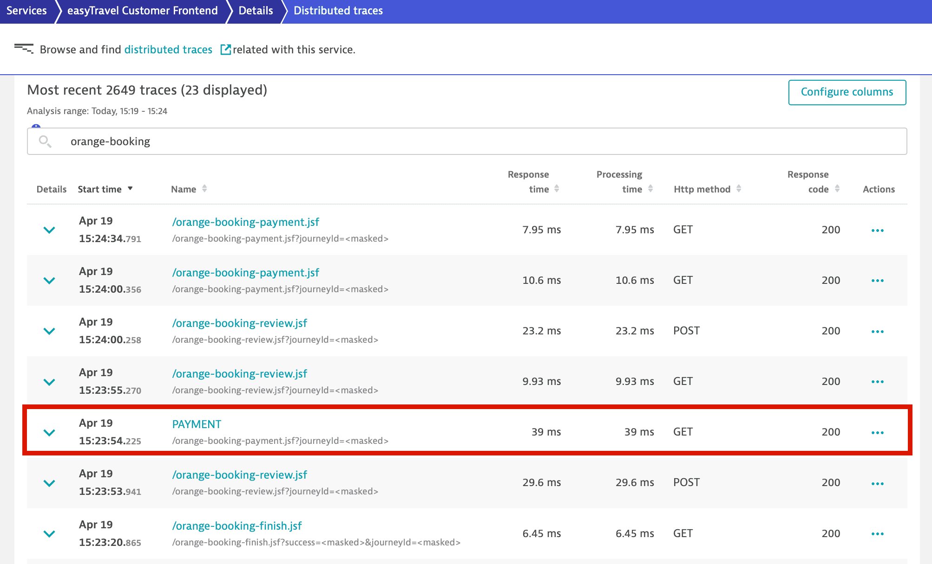

**Request Attribute**

Dynatrace tracks all requests, from end to end, and automatically monitors the services that underlie each transaction.

Define request attributes to enrich monitored requests with metadata. [Request attributes](https://dt-url.net/lb5b0pzr) are derived from captured data (Web request URLs, HTTP request headers, and other request metadata) in requests that you define.

For example, if you have a travel website that tracks the destinations of each of your customers’ bookings, you can set up a destination attribute for each service request.

**Define request attributes**

You can capture request attributes based on:

* [Web request data](https://docs.dynatrace.com/docs/observe/applications-and-microservices/services/request-attributes/capture-request-attributes-based-on-web-request-data)
* [Java, .NET, and PHP method arguments](https://docs.dynatrace.com/docs/observe/applications-and-microservices/services/request-attributes/capture-request-attributes-based-on-method-arguments)
* Any data captured with the [OneAgent SDK](https://docs.dynatrace.com/docs/ingest-from/extend-dynatrace/extend-tracing/oneagent-sdk)

**Request attribute sources for web requests**

Request attribute data sources for web requests include

* Technology-independent sources, such as:
  + HTTP POST parameters
  + [Client IP addresses](https://docs.dynatrace.com/docs/observe/digital-experience/rum-concepts/detection-of-ip-addresses-locations-and-user-agents#ip-addresses)  
    The value of the first matching header is reported.
  + HTTP request and response headers
  + Web request URL or one of its constituents, like the path or a query parameter

**Capture request attributes based on web request data**

To define a request attribute based on web request data:

1. Go to **Settings** > **Server-side service monitoring** > **Request attributes**.
2. Select the **Create new request attribute** button.
3. Provide a unique **Request attribute name**. You can rename an attribute at any point in the future.
4. Indicate **Data type**.  
   You can't change **Data type** following request attribute setup. **Request attribute rules**
5. Have a look at the example request attribute rule below. Note that the request attribute destination can obtain its value from two different sources, either an HTTP Post parameter (iceform:destination) or an HTTP GET parameter (destination). Rules are executed in order. If a request meets the criteria for both rules, its value will be taken from the first rule.
6. Each rule needs a source. In the example below, the request attribute source is a web request HTTP GET parameter (destination).

The example below is set up to only consider iceform:destination HTTP POST parameters that begin with the string Journey :. This approach will extract everything that follows the string Journey: and store it in the request attribute.

