The developed network could re-localize the robot in the given indoor environment quite effectively as seen in the graph below.
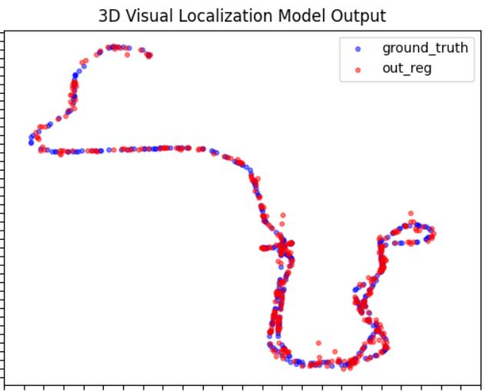

The mean absolute error/deviation was around 0.1m for x, y and the error in orientation was around 12 degrees.

