### Jury Selection

### In 2010, the ACLU presented a report on jury selection in Alameda County, California. The Report concluded that certain ethnic groups are underrepresented among jury panellists inAlameda County, and suggested some reforms of the process by which eligible jurors are assigned to panels. In this section, we will perform our own analysis of the data and examine some questions that arise as a result

### 

### ANSWER

### 

### Null Hypothesis:-panels were selected at random from the population of eligible jurors.

### 

### Alternate Hypothesis:-panels were not selected at random

### 

### A bias can be observed in the choosing panel members

### 

### Subtract the panel from the eligible panel to find the bias. The bias is such that more people are selected as eligible in the panel if they get +ve values. If there is a -ve value, the bias is such that the panel selects fewer than eligible people, and zero selects all eligible people for the panel.

### 

Total distance variation is 0.14

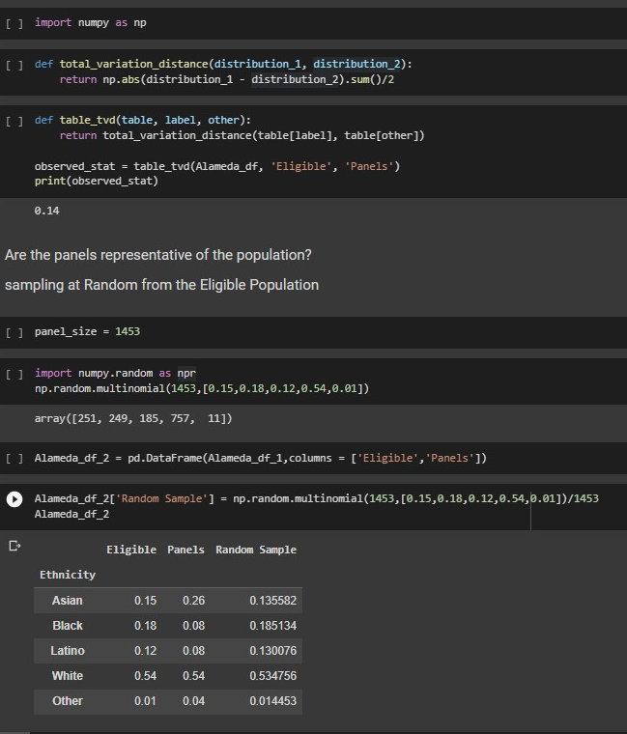

### 

### The total distance between the random sample size of 1453 and the potential jury population is different for each row of df_4.

### 

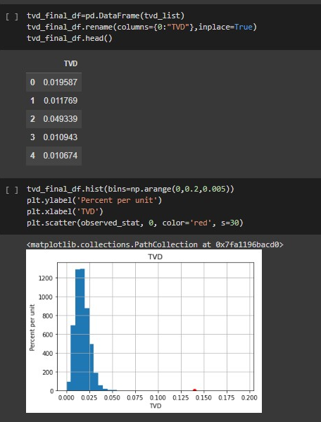

Randomly picking 1453 judges from the pool of eligible candidates, according to the above empirical histogram, the distribution of eligible judges and over 0.059085 You get distributions that do not differ. The red dots in the top histogram show that the total variation gap (0.14) between the panel and the target population is very large. The panel data are inconsistent with extrapolation of statistics by random selection models. Therefore the null hypothesis is rejected