**Objective question solutions** :

1. The file contains 2 worksheets (Raw data and Country description) and hence **2 tables** (structured datasets)
2. Number of attributes(columns) in the Raw data worksheet and Country Description worksheet is **20 and 2** respectively.
3. **Categorical columns :** either have text or fixed set of values as a value ,in the given raw data file , there are **14** categorical columns in the dataset. These are **RestaurantName, CountryCode, Country, City, Address, Locality, LocalityVerbose, Cuisines, Currency, Has_Table_booking, Has_Online_delivery, Is_delivering_now, Switch_to_order_menu,** and **Price_range**. While most of these columns clearly contain categorical data, **CountryCode** is considered categorical because it represents different countries rather than being a continuous numeric value. Similarly, **Price_range** is categorical as it classifies restaurants into predefined price categories rather than representing a continuous numerical range.

**NOTE: reference worksheet is raw data**

1. In the worksheet **Data clean up** ,have used **COUNTBLANK()** function to check the number of cells with missing values , then I have checked for columns which has **BLANK as a filed** using filter option . Found out Cuisines column with **9** cell values missing.

Have filled the missing values using based on most common cuisine of that particular country , in this case we have all missing values corresponding to country USA & most common cuisine in USA i.e **MEXICAN** ; This is accomplished using a pivot table with country filter .



**Other changes performed** :

Datekey_Opening column has been used to create a proper date format column ,month and year columns respectively.

FUNCTIONS USED :

1.VALUE(SUBSTITUTE(U2,"_","/")) & FORMAT as DATE option

2. TEXT(V2,"mmmm")

3. TEXT(V2,"yyyy")

1. Added country column(D) in the Data clean up worksheet using VLOOKUP function :

**=VLOOKUP(C2,$AA$27:$AB$42,2,0)**

1. Table to represent the number of restaurants opened in **each country** has been performed using **PIVOT TABLE** in the **tables** worksheet using the FINAL DATA FOR DASHBOARD worksheet as reference

1. Number of restaurants opened **each year** is represented in a pivot table in the Tables worksheet referring to the Final data for dashboard worksheet .

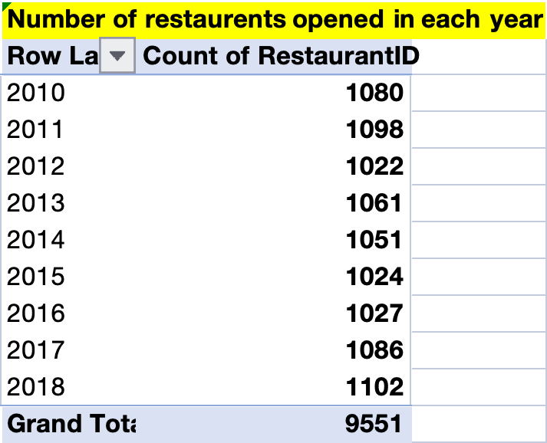

1. Total number of restaurants in India in the price range of 4 = **388**, Formula : =COUNTIFS('Final data for Dashboard '!$O:$O,"4",'Final data for Dashboard '!$D:$D,"India") , in the worksheet **TABLES ( cell I3)**



1. Average number of voters for the restaurants in each country :

Overall average of all countries is represented through grand total i.e 156.91 and respective countries average votes are adjacent to country names

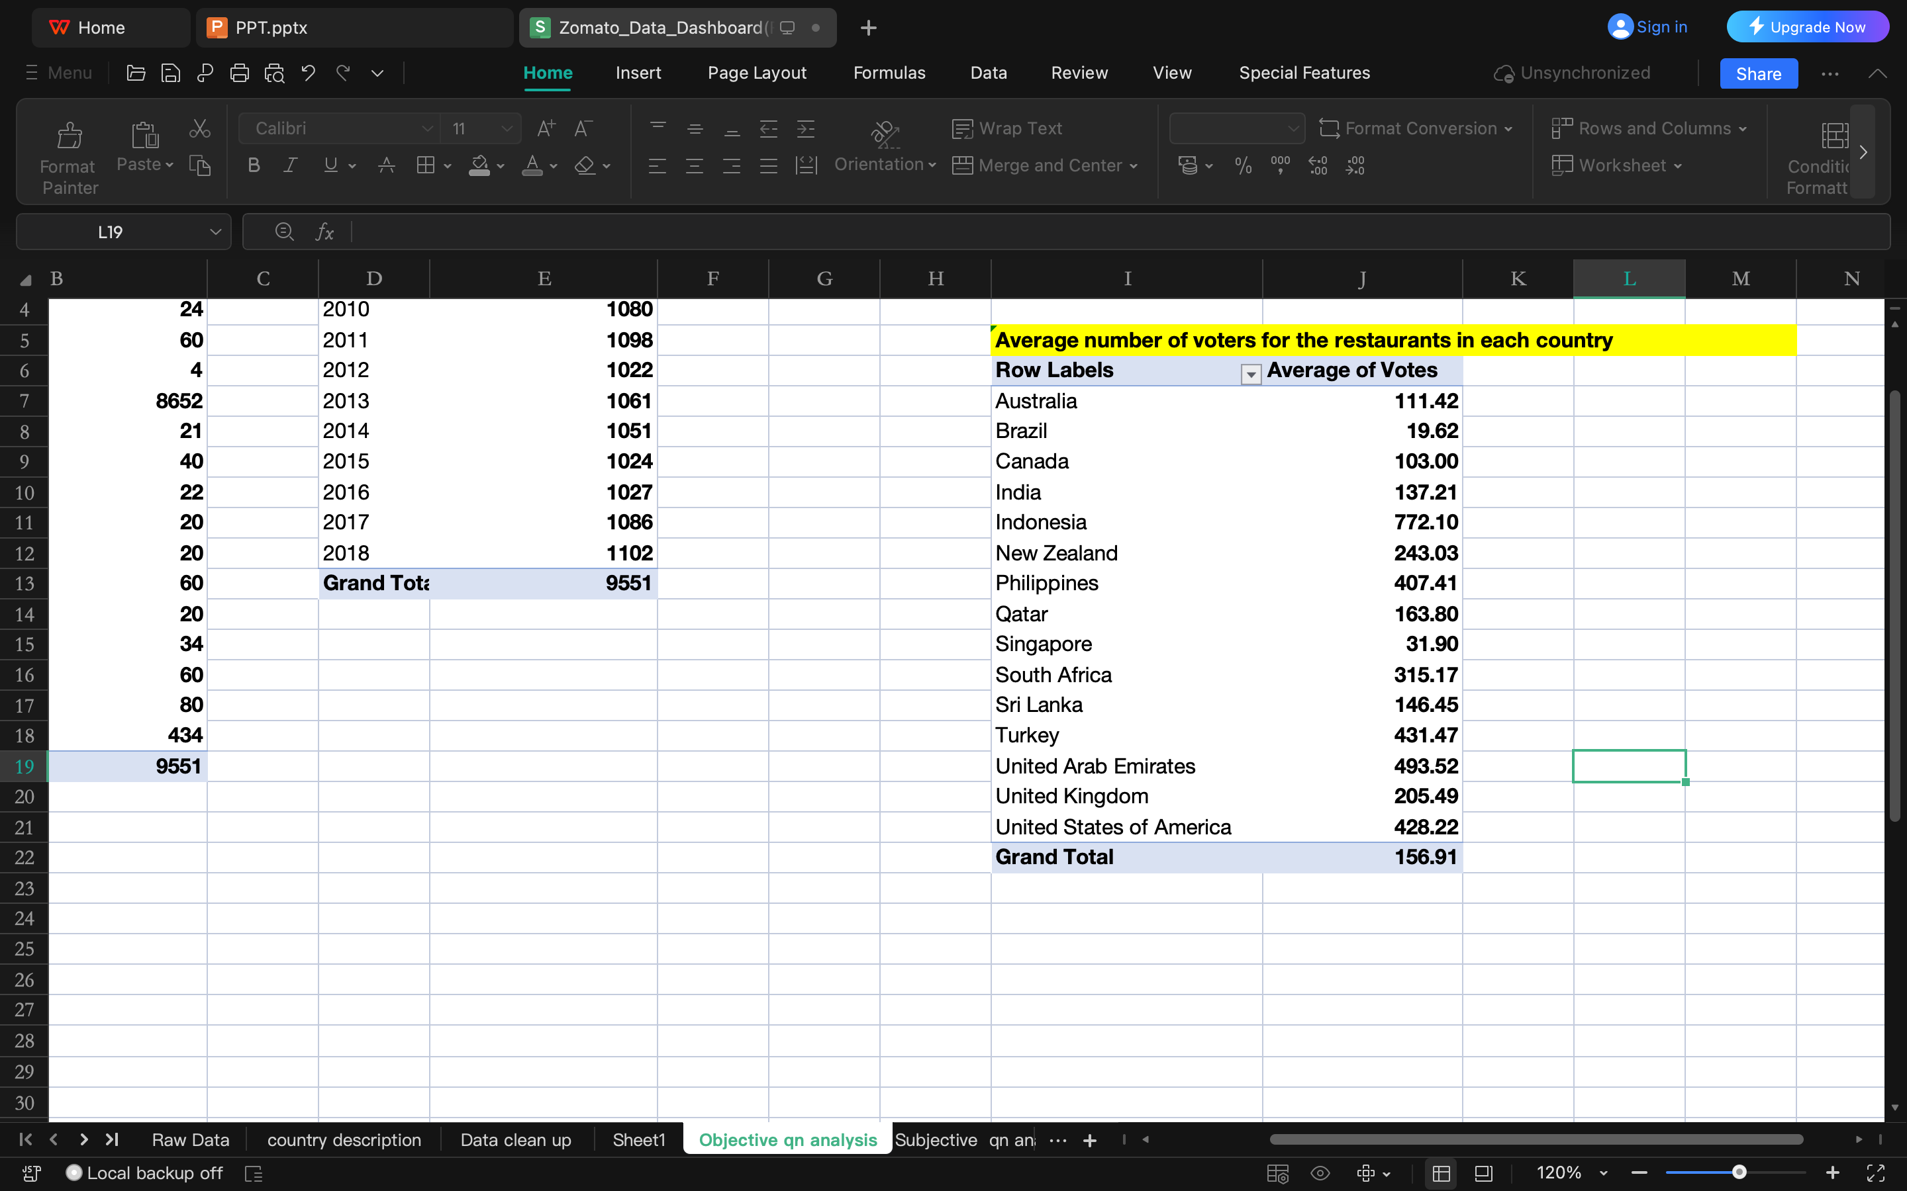

1. Average rating for all the restaurants that have price_range < 4 and provide online delivery:

**Formula used :**

**=AVERAGE(IF(('Final data for Dashboard '!$O$2:$O$9552 < 4) * ('Final data for Dashboard '!$L$2:$L$9552="Yes"), 'Final data for Dashboard '!$R$2:$R$9552))**

**Worksheet : TABLES**

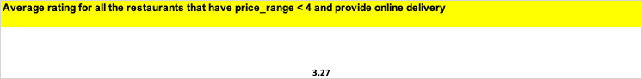

11.Conditional formatting used to highlight restaurant names based on cities and countries chosen : Using the below formula within the format rule :

=OR($G2="New Delhi", $G2="Davenport", $G2="Auckland", $G2="Birmingham", $G2="Sharjah", $G2="São Paulo", $G2="Rio de Janeiro", $G2="Brasília", $G2="Paynesville", $G2="Gurgaon", $G2="Nagpur", $G2="Noida", $G2="Faridabad", $G2="Jaipur", $G2="Pocatello", $G2="Gainesville", $G2="Mc Millan", $G2="Montville", $G2="Mayfield", $G2="Colombo")

NOTE: Cities chosen as per Subjective analysis which is included in the further page**s**

**Reference worksheet: Final data for dashboard**

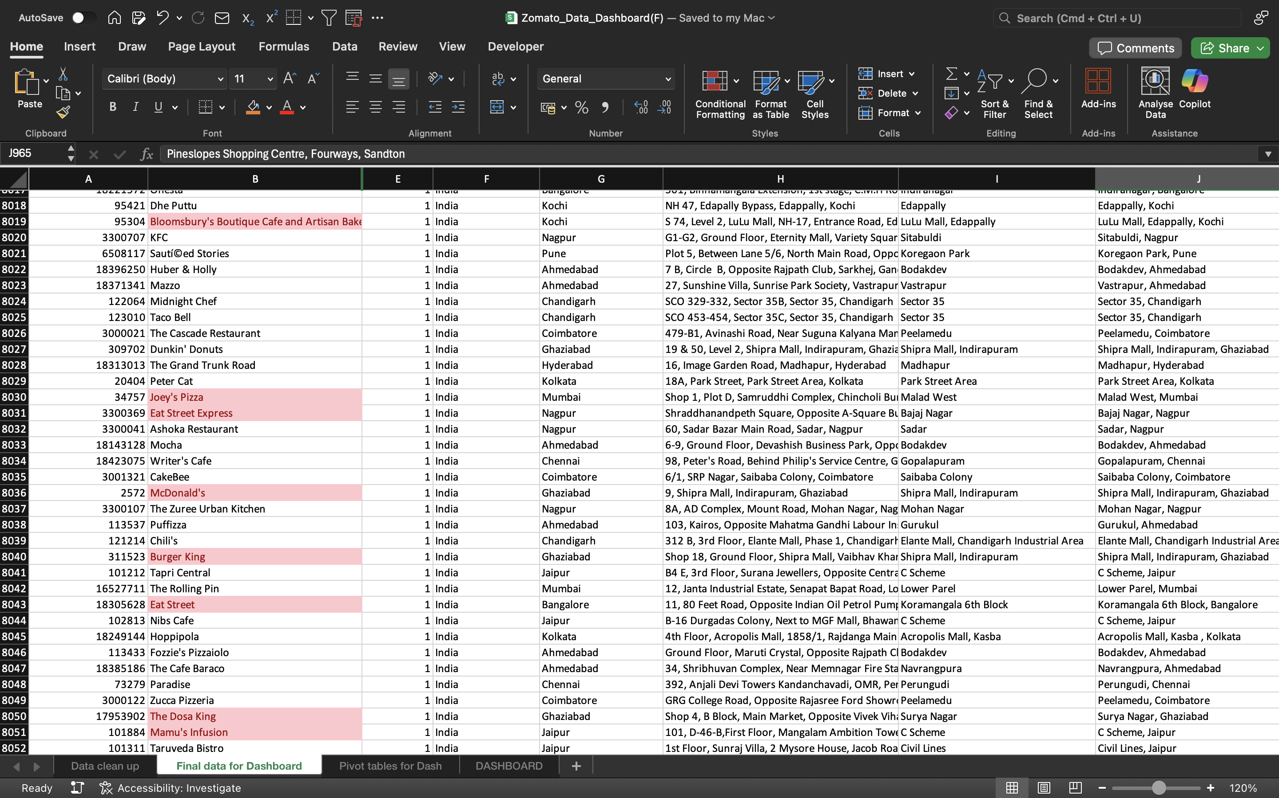

12.Customized price column: Formula used :

**=CONCATENATE(TEXTBEFORE(TEXTAFTER(J2,"("),")"),Q2)**

**Worksheet : Final data for dashboard**

13.Count of **number of restaurants** listed that **do not offer online delivery**, are in the **lowest price range(considered 1)**, and have an **average cost for two people less than or equal to** 250 Indian Rupees:

Excel :

=COUNTIFS('Final data for Dashboard '!O:O, "=1",'Final data for Dashboard '!L:L,"No",'Final data for Dashboard '!Q:Q,"<=250",'Final data for Dashboard '!J:J,"Indian Rupees(Rs.)")

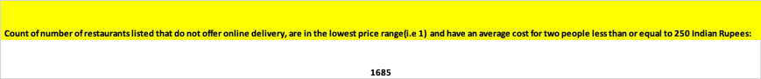

**Subjective Question solutions :**

1. **Countries where the team can open newer restaurants with lesser competition:**

* Key factors to consider are number of restaurants already set up in each country , average rating given by people for restaurants in respective countries , Average expenditure by people with respect to each country ,Number of new restaurants set up each month across various years. We can analyze this using pivot tables and column charts
* After analyzing combining these factors potential countries where we can establish new restaurants are **Australia ,Brazil ,India ,Newzealand,Qatar , Singapore , UAE, USA, UK**
* Of these countries Australia offers the best opportunity with people willing to spend more and both numbers and ratings of restaurants being lowest
* Sri Lanka will be the last choice as the amount people are willing to spend is lowest compared to other countries
* This analysis is presented in the form of column charts which also can be viewed in the dashboard by selecting rating range ( <=3 ) , Price range for two (>=3000) also can be analyzed by viewing number of restaurants in the column chart ( Country vs number of restaurants )

2.**Names of cities in the selected countries** :

* To identify names of states or cities where we can target ,its better to look beyond the countries that we have selected as per our objective analysis ,the reason being there might be cities in other countries with <5 restaurants ,poor rating (<=3),people’s willingness to spend based on conversion of different currencies to Indian rupees(>=500) ( Note : I have done the currency conversion to Indian rupees with conversion factor to facilitate uniformity in decision making )
* With this approach we will create a pivot table with cities , count of restaurants , average rating and expenditure criteria to finalize our main target cities.
* They are as follows :
* **Australia ( Mayfield , Montville , Paynesville ) , Brazil (Brasilia, Rio De Janeiro , Silo Paulo),India ( Faridabad , Ghaziabad , Gurgaon, Jaipur, Nagpur , New Delhi , Noida),New Zealand(Auckland),Sri Lanka (Colombo),UAE(Sharjah), UK(Birmingham) , USA(Davenport , Gainesville , Mc Millan , Pocatello )**
* Example considering Australia , rating <=3 , expenditure>=500 gives us 3 output cities .

3.**Current quality regarding ratings for restaurants that are open in the countries or cities that we have chosen** :

* Average ratings of restaurants in the list of selected countries can be analyzed with the help of a pivot table, chart and a slicer for rating
* We cannot consider rating alone as a standalone factor because number of restaurants will also play a key role with ratings but still these values add validate our findings
* **Among the countries of our choice , Newzealand , UK , USA , UAE have best ratings .So we can start off with our new restaurants beginning with these countries considering other factors alongside** .

4.**Current expenditure on food in the suggested countries:**

* Average expenditure by people based on our selected countries (image)
* Clearly **Singapore, Qatar , UK , UAE** offer best opportunity in terms of people willing to spend thus making these countries a better choice over others .Again, considering this as a standalone factor by ignoring number of restaurants is not the best decision but truly adds value

5.**Names of restaurants from the recommended cities that are our biggest competitors and also those that are rated in the lower brackets, i.e. 1-2 or 2-3**

* Biggest competitor restaurants can be analyzed considering restaurants with >=5 outlets, expenditure per two <=500(affordable) & with a rating >=3 respectively
* Whereas the lower ranked restaurants can simply be analyzed considering poor ratings(<3) and highly priced(>=1000) for two people and less than 5 restaurants.
* We can analyze this using a pivot table with the count of restaurants beside the restaurant name adding filters to select the rating ,expenditure per two , specific cities which we are looking for as per our earlier analysis .
* **High competitors**: Cafe Coffee Day, Green Chick Chop, Keventers, Giani, Giani's, Chaayos, Baskin Robbins, Twenty Four Seven, Cocoberry, Gopala, Frontier, Burger Point, RollsKing, 34 Chowringhee Lane, Angels in my Kitchen, Tibb's Frankie, Republic of Chicken, BTW, Wow! Momo, Pudding & Pie, Nirula's Ice Cream, L'Opera, Mad Over Donuts, and Goli Vada Pav No. 1
* **Lowest rated :** Jade Garden, K2 Multi Cuisine Restaurant, 9 Mars Lounge, 4 on 44 Restaurant & Bar, Admission Lounge, Kayasth Cuisine, Alcoholic Lounge & Bar, Lattitude - Skycity Hotel, Amber, Le Chef Restro Bar, Anchor Bar & Kitchen, London Eye - The Open Lounge, Aqua Grill - Pride Plaza Hotel, Lord's - The Sports Lounge, Asia 21, Los Agaves, Attitude Kitchen & Bar, Malt n Brew, Barichi, Manami Japanese Restaurant, Basil Tree, Metro Bar & Family Restaurant, By The Way - Bellagio, Mini Mahal Delux, Cheenos, Mirage Restro Bar, Chez Jerome - Q Cafe, Moets Curry Pot, Chidya Ghar - Roseate House, Mosaic - SK Premium Park, Citron - Hotel Haut.Monde, Moti Mahal Deluxe Advant, Clove - The Galgotias, My Bar Lounge & Restaurant, Club Mojo, My Bar Square, Club Tokyo - Best Western Skycity Hotel, My Love Restaurant & Bar, Coffee Shop - Centaur Hotel, Nando's, Copper Restro Bar, Nile Restro & Bar, Crazy Noodles, Nosh Mahal, Curry Capital - Hotel Classic Diplomat, Not Just Paranthas, D'Casa, NSD Resto Bar & Kitchen, Dawat Khana, Opium Bar - Hotel City Park, Deli Belly, Orchid - Fortune Select Global, Divino Fogí£o, Pepe's Piri Piri, Empress, Pier 70, F Marquee, Playboy Club, Flaming Wok, Poets Cafe, Gardenia - Hotel Grenville, Power Play Resto Bar, Gravity, Princess Garden, Hang Out, Qash Retro Bar, Ikko, Quiosque Chopp Brahma, Ion Club & Dining Lounge, R1 Lounge, Aces - The Card Room, Roasted - Roseate, Alpha 63, Rocking Woods, Angaar, RPM, ATM Bistro, RPM - Zanzi Bar, Barichi Restaurant, RSVP, Cafe Cruise, Shi Cafe, Chicane, Shooters Lounge and Bar, Citrus Cafe - Lemon Tree Hotel, Silver, Club Prison, Sky Beach, Coffee to Cocktail Bar - Hyatt Place, Spice Court, Cuisine, Spice It - Hotel IBIS, Damascena Coffee House, Star Buffet, Dilli Darbar, Suburbia - The Empire, Eywa by Saby @ Celeste, Taste of India, Frick's Tap, TcozY, Great Wall, The Atrium - By Jukaso It Suites, Illusion The Lounge Bar - Hotel Clark Inn Gurgaon, The Beer Cafe, Airborne, The Blue Tandoor, Armory - Hotel Haut.Monde, The Bridge - Hotel Clark Inn Gurgaon, Bromfy Public House, The Butler & The Chef - Jaypee Greens, Cinch, The Caspian, Coffee Shop, The Cavalry Bar - Maidens Hotel, Curzon - The Royal Bar, The Hangout-Deli, Elements - Mapple Express, The Retriever, Go Kylin, The Wine Company, Zune - Piccadily Hotel, The Yellow Chilli, August Moon, Troll Tavern, Club Ice Cube, Typsy Crow, De Fontein Belgian Beer Cafe, Upper Deck, High Street Kitchen & Bar, Urban Degchi Kitchen & Bar, Cheers Lounge Bar, Viceroy - The Coffee Shop, Filmy Cafe & Bar, Vivino - Hotel Golf View, Courtyard Grill - Courtyard by Marriott, White Heart Restro Bar, Ambrosia - The Golden Palms Hotel, Yu Turn, Karim's, Americana Kitchen and Bar, Chawla's 2, Nirula's, Chutneez Restaurant Lounge & Bar, The Golden Dragon, Moti Mahal Delux Tandoori Trail, Yo! China, Captain Bill$ Deliverz, Moti Mahal Delux.

**High competitors**:

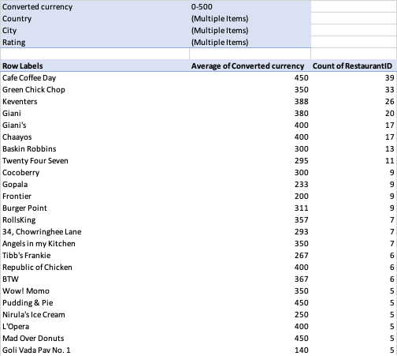

Lowest rated

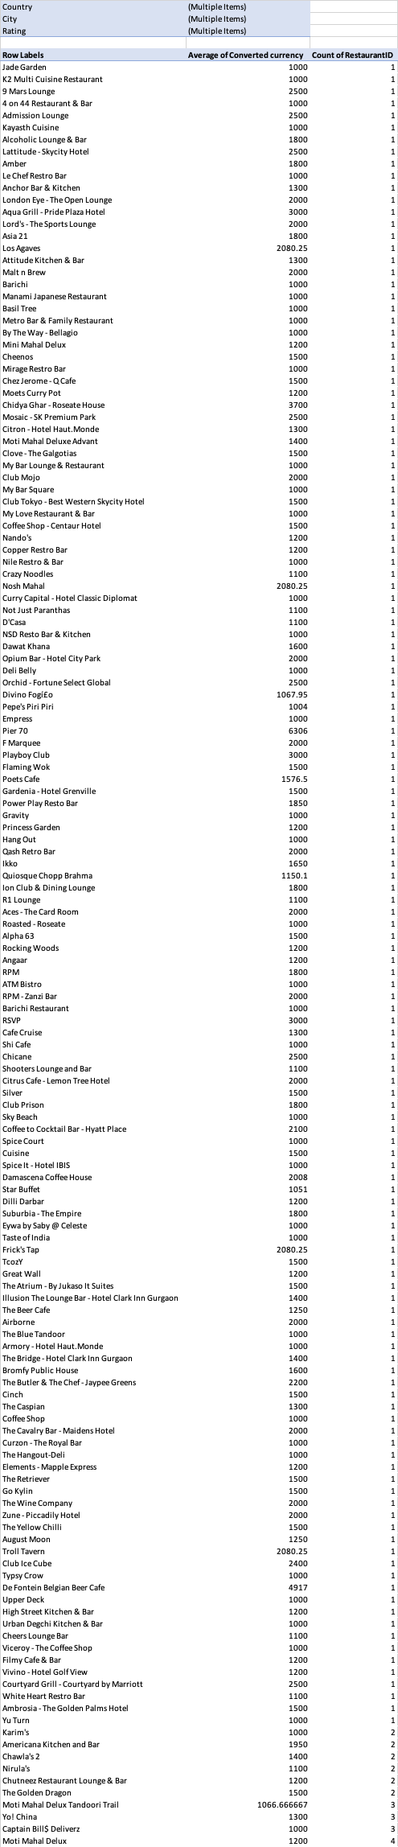

6.**Cuisines to focus on in the newer restaurants to get better feedback :**

* By the analysis we can clearly see that the choice of cuisines also had an impact on the ratings of restaurants , in the cities where we have planned to set up our new restaurants we need to focus on the following cuisines to attract customers. Hence analyzed as per cuisines average rating >=4 ), filtering the cities that we have identified , expenditure per two (<=2000) affordable.
* The following cuisines should be the target group: **Australia,USA, Brazil ( Sandwich , Seafood , Kajun ) ,India ( North Indian , mediterranean ,Mexican , healthy food ),UK(Latin American) , UAE(Indian , north Indian ) ,Newzealand ( Desserts ) , Brazil ( Beverages ) , Sri Lanka ( Sea food )**
* **Example : UAE A screenshot of a computer

  AI-generated content may be incorrect.**

7.**Impact of online delivery and table options on ratings :**

* Choice of online delivery and table booking matters while setting up new restaurants and the analysis clearly says **having both online delivery and table booking helped improve ratings significantly** as seen here in both Pie charts and pivot table images ( illustrating there is scope for extension of these services to have a positive impact on rating )

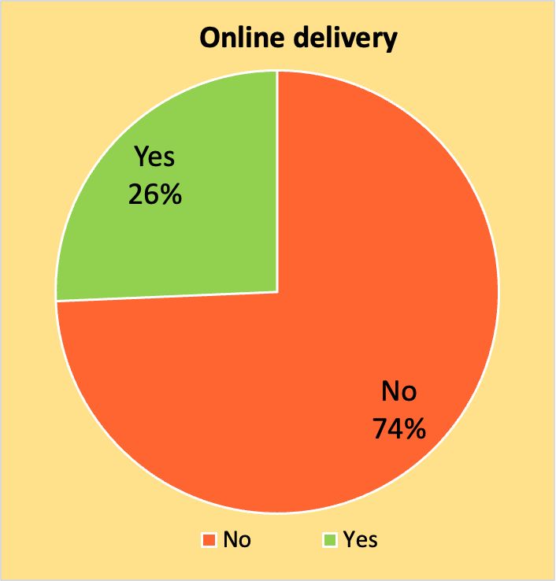 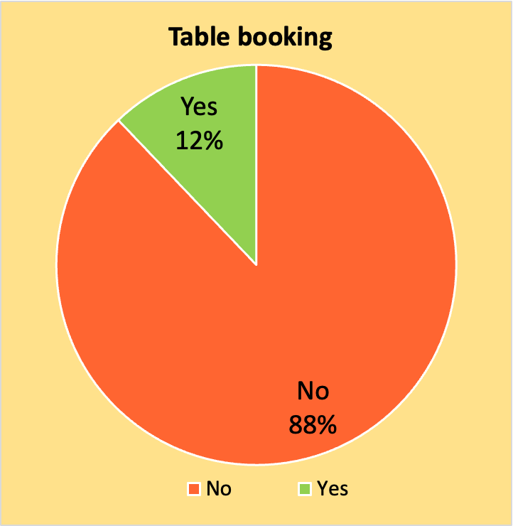

8**.Rate of cuisines and its correlation with ratings :**

* Correlation between price and ratings of restaurants can be analyzed for the shortlisted cities as per our analysis in the previous slides.
* In the image below , we can clearly see that for the cities of our choice the price range between 1000-2000 and 2000-3000 have a significant sample space of >1000 restaurants compared to all other ranges .
* Thus, the pricing should be in the range of **1000-3000** in the new restaurants in the selected cities.



**This computation using CORREL() function clearly shows that the correlation between cuisines prices and ratings is not very significant but still has an impact , with the value nearing 0.**

NOTE : value of 1 signifies absolute direct relation , 0 – inverse relation .

**Further analysis : to decide on the price range we need to focus on in our new restaurants that will be established.**

|  |  |  |
| --- | --- | --- |
| **Country** | **(Multiple Items)** |  |
| **City** | **(Multiple Items)** |  |
| **YEAR** | **(All)** |  |
|  |  |  |
| **Row Labels** | **Average of Rating** | **Count of RestaurantID** |
| **0-1000** | **2.55** | **6622** |
| **1000-2000** | **3.51** | **858** |
| **2000-3000** | **3.57** | **240** |
| **3000-4000** | **3.65** | **77** |
| **4000-5000** | **3.99** | **43** |
| **5000-6000** | **3.86** | **21** |
| **6000-7000** | **3.80** | **8** |
| **7000-8000** | **4.10** | **1** |
| **8000-9000** | **4.05** | **2** |
| **9000-10000** | **4.70** | **1** |
| **>10000** | **4.50** | **1** |
| **Grand Total** | **2.71** | **7874** |

9. **Distribution of the number of restaurants of different price ranges in all the countries:**

* To analyze this, we will need a pivot column chart :
* Considering price ranges **1,2,3,4 as budget , moderate , expensive , luxury**
* Here we can clearly notice that the number of restaurants are high for India and **USA , price range of 4 ( highest ) dominates in Brazil , Sri Lanka , Qatar , South Africa which clearly tells us that the LUXURY category is dominating in these countries whereas other countries have a price range of moderate to expensive in dominance**

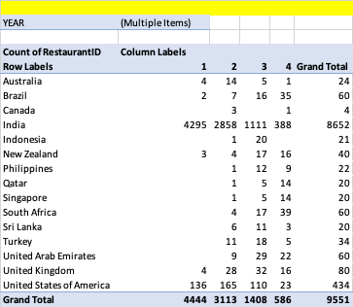

10.**Approach without Objective and Subjective questions being provided :**

* The core objective of this analysis is to identify the most viable countries and cities for setting up new restaurants. To achieve this, the approach is structured around three key questions:
* Why? To maximize profitability and enhance market reach by strategically expanding into high-potential locations.
* Where? Selection is based on multiple critical factors, including customer ratings, expenditure patterns, price range distribution, and competition intensity at the city level.
* How? By optimizing the business model through highly profitable cuisines, enabling online delivery and table booking, and maintaining an affordable yet sustainable pricing strategy (expenditure per two in Indian Rupees).
* Data-backed insights:

1. Market Entry Strategy

* Target Countries for Expansion:
* High potential markets: Australia, Canada, Indonesia, Philippines, Qatar, Singapore
* Best opportunity: Australia (high spending, low competition)
* Last choice: Sri Lanka (lowest spending behaviour)
* Target Cities within Selected Countries:
* Australia: Mayfield, Montville, Paynesville
* Brazil: Brasília, Rio de Janeiro, São Paulo
* India: Faridabad, Ghaziabad, Gurgaon, Jaipur, Nagpur, New Delhi, Noida
* New Zealand: Auckland
* Sri Lanka: Colombo
* UAE: Sharjah
* UK: Birmingham
* USA: Davenport, Gainesville, Mc Millan, Pocatello

2.Competitive Positioning

Low-Competition Cities

* Target cities with less than 5 restaurants & poor ratings (≤3)
* Focus on expenditure for two ≥ INR 2000 after currency conversion( expensive )

Competitive Threats & Differentiation

* **High competitors**: Cafe Coffee Day, Green Chick Chop, Keventers, Giani, Giani's, Chaayos, Baskin Robbins, Twenty Four Seven, Cocoberry, Gopala, Frontier, Burger Point, RollsKing, 34 Chowringhee Lane, Angels in my Kitchen, Tibb's Frankie, Republic of Chicken, BTW, Wow! Momo, Pudding & Pie, Nirula's Ice Cream, L'Opera, Mad Over Donuts, and Goli Vada Pav No. 1
* **Lowest rated:** Jade Garden, K2 Multi Cuisine Restaurant, 9 Mars Lounge, 4 on 44 Restaurant & Bar, Admission Lounge, Kayasth Cuisine, Alcoholic Lounge & Bar, Lattitude - Skycity Hotel etc
* How to stand out?
  + Improve customer service & hygiene
  + Focus on price-value balance
  + Introduce unique cuisines

3. Pricing & Consumer Behaviour

Pricing Strategy:

* Ideal price range for new restaurants: INR 1000-3000 for two people
* Most successful restaurants are within this pricing bracket

Cuisines to Focus On (Based on Ratings & Preferences):

* Australia, USA, Brazil: Sandwiches, Seafood, Cajun
* India: North Indian, Mediterranean, Mexican, Healthy food
* UK: Latin American
* UAE: Indian, North Indian
* New Zealand: Desserts
* Sri Lanka: Seafood

4. Service Model & Customer Experience

Must-Have Features for Higher Ratings:

* + Both Online Delivery and Table Booking

Improves ratings and customer satisfaction

Fast Service & Customization Options

* + Faster service drives repeat customers
  + Customization (e.g., spice levels, portion sizes) increases loyalty

Marketing Strategies:

* Localized Promotions: Target specific cities with influencer marketing and partnerships.
* Digital-First Approach: Optimize Zomato application with updates.
* Loyalty Programs: Discounts & memberships for repeat customers.

5. Expansion Risks & Mitigation

Challenges & How to Overcome Them:

* High Competition in Some Markets → Offer unique cuisine & premium service
* Changing Consumer Behaviour → Data-driven decisions, trend tracking
* Regulatory & Operational Challenges → Local partnerships for smoother entry

By integrating this framework, I have successfully identified specific target cities and countries, optimal cuisine offerings, ideal pricing ranges, and the necessity of key service features like online delivery and table booking. With these data-backed insights, we can confidently proceed with restaurant expansion, ensuring a competitive edge and market success