Table of Contents

Ephemeral Cloud & Kubernetes Resource Risk Detection
Technical Report — Hackathon Submission Track: Cloud Security Governance & Risk
🔗 Live demo: https://sentinel-rho-sooty.vercel.app/app · 📹 Demo video: add link · Repository: add GitHub URL

A legitimate autoscaler burst and a crypto-mining hijack are statistically identical at the event level — same API calls, same burst rate. The signal that separates them isn’t in the event, it’s in the context. So we detect on context, not events.

1. The Problem
Modern cloud and Kubernetes infrastructure runs on ephemeral resources — CI/CD job pods, spot instances, assumed-role sessions, and autoscaled containers that live for minutes and then vanish. Traditional security controls were built for a world of stable, long-lived assets, and they break on every assumption ephemerality violates:
Traditional assumption | Ephemeral reality
Assets are stable; inventory can be synced daily | Assets exist for minutes; a daily sync never sees them
Each alert maps to a durable resource to investigate | The resource is gone before triage; no forensic evidence remains
Identities are long-lived and can be baselined | Sessions have 15-minute TTLs; there is no stable identity to baseline
Alert volume is manageable | Autoscaling and CI/CD generate thousands of near-identical events

1.1 The four canonical incidents (concrete business impact)
- Crypto-mining via a compromised CI/CD account — 20 spot VMs spun up at 3 AM, terminated before the SOC shift began. Cost: ~$14,000 in 90 minutes; zero alerts fired. Demands off-hours + novelty + cohort-deviation detection, and detection latency shorter than the resource lifetime.
- Debug pod with NodePort exposed to 0.0.0.0/0 — ran 11 minutes, exploited by an external scanner, and died before any scan could catch it. Demands exposure scoring that distinguishes a load balancer (public IP is normal) from a debug pod (public IP is dangerous).
- Assumed-role session reads PII from S3 — the session expired in 15 minutes and was never correlated to the compromised Lambda that triggered it. Demands cross-source graph correlation linking Lambda → session → S3 access.
- Autoscaler burst of 40 pods — 40 false-positive alerts buried one real credential-abuse alert. Demands correlation that collapses 40 alerts into 1 incident, plus suppression of cohort-normal bursts.

2. Why This Is Hard — The Confusability Thesis
Every hard case in this problem is a pair of look-alikes the system must separate:
- 40 pods in 2 minutes → HPA autoscale or resource hijacking?
- Spot VM with a public IP and no tags → misconfigured CI job or attacker staging?
- Assumed-role session hits S3 at 3 AM → scheduled Lambda or compromised credential?
- Privileged debug pod runs 5 minutes → developer troubleshooting or container escape?
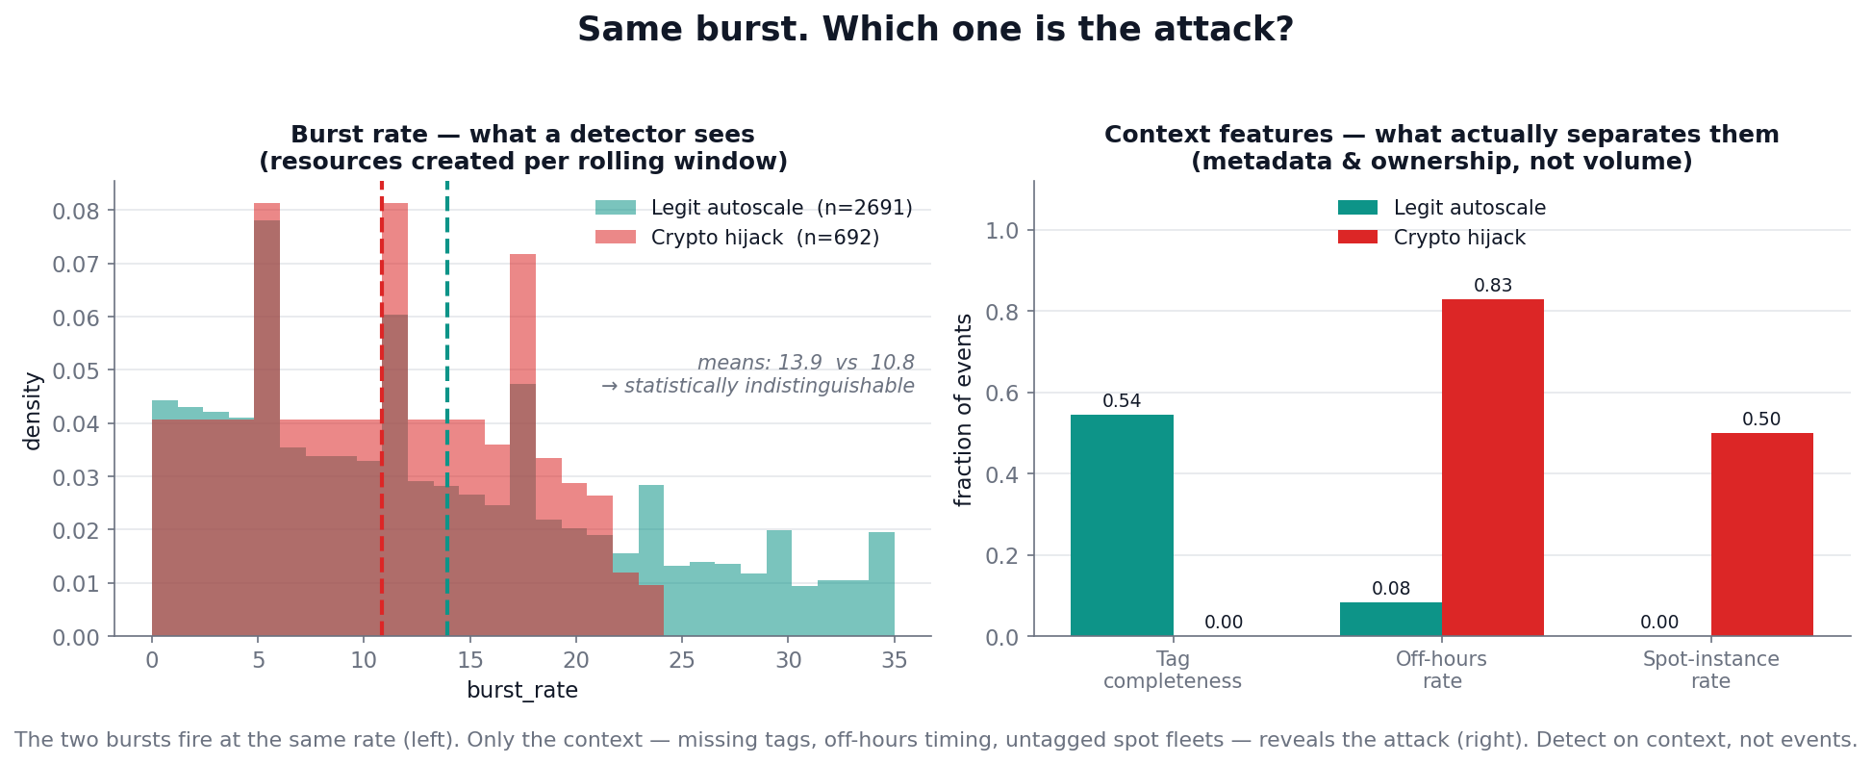
Same burst — which is the attack?
The figure above shows two real populations from our generated data: a legitimate autoscaler burst and a crypto-mining hijack. They fire at the same rate (left — the burst_rate distributions sit directly on top of each other, mean 10.8 vs 13.9). The only thing that separates them is context (right): tag completeness (0.00 vs 0.54), off-hours timing (0.83 vs 0.08), and untagged spot fleets (0.50 vs 0.00).
This is the design discipline most submissions skip. It is trivial to make malicious bursts bigger or faster than benign ones — that makes the metrics look great and proves nothing, because it makes the noise-reduction problem disappear. Our simulator deliberately refuses that shortcut: every malicious scenario ships a volume- and timing-matched benign twin, differing only in metadata completeness and ownership. Any system that detects on event volume alone fails on exactly the ambiguous cases this project exists to solve.
The confusability figure above is the three-feature teaser for one scenario pair. The same effect holds across all eight context features and the entire dataset (8,147 benign vs 1,710 risky events):
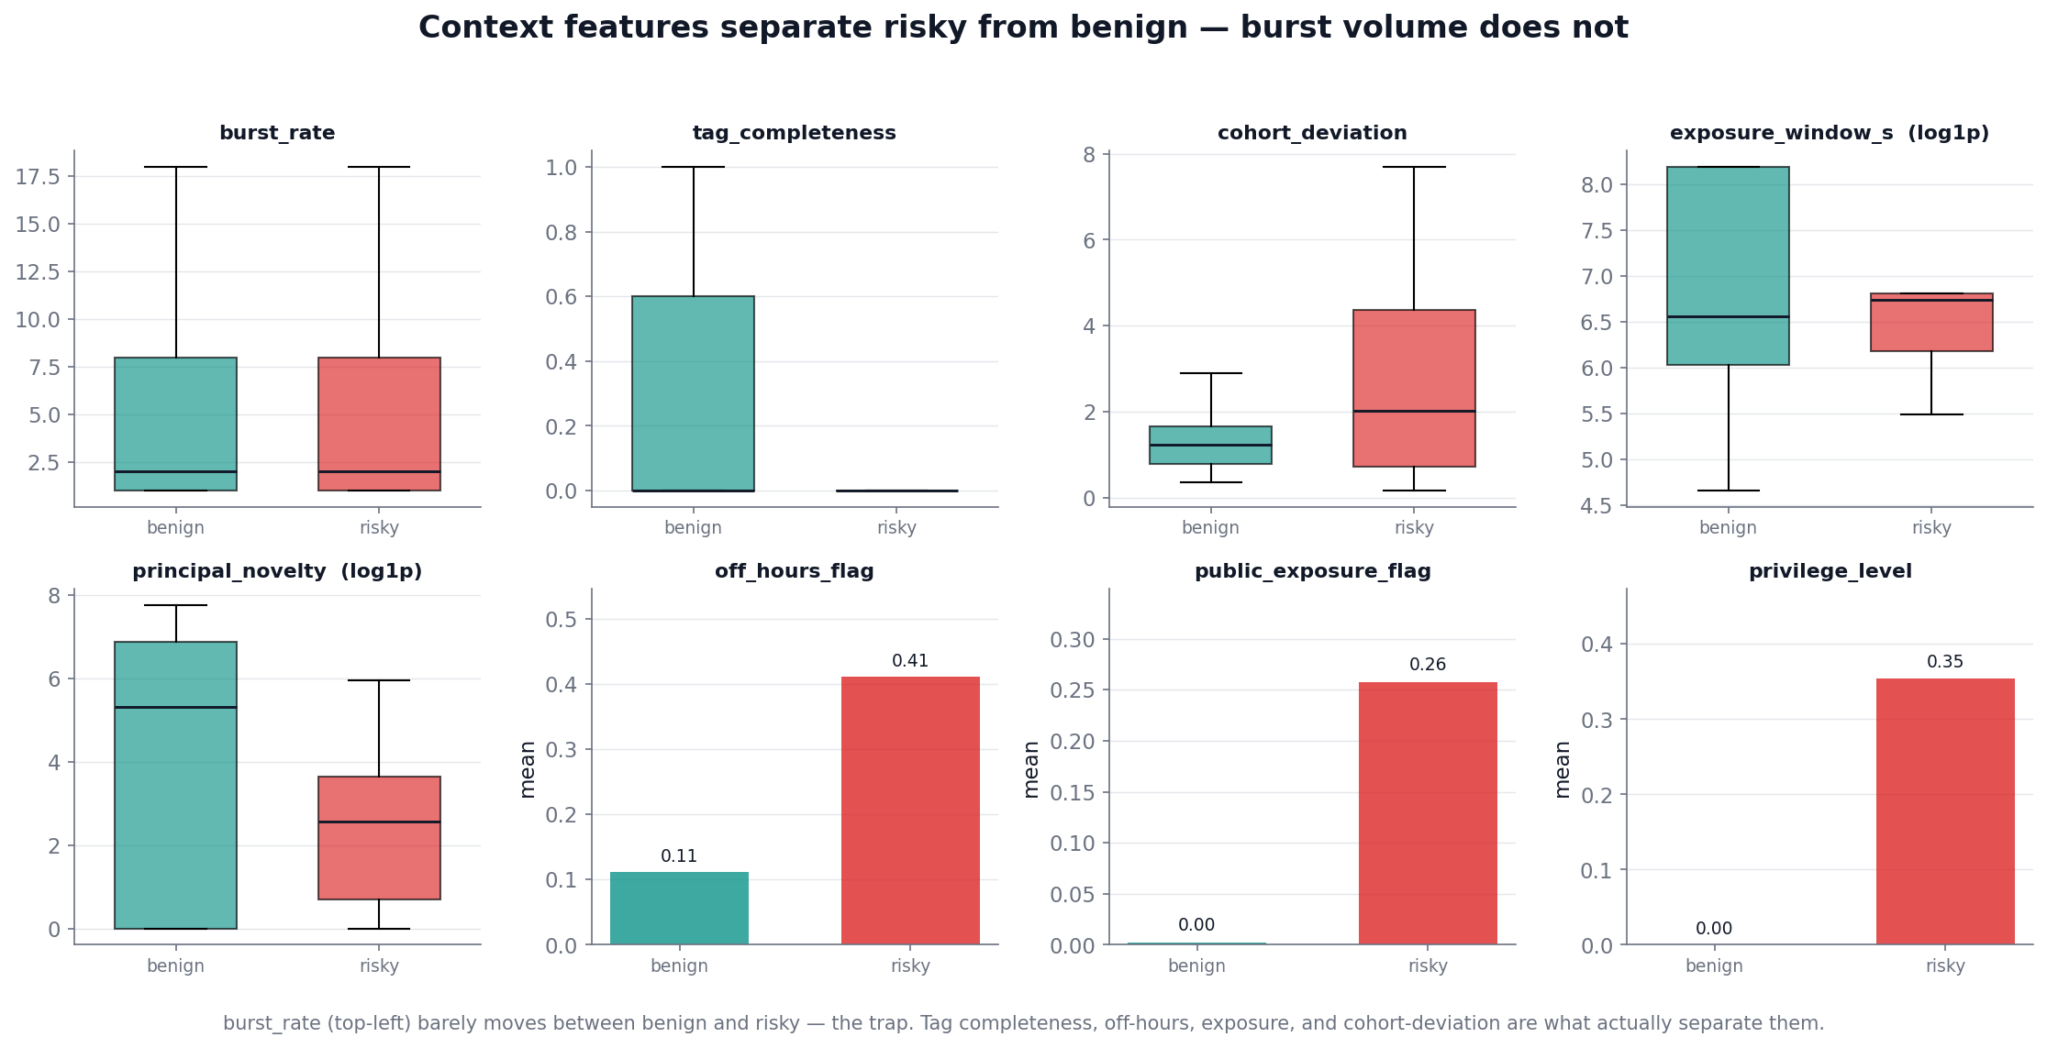
Context features separate risky from benign; burst volume does not
burst_rate (top-left) barely moves between benign and risky — that’s the trap a volume detector falls into. Tag completeness, off-hours timing, exposure window, and cohort-deviation are what actually carry the separation.
The conclusion that drives every design decision: detect on context, not events.

3. Architecture
The pipeline follows the brief’s prescribed order literally: ingest → enrich → detect → cluster → score → LLM narrative → dashboard.
flowchart TD
CT[Cloud audit<br/>CloudTrail]:::src --> S1
K8[K8s audit<br/>audit.k8s.io]:::src --> S1
IDP[Identity / session<br/>IdP]:::src --> S1
S1[1 · Ingest + enrich<br/><small>unified schema · behavioral cohorts · context features</small>] --> S2
S2[2 · Detect<br/><small>tripwires + recall-first anomaly ensemble (IF + ECOD) + cohort suppression</small>] --> S3
S3[3 · Cluster<br/><small>NetworkX entity graph · incidents = connected components (id + ns + time)</small>] --> S4
S4[4 · Score<br/><small>fused, isotonic-calibrated risk — at the INCIDENT level, AFTER clustering</small>] --> S5
S5[5 · LLM triage<br/><small>validated structured JSON: intent · confidence · MITRE · guardrails</small>] --> S6
S6[6 · Dashboard<br/><small>React SOC console fed by static JSON — offline, demo needs no network</small>]
classDef src fill:#f3f4f6,stroke:#111827;
(For PDF/PPT renderers without Mermaid support, the same diagram is committed as figures/architecture.png.)
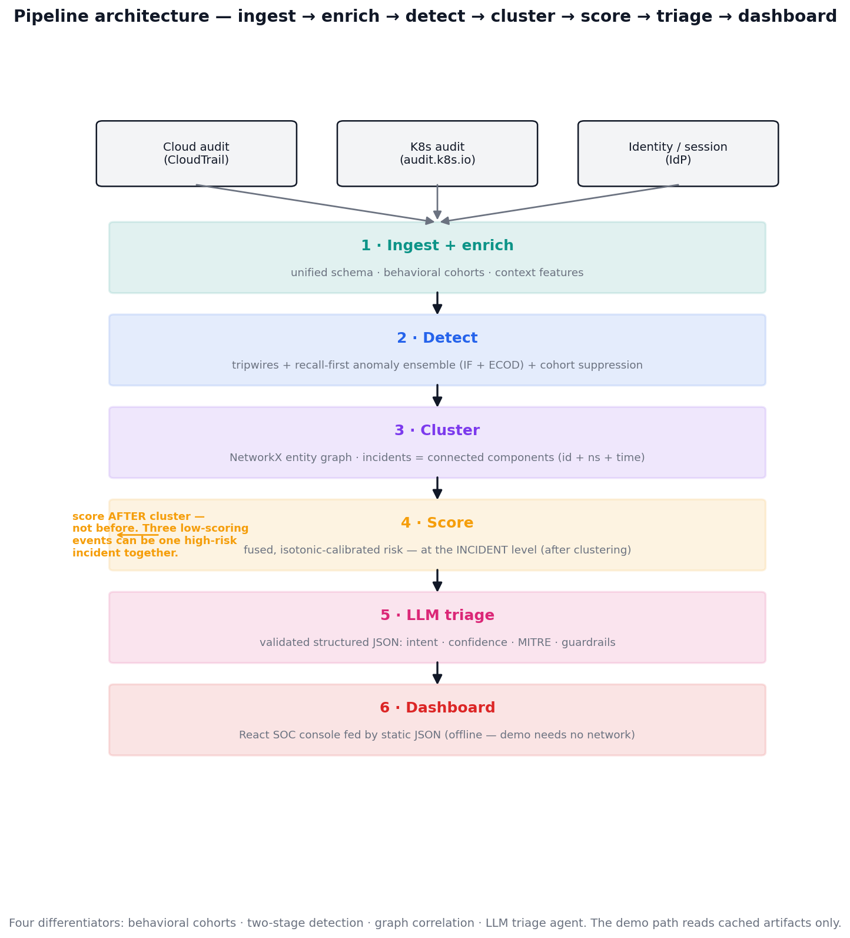
Pipeline architecture

The four differentiators
- Behavioral cohorts replace per-identity baselines. Ephemeral identities have no stable history, so we cluster principals into cohorts (ci_runner, hpa_autoscaler, human_dev, scheduled_lambda) and baseline the cohort. A brand-new pod inherits its cohort’s baseline instantly — converting the brief’s stated blocker (“no stable identity to baseline”) into the solution’s strongest signal.
- Two-stage detection separates recall from precision. Stage 1 is a recall-first anomaly ensemble (Isolation Forest + ECOD) where over-flagging is expected and acceptable. Stage 2 suppresses candidates that are normal for their cohort. This is how high recall and meaningful alert reduction are achieved simultaneously instead of being traded against each other.
- Graph correlation surfaces campaigns time-windowing cannot. A NetworkX graph with time-gated, typed edges links related events across all three sources. This is what collapses 40 autoscaler alerts into 1 incident and recovers the Lambda → assumed-role session → S3 chain that occurs over minutes and across log boundaries.
- The LLM is a triage agent, not a prose generator. It returns validated structured JSON (intent, confidence, MITRE techniques, guardrails) under a strict schema with retry and a templated fallback. Responses are cached so the live demo never depends on a network call.

The critical ordering catch — score after clustering
Three individually low-scoring events from the same principal in the same five-minute window can be one high-severity incident together. Per-event scoring before clustering misses that. Risk scoring therefore happens at the incident level, after correlation — never before.

4. How Each Stage Works
Stage 0 — Data simulation. Generates three labeled, synthetic log streams (CloudTrail, audit.k8s.io, Okta-style IdP — 9,857 events over a 5-day span, fixed seed 1337). Built ground-truth-first: the real incident structure is constructed first, then every record and label is derived from it. Each row carries is_risky, scenario_type, cohort, and campaign_id (shared across all events of one attack, across all three sources). Schemas are grounded field-by-field in real AWS / Kubernetes / Okta record formats. A 16-check validator gates the dataset.
Stage 1 — Ingest + enrich. Normalizes all three sources into one unified schema, assigns behavioral cohorts via deterministic rules (K8s service-account → CloudTrail role → IdP email prefix → source-IP CIDR), and computes the eight context features (burst rate, novelty, tag completeness, privilege, exposure, off-hours, cohort deviation). Principals matching no known cohort become unknown — itself a signal, not silently forced into the wrong baseline.
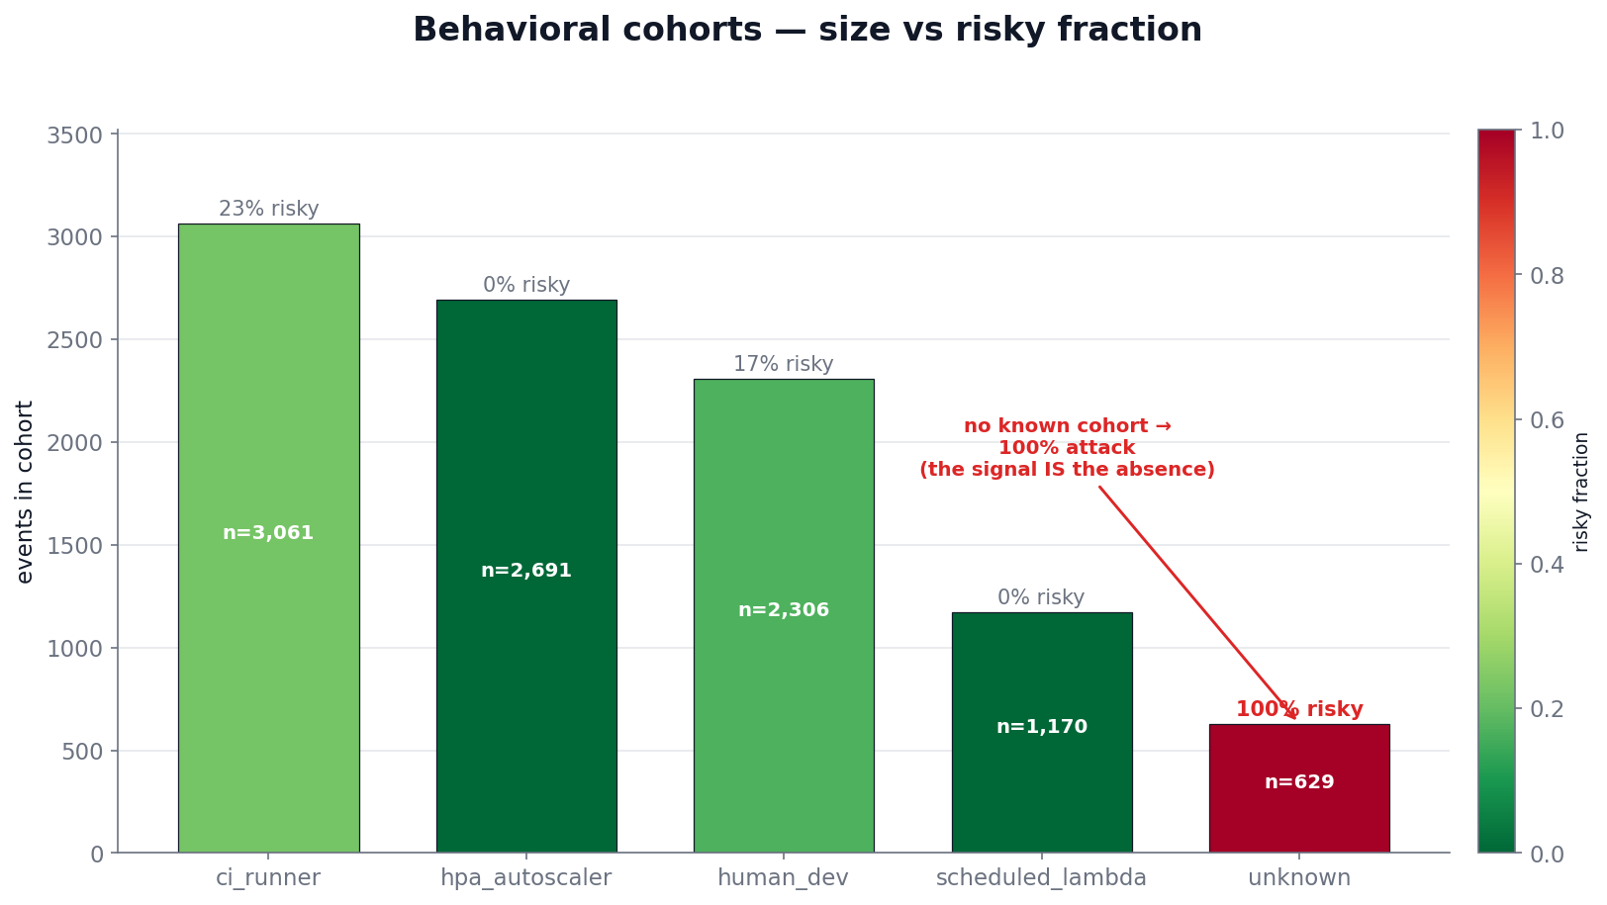
Behavioral cohorts — size vs risky fraction
The unknown cohort is the proof: all 629 of its events are the identity-anomaly attack (100% risky). “Fits no cohort baseline” is not noise to be cleaned up — it is the detection signal. Cohort accuracy on the 9,228 recognizable principals is 100%.
Stage 2 — Detection. Always-on tripwires force a severity floor (NodePort 0.0.0.0/0, bare privileged pod, burst_rate > 10, broad RBAC, and cohort == unknown). A recall-first ensemble (Isolation Forest primary + ECOD second vote, scores min-max normalized and averaged) flags the top candidates. A no-ML suppression pass drops candidates that are cohort-normal.
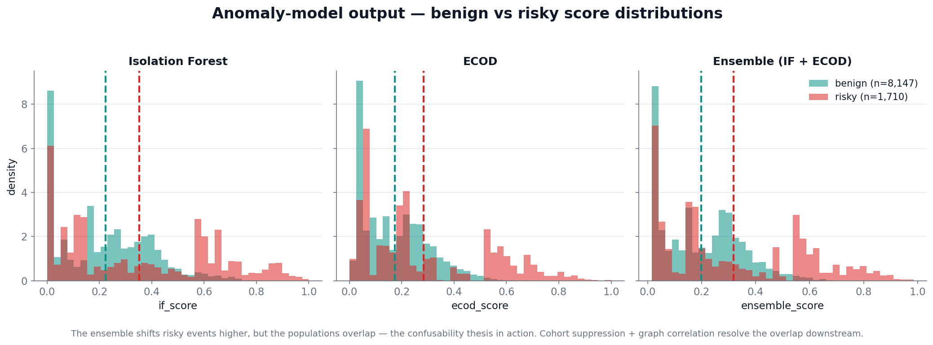
Anomaly-model output — benign vs risky score distributions
The ensemble shifts risky events to higher scores, but — honestly — the populations overlap. That overlap is the confusability thesis in action, not a model failure: the right tail is clearly more risky, but the ambiguous middle is exactly what the cohort suppression and graph correlation stages resolve downstream.
Stage 3 — Correlation. Builds an event-node graph with time-gated typed edges (same_principal, same_session, external_session, shared_event, same_resource), each enforcing the identity + namespace + time envelope at edge-creation time. Incidents are connected components seeded from flagged events with one-hop bridge expansion. This both collapses noise and recovers missed detections — benign bridge events one hop from a flagged seed pull the missed true positives back in.
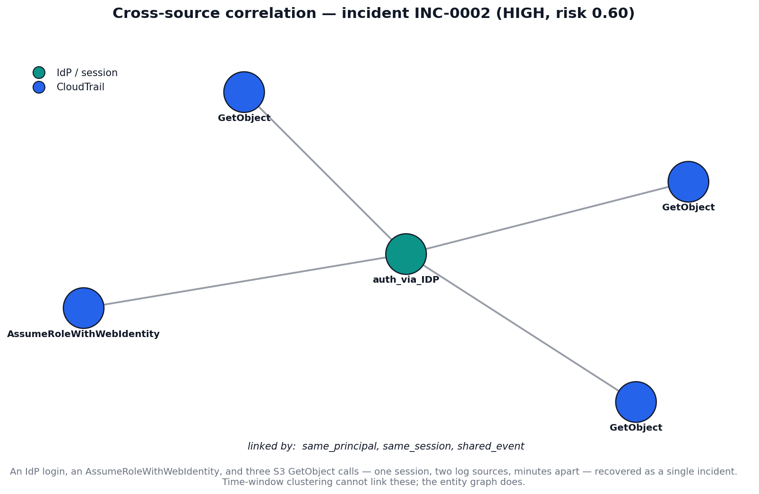
Cross-source correlation of one incident
This is the payoff time-window clustering cannot reach: an IdP login, an AssumeRoleWithWebIdentity, and three S3 GetObject calls — one session, two log sources, minutes apart — recovered as a single incident via same_principal / same_session / shared_event links.
Stage 4 — Risk fusion. Computes a label-free event-level raw risk (fixed-weight fusion of anomaly score, tripwire signal, exposure, privilege, novelty), calibrates it to a probability via out-of-fold isotonic regression (the one sanctioned label touch — no event is scored by a model that saw its label), then aggregates to an incident risk_score (0.7·max + 0.3·mean of member probabilities) with severity bands and a tripwire floor.
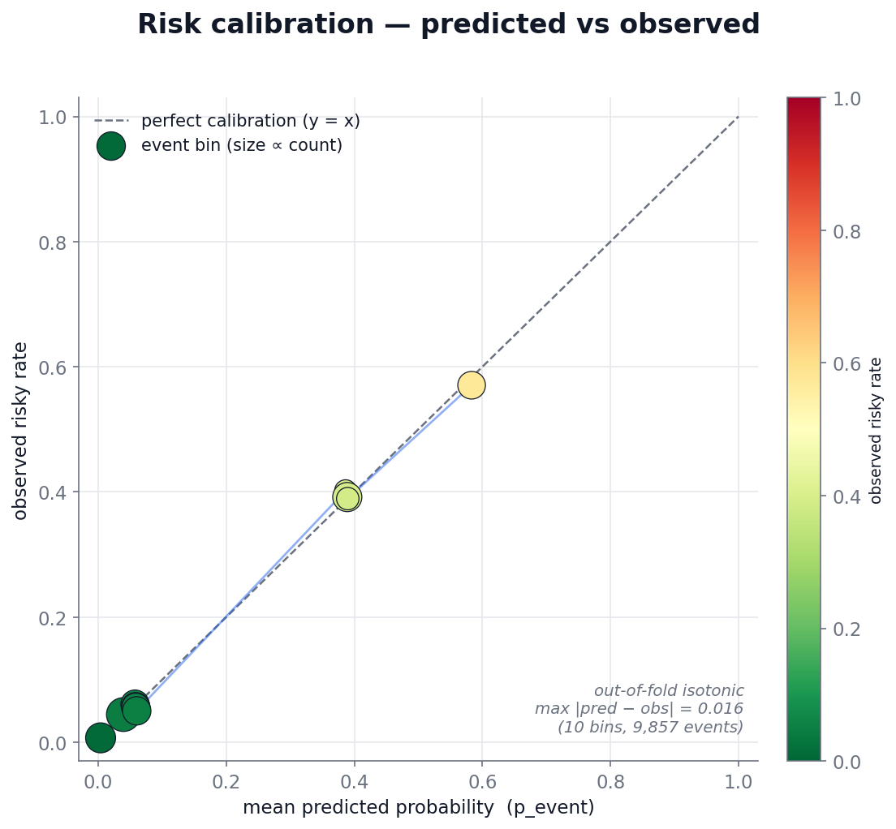
Risk calibration — predicted vs observed
Calibration is near-perfect: across ten event bins the predicted probability tracks the observed risky rate with a maximum deviation of 0.016. A p_event of 0.8 really does mean ~80% likely-malicious, so the ranked incident queue is meaningfully ordered.
Stage 5 — LLM triage. Builds an evidence bundle per CRITICAL/HIGH incident and asks gpt-4o-mini (strict JSON-schema structured output) for intent, confidence, MITRE techniques, disambiguation, evidence, and guardrails. Validated, retried, cached per incident, with a deterministic label-free template fallback so the stage never crashes and reruns cost nothing.
Stage 6 — Dashboard. A React 19 + Vite + Tailwind SOC console (“EphemeraLens”) fed by static JSON exported from the pipeline — no live model or LLM in the demo path. Headline feature: a real-time replay simulation that plays the 5-day event stream against a virtual clock, forming incidents live and contrasting pipeline detection time against the next daily scan.

Data artifacts — what each stage writes
The pipeline persists every stage to Parquet, so each transform is independently inspectable and 1:1-joinable on record_id / incident_id. The backbone tables:
Artifact | Rows × cols | Key columns (beyond the unified event schema)
events_enriched.parquet | 9,857 × 43 | cohort, burst_rate, principal_novelty, tag_completeness, privilege_level, public_exposure_flag, exposure_window_s, off_hours_flag, cohort_deviation
detections.parquet | 9,857 × 51 | + tripwire_hit, severity_floor, if_score, ecod_score, ensemble_score, is_candidate, is_suppressed, predicted_risky
incidents_scored.parquet | 529 × 26 | incident_id, member_record_ids, event_count, edge_types, source_{cloudtrail,k8s,idp}_count, risk_score, risk_band, risk_rank
events_scored.parquet | 9,857 × 3 | record_id, raw_risk, p_event (calibrated probability)
incidents_triaged.parquet | 263 × 11 | likely_intent, confidence, mitre[], key_evidence[], disambiguation, recommended_guardrails[], triage_source
The unified event schema (carried by every enriched/detection row) spans identity (record_id, event_time, source, action, principal_id/type/arn, role_name), AWS/IAM (region, session_name, session_ttl, assumed_role_id, shared_event_id), Kubernetes (namespace, controller_owner, privileged, host_network, service_type, exposed_open, rbac_change, broad_rbac), network/session (source_ip, public_ip, external_session_id), and resource (resource_id/type, is_spot, tags, labels, read_only) columns — plus the full original raw JSON for forensics.

5. Results
Each row of the ablation table adds exactly one differentiator, measured against the ground-truth labels we control (9,857 events, 17.3% risky). The table is the single most persuasive artifact — it proves each differentiator earns its place.
Configuration | Precision | Recall | Alert reduction
Tripwires only | 43.5% | 72.5% | 38%
+ Stage-1 anomaly ensemble | 31.1% | 84.2% | 0%
+ Stage-2 cohort suppression | 33.6% | 84.2% | 8%
+ Graph correlation | 24.1% | 100% | 89%
+ Risk fusion (incident, band ≥ HIGH) | 68.4% | 99.5% | 89%
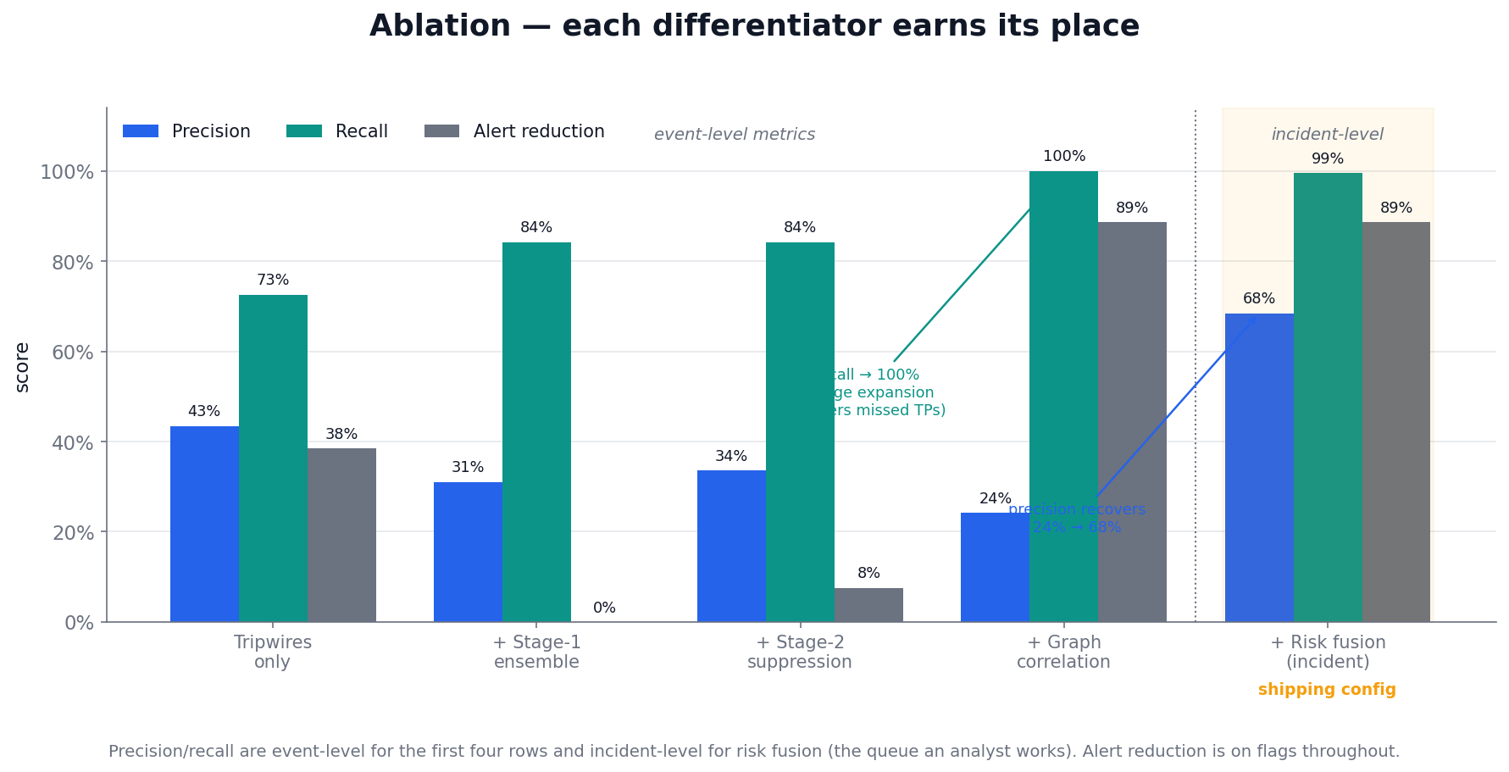
Ablation — each differentiator earns its place
(Precision and recall are event-level for the first four rows and incident-level for the risk-fusion row — the queue an analyst actually works. Alert reduction is on flags throughout.)
Headline numbers:
- Recall climbs 72% → 100% — graph bridge-expansion recovers detections the anomaly model missed.
- Alerts collapse 89% — 4,638 raw flags become 529 correlated incidents. The SOC investigates 529 things, not 9,857.
- Ranked queue hits precision@50 = 96% (and @10 = 90%, @20 = 95%) — the brief’s prescribed risk-quality metric (precision@K against injected severity).
- Correlation accuracy vs injected campaign_id: homogeneity 0.88 / completeness 0.99 / V-measure 0.93.
- Calibration is near-perfect: in every reliability bin, predicted probability ≈ observed risky rate.
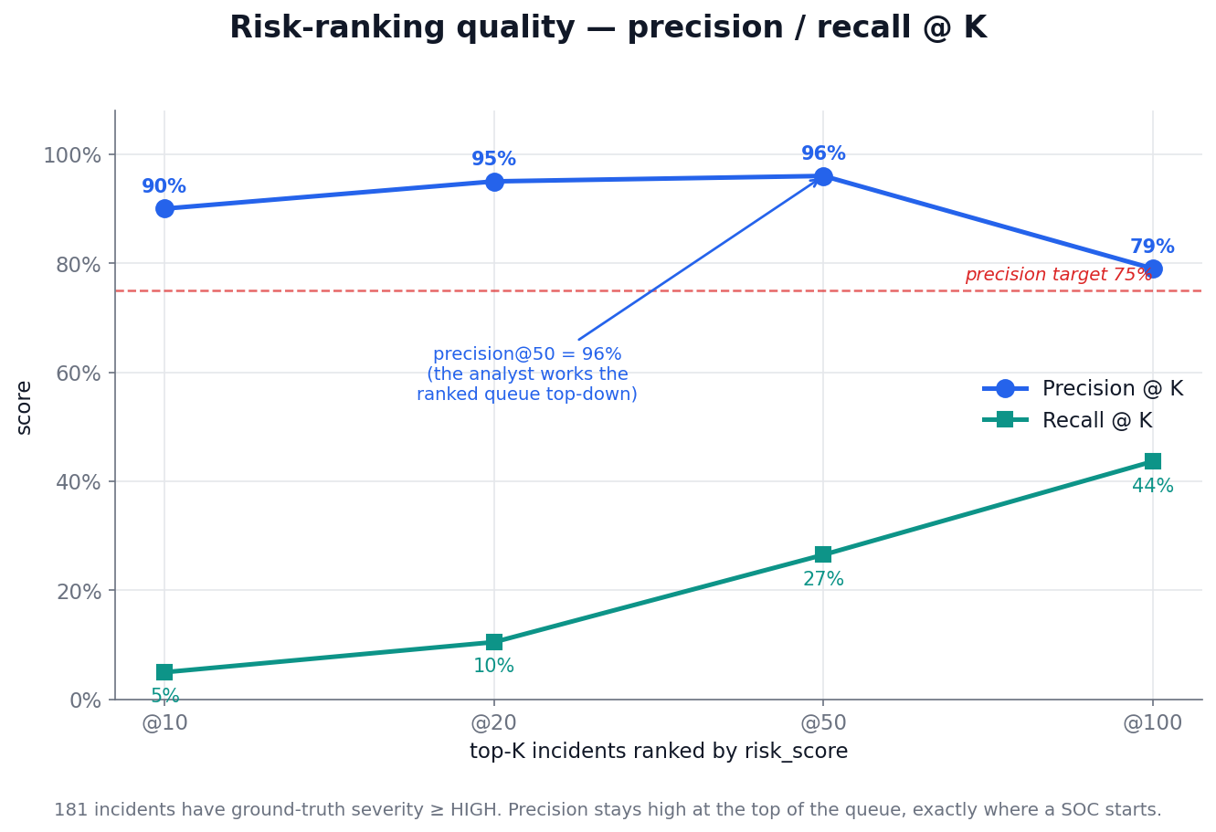
Risk-ranking quality — precision / recall @ K
Precision stays high at the top of the queue — exactly where a SOC analyst starts. This is the honest risk-quality metric, not a single threshold tuned to look good.
Alert-fatigue funnel: 9,857 raw events → 3,517 flagged → 3,167 after suppression → 529 correlated incidents → 263 triaged.
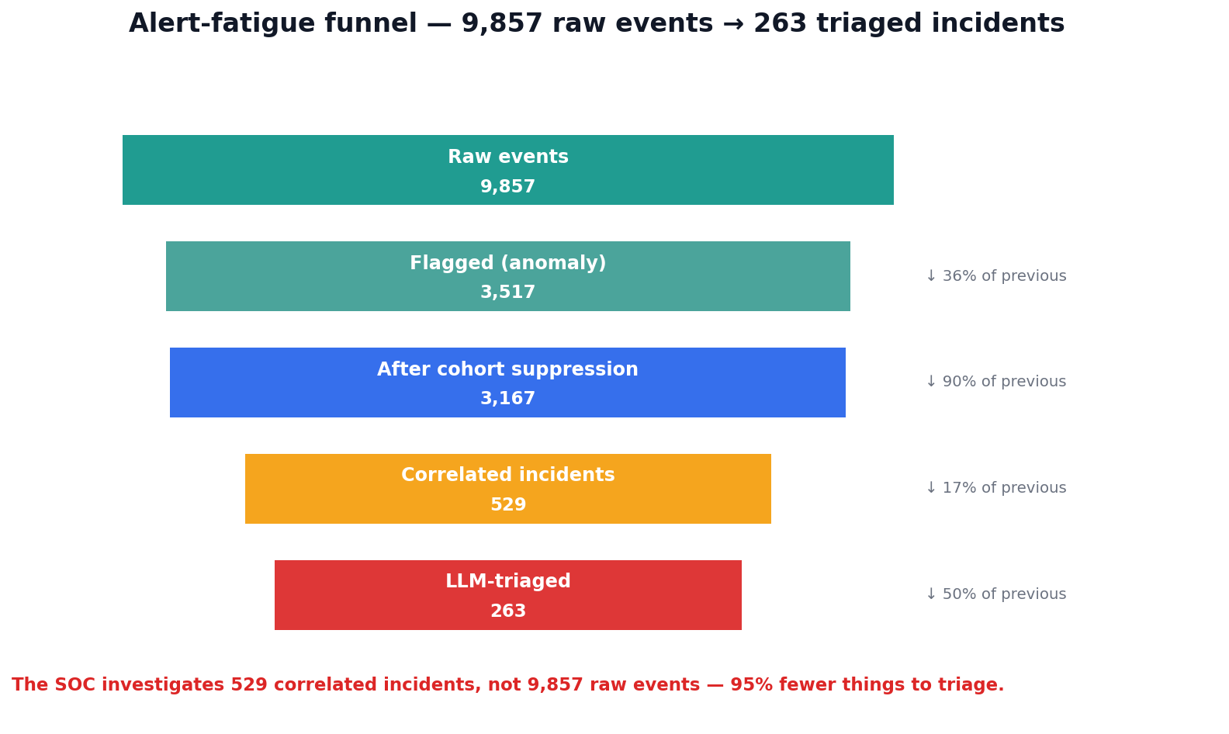
Alert-fatigue funnel
Canonical incident recovery: INC-A (crypto burst) 40 alerts → 1 incident; INC-B (debug pod) 3 → 1; INC-C (compromised session) 7 → 1 (spanning CloudTrail + IdP); INC-D (autoscaler noise) correctly keeps the buried credential-abuse alert as its own HIGH incident while collapsing the surrounding noise.

6. Honest Evaluation — Questions a Judge Should Ask
“Isn’t detecting cohort = unknown just detecting a label you injected?” No. Confusability is enforced at generation time — the figure in §2 shows benign and malicious bursts are statistically indistinguishable in volume and rate. The risk-fusion score is label-free (anomaly score, exposure, privilege, novelty). The only sanctioned label touch is out-of-fold isotonic calibration, where no event is scored by a model that saw its label. We detect the behavior; the label is downstream ground truth used to measure, not to predict.
“Precision is 68%, but the target was 75%.” 68.4% is the deliberately high-recall band cut (band ≥ HIGH) — by design, a tripwire incident is never silently dismissed. The brief’s actual risk-scoring-quality metric is precision/recall@K against severity, where the ranked incident queue hits 96% @50. We optimize the ranked queue an analyst actually works top-down, not a single global threshold.
“It’s all synthetic.” Yes, and that is controlled, not faked. No public dataset carries the labeled ground truth (is_risky, campaign_id, severity) this problem requires. The simulator is grounded field-by-field in real AWS CloudTrail / audit.k8s.io / Okta schemas and real burst-timing distributions, and every metric is measured against labels we constructed ground-truth-first.

7. Framework Alignment
Framework | Controls addressed
NIST SP 800-53 | CM-8 (system component inventory of ephemeral assets), SI-4 (system monitoring), IR-4 (incident handling)
MITRE ATT&CK | T1496 (Resource Hijacking), T1578 (Modify Cloud Compute Infrastructure), T1190 (Exploit Public-Facing Application), T1610 (Deploy Container), T1078 (Valid Accounts)
CIS Kubernetes Benchmark | privileged-container and network-exposure controls (tripwire rules)
GDPR Art. 32 | security of processing — the PII-exfiltration incident (INC-C) is detected and triaged
The MITRE mapping is not hand-waved — it is what the Stage-5 triage agent actually attributes across the triaged incidents:
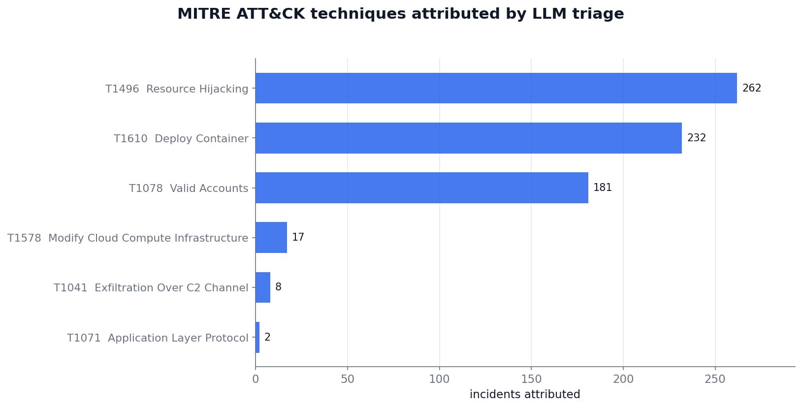
MITRE ATT&CK techniques attributed by LLM triage

8. Reproducibility
The full pipeline is deterministic (fixed seed 1337) and reproducible end-to-end:
pip install -r requirements.txt
python -m modules.data_simulation.generator.build # generate data/raw/
python -m modules.ingest_enrich.build # → events_enriched.parquet
python -m modules.detection.build # → detections.parquet
python -m modules.correlation.build # → incidents.parquet
python -m modules.risk_fusion.build # → incidents_scored.parquet
python -m modules.llm_triage.build --no-llm # → incidents_triaged.parquet (offline)
python -m modules.dashboard.build # → frontend/public/data/*.json
python -m modules.dashboard.figures.build_all # → docs/figures/*.png (every figure in this report)
python -m pytest tests/ -q # 50 passed
cd modules/dashboard/frontend && npm install && npm run dev # http://localhost:5173/app
The dashboard reads static JSON exported from the pipeline — no live model or LLM call in the demo path, so it runs fully offline. The LLM triage (gpt-4o-mini) is pre-generated and cached; the --no-llm path and the entire test suite need no API key. Every figure in this report regenerates from the same Parquet artifacts via build_all — none are hand-drawn or mocked.

🔗 Live demo: https://sentinel-rho-sooty.vercel.app/app · 📹 Demo video: add link · Repository: add GitHub URL

