1. Cloud Architecture & Scaling (The 'How')
This domain focuses on the non-AI tools required to handle the volume and complexity of the video processing task, primarily using Amazon Web Services (AWS).
A. AWS Batch (The Factory Manager)
This is the central orchestration service that turns your single Python script into a scalable, industrial "factory."
- What It Is: AWS Batch is a managed service that dynamically provisions the optimal quantity and type of compute resources (like EC2 instances, or in your case, GPU-equipped servers) based on the volume and resource requirements of the jobs submitted. It effectively manages your distributed workload.
- Why It Is Used:
  - Scalability: It allows you to process 4,320 videos simultaneously (in parallel) rather than sequentially (which would take days or weeks).
  - Cost Efficiency (Auto-Scaling): It ensures you only pay for the compute resources when they are actively processing a job. Once the queue is empty, the servers are automatically shut down.
- Focus Concepts (The Components):
  - Compute Environment: This is the pool of EC2 servers (the underlying hardware). It defines the type of worker (e.g., g4dn.xlarge with 4 vCPUs and 1 GPU) and the maximum capacity (e.g., 64 vCPUs).
  - Job Queue: This is the waiting list or "to-do list." When your submit_jobs.py script runs, it adds tickets for all 4,320 videos to this queue.
  - Job Definition: This is the instruction manual for a single job. It tells AWS Batch: "To run a job, pull the container image from ECR, allocate 4 vCPUs and 1 GPU, and execute the following command."

B. Docker (The Robot/Containerization)
Docker is the packaging technology that makes your code portable and reliable across different computing environments.
- What It Is: Docker allows you to bundle your application code, all its necessary libraries (like YOLO, InsightFace, and OpenCV), configuration files, and a miniature operating system environment into a single, light-weight, executable package called a container image (our "robot").
- Why It Is Used:
  - Consistency: It guarantees that the code environment that worked on your local machine is exactly the same as the environment running on the temporary, disposable EC2 servers in the AWS cloud. This eliminates dependency conflicts (e.g., "It works on my machine!").
  - Isolation: The container runs independently of the host server, preventing conflicts with other system software.
- Focus Concepts:
  - Container Image: The read-only blueprint created by your Dockerfile.
  - Dockerfile: The text file containing all the steps and commands needed to build the image (e.g., installing Python, adding GPU drivers, installing pip libraries).

C. Amazon S3 (Storage) and IAM (Permissions)
These two services manage the data and the security framework for the entire pipeline.
- Amazon S3 (Simple Storage Service):
  - What It Is: AWS's highly durable, scalable, object-based storage solution. It is the "hard drive" for the cloud.
  - Role in Project: S3 is used for both Input and Output.
    - Input: Stores the large, raw video files (tableiq-default-streams).
    - Output: Stores the final, small, structured JSON reports (tableiq-output-results).
- IAM (Identity and Access Management):
  - What It Is: The service that manages access, permissions, and security.
  - Role in Project: IAM Roles (specifically the ecsInstanceRole) are the "keys" that dictate what your "robot" can and cannot do. We had to grant two specific permissions:
    - Read Permission: Allow the role to s3:ListBucket and s3:GetObject from the input bucket (tableiq-default-streams).
    - Write Permission: Allow the role to s3:PutObject into the output bucket (tableiq-output-results).

That is a very clear direction. We will continue building your deep, conceptual understanding of the core technical domains, moving now into the AI component: Computer Vision (The Core Skill).
We will start with Object Detection (YOLO) and build upon our previous basic definition with more technical detail.

2. Computer Vision & AI (The Core Skill)
This domain covers the algorithms and neural networks that allow the system to interpret raw pixel data and convert it into meaningful spatial information.
A. Object Detection (YOLO)
YOLO (You Only Look Once) is the engine that finds and frames objects in real-time.
1. The Core Mechanism: One-Stage Detection
- What It Is: YOLO models are one-stage detectors, meaning they predict the bounding box coordinates and the class probabilities simultaneously (in one single pass through the neural network).
- Contrast (Two-Stage): Older systems (like R-CNN) first proposed regions where an object might be, and then ran a classification network on each region. This was more accurate but far too slow for video analysis.
- Significance: The "You Only Look Once" paradigm is why our system can process multiple frames per second (high FPS) on the GPU servers hired by AWS Batch.
2. Deep Dive: Bounding Box Parameters
- Output Data: When YOLO detects a person, it outputs a set of five numbers, which are the fundamental data we use throughout the project:
  - xcenter, ycenter: The normalized coordinates of the center point of the object.
  - w, h: The width and height of the box (also normalized).
  - Confidence Score (xP): The probability (0.0 to 1.0) that the box actually contains an object and that the object belongs to the predicted class (e.g., 'person').
- Normalization: These coordinates are usually normalized (scaled between 0 and 1) based on the image size. This is essential, as the final step in our script converts these normalized coordinates back into raw pixel values so we can draw the bounding box rectangle on the screen.
3. Anchor-Based vs. Anchor-Free
- Anchor Boxes (YOLOv3, v4, v5): Historically, YOLO used pre-defined "anchor boxes" (template box sizes, like "small," "medium," and "tall") to help the model predict shapes. This was effective but rigid.
- Anchor-Free (YOLOv8, v11): Modern versions (which we used) often skip anchor boxes entirely. They predict the center of the object and the distance to the edges directly.
- Significance: Anchor-free design simplifies the training process, leads to a smaller final model size, and generally results in a more robust and accurate model for diverse object shapes, such as people walking, sitting, or bending over near a table.
- Definition: Object detection is a technology that combines object localization (drawing a boundary box around an object) and object classification (assigning a label, like "person" or "table").
- Analogy: If Image Classification is just labeling a photo "This is a restaurant," Object Detection is drawing a box around every single person, every table, and every manager in the photo and labeling each one.
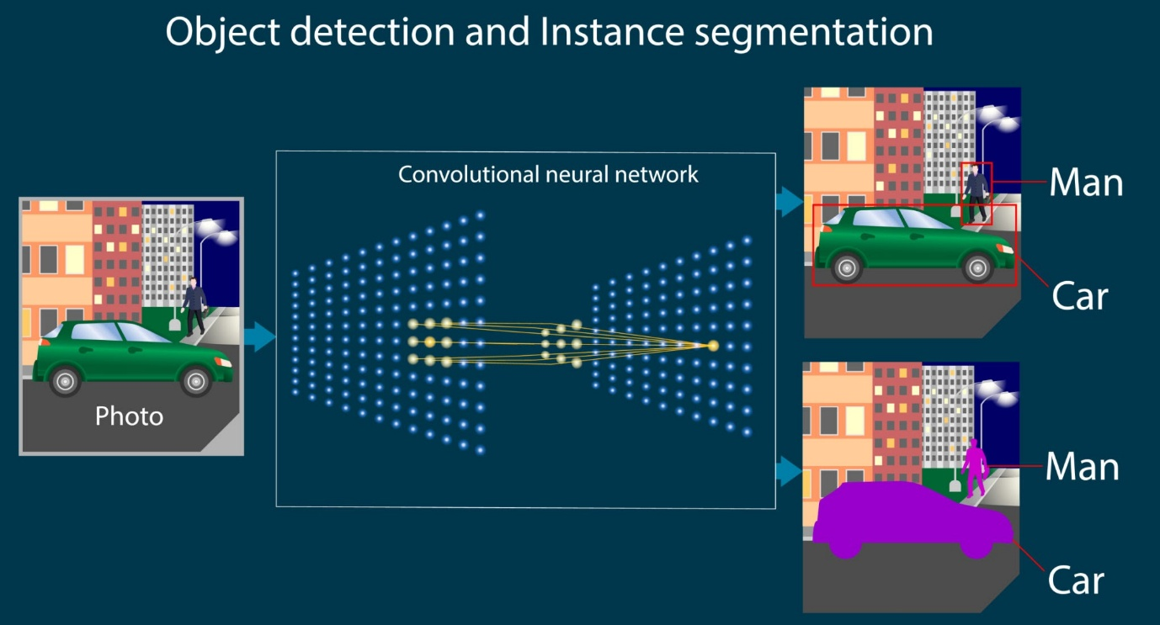
Getty Images
- How it Works (The Three Parts): Deep learning models for object detection generally consist of three main components:
  - Backbone: Extracts key features from the input image (like edges, shapes, and textures).
  - Neck: Gathers and blends features from different layers of the backbone to better identify objects at various scales (e.g., a person far away vs. a person close up).
  - Head: The final part that generates the bounding boxes and assigns the class label (e.g., "person" and its coordinates).
B. Why We Use YOLO (You Only Look Once)
- Speed is Essential: In video surveillance (like the TableIQ project), speed is the most important factor. Our system must analyze 25 or 30 frames per second (FPS).
- YOLO's Advantage: YOLO is a one-stage detector. Older models (like R-CNN) were two-stage: they first proposed candidate regions and then classified them. YOLO processes the entire image in a single pass through the neural network.
- Result: This single-pass method makes YOLO extremely fast, which is why it is the standard for real-time video processing and monitoring.
Object Tracking (DeepSORT / ByteTrack)
Object Tracking is the technical step that converts the initial "snapshot" of objects in one frame into a continuous trajectory over time. This is essential because all your business metrics (Dwell Time, Response Time, Table Touch Time) rely on consistent timing, which requires a consistent ID.
A. What It Is: Tracking vs. Detection
Feature | Object Detection (YOLO) | Object Tracking (DeepSORT/ByteTrack)
Question Answered | What is this, and where is it NOW? | What is this, and where has it BEEN?
Output | Bounding Box + Class Label (Per Frame) | Consistent Track ID + Trajectory
Process | Processes each frame independently. | Relies on temporal history (past frames) and prediction (future frames).
B. The Core Technical Components of Tracking
Tracking-by-detection algorithms, like the ones we use, rely on two key mathematical models working together:
1. Motion Prediction (Kalman Filter)
- What it Is: A mathematical tool that predicts where an object will be in the next frame based on its past movement (position and velocity).
- Why it's Required: When a person walks behind a waiter (an occlusion), the object detector (YOLO) might lose them for a few frames. The Kalman Filter keeps the track "alive" by guessing the object's likely location and size.
- Technical Detail: It estimates the object's state (position and velocity) at time $t$ based on the state at time $t-1$, plus some noise and uncertainty.
2. Data Association (Hungarian Algorithm)
- What it Is: The logic that matches a new detection (a new bounding box from YOLO) with one of the existing, predicted tracks from the Kalman Filter.
- Why it's Required: In a crowded environment, there are multiple predicted tracks and multiple new boxes. The Hungarian Algorithm is a highly efficient way to perform a one-to-one assignment that minimizes the overall "cost" or "distance" between all possible matches.
- Cost Function (Technical Detail): The "cost" is the measure of similarity. Simple trackers (like SORT) only use IoU (Intersection over Union) between the boxes. Advanced trackers (like DeepSORT/ByteTrack) use a cost function that also includes Appearance Features (Face Embeddings) to ensure the assignment is correct even if boxes overlap significantly.
C. Deep Dive: DeepSORT vs. ByteTrack
Our current pipeline utilizes DeepSORT or ByteTrack (built into Ultralytics YOLO). They differ in how they handle uncertainty:
Algorithm | Focus & Innovation | How it Reduces Identity Switches
DeepSORT | Appearance Feature Matching. | It extracts a deep appearance feature vector (an embedding) for every detection. The association metric then combines motion (Kalman Filter distance) and appearance (Cosine Similarity distance) to make the final decision. This is highly robust against occlusions.
ByteTrack | Handling Low-Score Detections. | Dual Threshold Matching: Instead of throwing away detections with low confidence scores (which often happen during occlusions), ByteTrack uses a two-stage matching process:  1. High Confidence matching (standard).  2. Low Confidence matching: It uses the remaining low-score boxes to re-associate tracks that might have been lost due to occlusion. This significantly reduces Identity Switches (when the system assigns a new ID to an object it should have been following). Object Tracking with DeepSORT - YouTube

Face Recognition (InsightFace)
Face Recognition is the technology that tells the system if a detected person is one of the specific managers we are tracking. It is a completely separate process from object detection or tracking.
A. What It Is: Identity Verification
- Definition: Face recognition is the process of mapping a face's unique features into a numerical code (an embedding) for storage and comparison. It answers the question, "Does this face match a known ID?"
- Analogy: The camera doesn't compare pictures; it compares lists of numbers. The process is like scanning a barcode that is unique to a person's face.
B. The Core Technical Concept: Face Embeddings
- What is an Embedding? An embedding is a unique, high-dimensional vector (a list of hundreds of numbers) that represents a face. It is generated by a deep neural network (our InsightFace model) that has been trained on millions of faces to recognize tiny differences between individuals.
- Why Numbers? Faces are compared based on distance in this vector space. Faces that are very similar (e.g., two pictures of the same person) have embeddings that are numerically close to each other. Faces that are different have embeddings that are numerically far apart.
- Our Project Application: Our script generates a database of embeddings for every picture in your known_faces/Manager_A folder. This is the Roster.
C. Deep Dive: Cosine Similarity and Thresholds
- How Comparison Works: Once the system detects a face in the video, it generates a Query Embedding (Q). It then compares this Query Embedding against every Roster Embedding (R) in the database.
- Cosine Similarity: This is the mathematical measure we use. It calculates the cosine of the angle between the two embedding vectors (Q and R).
  - Score = 1.0: The vectors point in the exact same direction (Perfect Match).
  - Score = 0.0: The vectors are perpendicular (No Match).
- The Threshold: Our script uses the FACE_RECOGNITION_THRESHOLD = 0.31. This is the cutoff point.
  - If the highest score between the new face and any manager is above 0.31, the script accepts the match.
  - If the highest score is below 0.31, the script labels the person "Unknown."

