Github Link For code: <https://github.com/SumanthMedavarapu/sumanth-Teslastockanalysis>

1. Here I am getting data from TSLA ticker, which gets information from yahoo and passed parameters to datareader module and given start and end date(present) from past 1 year

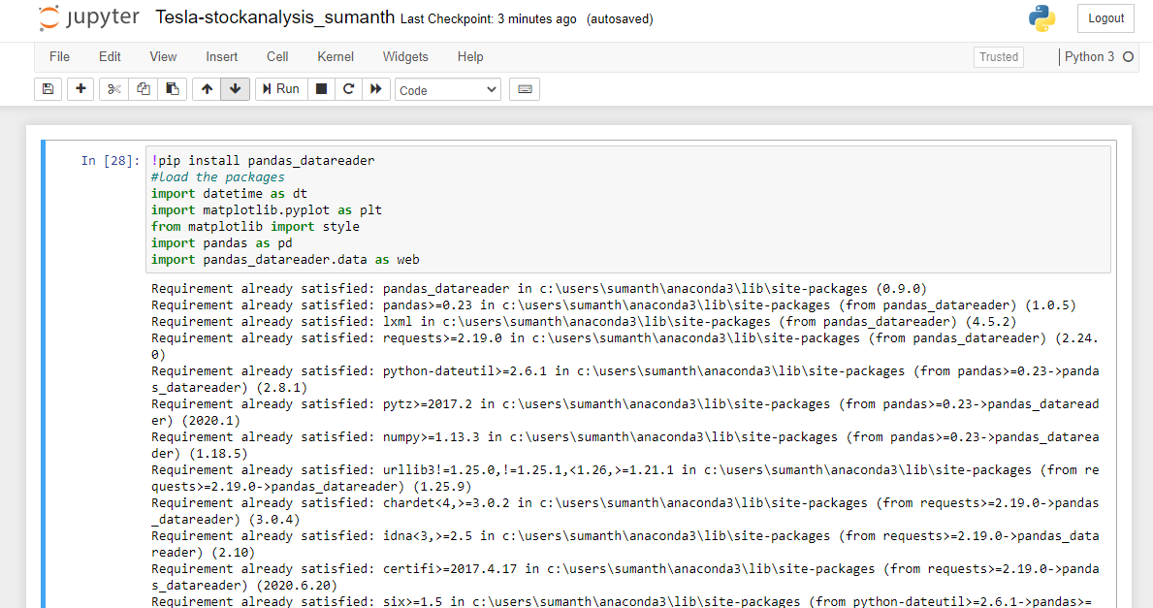

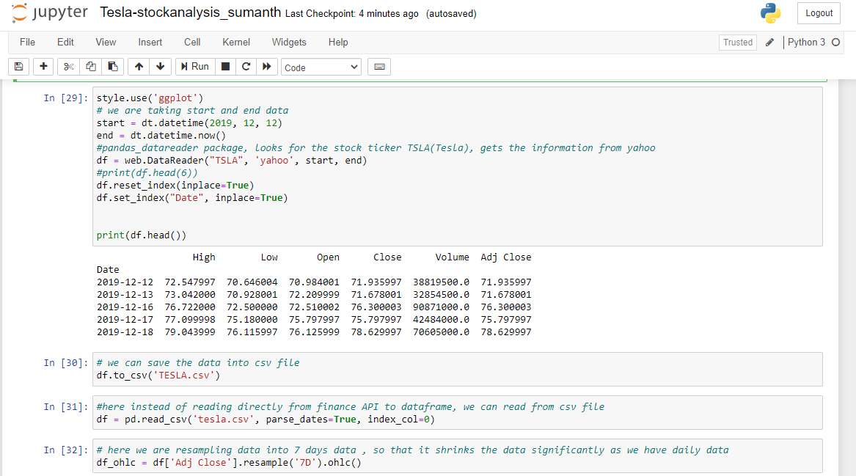

->Here resample the data to weekly data as shown below and plotted close price along with high and low as shown in graph.

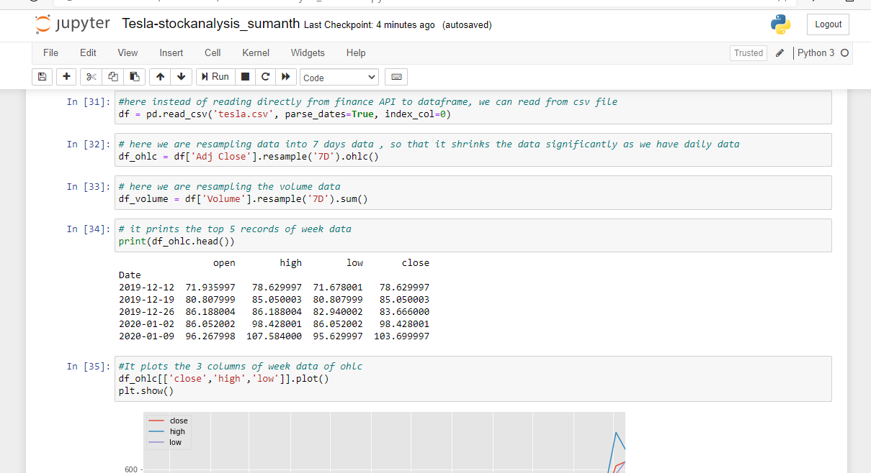

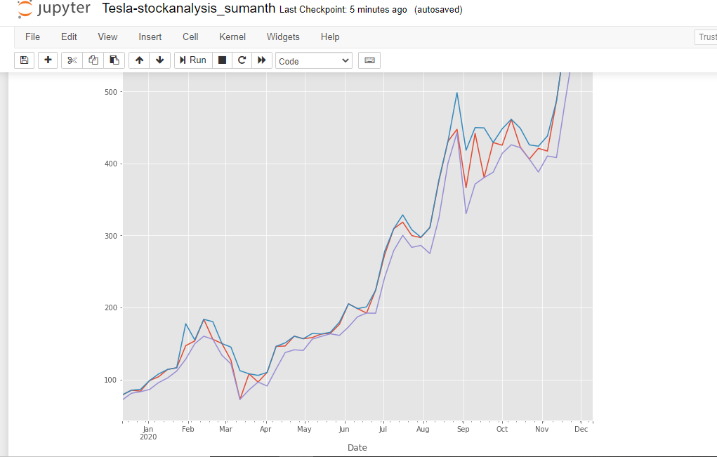

2) Here I have converted decimal type to integer, and later found the number of duplicates and grouped them, then plotted in bar graph

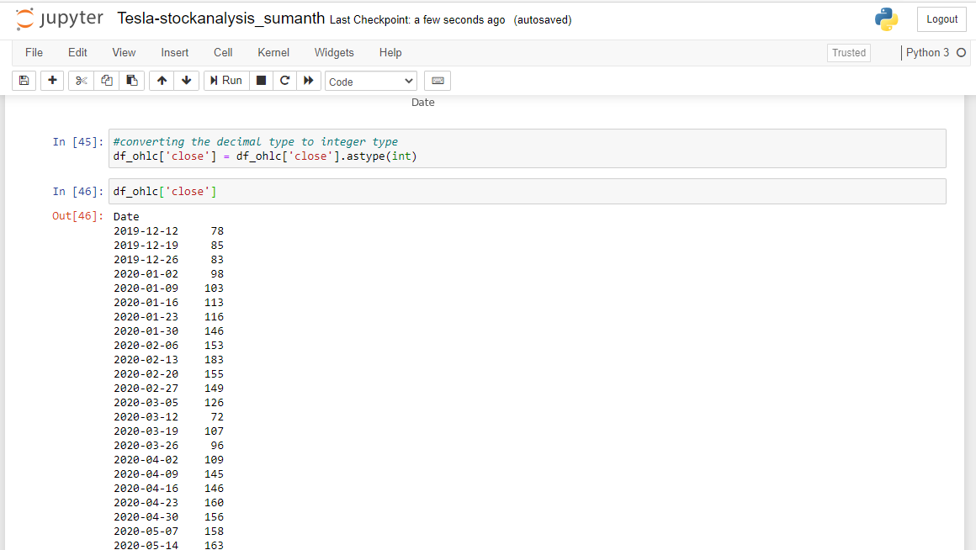

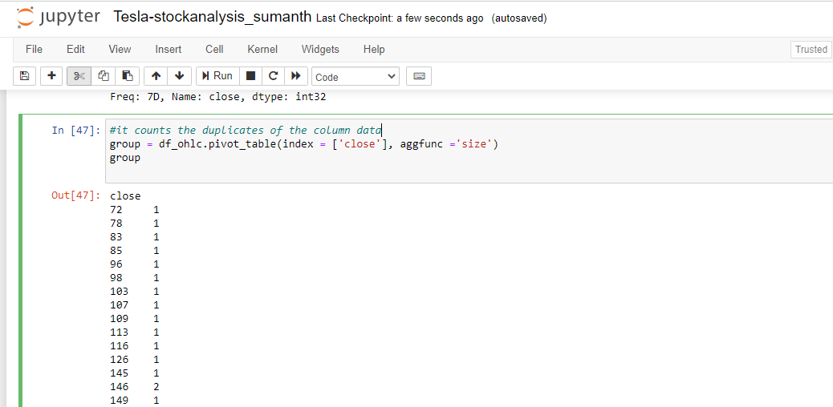

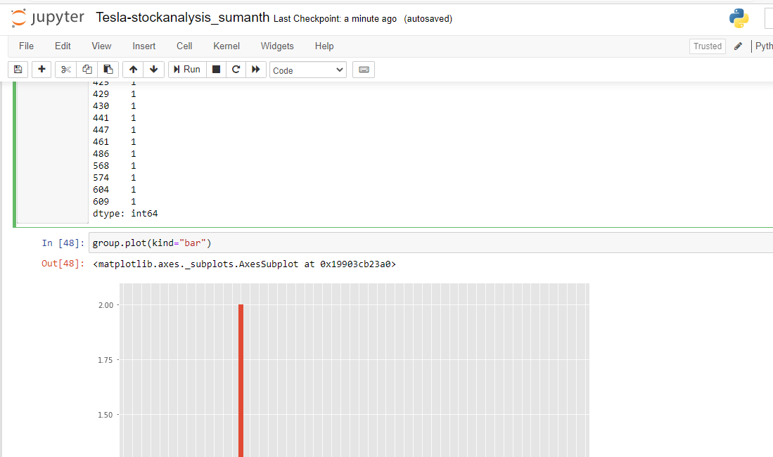

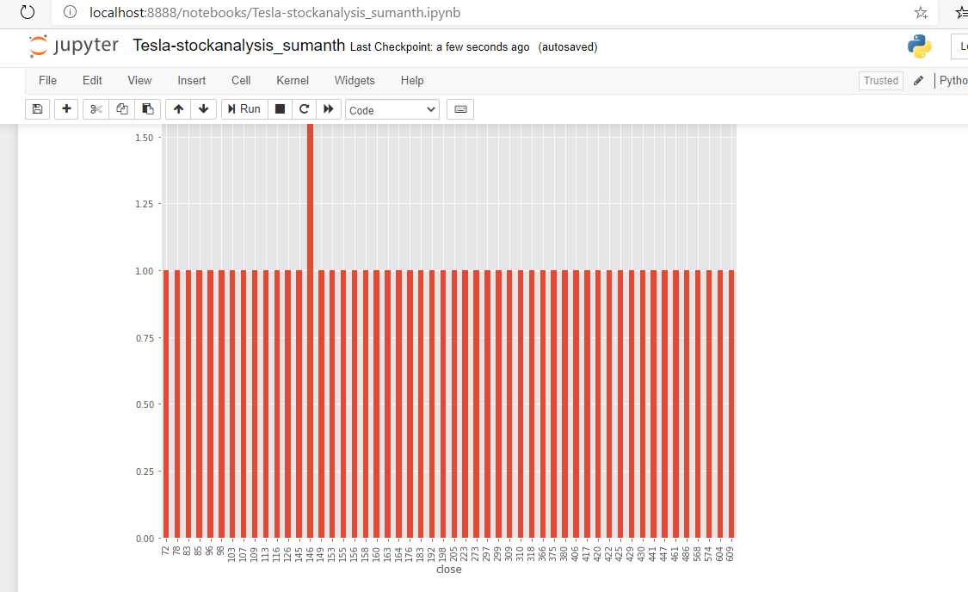

3)Here one thing we can observe stock high value got increased from November to December $420 to $680.Here to get the weekly data , I have used resampling to 7 day data so that it shrinks the data significantly as we have daily data

4)If we see the 1st plot graph in 1st question, we can say that

a)As we can see the Tesla stock value is keep on increasing from past 1 year, and it increased a lot from last one month to till now. By this we can say that it is worth buying it. If we buy now also, there are so many chances that we will get profit in the future

b)I have gathered information using stock ticker Tsla , which gets information from yahoo finance API