­ASSIGNMENT 1

1. curl -s <http://public-dns.info/nameserver/br.csv>

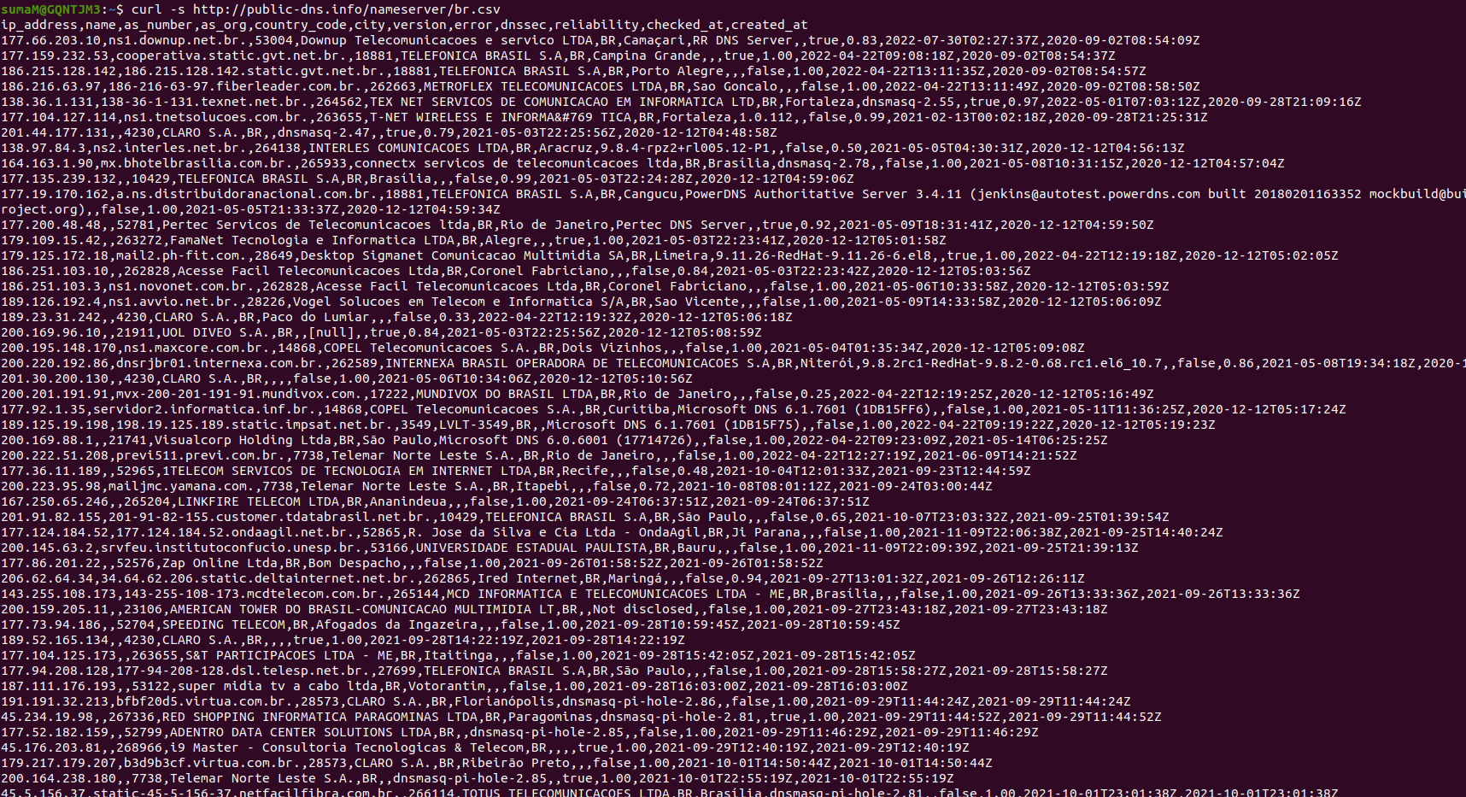

CURL stands for "Client URL" is a command line tool that enables data transfer over various network protocols such as HTTP, FTP, IMAP, POP3, SCP, SFTP, SMTP, TFTP, TELNET, LDAP, or FILE. It communicates with a web or application server by specifying a relevant URL and the data that need to be sent or received.

2. cut -d, -f1

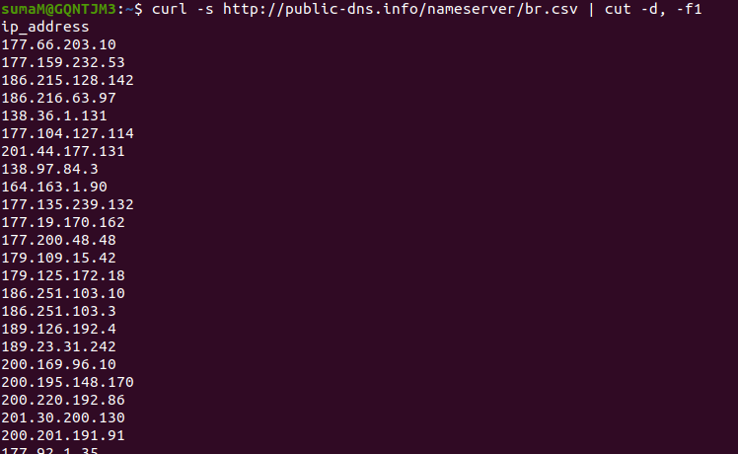

$ cut -d "delimiter" -f “field number” file.txt

Lines are splitted based on the delimiter and the only the number of fields as specified in field number are selected and displayed and rest all fields are cut.

3. shuf

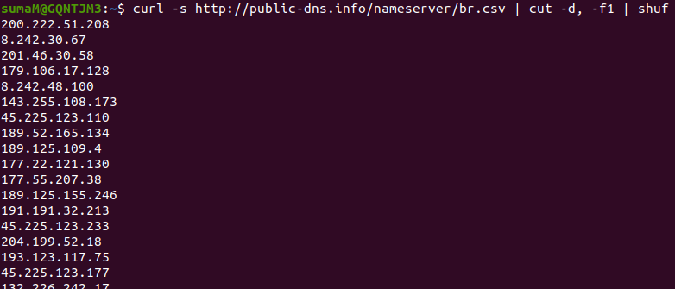

The shuf command in Linux writes a random permutation of the input lines to standard output. It pseudo randomizes an input in the same way as the cards are shuffled.

4. tail -n 50

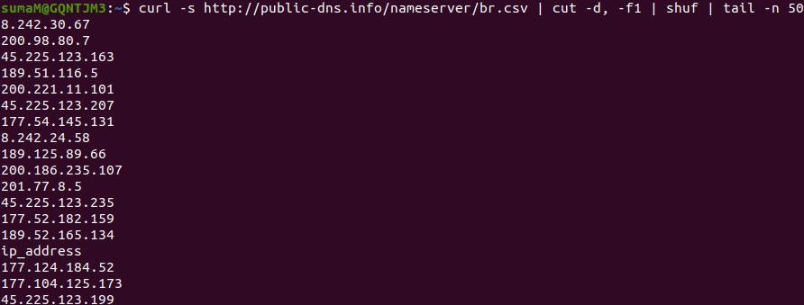

Linux tail command is used to display the last n lines of one or more files. By default, it displays the last ten lines of a file. Additionally, it is used to monitor the file changes in real-time.

tail -n <number> <filename>

The **'-n'** option displays the specified number of lines.

5. xargs -i timeout 1 ping -c1 -w 1 {}

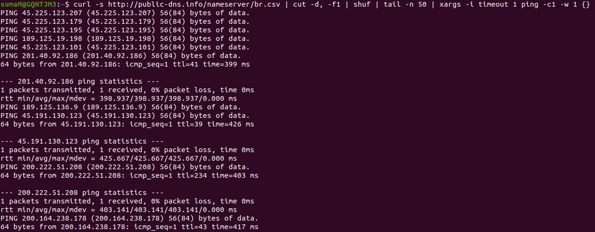

xargs is one of the oddest yet most powerful commands available to the shell. It reads lines of text from standard input, turns them into commands, and executes them. It takes the input and converts it into a command argument for another command.

timeout is set 1 for xargs, so that xargs should terminate reading from stdin after 1 sec.

ping -c<number> -w<timeout> {}

The number tells how many packets are to be sent to the server / host. To stop pinging after sometime use -w option.

Argument of {} means "print the log here". If {} is not provided, it gives error saying “for ping action, destination access required.”

6. grep “time=”

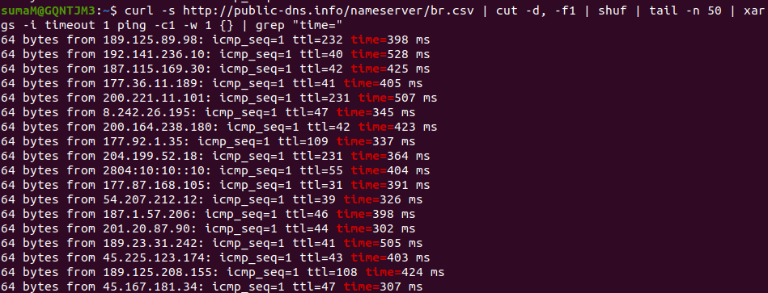

Grep is a command-line tool used to search for a string of characters in a specified file. The text search pattern is called a regular expression. When it finds a match, it prints the line with the result.

7. awk '{print substr($7, 6, length($7)) " " substr($4, 1, length($4) -1)}'

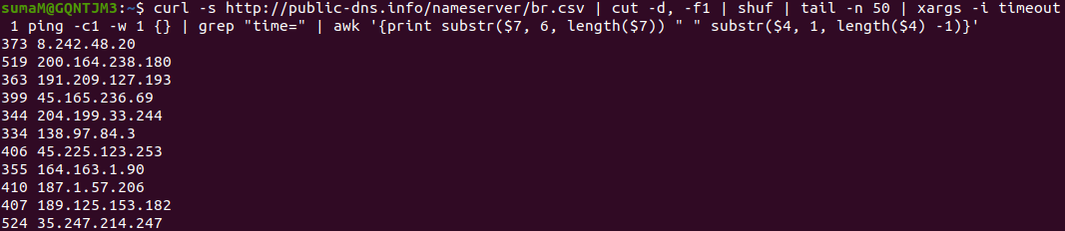

Awk is a scripting language used for manipulating data and generating reports. The awk command programming language requires no compiling and allows the user to use variables, numeric functions, string functions, and logical operators.

8. sort -n

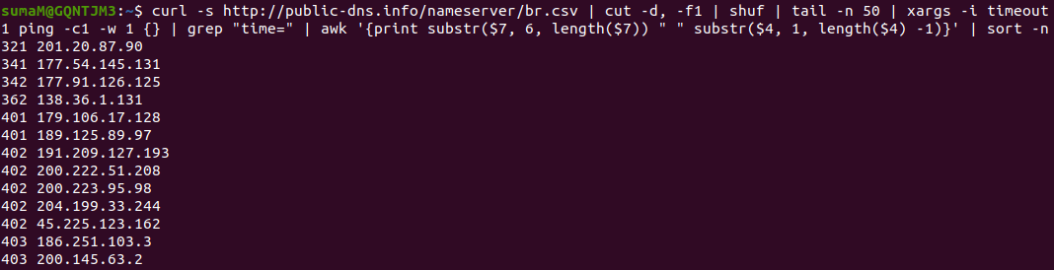

To sort a file numerically used –n option. This option is used to sort the file with numeric data present inside.

9. awk '{print $2 " " $1 "ms"}'

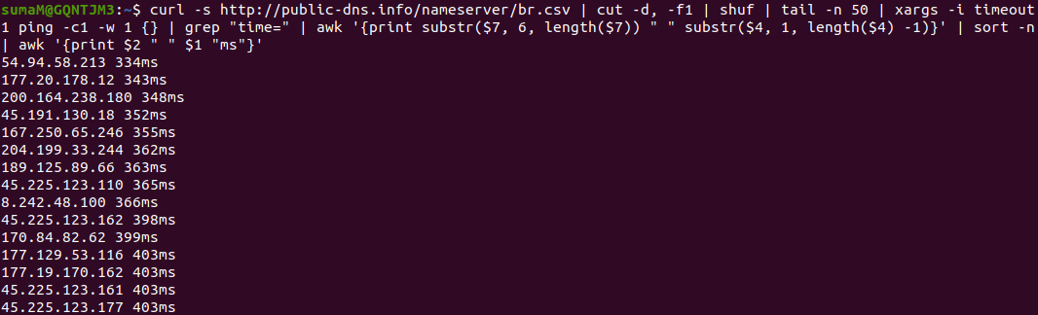

Awk is a scripting language used for manipulating data and generating reports. The awk command programming language requires no compiling and allows the user to use variables, numeric functions, string functions, and logical operators.

10. head -n 10

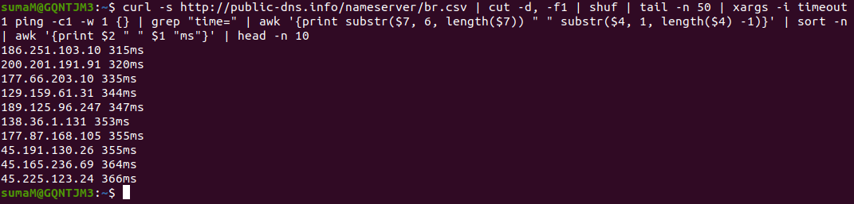

The head command, as the name implies, print the top N number of data of the given input. By default, it prints the first 10 lines of the specified files.

-n num: Prints the first ‘num’ lines instead of first 10 lines. Num is mandatory to be specified in command otherwise it displays an error.