ASSIGNMENT 2

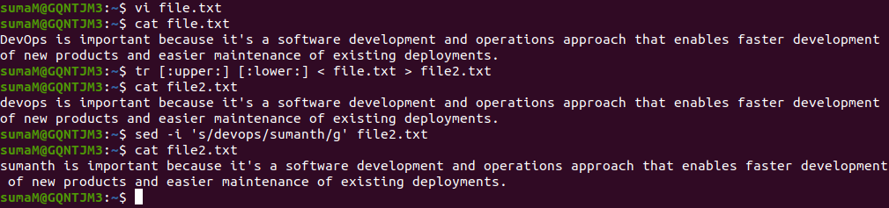

* Open the file – file.txt using vi text editor using the command : vi file.txt

This command will create a new file named file.txt and will be opened in the vi editor.

* Initially the vi editor will be in the command mode and we need to add some text in it. So, we need to get to the insert mode. Press ‘i’ to get to the insert mode and Type the text.

After typing the text, press ‘esc’ to get back to command mode. Then save and quit the vi editor using :wq command.

* Now, change the case from upper to lower using the translate command :

tr [:upper:][:lower:] < file.txt > file2.txt taking the input from the file.txt and printing the output to a new file file2.txt

* In the file2.txt, we need to replace the word ‘devops’ with ‘sumanth’, so we can do that using the stream editor command : sed -i ‘s/devops/sumanth/g’ file2.txt where it takes 2 arguments – old word, word to be replaced and the file name is mentioned.