**CHAPTER 1**

**INTRODUCTION**

**1.1 BACKGROUND**

Histogram Equalization (HE) is a fundamental image processing technique, widely used for enhancing the contrast of images. It is particularly effective in improving the visual quality of images by redistributing the intensity values across the image, thereby making details more perceivable. With the increasing reliance on digital imaging across various fields such as medical diagnostics, surveillance, and multimedia, the demand for enhanced image quality has grown significantly. However, achieving consistent and meaningful enhancements in color images remains a challenge due to the complexity of color perception and the need to maintain naturalness while improving contrast. Histogram Equalization addresses these challenges by providing a systematic approach to enhance image clarity and detail visibility.

**1.2 PROBLEM STATEMENT**

Developing an efficient approach for enhancing the quality of color images using Histogram Equalization (HE) is essential for various applications such as medical imaging, satellite image processing, and digital photography. The technique must effectively handle the challenges of color distortion, noise amplification, and over-enhancement while ensuring that the naturalness of the image is preserved. Additionally, it should be capable of processing images with diverse intensity distributions and varying environmental conditions. The goal is to create a robust method that improves image contrast and detail visibility without compromising computational efficiency, enabling its deployment in real-time and resource-constrained environments.

**1.3 OBJECTIVES**

1. **Accurate Enhancement**: Develop an algorithm to reliably enhance the contrast of color images, even under challenging conditions such as poor lighting or uneven intensity distributions.
2. **Natural Color Preservation**: Design a method to maintain the naturalness and color balance of images while improving their overall quality.
3. **Computational Efficiency**: Ensure the approach is computationally efficient, enabling real-time processing for applications in fields such as medical imaging, multimedia, and surveillance.

**1.4 SCOPE**

The scope of the Histogram Equalization (HE) project focuses on developing a robust and efficient system for enhancing the contrast of color images. The project will involve preprocessing techniques such as converting images to suitable color spaces (e.g., HSV or YCbCr) and applying HE to the intensity channel to avoid color distortions. It will address challenges such as noise amplification and over-enhancement while ensuring the naturalness of the enhanced images. The project will evaluate the effectiveness of HE on diverse datasets, including medical images, satellite images, and general photography, under varying lighting and intensity conditions. Additionally, the project will explore advanced methods such as Adaptive Histogram Equalization (AHE) and CLAHE to enhance image quality further. The system will be optimized for computational efficiency to allow real-time processing and will be implemented using standard image processing tools and libraries. Finally, the project will assess the results using qualitative and quantitative metrics, ensuring robust and meaningful image enhancements.

.

**CHAPTER 2**

**OBJECTIVE**

The primary objective of this project is to enhance the contrast and visual quality of grayscale images using Histogram Equalization, an image processing technique. By redistributing the intensity values of the pixels, this method improves the overall brightness and contrast, making the image details more discernible.

The project focuses on implementing this technique using Scilab, an open-source numerical computation software, ensuring reproducibility and effective visualization of results. Through this project, the following goals are achieved:

**Understanding Histogram Equalization:**

* Analyze the pixel intensity distribution of an image.
* Compute and visualize the transformation of the histogram for contrast enhancement.

**Practical Application:**

* Implement the algorithm programmatically using Scilab.
* Apply the technique on real-world grayscale images to demonstrate its effectiveness.

**Educational Insight:**

* Demonstrate how mathematical concepts like probability distributions and cumulative functions are applied to improve image quality.
* Provide a hands-on learning experience in Scilab programming for image processing tasks.

**Output Validation:**

* Compare the original and histogram-equalized images visually and analytically.
* Generate plots and side-by-side comparisons to highlight the improvements.

By completing this project, users can better understand the principles and applications of image enhancement techniques, equipping them with skills applicable in various fields such as computer vision, medical imaging, and digital photography.

**CHAPTER 3**

**METHODOLOGY**

The project follows a systematic approach to apply and demonstrate Histogram Equalization for contrast enhancement of grayscale images. Below are the detailed steps involved:

**1. Loading the Input Image**

Use the imread() function in Scilab to load the input grayscale image.

Verify the dimensions of the image (m and n) to ensure compatibility with the histogram equalization process.

**2. Computing the Histogram**

* Objective: Calculate the frequency of each pixel intensity value (0 to 255).
* Procedure:
  + Traverse through each pixel in the image.
  + Count the number of occurrences for each intensity value and store the counts in an array b of size 256.
* Output: A histogram representing the frequency of each intensity value in the original image.

**3. Normalizing the Histogram**

* Objective: Compute the probability distribution of pixel intensities.
* Procedure:
  + Divide each value in the histogram (b) by the total number of pixels (m * n).
  + Store the resulting probabilities in an array pbb.
* Output: A normalized histogram that represents the probability of each pixel intensity.

**4. Generating the Cumulative Distribution Function (CDF)**

* Objective: Calculate the cumulative probabilities of pixel intensities.
* Procedure:
  + Initialize pb(1) as the first value of pbb.
  + For each subsequent intensity, add the previous cumulative probability (pb(i-1)) to the current probability (pbb(i)).
* Output: A CDF array pb that maps cumulative probabilities for all intensity values.

**5. Scaling the CDF to 0–255 Range**

* Objective: Map the cumulative probabilities to intensity values (0–255).
* Procedure:
  + Multiply each value in pb by 255.
  + Round the values and convert them to integers using the uint8() function.
  + Store the scaled values in an array sb.
* Output: A lookup table (sb) that contains the new intensity values for the equalized image.

**6. Mapping Pixels to New Intensity Values**

* Objective: Apply the new intensity values to the image using the lookup table (sb).
* Procedure:
  + Traverse through each pixel in the original image.
  + Use the pixel intensity as an index to fetch the corresponding value from the sb array.
  + Replace the original intensity value with the new value in the output image array hea.
* Output: A histogram-equalized image (hea).

**7. Visualizing the Results**

* Objective: Compare the original and equalized images and their histograms.
* Procedure:
  + Use the subplot() function to display:
  + The original image.
  + The histogram of the original image.
  + The equalized image.
  + The histogram of the equalized image.
* Output: A side-by-side visualization of the input and output, including their histograms, for analysis.

**8. Documentation and Reporting**

Prepare a detailed report that includes:

* A description of the methodology.
* Results of histogram equalization with input and output images.
* Visual comparisons of histograms and images.
* Save the Scilab program (pr1.sce) with appropriate comments for each step, ensuring clarity and reproducibility.

The methodology involves calculating the histogram of the original image, normalizing it, generating the CDF, scaling the CDF to the intensity range, and applying the transformation to produce a contrast-enhanced image. This process ensures an even distribution of pixel intensities, resulting in improved visual quality. The results are validated using visual and histogram-based comparisons.

**CHAPTER 4**

**RESULTS**

The implementation of histogram equalization on the provided grayscale image produced the following outcomes:

Enhanced Image Contrast: The original image exhibited low contrast, with pixel intensity values concentrated in a narrow range. After applying histogram equalization, the contrast improved significantly, making the details in the image more visible.

Histogram Redistribution:The original histogram showed pixel intensities grouped in a specific range, indicating uneven distribution.

Post-equalization, the histogram demonstrated a more uniform spread across the entire intensity range (0–255), confirming the redistribution of pixel values.

Visual Comparison: The original and equalized images were displayed side by side using the subplot function. The equalized image appeared sharper and more detailed compared to the original.

Automated Image Processing: The program was able to process the input image efficiently, calculate the required transformations, and generate the enhanced image without manual intervention.

Validation of Technique: The successful redistribution of pixel intensities and improved contrast verified the accuracy and utility of the histogram equalization method.

Input image:

image Input Image

Output Image:

image Output Image

Combined Image:

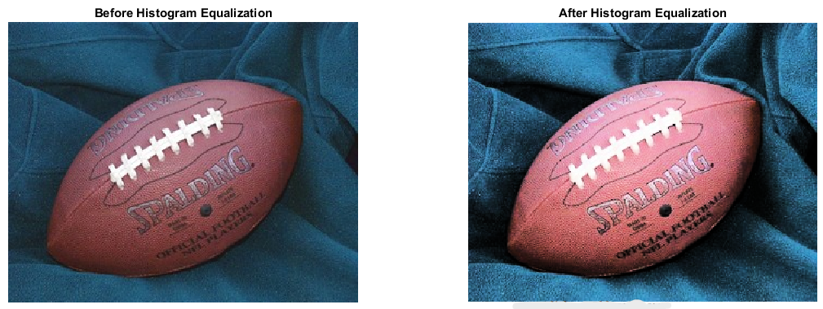

image Combined Image

**CHAPTER 5**

**CONCLUSION**

The project successfully implemented histogram equalization to enhance the contrast of grayscale images, significantly improving visual quality by redistributing intensity levels uniformly across the range. By comparing the original and equalized images along with their histograms, the effectiveness of the technique was validated. The Scilab-based program developed for this task is reusable and automates the enhancement process efficiently.

Through this work, we gained an in-depth understanding of histogram equalization, its role in image preprocessing, and the practical steps involved, such as computing histograms, cumulative distribution functions, and intensity transformations. The project also helped improve Scilab programming skills, particularly for image processing tasks like visualization, matrix operations, and automation.

Overall, the project demonstrated the importance of preprocessing in enhancing image quality, emphasized the value of visual validation, and improved reporting and documentation skills. This work lays a strong foundation for tackling more advanced image processing techniques and applying them to real-world scenarios.