1)ping:
Is a network diagnostic tool used to check the liveness of a connection or host.Ping is a networking utility program or a tool to test if a particular host is reachable.
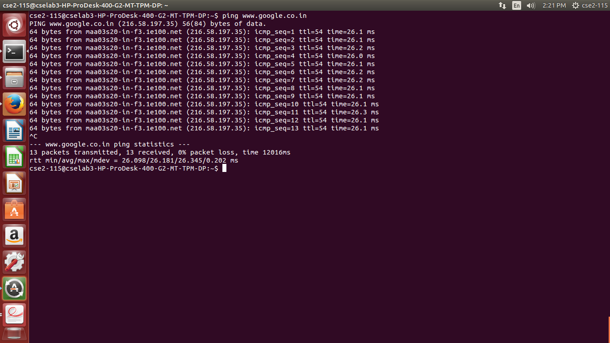
Syntax: i)ping <domain name>
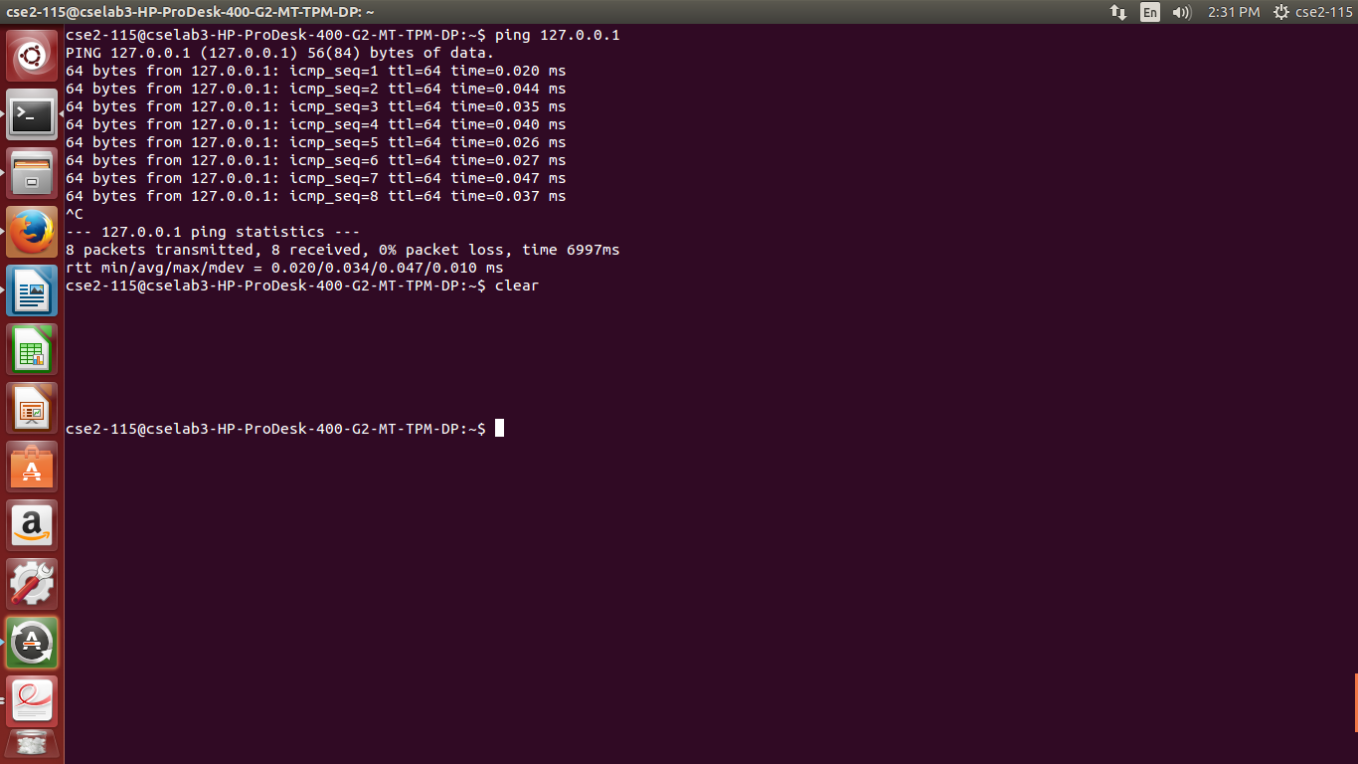
Syntax: ii)ping <ip address>

2)traceroute:
These are similar to ping command but, it additionally
gives the path the packet takes from the source to destination. It sends packets to remote destination asking each internet router along the way to reply. This command will give the information like hops,
delays(min, max, average) between the routers and their IPs or domains.
Syntax: i)traceroute <domain name>
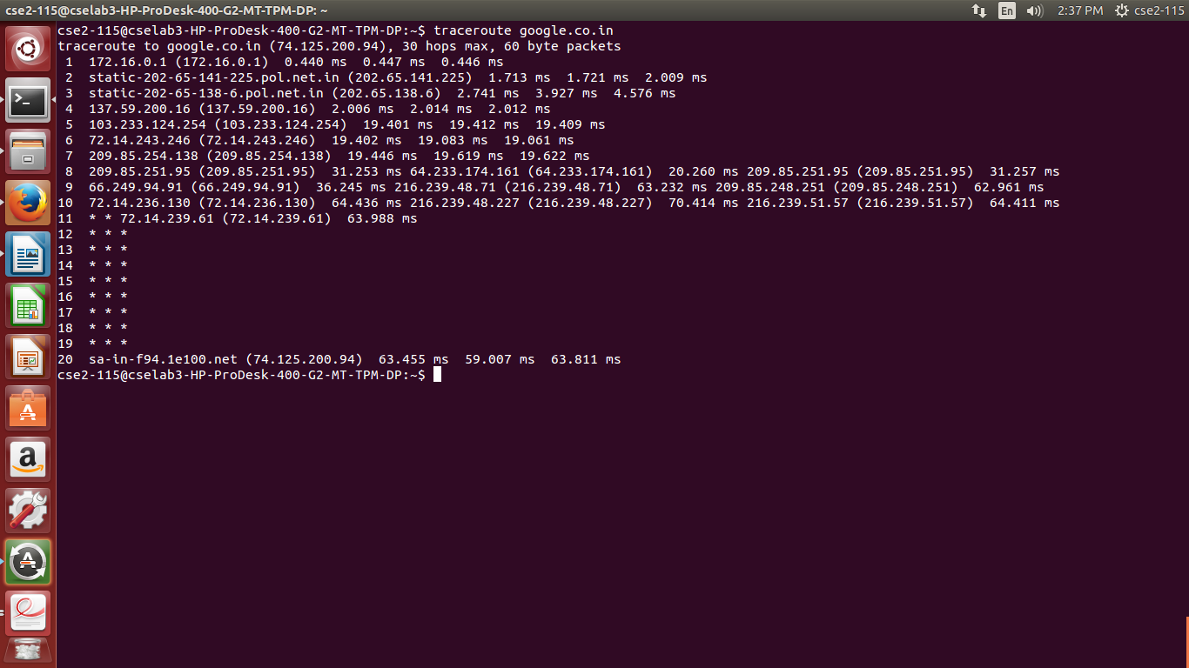
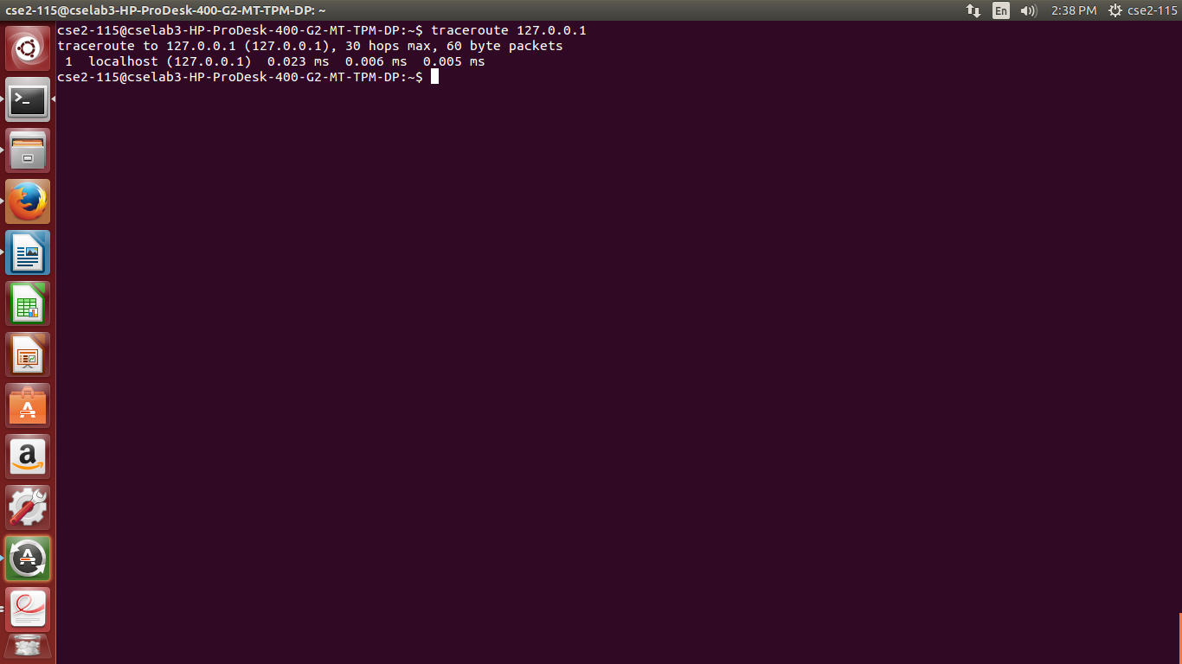
Syntax: ii)traceroute <ipaddress>

3)Ipconfig (Windows)/ifconfig (Linux like Oss):
Allows us to configure or view information about the
network interfaces. It can be used to view all the configured network interfaces, IP addresses, DNS
servers, subnet mask, gateways and other information. We can also enable, disable network interfaces,
and flush the DNS cache, forcing the Operating System to get new IP addresses from the DHCP server. It
helps to troubleshoot network problems. Ex: # nslookup cbit.ac.in
syntax : nslookup <Domain name>
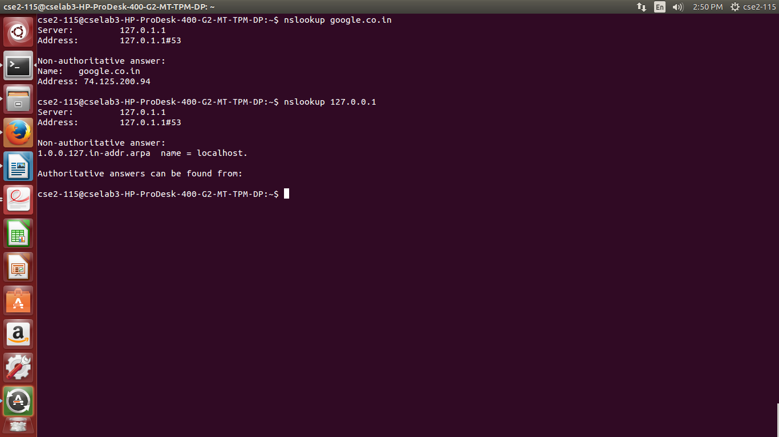

nslookup: Used to look up the IP Addresses associated with a domain name. it also allows us to perform
a reverse lookup to find the domain name associated with an IP address. Ex: # nslookup 210.212.217.73
will show the associate domain name

4)whois:
This command is not associated with Windows. It looks up the registration associated with a
domain name. This can show you more information about who registered and owns a domain name,
including their contact information.
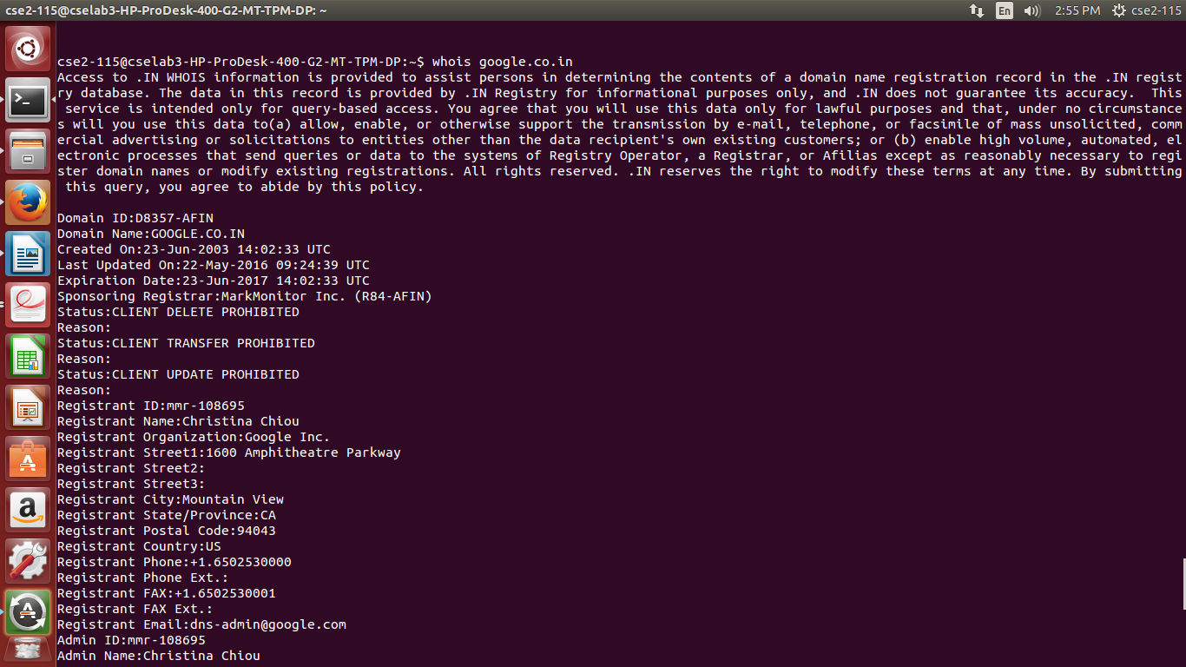
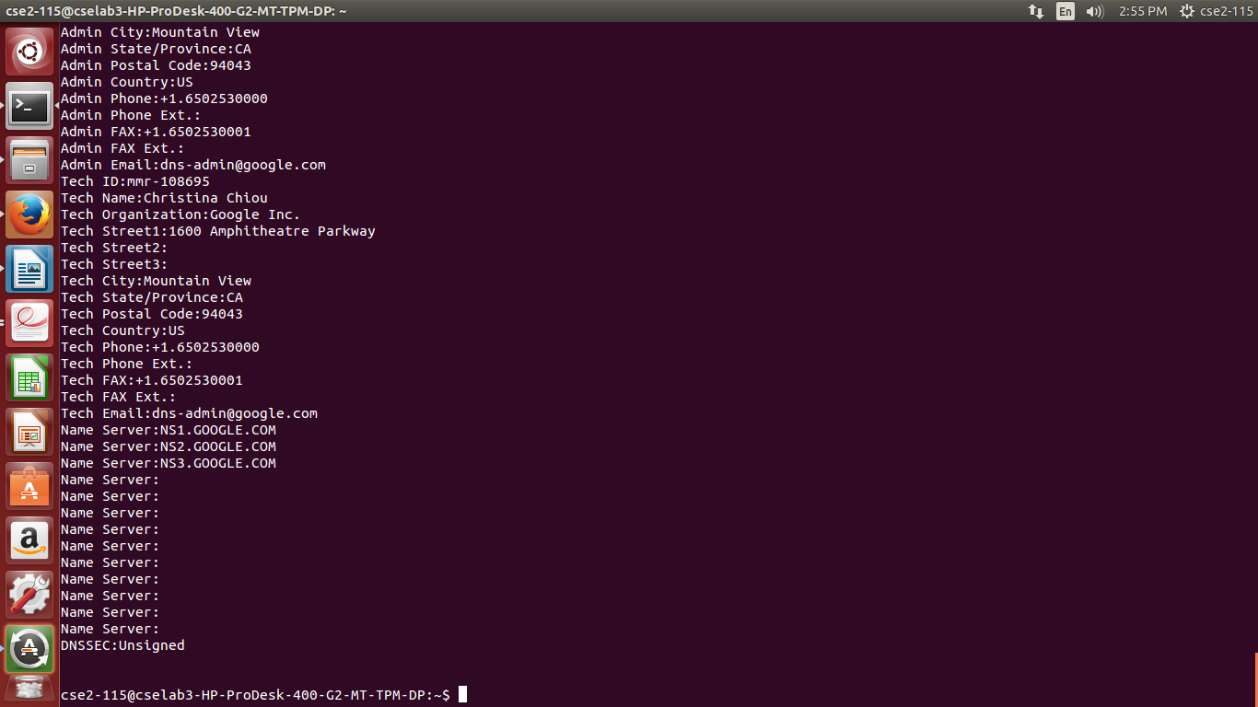

5)netstat:
netstat stands for network statistics. This command displays incoming and outgoing network
connections as well as other network information. It’s available on Windows, Mac, and Linux — each
version has its own command-line options you can tweak to see different types of information.
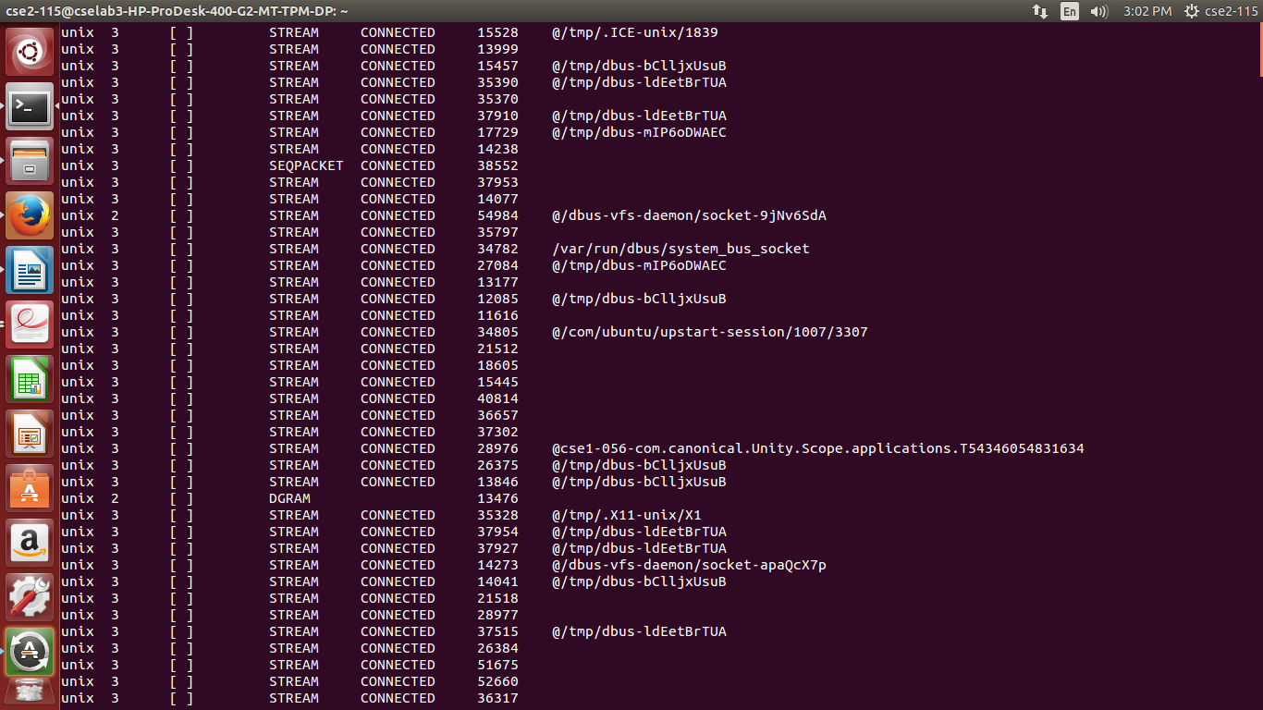
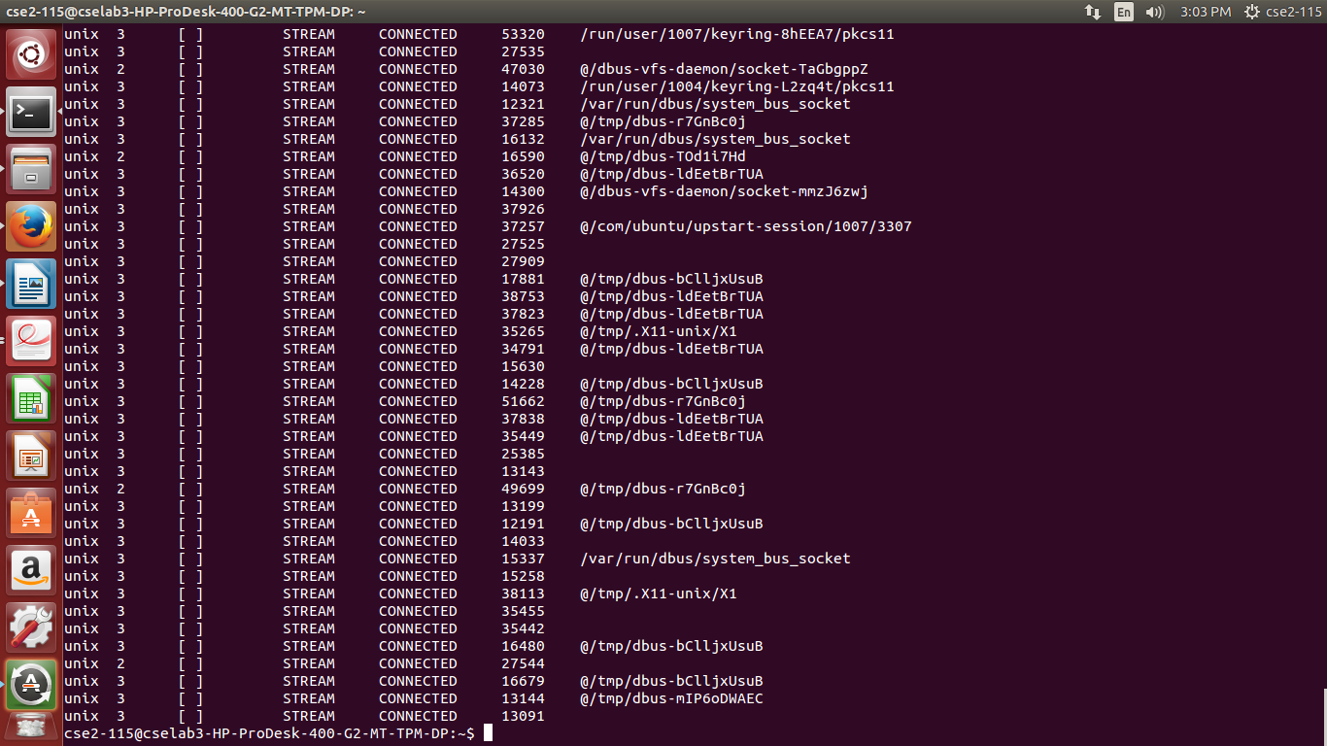
Syntax : $netstat

finger:
It is similar to who command but gives more information than who. The finger command is old
and is no longer widely used
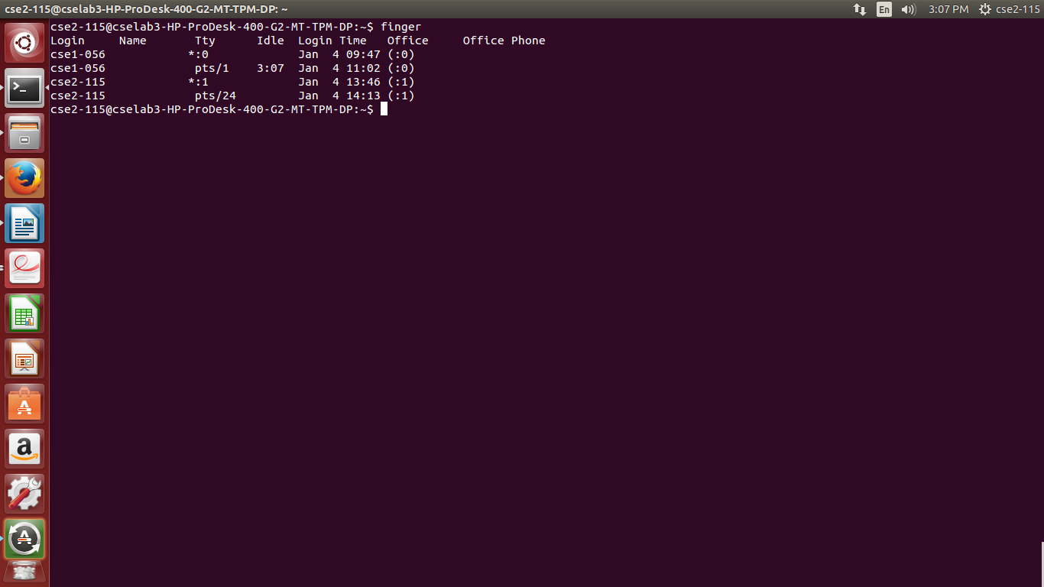
syntax : $finger

Port Scan / nmap:
This utility is a common tool used for port scans, but there are many utilities that can
run this sort of scan. A port scan is the process of attempting to connect to every port on a computer ports 1 through 65535 — and seeing if they’re open. An attacker might port-scan a system to find
vulnerable services or you may port scan our own computer to ensure that there are no vulnerable
services listening to the network.
b.Network-byte order functions:
Computers may not store the data (comprising more than one byte) in the same order. For example, a data item with 16-bit (2bytes) can be stored in two ways:
- Little Endian: In this scheme, low-order byte is stored on the address starting address (A) and
the high-order byte is stored on the next address (A+1).
- Big Endian: In this scheme, high-order byte is stored on the address starting address (A) and the low-order byte is stored on the next address (A+1).
But the network protocols are designed for big-endian notation. To allow the machines to
communicate with different byte-orders, we need conversion functions. the byte-order conversion
functions are:
(i)htons() -Converts a Host-byte(Little-Endian) order short integer into Network byte-order
(ii)htonl() -Converts a Host-byte(Little-Endian) order long integer into Network byte-order
(iii)ntohl() -Converts a Network-byte(Big-Endian) order short integer into Host-byte-order
(iv)ntohs() -Converts a Network-byte(Big-Endian) order short integer into Host-byte-order

1.3 Experimentation results and discussion:
Network components identified in our lab-3 :
i. Hardware information
Configuration of my system -
Network card Type and make
Transmission media and connectors - STAR
Topology and LAN type
Wireless adapters
ii. Network information
Communication protocol suites
Hardware/physical address
IP address
Subnet mask
Gateway
DNS

