StatLab AI: Enterprise Statistical Analysis & Numeric Modeling Platform
Technical User Guide & Operations Manual
1. Architectural Ecosystem Overview
StatLab AI is an elite, client-side analytical workspace engineered for zero-latency numeric modeling, high-throughput distribution processing, and dynamic statistical visualizations. Operating entirely within memory registers to maximize safety and responsiveness, the application eliminates server-side latency by anchoring execution mechanics via Simple-Statistics structural compute engines and Recharts reactive telemetry maps.
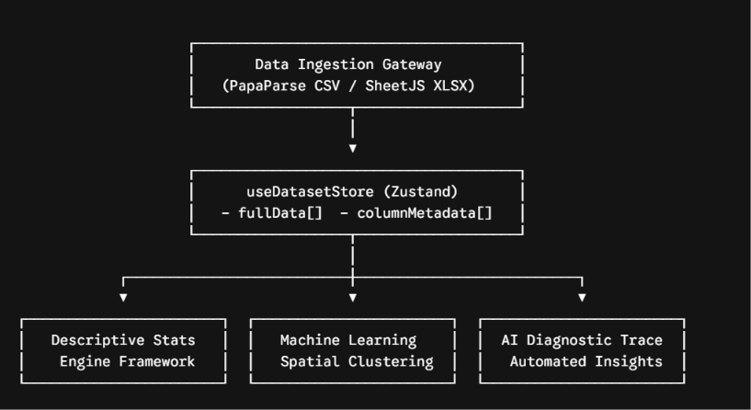
The system data pipeline operates sequentially:
- Ingestion Layer: Raw text or binary matrices are normalized into uniform discrete javascript object arrays.
- State Management Matrix: The reactive memory bus balances data consistency down into structural parameters (fullData, columnMetadata).
- Execution Engines: Analytics, ML clustering pipelines, and simulation frameworks extract vector registers on demand without modifying structural source profiles.
2. Module Functional Workbooks
Module A: Data Ingestion Gateway
- Purpose: High-throughput streaming and normalization of external data payloads.
- Supported Frameworks: Comma-Separated Values (.csv) via papaparse multi-threaded architectures; Excel Workbooks (.xlsx, .xls) via xlsx binary parsing sheets.
- Operations:
  - Drag-and-Drop / File Browsing Input: Evaluates raw file streams and checks extensions.
  - Dynamic Structural Typing: Converts valid text numeric features into localized Floating Point format while mapping text labels into safe categorical string indices.
  - Workspace Preview Area: Generates structured table schemas showing the top 6 preview samples of total parsed datasets.
Module B: Global Distribution Dashboard
- Purpose: Executive overview and quick telemetry tracking of active workspace data characteristics.
- Core Metrics Panels:
  - Total Parsed Observations: Active row pointer indices.
  - Identified Numeric Features: Computed feature arrays flagged as continuous variables.
  - Total Evaluated Actions: Tracking count of computed activities in the session lifecycle log.
- Telemetry Chart Mapping:
  - Continuous Distribution Histogram: Divides numeric parameters into 8 uniform range bins (x0 to x1), measuring item count density.
  - Categorical Distribution Pie Chart: Evaluates categorical features and builds sector divisions based on computed frequency angles ().
Module C: Statistics Engine Core
- Purpose: Classical statistical inference testing, data normality auditing, and Ordinary Least Squares (OLS) regression mapping.
- Analytic Packages:
  - Descriptive Analysis: Computes structural distribution indicators: Mean (), Median (), Interquartile Range (IQR), and Variance ().
  - Hypothesis Verification & ANOVA: Executes one-way variance analyses, independent two-sample checks, and parametric evaluation criteria.
  - OLS Trendline Regression: Maps raw observation parameters to identify relationships and builds structural paths charting Actual vs. Predicted parameters.
Module D: Machine Learning Studio
- Purpose: High-dimensional spatial cluster identification and classification.
- Supported Pipelines:
  - K-Means Partitions: Groups coordinate nodes into spatial quadrants.
  - DBSCAN Density-Based Matrix: Traces cluster formations based on density thresholds and neighborhood minimum bounds.
  - Decision Tree Classification: Trains splitting node axes based on information gain rules.
  - Principal Component Analysis (PCA): Projects high-dimensional data along orthogonal component vectors (PC1/PC2) that capture the highest data variance.
  - Probability Functions (PDF / CDF): Traces feature characteristics against automated Gaussian distribution profiles.
Module E: AI Diagnostic Insights
- Purpose: Automated heuristic data auditing and automated warning logs.
- Diagnostic Actions: Monitors structural symmetry ratios, alerts users to missing cells or values, and warns when categorical vectors show extreme high-cardinality dispersion traits that might impact ML performance.
3. Comprehensive CLI Reference Guide
The programmatic command-line sandbox interaction vectors mirror all primary application actions. Developers can run automated data pipelines through the syntax guide mapped below:
Command Syntax Pattern | Functional Scope | System Expected Terminal Response Example
stattoolkit ingest --file <name.csv> | Parses file matrix data streams directly into the core application state. | [SUCCESS] Parsed file matrix containing 2,500 continuous entries.
stattoolkit analyze descriptive --col <feature> | Extracts selected parameter array and dumps core baseline indicators. | Mean: 42.19 | Median: 39.00 | Variance: 12.4
stattoolkit test t-test --col1 <x> --col2 <y> | Runs independent two-sample t-test verification across parameters. | p-Value: 0.0166 (Reject Null Hypothesis at Alpha 0.05).
stattoolkit train kmeans --k <nodes> --features <list> | Computes spatial clustering coordinates across multiple numeric features. | Convergence optimized successfully in 12 iterations.
stattoolkit transform pca --components <count> | Extracts principal component axes and handles dimensionality reduction. | Component evaluation ready. PC1 explains 54.2% variance.
4. Technical Setup & Deployment Manual
Follow these technical configuration steps to run, compile, and deploy the application environment:
Prerequisites
Ensure the system machine has stable installations of Node.js (v18.0.0 or higher recommended) and npm or yarn package managers.
Step 1: Clone and Dependencies Initialization
Extract the workspace files to a local directory and initialize the software dependencies:
Bash
# Navigate to the project directory
cd statlab-ai-core

# Install required package dependencies
npm install
Step 2: Local Development Execution
Launch the local Vite development server to test features in real time:
Bash
npm run dev
The terminal will output a local address (typically http://localhost:5173). Open this URL in any modern browser to access the system sandbox.
Step 3: Production Code Compilation & Asset Bundling
To generate optimized production build bundles for deployment, trigger the Vite compiler:
Bash
npm run build
This routine audits all TypeScript typings and generates highly compressed, code-split JavaScript, CSS, and HTML assets inside the target /dist export directory.
Step 4: Deployment Options
Because the platform operates entirely client-side, the compiled /dist asset folder can be uploaded directly to any static web hosting provider (e.g., Netlify, Vercel, AWS S3, or GitHub Pages) without needing backend server configuration.

