**SEMISTER 1 RESULT**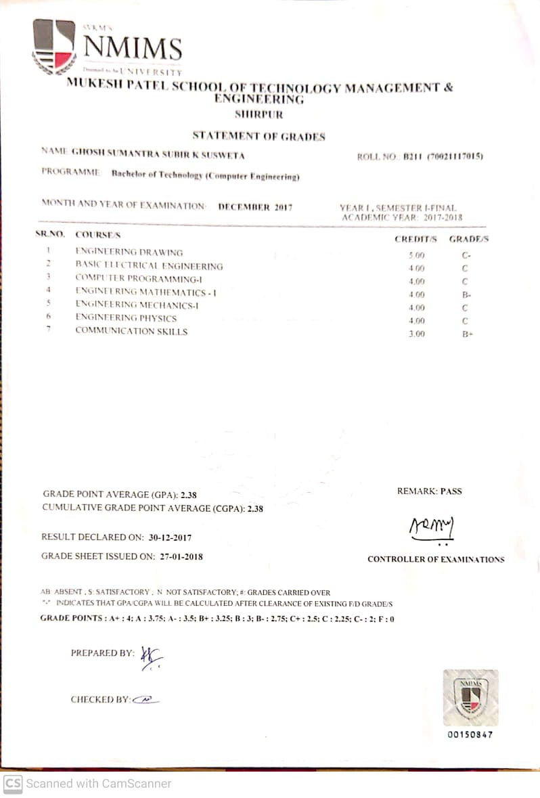

**SEMISTER 2 RESULT** 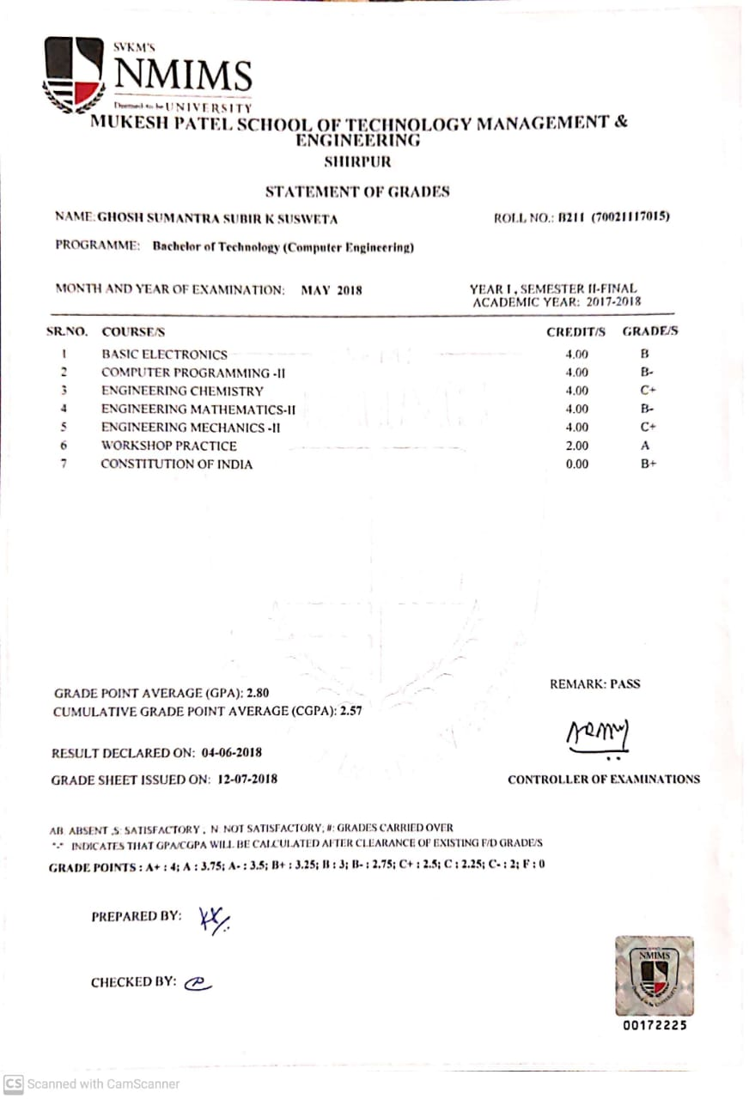

**SEMISTER 3 RESULT** 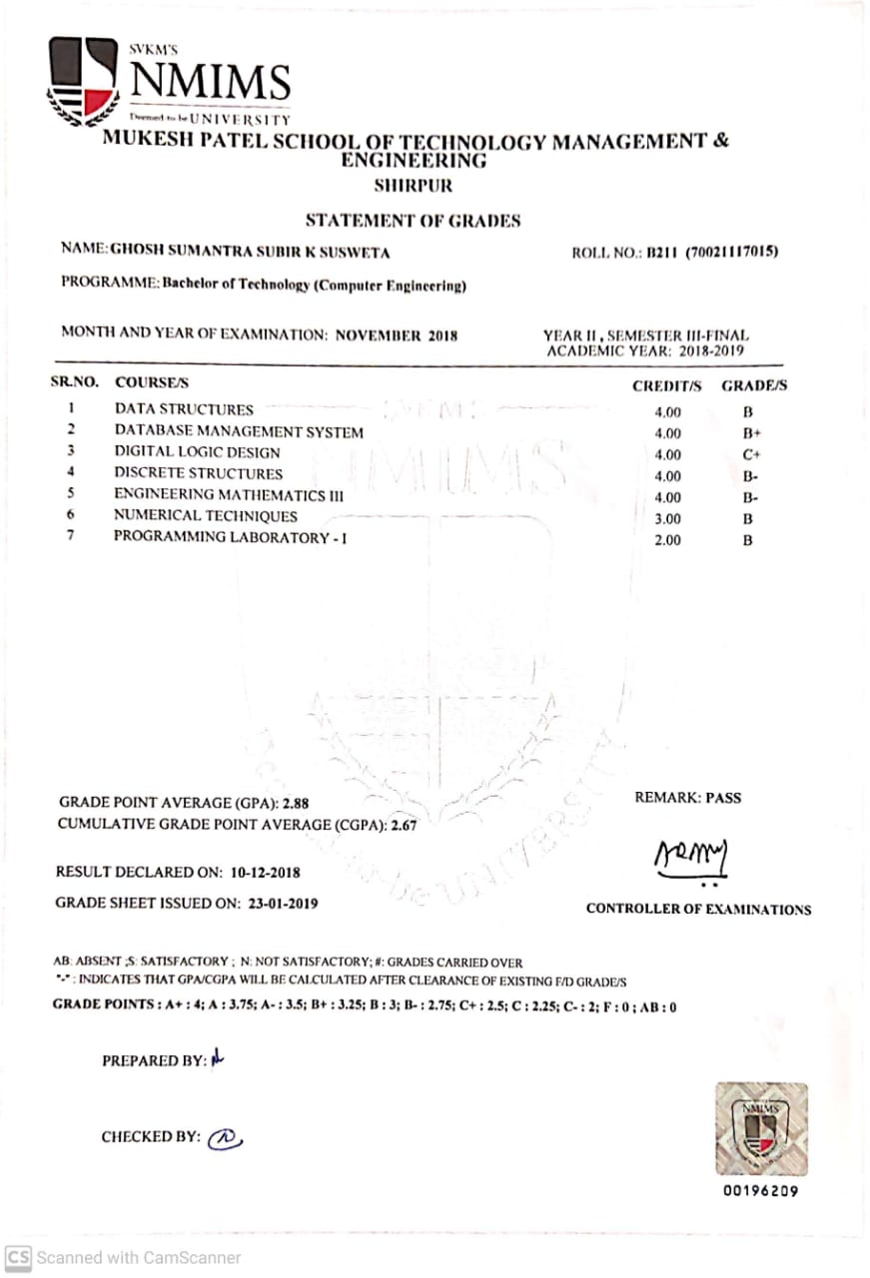

**SEMISTER 4 RESULT**

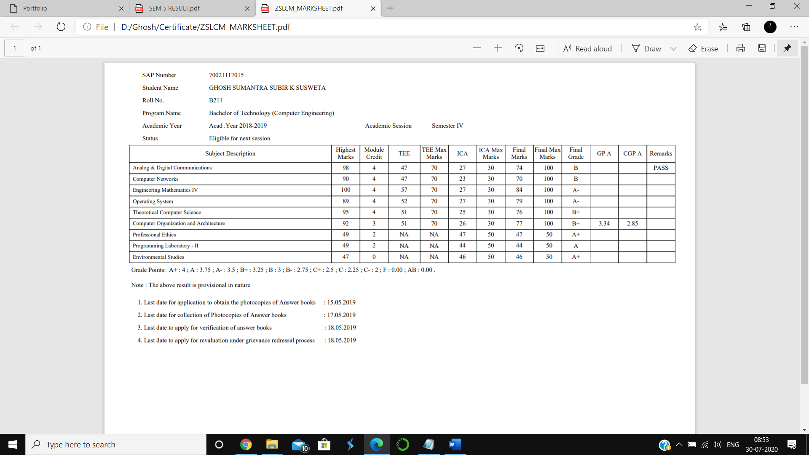

**SEMISTER 5 RESULT**

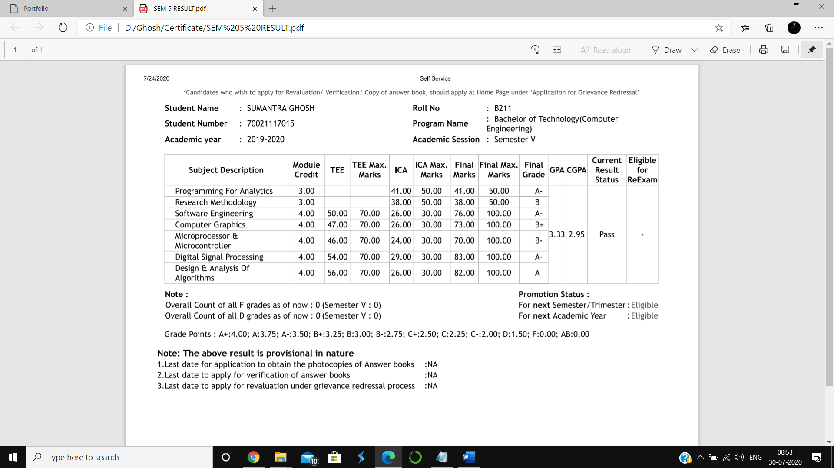

**SEMISTER 6 RESULT**

