IBM SkillsBuild Cyber Security Bootcamp 2026
Conducted by BharatCares
PROJECT REPORT
Automated Web Security Scanner
A Python tool to audit websites for secure-header, cookie and CORS misconfigurations
Submitted by
Suman Vyas
Project Topic: Automated Web Scanner (Cyber Security)
October 2026

Abstract
Security misconfiguration is one of the most common causes of web application compromise and is ranked A05 in the OWASP Top 10 (2021). Missing HTTP security headers, cookies without protective attributes and over-permissive Cross-Origin Resource Sharing (CORS) policies can all be detected automatically, yet many sites still ship with these flaws.
This project presents an Automated Web Security Scanner written in Python. For every target URL the tool audits seven security headers, two information-disclosure headers, the attributes of every cookie set, and runs six CORS probes using crafted Origin headers. Each failed check is classified as High, Medium or Low severity and the site receives a 0-100 score and a letter grade. Results are exported as CSV, JSON and a standalone HTML report, and visualised with charts.
To make the work safe and reproducible, a local test lab of three web servers (vulnerable, partially hardened and hardened) was built. The scanner scored them 0 (F), 59 (D) and 100 (A) respectively, detected every seeded CORS flaw and produced no false positives on the hardened server.
Keywords: web security, HTTP security headers, CORS, cookie security, OWASP, security misconfiguration, Python.

1. Introduction
Web applications are the primary attack surface of modern organisations. While complex vulnerabilities such as SQL injection require careful testing, a large class of weaknesses lies in how the server instructs the browser to behave. HTTP response headers tell the browser whether a page may be framed, which scripts may run, whether HTTPS must be enforced and which foreign origins may read responses. When these instructions are absent or wrong, attacks such as clickjacking, cross-site scripting (XSS), session hijacking and cross-origin data theft become easier.
Manual review of these controls is slow and error-prone, particularly for organisations that operate many sites. An automated scanner that checks the same controls consistently and produces an objective score is therefore valuable for developers, auditors and security operations teams.

1.1 Problem statement
Design and implement a lightweight, automated tool that audits a website for missing or weak security headers, insecure cookies and exploitable CORS configurations, and reports the results in a prioritised, actionable form.

1.2 Objectives
- Detect missing or weakly configured security response headers by validating header values, not only their presence.
- Detect information disclosure through version banners and technology headers.
- Audit every cookie for the Secure, HttpOnly and SameSite attributes.
- Actively probe CORS behaviour with reflected, null, suffix, prefix, wildcard and pre-flight tests.
- Calculate a transparent security score and grade for each target.
- Export results in CSV, JSON and HTML formats and visualise them.
- Validate the scanner against a controlled lab to measure detection accuracy and false positives.

1.3 Scope
The scanner assesses the landing page of each supplied URL using a small number of HTTP GET and OPTIONS requests. It does not crawl, brute-force, exploit or test TLS ciphers. It must only be used against systems the operator owns or is authorised to test.

2. Background

2.1 HTTP security headers
Header | Severity | Protection provided
Strict-Transport-Security | High | Forces HTTPS and defeats SSL-stripping attacks.
Content-Security-Policy | High | Restricts script/content sources; main defence-in-depth against XSS.
X-Frame-Options | Medium | Prevents the page being framed (clickjacking).
X-Content-Type-Options | Medium | Disables MIME sniffing (nosniff).
Referrer-Policy | Low | Limits URL leakage to third parties.
Permissions-Policy | Low | Disables unused browser features such as camera and geolocation.
Cross-Origin-Opener-Policy | Low | Isolates the browsing context from cross-origin windows.

2.2 Cookie attributes
The Secure attribute ensures a cookie is sent only over HTTPS. HttpOnly hides the cookie from JavaScript so that an XSS bug cannot steal the session. SameSite restricts cross-site sending and reduces cross-site request forgery (CSRF) risk.

2.3 Cross-Origin Resource Sharing (CORS)
Browsers enforce the Same-Origin Policy, which stops a page on one origin reading responses from another. CORS lets a server selectively relax this rule using the Access-Control-Allow-Origin (ACAO) and Access-Control-Allow-Credentials (ACAC) headers. The most dangerous misconfiguration is a server that reflects any request Origin into ACAO while also allowing credentials: a malicious website visited by a logged-in victim can then read the victim's private data. Other common errors include trusting the null origin, validating origins with weak string matching (suffix/prefix bypass) and using a wildcard policy.

3. Tools and Technologies
Component | Purpose
Python 3 | Core programming language.
requests | Sends HTTP requests with custom Origin headers and reads raw Set-Cookie headers.
pandas | Stores findings in tables; exports CSV and JSON.
matplotlib | Generates the score and severity charts.
http.server + threading | Builds the three-server local test lab.
Jupyter Notebook | Interactive environment that combines code, results and documentation.

4. System Design

4.1 Workflow
- Load configuration (targets, timeout, output folder).
- For each target send a GET request and collect the response headers and cookies.
- Run the header, disclosure and cookie modules on that response.
- Run the CORS module, which sends additional requests with crafted Origin headers and one OPTIONS pre-flight request.
- Convert every result into a Finding record (target, category, check, status, severity, detail, recommendation).
- Compute the score and grade; build summary tables and charts.
- Export CSV, JSON and HTML reports.

4.2 Scoring model
Every failed check subtracts a penalty from 100: High = 15, Medium = 8, Low = 3, Info = 0. The score cannot fall below zero. Grades are A (90-100), B (80-89), C (65-79), D (50-64) and F (below 50). The model is deliberately simple so that auditors can explain exactly why a site received its score.

4.3 Value validation
A header that is present but weak is still reported. For example, HSTS must have max-age of at least 180 days; a Content-Security-Policy containing unsafe-inline, unsafe-eval or wildcard script sources fails; X-Frame-Options must be DENY or SAMEORIGIN.

5. Implementation
The complete implementation is provided in the Jupyter Notebook Suman_Vyas_WebSecurityScanner.ipynb. The main components are described below.
Function | Responsibility
check_security_headers() | Evaluates HTTPS usage and the seven header rules using per-header validator functions.
check_disclosure() | Flags version numbers in the Server header and any X-Powered-By header.
check_cookies() | Parses each Set-Cookie header and tests Secure, HttpOnly and SameSite.
check_cors() | Sends reflected, null, suffix, prefix and wildcard probes plus an OPTIONS pre-flight; checks Vary: Origin.
scan_target() | Orchestrates all modules for one URL.
compute_score() | Converts failed checks into a score and a grade.
build_html_report() | Creates the standalone HTML report with escaped output.

5.1 CORS probe design
Probe | Origin sent | Reported as vulnerable when
Reflected origin | https://evil.example.com | ACAO equals the attacker origin
Null origin | null | ACAO equals null
Suffix bypass | https://<host>.evil.example.com | ACAO equals the crafted origin
Prefix bypass | https://evil<host> | ACAO equals the crafted origin
Wildcard | https://probe.example.org | ACAO is *
Pre-flight | OPTIONS + DELETE request | Untrusted origin allowed with DELETE/PUT/PATCH
Severity is raised to High when Access-Control-Allow-Credentials: true is also returned, because authenticated data can then be read by the attacker site.

5.2 Safety design
The scanner issues fewer than ten requests per target, does not follow redirects automatically, uses timeouts, never sends exploit payloads and escapes all target-controlled text before writing it into the HTML report to avoid injecting content into the report itself.

6. Test Environment
Scanning real websites without permission is illegal and unethical. A local lab of three Python web servers bound to 127.0.0.1 was therefore created. Each server represents a different security posture.
Server | Configuration
Lab-Vulnerable | No security headers; Server banner with version; X-Powered-By: PHP/5.6.40; session cookie without any flags; reflects any Origin with credentials allowed; permits PUT/DELETE.
Lab-Partial | nosniff and X-Frame-Options present; nginx/1.14.0 banner; cookie with HttpOnly only; wildcard CORS.
Lab-Hardened | Full header set including HSTS, CSP, COOP and Permissions-Policy; generic server banner; Secure+HttpOnly+SameSite=Strict cookie; CORS allow-list with Vary: Origin.

7. Results and Analysis

7.1 Executive summary
Target | Score | Grade | High | Medium | Low | Checks
Lab-Vulnerable | 0 | F | 5 | 5 | 7 | 18
Lab-Partial | 59 | D | 1 | 1 | 6 | 17
Lab-Hardened | 100 | A | 0 | 0 | 0 | 17
A total of 52 checks were executed in about 0.03 seconds.
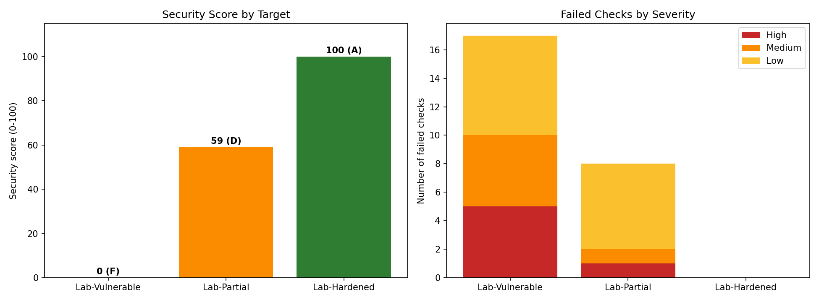
Figure 1: Security score (left) and failed checks by severity (right) per target.

7.2 Findings on Lab-Vulnerable
Category | Check | Severity | Observation
Headers | Content-Security-Policy | High | Header missing.
Headers | X-Frame-Options | Medium | Header missing; clickjacking possible.
Headers | X-Content-Type-Options | Medium | Header missing.
Headers | Referrer-Policy / Permissions-Policy / COOP | Low | Three headers missing.
Disclosure | Server banner, X-Powered-By | Low | Python version and PHP/5.6.40 revealed.
Cookies | sessionid: Secure, HttpOnly | Medium | Cookie has neither protective flag.
Cookies | sessionid: SameSite | Low | Attribute missing.
CORS | Reflected origin | High | Attacker origin trusted with credentials.
CORS | Null origin | High | null trusted with credentials.
CORS | Suffix bypass | High | Crafted host-suffix origin trusted.
CORS | Prefix bypass | High | Crafted host-prefix origin trusted.
CORS | Vary: Origin | Low | Dynamic ACAO without Vary header.
CORS | Pre-flight (DELETE) | Medium | DELETE allowed for untrusted origin.

7.3 Findings on Lab-Partial
The partially hardened server lost points for the missing Content-Security-Policy (High), the missing Secure flag on its cookie (Medium), and six Low findings: three absent headers (Referrer-Policy, Permissions-Policy, COOP), a versioned nginx banner, a missing SameSite attribute and a wildcard CORS policy. Because the wildcard policy does not allow credentials, it was rated Low rather than High.

7.4 Findings on Lab-Hardened
No checks failed; the server obtained 100/A. This confirms that the scanner does not produce false positives when all controls are correctly configured.
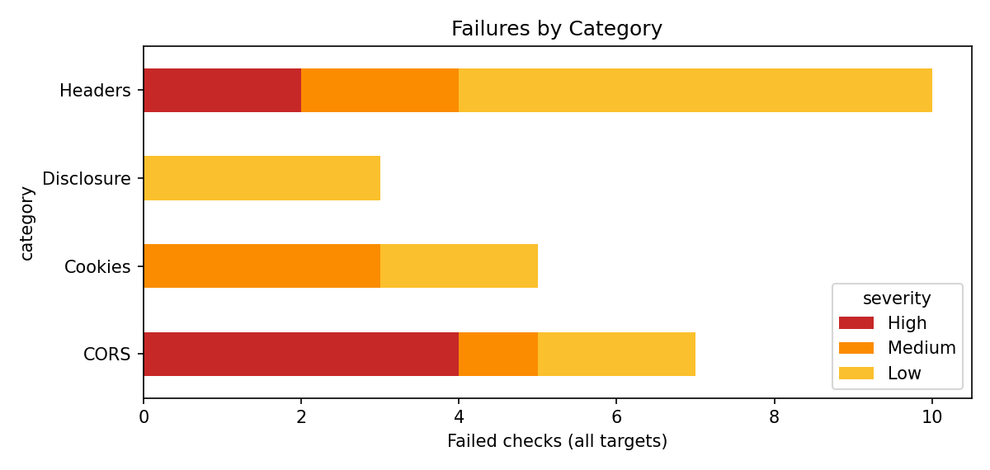
Figure 2: Failed checks grouped by category across all targets.

7.5 Validation
Three automated assertions are included in the notebook and all passed:
- Score ordering: Vulnerable (0) < Partial (59) < Hardened (100).
- No failed checks on the hardened server (zero false positives).
- Reflected-origin and null-origin CORS flaws were detected on the vulnerable server.

7.6 Recommendations produced
For every failed check the tool prints a remediation, for example: add Strict-Transport-Security: max-age=31536000; includeSubDomains; use a strict Content-Security-Policy; set cookies with Secure, HttpOnly and SameSite; replace reflected CORS origins with an exact allow-list; remove version information from Server and X-Powered-By.

8. Limitations and Ethical Considerations
- Only the landing page is assessed; other pages may use different headers.
- The scanner reports configuration weaknesses; it does not prove an exploit is possible.
- TLS protocol and certificate quality are outside the current scope.
- Some headers (e.g. COOP) are recommendations that may not suit every application, so Low-severity findings should be reviewed in context.
- The tool must only be used with explicit authorisation. The included local lab allows full demonstration without any third-party risk.

9. Future Work
- Add TLS/certificate analysis (expiry, protocol versions, cipher suites).
- Crawl multiple pages and authenticated areas.
- Accept target lists from a file and run scheduled scans.
- Forward the JSON output to a SIEM such as Wazuh for alerting and dashboards.
- Add a command-line interface and CI/CD integration so builds fail on High findings.

10. Conclusion
The project met its objectives. The Automated Web Security Scanner detects missing and weak security headers, insecure cookies, information disclosure and multiple classes of CORS misconfiguration, scores each target transparently and exports reports in three formats. Validation against a controlled three-server lab showed correct ranking of the targets, detection of all seeded flaws and no false positives. The work demonstrates how routine security misconfigurations can be found quickly and consistently with a small amount of Python code, and it provides a practical foundation for integration into DevSecOps and monitoring workflows.

References
[1] OWASP Foundation, OWASP Secure Headers Project. https://owasp.org/www-project-secure-headers/
[2] OWASP Foundation, OWASP Top 10:2021 - A05 Security Misconfiguration. https://owasp.org/Top10/A05_2021-Security_Misconfiguration/
[3] Mozilla Developer Network, Cross-Origin Resource Sharing (CORS). https://developer.mozilla.org/docs/Web/HTTP/CORS
[4] PortSwigger Web Security Academy, Cross-origin resource sharing (CORS). https://portswigger.net/web-security/cors
[5] Python Software Foundation, Python documentation (http.server, threading). https://docs.python.org/3/
[6] Requests: HTTP for Humans. https://requests.readthedocs.io/

Appendix A - How to run the project
pip install -r requirements.txt
jupyter notebook Suman_Vyas_WebSecurityScanner.ipynb
Kernel > Restart & Run All
Open the output/ folder for CSV, JSON, HTML and PNG results.

