Experiment 3

Student Name: Sumanyu Seth UID: 25MCI10040
Branch: MCA (AI & ML) Section/Group: 25MAM_KAR-1_A
Semester: II Date of Performance: 27/01/26
Subject Name: Technical Training Subject Code: 25CAP-652

Aim / Overview of the Practical: To implement conditional decision-making logic in PostgreSQL using IF–ELSE constructs and CASE expressions for classification, validation, and rule-based data processing.

Software Requirements:
● PostgreSQL
Objectives:

To understand conditional execution in SQL

To implement decision-making logic using CASE expressions

To simulate real-world rule validation scenarios

To classify data based on multiple conditions

To strengthen SQL logic skills required in interviews and backend system

Theory

In real-world database systems, data often needs to be validated, categorized, or transformed based on business rules. Conditional logic allows the database to make decisions dynamically instead of relying solely on application-layer logic.

PostgreSQL supports conditional logic mainly through:

CASE Expressions (used inside SELECT, UPDATE, INSERT)

IF–ELSE constructs (used inside PL/pgSQL blocks such as functions and procedures)

CASE Expression

Evaluates conditions sequentially

Returns a value based on the first true condition

Can be used in SELECT, UPDATE, ORDER BY, and WHERE clauses

Types of CASE

Simple CASE → compares expressions

Searched CASE → evaluates boolean conditions

Conditional logic is heavily used in:

Data classification (grades, salary slabs)

Violation detection

Status mapping

Business rule enforcement

Companies like Amazon, SAP, Oracle, and Adobe frequently test CASE-based logic in SQL interviews.

Experiment / Practical Steps:

Prerequisite Understanding
Students should first create a table that stores:
- A unique identifier
- A schema or entity name
- A numeric count representing violations or issues
Populate the table with multiple records having different violation counts.

Step 1: Classifying Data Using CASE Expression
Task for Students:
- Retrieve schema names and their violation counts.
- Use conditional logic to classify each schema into categories such as:
  - No Violation
  - Minor Violation
  - Critical Violation
Learning Focus:
- Using searched CASE
- Sequential condition checking
- Real-world compliance reporting logic

Step 2: Applying CASE Logic in Data Updates
Task for Students:
- Add a new column to store approval status.
- Update this column based on violation count using conditional rules such as:
  - Approved
  - Needs Review
  - Rejected
Learning Focus:
- Automating decisions inside the database
- Reducing application-side logic
- Using CASE inside UPDATE statements

Step 3: Implementing IF–ELSE Logic Using PL/pgSQL
Task for Students:
- Use a procedural block instead of a SELECT statement.
- Declare a variable representing violation count.
- Display different messages based on the value of the variable using IF–ELSE logic.
Learning Focus:
- Understanding procedural SQL
- ELSE-IF ladder execution
- Backend validation logic in stored procedures

Step 4: Real-World Classification Scenario (Grading System)
Task for Students:
- Create a table to store student names and marks.
- Classify students into grades based on their marks using conditional logic.
Learning Focus:
- Common interview use case
- Data categorization
- Rule-based evaluation

Step 5: Using CASE for Custom Sorting
Task for Students:
- Retrieve schema details.
- Apply conditional priority while sorting records based on violation severity.
Learning Focus:
- Advanced CASE usage
Custom ordering logic and Dashboard and reporting scenarios

Practical / Experiment Steps:
create table my_schemas (
id serial primary key,
schema_name varchar(50),
violation_count int
);

insert into my_schemas (schema_name, violation_count) values
('alpha', 0),
('beta', 2),
('gamma', 5),
('delta', 10),
('epsilon', 1);

SELECT * from my_schemas;
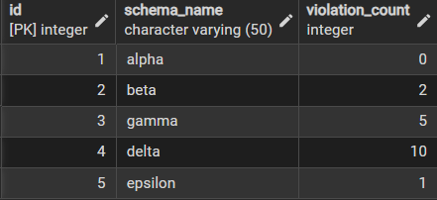

Step 1 : Classifying data using case expression
select
schema_name,
violation_count,
case
when violation_count = 0 then 'no violation'
when violation_count between 1 and 3 then 'minor violation'
else 'critical violation'
end as violation_status
from my_schemas;
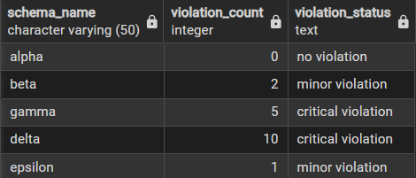

Step 2: Applying CASE Logic in Data Updates
update my_schemas
set approval_status = case
when violation_count = 0 then 'approved'
when violation_count between 1 and 3 then 'needs review'
else 'rejected'
end;
select * from my_schemas;

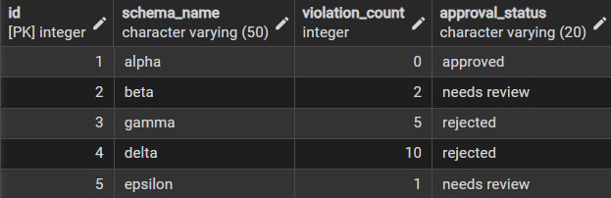

Step 3: Implementing IF–ELSE Logic Using PL/pgSQL

do $$
declare
v_count int := 3;
begin
if v_count = 0 then
raise notice 'no violation';
elsif v_count between 1 and 3 then
raise notice 'minor violation';
else
raise notice 'critical violation';
end if;
end;
$$;
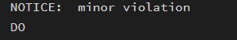
do $$
declare
v_count int := 0;
begin
if v_count = 0 then
raise notice 'no violation';
elsif v_count between 1 and 3 then
raise notice 'minor violation';
else
raise notice 'critical violation';
end if;
end;
$$;
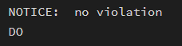

do $$
declare
v_count int := 6;
begin
if v_count = 0 then
raise notice 'no violation';
elsif v_count between 1 and 3 then
raise notice 'minor violation';
else
raise notice 'critical violation';
end if;
end;
$$;
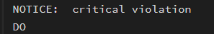

Step 4: Grading system
create table student_marks (
id serial primary key,
student_name varchar(50),
marks int
);

insert into student_marks (student_name, marks) values
('amit', 85),
('bobby', 60),
('chaman', 40),
('daksh', 95);
select
student_name,
marks,
case
when marks >= 80 then 'grade a'
when marks >= 60 then 'grade b'
when marks >= 40 then 'grade c'
else 'fail'
end as grade
from student_marks;
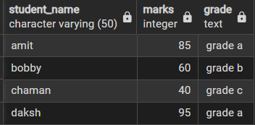

Step 5: Custom sorting
select
schema_name,
violation_count
from my_schemas
order by case
when violation_count = 0 then 1
when violation_count between 1 and 3 then 2
else 3
end;
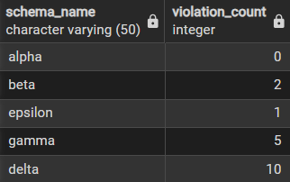

Learning Outcomes:

Understand how to classify records using simple case expressions.

Learn to automate approval logic directly inside update statements.

Practice writing if–else blocks in pgsql for backend validation.

Apply conditional rules to grade students based on marks.

Explore custom sorting with case for reporting and dashboards.

