Experiment 2

Student Name: Sumanyu Seth UID: 25MCI10040
Branch: MCA (AI & ML) Section/Group: 25MAM_KAR-1_A
Semester: II Date of Performance: 20/01/26
Subject Name: Technical Training Subject Code: 25CAP-652

Title
Implementation of SELECT Queries with Filtering, Grouping and Sorting in PostgreSQL

Aim
To implement and analyze SQL SELECT queries using filtering, sorting, grouping, and aggregation concepts in PostgreSQL for efficient data retrieval and analytical reporting.

Objectives
- To retrieve specific data using filtering conditions
- To sort query results using single and multiple attributes
- To perform aggregation using grouping techniques
- To apply conditions on aggregated data
- To understand real‑world analytical queries commonly asked in placement interviews

Practical:

Step 1: Database and Table Preparation
create table orders (
order_id serial primary key,
customer_name varchar(50),
product varchar(50),
quantity int,
price numeric(10,2),
order_date date
);
insert into orders (customer_name, product, quantity, price, order_date) values
('amit', 'laptop', 1, 65000, '2024-01-10'),
('neha', 'mobile', 2, 40000, '2024-01-12'),
('rohan', 'tablet', 1, 25000, '2024-01-15'),
('simran', 'laptop', 1, 70000, '2024-01-18'),
('ankit', 'mobile', 3, 60000, '2024-01-20'),
('pooja', 'headphones', 2, 5000, '2024-01-22'),
('rahul', 'tablet', 2, 48000, '2024-01-25');

Step 2: Filtering Data Using Conditions
select * from orders where price > 50000;
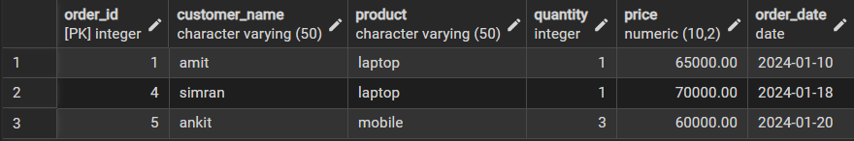

select customer_name, product, price from orders where price > 30000 and quantity >= 2;
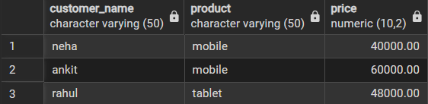

Step 3: Sorting Query Results
select customer_name, product, price from orders order by price asc;
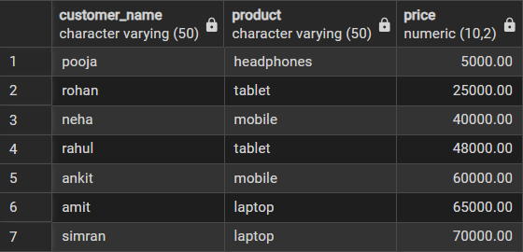

select customer_name, product, price from orders order by price desc;
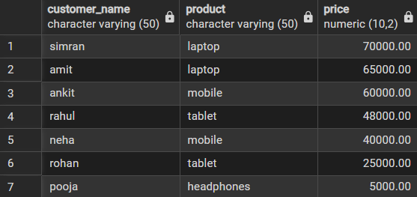

select customer_name, product, price, quantity from orders order by product asc, price desc;
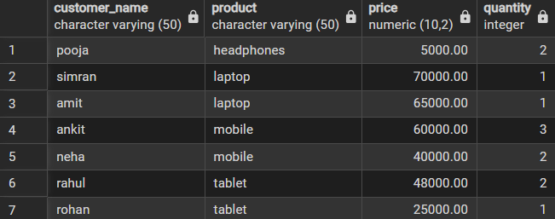

Step 4: Grouping Data for Aggregation
select product, sum(price) as total_sales from orders group by product;
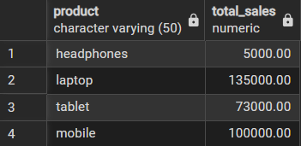

select product, sum(quantity) as total_quantity from orders group by product;
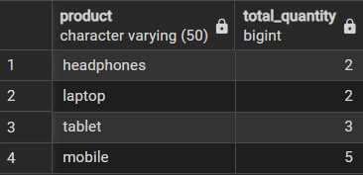

Step 5: Applying Conditions on Aggregated Data
select product, sum(price) as total_sales from orders group by product having sum(price) > 50000;
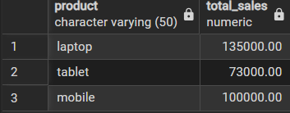

Step 6: Conceptual Understanding of Filtering vs Aggregation Conditions
select product, sum(price) from orders where sum(price) > 50000 group by product;

select product, sum(price) from orders group by product having sum(price) > 50000;
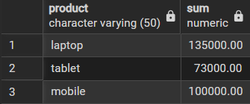

Learning Outcomes
● Understand how conditional filtering is used to retrieve only relevant records from a database.
● Explain how sorting enhances the readability and usefulness of query results in reports.
● Apply grouping techniques to organize data for analytical and summary purposes.
● Distinguish clearly between row-level conditions and group-level conditions using appropriate sql clauses.
● Develop confidence in writing analytical sql queries applicable to real-world database scenarios.
● Demonstrate improved readiness for placement and interview questions related to filtering, grouping, and aggregation concepts.

