Experiment 1.1

Student Name: Sumanyu Seth UID: 25MCI10040
Branch: MCA (AI & ML) Section/Group: 25MAM_KAR-1_A
Semester: II Date of Performance: 12/01/26
Subject Name: Technical Training Subject Code: 25CAP-652

AIM:

To design and implement a sample database system using DDL, DML, and DCL commands, including database creation, data manipulation, schema modification, and role-based access control to ensure data integrity and secure, read-only access for authorized users.
S/W Requirement: Oracle Database Express Edition and pgAdmin

Objective :
To gain practical experience in implementing Data Definition Language (DDL), Data Manipulation Language (DML), and Data Control Language (DCL) operations in a real database environment. This will also include implementing role-based privileges to secure data.
An organization wants to design a sample database system to manage Departments, Employees, and Projects. The database must ensure data integrity, controlled access, and proper privilege management for different users.

Requirements:
- Database Design
  - Create multiple tables such as Department, Employee, and Project.
  - Define appropriate PRIMARY KEY and FOREIGN KEY constraints.
  - Enforce NOT NULL, UNIQUE, and CHECK constraints where necessary.
- Data Manipulation
  - Insert sample records into all tables.
  - Perform UPDATE operations to modify existing records.
  - Perform DELETE operations while maintaining referential integrity.
- Access Control & Security
  - Create a role/user for a reporting staff member.
  - Grant ONLY SELECT privilege on required tables to this role/user.
  - Explicitly REVOKE CREATE privilege so that the user cannot create any database objects.
  - Ensure the user has read-only access to the database.
- Schema Modification
  - Use ALTER TABLE to add or modify a column.
  - Drop a table that is no longer required using DROP TABLE.
Implementation/Code:

CREATE TABLE Department ( dept_id INT PRIMARY KEY, dept_name VARCHAR(50) NOT NULL UNIQUE, location VARCHAR(50) );

CREATE TABLE Employee ( emp_id INT PRIMARY KEY, emp_name VARCHAR(50) NOT NULL, salary INT CHECK (salary > 0), dept_id INT, CONSTRAINT fk_dept FOREIGN KEY (dept_id) REFERENCES Department(dept_id) ON DELETE SET NULL );

CREATE TABLE Project ( project_id INT PRIMARY KEY, project_name VARCHAR(50) NOT NULL, dept_id INT NOT NULL, CONSTRAINT fk_project_dept FOREIGN KEY (dept_id) REFERENCES Department(dept_id) );

INSERT INTO Department VALUES (1, 'HR', 'Delhi');
INSERT INTO Department VALUES (2, 'IT', 'Bangalore');
INSERT INTO Department VALUES (3, 'Finance', 'Mumbai');
INSERT INTO Employee VALUES (101, 'Amit', 50000, 2);
INSERT INTO Employee VALUES (102, 'Riya', 45000, 1);
INSERT INTO Employee VALUES (103, 'Karan', 60000, 2);

INSERT INTO Project VALUES (201, 'Payroll System', 1);
INSERT INTO Project VALUES (202, 'Website Upgrade', 2);

UPDATE Employee SET salary = 55000 WHERE emp_id = 101;

DELETE FROM Department WHERE dept_id = 3;

CREATE ROLE reporting_staff LOGIN PASSWORD 'reportS1' ;

GRANT SELECT ON Department TO reporting_staff;
GRANT SELECT ON Employee TO reporting_staff;
GRANT SELECT ON Project TO reporting_staff;

REVOKE CREATE ON SCHEMA public FROM reporting_staff;

ALTER TABLE Employee ADD email VARCHAR(50);

DROP TABLE Project;

OUTPUT:
SELECT * FROM department;
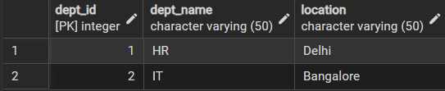
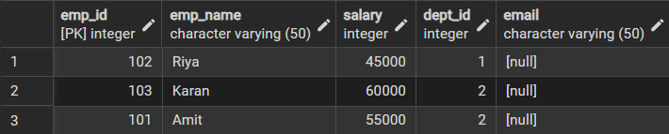
SELECT * FROM employee;

LEARNING OUTCOMES:
- Design a relational database using proper table structure and relationships.
- Apply DDL commands to create, alter, and drop database objects.
- Use DML commands to insert, update, and delete records while maintaining data integrity.
- Implement PRIMARY KEY and FOREIGN KEY constraints to enforce referential integrity.
- Understand and apply CHECK, NOT NULL, and UNIQUE constraints effectively.
- Implement role-based access control using DCL commands.
- Grant and revoke privileges to ensure secure, read-only access for authorized users.
- Gain hands-on experience with database security and schema modification.

