Experiment 7
Student Name: Sumanyu Seth UID: 25MCI10040
Branch: MCA (AI & ML) Section/Group: 25MAM_KAR-1_A
Semester: II Date of Performance: 24/02/26
Subject Name: Technical Training Subject Code: 25CAP-652

Experiment Aim: To understand and implement different types of SQL joins (INNER, LEFT, RIGHT, SELF, CROSS) in PostgreSQL for retrieving meaningful relationships between students, courses, and departments.
Objectives:
- Demonstrate how INNER JOIN retrieves common records between tables.
- Use LEFT JOIN to identify students without course enrollment.
- Apply RIGHT JOIN to display all courses, even those without students.
- Explore SELF JOIN / multiple joins to connect students with their department information.
- Implement CROSS JOIN to generate all possible student-course combinations.

Experiment Steps:
- Write queries to list students with their enrolled courses (INNER JOIN).
SELECT s.student_id, s.student_name, c.course_name
FROM students s
INNER JOIN enrollments e ON s.student_id = e.student_id
INNER JOIN courses c ON e.course_id = c.course_id;
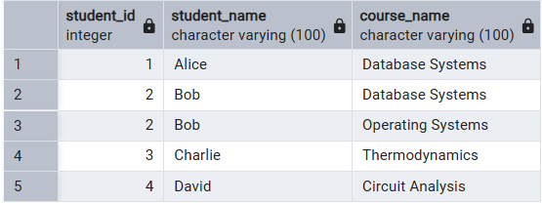
- Find students not enrolled in any course (LEFT JOIN).
SELECT s.student_id, s.student_name
FROM students s
LEFT JOIN enrollments e ON s.student_id = e.student_id
WHERE e.course_id IS NULL;
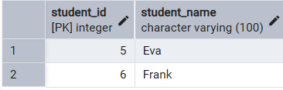
- Display all courses with or without enrolled students (RIGHT JOIN).
SELECT c.course_id, c.course_name, s.student_name
FROM students s
RIGHT JOIN enrollments e ON s.student_id = e.student_id
RIGHT JOIN courses c ON e.course_id = c.course_id;
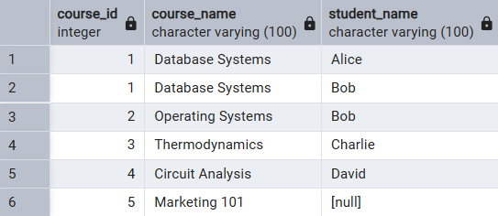
- Show students with department info using SELF JOIN or multiple joins.
SELECT s.student_id, s.student_name, d.department_name
FROM students s
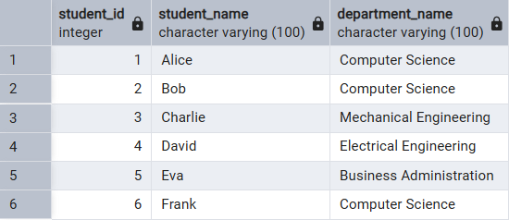
INNER JOIN departments d ON s.department_id = d.department_id;
- Display all possible student-course combinations (CROSS JOIN). (Oracle, SAP, IBM, Microsoft)
student_name | course_name
Alice | Database Systems
Bob | Database Systems
Charlie | Database Systems
David | Database Systems
Eva | Database Systems
Frank | Database Systems
Alice | Operating Systems
Bob | Operating Systems
Charlie | Operating Systems
David | Operating Systems
Eva | Operating Systems
Frank | Operating Systems
Alice | Thermodynamics
Bob | Thermodynamics
Charlie | Thermodynamics
David | Thermodynamics
Eva | Thermodynamics
Frank | Thermodynamics
Alice | Circuit Analysis
Bob | Circuit Analysis
Charlie | Circuit Analysis
David | Circuit Analysis
Eva | Circuit Analysis
Frank | Circuit Analysis
Alice | Marketing 101
Bob | Marketing 101
Charlie | Marketing 101
David | Marketing 101
Eva | Marketing 101
Frank | Marketing 101
SELECT s.student_name, c.course_name
FROM students s
CROSS JOIN courses c;

Outcomes:
- Gain practical knowledge of different SQL joins (INNER, LEFT, RIGHT, SELF, CROSS).
- Learn how to retrieve, combine, and analyze data across multiple tables.
- Develop skills to identify missing or related data using joins.

