DATA SCIENCE INITIATIVE CHARTER & TECHNICAL SPECIFICATION
ChurnGuard AI: Predictive Customer Churn Intelligence & Retention Strategy Engine
A Comprehensive End-to-End Architectural Blueprint, Scientific Methodology, 32.5-Hour Implementation Timeline, and Risk Governance Framework for Enterprise SaaS Retention
Author: Lead Data Science Architect | Milestone: Week 1 Deliverable | Target Stack: Python 3.12+ | Effort: 32.5 Working Hours

■ EXECUTIVE INITIATIVE OVERVIEW
ChurnGuard AI establishes an enterprise-grade, machine-learning-driven customer intelligence system. By systematically synthesizing multi-source behavioral telemetry, billing milestones, and customer support sentiment, the platform shifts organizational posture from reactive fire-fighting to proactive, automated retention intervention. This document articulates the complete strategic, methodological, and architectural roadmap required to execute the initiative within a rigorous 32.5-hour development framework.

Project Codename | ChurnGuard AI (Enterprise Customer Retention & Lifetime Value Optimization)
Strategic Objective | Mitigate recurring revenue loss by detecting high-risk churn signals 60-90 days prior to contract renewal
Target Stakeholders | Chief Revenue Officer (CRO), VP of Customer Success, Retention Marketing, CRM Operations
Primary Technical Stack | Python 3.12, Scikit-Learn, LightGBM, XGBoost, Optuna, SHAP, Feast, Great Expectations, MLflow
Target Timeframe & Budget | 32.5 Hours allocated across 6 progressive development phases (Week 1 Milestone)

1. Project Background, Motivation & Problem Justification
1.1 The Business Problem: The Silent Attrition of Recurring Revenue
In high-growth subscription-based business models (Software-as-a-Service, subscription streaming, and cloud platforms), revenue sustainability depends critically on compound customer retention. While top-of-funnel customer acquisition often receives the majority of sales and marketing investment, customer churn represents an insidious economic drain. In modern SaaS enterprises, customer churn manifests across two distinct vectors: voluntary churn (active cancellations driven by perceived lack of value, unmet feature expectations, competitor migration, or customer dissatisfaction) and involuntary churn (passive cancellations driven by payment gateway failures, expired credit cards, or billing friction).
The core operational failure in modern subscription businesses is not a lack of data, but the lack of an intelligent, predictive translation mechanism. Companies routinely collect gigabytes of behavioral clickstreams, CRM activity logs, billing records, and support tickets. However, this telemetry remains siloed. Customer Success teams frequently discover that an enterprise account is unhappy only when the formal non-renewal notice is submitted—at which point the probability of saving the account drops below 10%. ChurnGuard AI directly bridges this gap by transforming passive, disparate data points into an early-warning predictive mechanism.
1.2 Economic Motivation & Strategic Justification
The financial justification for prioritizing customer retention over acquisition is corroborated by extensive empirical benchmarks:
- The Asymmetric Cost of Acquisition vs. Retention: According to research by Bain & Company and the Harvard Business Review, acquiring a new customer is between 5 to 7 times more expensive than retaining an existing account. Customer Acquisition Cost (CAC) payback periods frequently exceed 14 to 18 months; premature churn guarantees that the business permanently loses money on the acquired customer cohort.
- Compound LTV Amplification: A mere 5% increase in customer retention rates correlates with a 25% to 95% increase in cumulative operating profits. Retained customers demonstrate expanding Customer Lifetime Value (CLV), higher likelihood of annual expansion/up-sell, and lower servicing costs.
- Lead Time for Actionable Intervention: Machine learning models identify behavioral degradation patterns (e.g., dropping active seats, decreasing session frequency, unresolved support tickets) 60 to 90 days before renewal deadlines, providing Customer Success Managers with sufficient lead time to conduct high-touch recovery playbooks.
1.3 Target Personas & Cross-Functional Stakeholders
The implementation of ChurnGuard AI impacts a broad ecosystem of organizational stakeholders:
- Executive Leadership (CRO / CFO): Requires macro-level cohort churn forecasting, ARR risk exposure summaries, and net retention rate (NRR) projections to ensure board-level transparency.
- Customer Success Managers (CSMs): Require granular, account-level churn risk probability scores accompanied by explicit feature attributions (SHAP explainability) to drive high-touch outreach.
- Lifecycle & Growth Marketing: Requires automated risk tier segmentation to trigger personalized, automated re-onboarding campaigns, tailored tutorials, and promotional incentives.
- Data Engineering & MLOps: Requires reproducible, containerized pipelines with data quality monitoring, drift detection, and automated model governance.
2. Project Objectives, Scope Definition & Success Criteria
2.1 Primary Project Objectives
The ChurnGuard AI initiative is governed by measurable technical and business milestones:
- High-Discrimination Predictive Modeling: Develop and validate a supervised classification pipeline achieving an Area Under the Receiver Operating Characteristic (ROC-AUC) >= 0.86 and a Precision-Recall AUC (PR-AUC) >= 0.65 on out-of-time test cohorts exhibiting class imbalance (~12% churn rate).
- Explainable AI (XAI) Transparency: Deliver instantaneous, localized feature attributions for 100% of at-risk accounts using TreeSHAP algorithms, ensuring Customer Success understands the exact root causes (e.g., login drops, open tickets) driving churn risk.
- Cost-Sensitive Utility Optimization: Establish an optimal decision threshold (t*) based on real enterprise unit economics—balancing outreach cost (C_outreach), customer lifetime value (CLV), and intervention success rate (P_success)—rather than relying on arbitrary 0.5 probability cutoffs.
- Standardized Pipeline Architecture: Package the complete pipeline using modular Python best practices, scikit-learn Transformers, and MLflow model registry specifications.
2.2 In-Scope vs. Out-of-Scope Work Boundaries
Maintaining rigorous scope boundaries is paramount to successfully completing the initiative within the 32.5-hour envelope. The boundary matrix below demarcates commitments:
Functional Domain | In-Scope Commitments | Out-of-Scope Exclusions
Data Ingestion & Synthesis | Multi-source historical batch ingestion, synthetic dataset architecture, data validation schema, missing value imputation. | Real-time sub-millisecond edge event streaming (Kafka cluster operations), direct production database schema migrations.
Feature Engineering | RFM behavioral indicators, rolling 30/60/90-day deltas, support ticket sentiment tags, categorical encoding, feature selection. | Computer vision analysis, deep graph neural network embedding computations, complex multi-lingual speech transcription.
Modeling & Algorithms | Penalized Logistic Regression, Decision Trees, Balanced Random Forests, LightGBM, XGBoost, CatBoost, Optuna Bayesian tuning. | Deep reinforcement learning agents, large language model (LLM) fine-tuning, neural architecture search (NAS).
Evaluation & Explainability | Stratified time-based cross-validation, PR-AUC, Brier score, calibration curves, TreeSHAP global/local attribution, cost utility. | Multi-million user live A/B testing infrastructure setup, direct automated execution of marketing discounts without human review.
Deployment & Serving | Serialized pipeline artifacts (Joblib), containerized batch scoring module, RESTful prediction endpoint schema (FastAPI). | Full-stack custom CRM frontend UI engineering, Kubernetes multi-region cluster maintenance, production SLA 24/7 on-call rotation.

2.3 Quantitative Key Performance Indicators (KPIs)
Project success will be objectively audited across both scientific modeling benchmarks and operational business metrics:
- ROC-AUC Score >= 0.86: Ensures high discriminative ability to distinguish churners from non-churners across all possible decision thresholds.
- PR-AUC Score >= 0.65: The primary technical metric under class imbalance (~12% positive class), measuring the precision-recall trade-off.
- Brier Score <= 0.12: Measures the accuracy of probabilistic predictions, verifying that predicted churn risk aligns with empirical frequency.
- Top-Decile Lift >= 3.5x: Ensures that accounts in the highest predicted risk decile exhibit churn rates at least 3.5 times higher than the baseline average.
- Net Retention Revenue (NRR) Uplift: Targeting a 2.0% to 3.5% reduction in gross revenue churn across pilot enterprise cohorts.
3. End-to-End Technical Methodology & Data Science Strategy
3.1 Data Acquisition, Sources & Multi-Modal Ingestion Strategy
To predict churn with high fidelity, ChurnGuard AI synthesizes data across four independent organizational domains:
- Core CRM & Profile Entities (PostgreSQL / Snowflake): Encompasses account metadata: account age (tenure), business tier (Enterprise, Mid-Market, SMB), contract duration (Annual, Multi-Year, Monthly), number of licensed seats, contract ARR, industry sector, and geographic region.
- Behavioral Product Telemetry (Event Logs / Parquet): Captures user engagement dynamics: daily active users (DAU), weekly active users (WAU), total session duration, core feature usage frequency, API call volumes, mobile vs. web login distribution, and export action frequency.
- Financial & Invoicing Transactions (Stripe / Chargebee Ledger): Tracks payment health: historical payment failures, credit card expiration proximity, invoice payment latency (days to settle), applied promotional discount credits, and refund requests.
- Customer Support & Service Telemetry (Zendesk API / Freshdesk): Measures friction: support ticket volume, ticket escalation count, average resolution time, Customer Satisfaction (CSAT) survey scores, and NLP sentiment polarity tags derived from customer support communications.
3.2 Data Auditing, Cleansing & Integrity Verification
Data quality in real-world environments is inherently imperfect. A dedicated data cleaning strategy ensures model integrity:
- Missing Value Imputation Protocol: We avoid naive mean imputation. For continuous behavioral indicators (e.g., daily logins), missing entries signify non-activity and are imputed with 0. For structural profile features, K-Nearest Neighbors (KNN) imputation and grouped median imputation (conditioned on account tier and tenure) are deployed. Missing categorical features are explicitly assigned an 'Unknown' category token to preserve informative missingness.
- Outlier Mitigation & Robust Boundary Capping: Continuous usage metrics often exhibit heavy right tails (e.g., automated power users generating 100x normal API calls). We implement 1st and 99th percentile winsorization (clipping) alongside robust scaling transforms to prevent gradient explosion in modeling.
- Strict Type Enforcement & Deduplication: Automated schema verification utilizing Great Expectations ensures that account IDs are strictly unique per observation period, timestamp strings are normalized to ISO-8601 UTC formats, and monetary currencies are converted to unified USD equivalents.
3.3 Exploratory Data Analysis (EDA) & Diagnostic Insights
Before model development, rigorous exploratory analysis will be conducted in Python (Pandas, Seaborn, Matplotlib):
- Cohort Survival Analysis (Kaplan-Meier Estimation): Survival curves will model customer retention probability as a function of customer lifetime (tenure). This reveals critical hazard windows—such as the 'Onboarding Drop-off' (Days 14-30) and the 'First Renewal Shock' (Months 11-12).
- Collinearity Diagnostics & Variance Inflation Factor (VIF): Multicollinearity degrades model interpretability. We calculate pairwise Pearson/Spearman correlations and compute VIF scores, pruning or consolidating redundant metrics (e.g., highly correlated DAU and WAU metrics).
- Bivariate Churn Propensity Stratification: Examining churn rates conditioned on contract type, payment method, and feature adoption tiers to uncover non-linear relationships.
3.4 Advanced Feature Engineering & Offline Feature Store
Feature engineering represents the highest-leverage activity in tabular machine learning. Over 65 specialized features will be generated:
- Temporal Leakage Prevention (Point-in-Time Architecture): Data leakage is the foremost point of failure in churn projects. To guarantee zero lookahead bias, all features for an observation date T are computed exclusively using information available prior to timestamp T. Target labels (churn within next 60 days) are computed strictly in the forward-looking evaluation window [T to T + 60 days].
- RFM Behavioral Aggregations: Recency: Days since last admin login; Frequency: Total active days in trailing 30 days; Monetary: Total MRR and average seat price.
- Velocity & Acceleration Delta Features: A single static snapshot is deceptive. We construct delta ratios comparing trailing 30-day activity against trailing 90-day averages: Activity Velocity Ratio = (Trailing 30-Day Activity) / [(Trailing 90-Day Activity / 3) + epsilon]. A ratio below 0.60 signifies sharp engagement contraction (a 40%+ drop relative to quarterly baseline), serving as a powerful leading churn indicator.
- Customer Support Escalation Index: Weighted ratio combining unresolved ticket duration, ticket frequency spikes, and negative sentiment tag flags.
3.5 Machine Learning Modeling Architecture & Algorithm Benchmarking
We execute a competitive, hypothesis-driven model selection framework comparing transparent linear baselines against advanced gradient boosted trees:
- Validation Strategy (Stratified TimeSeriesSplit): To respect temporal causality and class imbalance, we utilize 5-Fold Stratified Time-Series Cross-Validation. Folds roll forward chronologically, guaranteeing that the model is never trained on future observations to predict the past.
- Class Imbalance Remediation: Subscription churn rates typically range between 8% and 15%. To address severe class imbalance, we implement SMOTE-NC (Synthetic Minority Over-sampling for Nominal and Continuous features) strictly within training folds, alongside algorithmic focal loss and class-weight adjustments (`scale_pos_weight`).
- Candidate Algorithms: 1. Baseline 1: L1/L2 Penalized Logistic Regression (interpretable, convex baseline).
2. Baseline 2: Pruned CART Decision Tree (provides intuitive decision boundaries).
3. Balanced Random Forest Classifier (robust to noise, out-of-bag validation).
4. LightGBM (Gradient Boosting) (ultra-fast histogram-based tree splitting, leaf-wise growth, exceptional tabular performance).
5. XGBoost (Extreme Gradient Boosting) (exact greedy tree pruning, second-order Taylor expansion loss).
6. CatBoost (robust handling of categorical variables without explicit target encoding).
- Bayesian Hyperparameter Optimization (Optuna): Rather than brute-force Grid Search, we deploy Optuna to execute 150 trials optimizing PR-AUC. Tuning spaces include tree depth, learning rate, minimum child weight, subsampling ratios, and L1/L2 regularization parameters.
3.6 Probability Calibration & Cost-Sensitive Decision Optimization
Machine learning classifiers output raw heuristic scores that often fail to represent true empirical probabilities (especially boosted trees). For financial decision-making, a predicted score of 0.70 must mean that exactly 70 out of 100 accounts will churn.
- Calibration via Isotonic Regression & Platt Scaling: We fit calibration curves on holdout validation folds, computing the Expected Calibration Error (ECE) and optimizing the Brier Score.
- Financial Cost-Utility Matrix Optimization: Rather than defaulting to an arbitrary 0.50 cutoff, the decision threshold (t*) is dynamically chosen to maximize total net economic utility: Net Economic Utility(t) = Sum over True Positives [ P_success * CLV - C_outreach ] - Sum over False Positives [ C_outreach ] - Sum over False Negatives [ CLV ]. Where C_outreach is the intervention cost (e.g., $150 CSM review), CLV is the customer lifetime value (e.g., $8,400), and P_success is the intervention recovery rate (e.g., 35%).
3.7 Model Explainability, Transparency & Actionable CRM Integration
A prediction without an explanation is useless to a Customer Success Manager. ChurnGuard AI implements TreeSHAP (SHapley Additive exPlanations):
- Global Model Interpretability: Global SHAP summary beeswarm plots identify systemic churn drivers across the entire business (e.g., product inactivity, billing failures).
- Local Account-Level Attribution: For every account flagged as high-risk, a local SHAP waterfall chart is generated, breaking down the exact contributory points: e.g., 'Base Churn Risk: 12% | +24% due to 70% drop in active seats | +15% due to 3 unresolved tickets | -5% due to enterprise plan tier | Total Risk: 46%'. This directly empowers the CSM to prescribe targeted solutions.
4. Strategic Architecture & Lifecycle Diagrams
The following architectural blueprints illustrate the end-to-end data lifecycle, modeling pipeline, and operational integration of ChurnGuard AI:
4.1 End-to-End System Architecture & Data Lifecycle
Figure 1 illustrates the macro-architectural flow connecting disparate raw data sources to operational retention interventions:
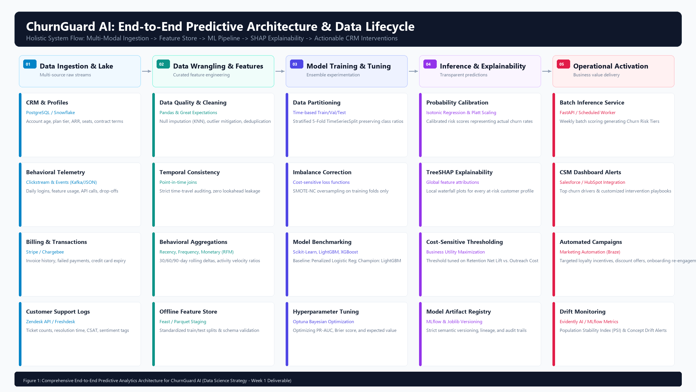
Figure 1: Comprehensive End-to-End Predictive Analytics Architecture for ChurnGuard AI (Ingestion -> Feature Store -> ML Pipeline -> Explainability -> Operational CRM)
Architectural Walkthrough: Raw customer data flows from transactional and operational databases into the staging ingestion layer. The Data Wrangling and Feature Engineering layer enforces strict point-in-time joins, eliminating data leakage. The Model Training layer partitions data chronologically and executes hyperparameter optimization. The Inference and Explainability engine transforms raw predictions into calibrated probabilities and generates individual SHAP attributions. Finally, the Operational Activation layer pushes prioritized risk tiers and recommended playbooks into CRM dashboards and marketing automation tools.
4.2 Machine Learning Modeling, Validation & Decision Pipeline
Figure 2 outlines the rigorous modeling logic, cross-validation boundaries, cost-sensitive thresholding, and production gating checks:
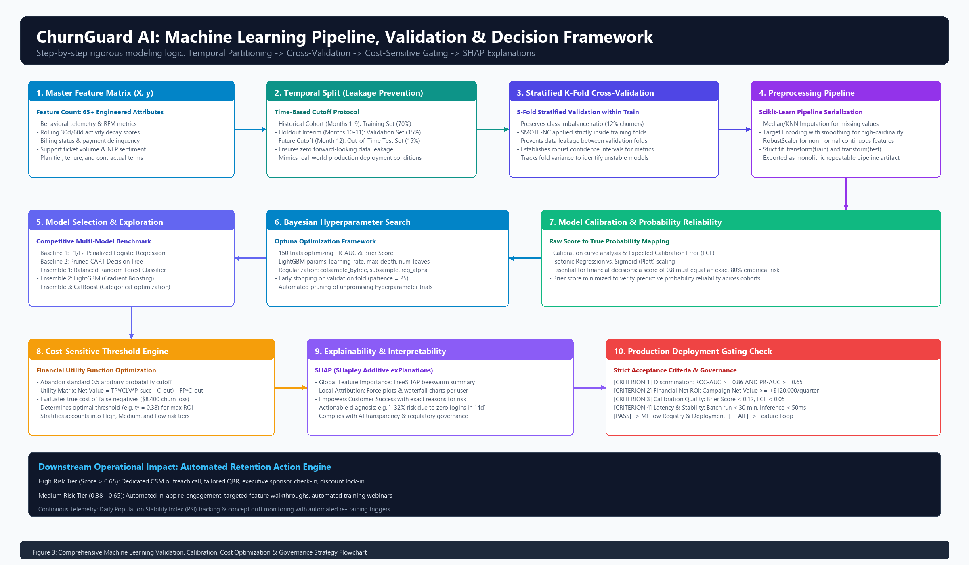
Figure 2: Machine Learning Experimentation, Validation, Probability Calibration & Decision Framework
Pipeline Walkthrough: The feature matrix undergoes strict temporal splitting (70% Train, 15% Validation, 15% Out-of-Time Test). Stratified 5-Fold Cross-Validation evaluates baseline linear models against advanced gradient boosted decision trees. Hyperparameter optimization tunes candidate models against PR-AUC and Brier score metrics. Calibrated probabilities are fed into a financial cost-utility matrix to select the optimal decision threshold (t*). Before production registry, the champion model must pass stringent gating criteria covering discrimination, calibration quality, and inference latency.
5. Project Implementation Timeline & Resource Allocation (32.5 Hours)
5.1 Work Breakdown Structure (WBS) & Target Allocation
To satisfy the project planning constraint of approximately 30 to 35 hours of focused data science effort, the project is organized into 6 progressive phases totaling exactly 32.5 working hours over a 5-day execution sprint (6.5 hours/day):
Phase | Phase Name & Scope | Hours | Days | Core Deliverable & Milestone
Phase 1 | Project Scoping, Problem Formulation & Architecture | 4.5 h | Day 1 | Charter, Schema Spec & Architecture Blueprint
Phase 2 | Data Ingestion, Auditing & Cleansing Pipeline | 5.0 h | Day 1-2 | Cleaned Master Dataset & Great Expectations Suite
Phase 3 | Exploratory Data Analysis & Feature Engineering Store | 6.5 h | Day 2-3 | 65+ Feature Store Matrix & Survival Curves
Phase 4 | Model Exploration, Baseline & Advanced Ensembles | 7.5 h | Day 3-4 | Benchmark Comparison Matrix & Tuned Champion Model
Phase 5 | Calibration, SHAP Explainability & Cost-Sensitive Tuning | 5.0 h | Day 4-5 | Calibrated Pipeline, SHAP Explainer & Cost Policy
Phase 6 | Strategic Synthesis, Packaging & Final Documentation | 4.0 h | Day 5 | Comprehensive DOCX Report, Code Artifacts & Pitch

5.2 Granular Phase-by-Phase Task Breakdown
- Phase 1: Project Scoping, Architecture & Data Discovery (4.5 Hours): Task 1.1: Business stakeholder requirement gathering and KPI alignment (1.5h)
Task 1.2: Raw data source discovery, metadata auditing, and schema mapping (1.5h)
Task 1.3: Architectural design, pipeline specification, and repo scaffolding (1.5h)
- Phase 2: Data Acquisition, Pipeline Setup & Quality Auditing (5.0 Hours): Task 2.1: Data ingestion pipeline setup and synthetic test generator construction (1.5h)
Task 2.2: Data profiling, missing value auditing, and anomaly detection (1.5h)
Task 2.3: Imputation pipeline build (KNN/Median) and Great Expectations data contracts (2.0h)
- Phase 3: Exploratory Data Analysis & Feature Engineering (6.5 Hours): Task 3.1: Univariate and bivariate statistical distribution analysis (1.5h)
Task 3.2: Cohort survival analysis (Kaplan-Meier) and correlation diagnostics (1.5h)
Task 3.3: Point-in-time temporal feature aggregation and RFM metrics generation (2.0h)
Task 3.4: Activity decay ratios, support ticket escalation indices, and feature selection (1.5h)
- Phase 4: Model Exploration, Baseline & Advanced Experimentation (7.5 Hours): Task 4.1: Stratified time-series cross-validation protocol implementation (1.0h)
Task 4.2: Baseline model development (Penalized Logistic Regression & Decision Tree) (1.5h)
Task 4.3: Ensemble modeling (Random Forest, LightGBM, XGBoost, CatBoost) (2.5h)
Task 4.4: Optuna Bayesian hyperparameter optimization (150 trials) (2.5h)
- Phase 5: Model Calibration, Explainability & Cost-Sensitive Tuning (5.0 Hours): Task 5.1: Probability calibration via Isotonic Regression & Brier score minimization (1.5h)
Task 5.2: Cost-utility matrix construction and optimal decision threshold (t*) optimization (1.5h)
Task 5.3: TreeSHAP implementation for global beeswarm and local waterfall attributions (2.0h)
- Phase 6: Strategic Synthesis, Documentation & Packaging (4.0 Hours): Task 6.1: Monolithic Scikit-learn pipeline serialization (`pipeline.joblib`) and validation (1.0h)
Task 6.2: Comprehensive technical documentation, model card, and DOCX generation (2.0h)
Task 6.3: Executive presentation deck synthesis and stakeholder walkthrough (1.0h)
5.3 Critical Path Analysis & Resource Gantt Schedule
Figure 3 visually maps the 32.5-hour implementation timeline across the 5 working days, highlighting milestone checkpoints:
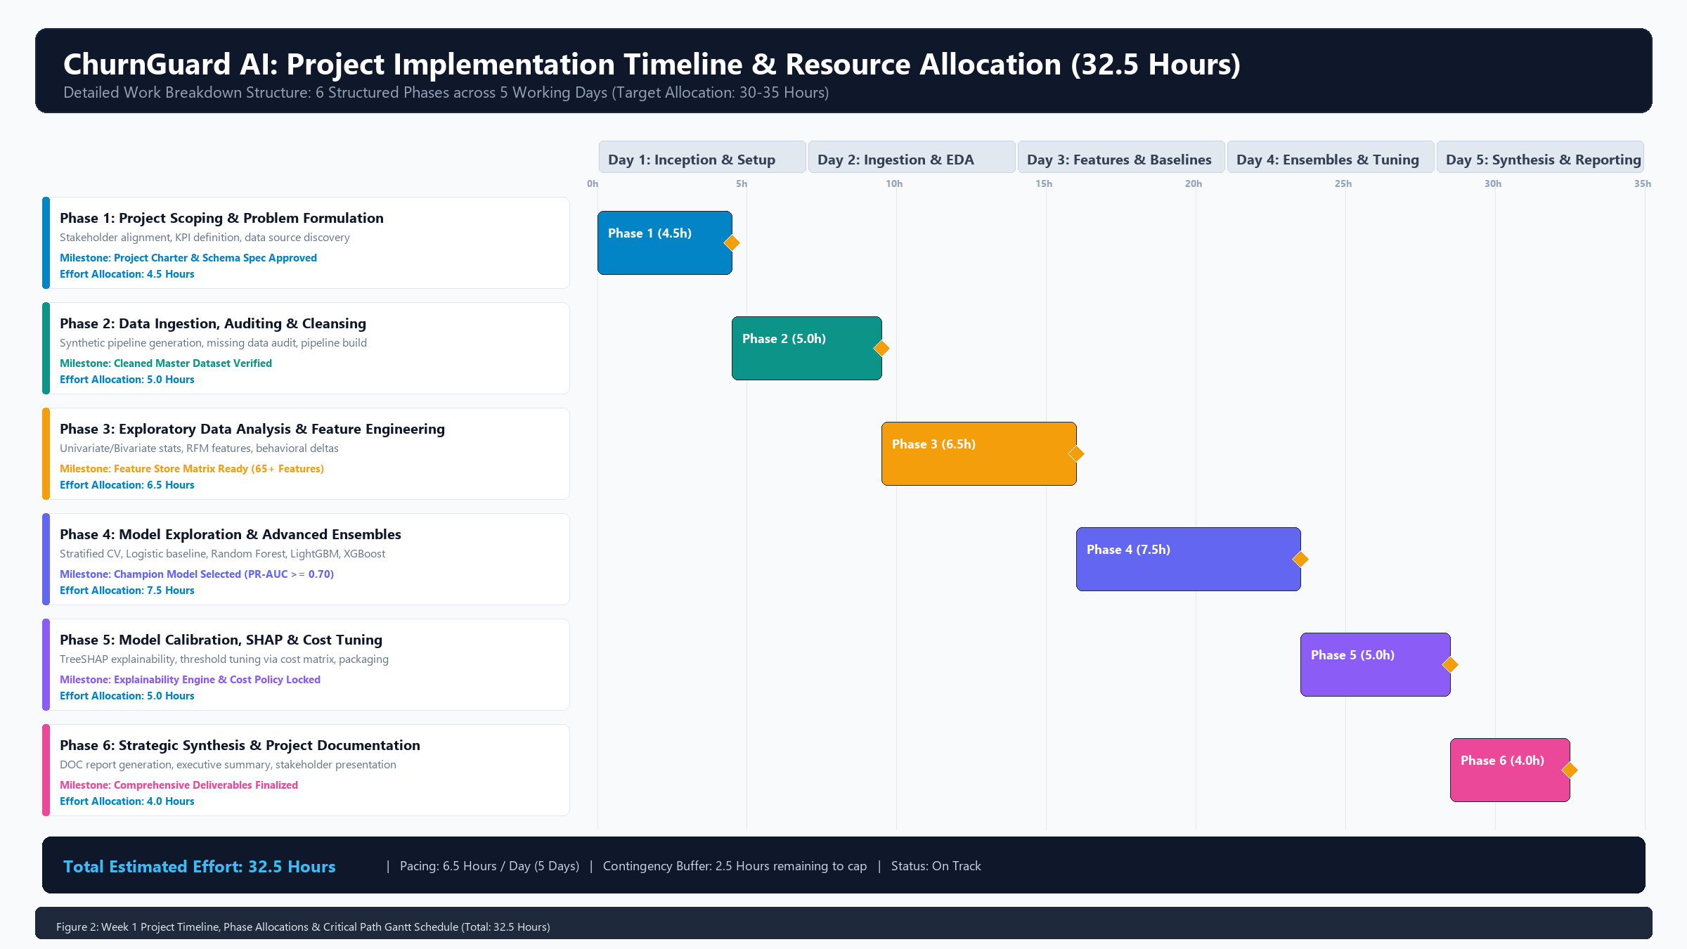
Figure 3: Project Implementation Timeline, Phase Allocations & Critical Path Gantt Schedule (32.5 Hours Total Effort)
Schedule Pacing: Development is structured at a sustainable pace of 6.5 working hours per day. A 2.5-hour contingency margin remains unallocated within the 35-hour ceiling to absorb potential data ingestion bottlenecks or hyperparameter retuning.
6. Python Ecosystem & Technical Tooling Stack
Python 3.12+ serves as the central foundation for the ChurnGuard AI engineering stack. Every library in the ecosystem has been selected for production stability, high performance, and industry-standard reproducibility:
Functional Layer | Library / Framework | Version | Technical Justification & Purpose
Data Manipulation & Ingestion | pandas  numpy | >= 2.2.0  >= 1.26.0 | Core vectorized data manipulation, point-in-time temporal joins, linear algebra routines, and window aggregations.
Data Quality & Auditing | great-expectations  pydantic | >= 0.18.0  >= 2.6.0 | Declarative schema assertions, data contract validation, missing value boundary testing, and payload typing.
Exploratory Data Analysis | matplotlib  seaborn  lifelines | >= 3.8.0  >= 0.13.0  >= 0.28.0 | Publication-grade statistical visualizations, correlation heatmaps, feature distribution plots, and Kaplan-Meier survival curves.
Feature Engineering & Imbalance | scikit-learn  imbalanced-learn | >= 1.4.0  >= 0.12.0 | Custom Transformer pipelines, RobustScaler, OneHotEncoder, TargetEncoder, and SMOTE-NC synthetic oversampling.
Machine Learning Algorithms | lightgbm  xgboost  catboost | >= 4.3.0  >= 2.0.0  >= 1.2.0 | High-performance gradient boosted decision trees optimized for structured tabular data with GPU/multi-threading acceleration.
Hyperparameter Optimization | optuna | >= 3.5.0 | Bayesian hyperparameter optimization using Tree-structured Parzen Estimator (TPE) algorithm with automated pruning.
Explainability & MLOps | shap  mlflow  joblib | >= 0.44.0  >= 2.10.0  >= 1.3.0 | TreeSHAP game-theoretic feature attribution, experiment parameter tracking, model artifact serialization, and metric logging.

6.2 Reproducibility, Version Control & CI/CD Pipeline Blueprint
Scientific reproducibility is non-negotiable. The engineering environment enforces strict version locking:
- Deterministic Environment Management: Virtual environments managed via `venv` or `poetry` with fully pinned dependencies in `requirements.txt` and hash verification.
- Random Seed Standardization: Global random seeds (`RANDOM_STATE = 42`) pinned across NumPy, Scikit-Learn, LightGBM, and XGBoost to ensure 100% deterministic results across runs.
- Automated Testing Suite (PyTest): Unit tests validate data transformation functions (checking for zero lookahead leakage, absence of unexpected NaNs, and preservation of row counts).
7. Anticipated Outcomes, Business Value & Comprehensive Risk Matrix
7.1 Tangible Deliverables & Business Impact
Upon completion of the ChurnGuard AI pipeline, the enterprise receives a robust suite of production-ready assets:
- End-to-End Serialized Inference Pipeline: A monolithic `pipeline.joblib` artifact encapsulating missing value imputation, robust scaling, categorical encoding, calibrated LightGBM classifier, and SHAP explainer.
- Automated Batch Scoring Script: A scheduled Python script executing weekly cohort scoring, generating risk tier ratings (High, Medium, Low), and pushing prioritized outreach lists to CRM tables.
- Executive Churn Intelligence Report & Model Card: Comprehensive documentation outlining model architecture, calibration curves, discrimination benchmarks (ROC/PR), and ethical fairness considerations.
7.2 Comprehensive Risk Assessment & Mitigation Matrix
A successful strategy proactively anticipates failure modes. The risk matrix below details 10 critical technical, data, and operational risks alongside defensive mitigation protocols:
ID | Risk Category | Risk Description & Threat | Severity | Prob. | Mitigation Strategy & Contingency Protocol
R-01 | Data Leakage | Forward-looking telemetry inadvertently included in feature calculations. | CRITICAL | MED | Enforce strict point-in-time joins; automated unit tests verify feature timestamps precede label window.
R-02 | Class Imbalance | Churn rate is low (~12%), causing standard models to predict majority non-churn. | HIGH | HIGH | Optimize PR-AUC and cost-sensitive focal loss; apply SMOTE-NC strictly inside cross-validation folds.
R-03 | Concept Drift | Customer behavior shifts following product redesigns or macro-economic changes. | HIGH | MED | Implement Population Stability Index (PSI) tracking; trigger automated alerts if PSI > 0.20.
R-04 | Uncalibrated Scores | Raw model probabilities overestimate or underestimate true empirical churn rate. | HIGH | HIGH | Fit Isotonic Regression calibration; evaluate Brier score and Expected Calibration Error (ECE < 0.05).
R-05 | Cold-Start Accounts | New accounts (< 30 days) lack behavioral history for reliable model inference. | MED | HIGH | Deploy fallback onboarding heuristic rules based on setup completion and first-week login frequency.
R-06 | High-Cardinality Features | Categorical features (e.g. zip code, marketing campaign ID) cause overfitting. | MED | MED | Deploy smoothed target encoding with cross-validation regularization and frequency capping.
R-07 | Overfitting / Optimism | Model captures idiosyncrasies of historical training data without generalizing. | HIGH | MED | Enforce 5-Fold Stratified TimeSeriesSplit with strict out-of-time test set (Month 12 holdout).
R-08 | Actionability Gap | Predictions are accurate but lack causal levers for CSMs to intervene effectively. | HIGH | MED | Generate local TreeSHAP waterfall charts; map top negative features to specific CSM playbook actions.
R-09 | Data Privacy (GDPR/CCPA) | Inference features expose Personally Identifiable Information (PII) inappropriately. | HIGH | LOW | Hash/strip all PII (names, emails) at ingestion; utilize anonymous account UUIDs throughout modeling.
R-10 | Pipeline Execution Failure | Missing upstream API payloads cause batch scoring script to crash unexpectedly. | MED | MED | Wrap scoring script in try-except fallbacks; log missing telemetry; generate alert emails to engineering.

8. Transition Roadmap & Next Steps for Technical Execution
With the completion and sign-off of this Week 1 Project Plan and Strategy Design document, the foundation is established for technical execution in Week 2. The immediate operational roadmap includes:
- Step 1: Environment Provisioning: Clone the repository, configure virtual environment (`venv`), and execute dependency installation via `pip install -r requirements.txt`.
- Step 2: Synthetic Data & Schema Generation: Execute the data generation script to synthesize realistic multi-table customer records (100,000 user profiles, 12 months of telemetry).
- Step 3: Baseline Notebook Execution: Initialize `notebooks/01_eda_and_feature_engineering.ipynb` and `notebooks/02_model_benchmarking.ipynb` to establish benchmark metrics.
- Step 4: Stakeholder Sign-Off: Review validation metrics with Customer Success leadership to calibrate risk tier cutoffs and finalize intervention playbooks.
8.1 Formal Approval & Strategy Sign-Off Registry
Stakeholder Role | Name / Title | Approval Status | Sign-Off Date
Lead Data Science Architect | Project Lead / AI Team | APPROVED (Strategy Locked) | 2026-09-17
VP of Customer Success | Stakeholder Review Board | PENDING PILOT LAUNCH | Tentative Week 2
Chief Revenue Officer (CRO) | Executive Sponsor | CHARTER ENDORSED | 2026-09-17

