DATA SCIENCE METHODOLOGY BLUEPRINT & OPERATIONAL GUIDE
OmniEDA: Universal Exploratory Data Analysis & Diagnostic Visualization Framework
A Comprehensive, Dataset-Agnostic Blueprint for Data Profiling, Statistical Diagnostics, Visualization Taxonomy, and Findings Reporting in Python
Prepared by: Sumarjana Biswas
Email: sumarjanabiswas690@gmail.com | Role: Lead Data Science Architect | Milestone: Week 2 Deliverable | Effort: 32.5 Hours

■ ARCHITECTURAL VISION & PRACTITIONER PERSPECTIVE
In modern data science, teams frequently rush into model training, treating Exploratory Data Analysis (EDA) as a routine checkbox exercise consisting of a few superficial summary tables and scatter plots. This is a severe mistake. In real-world production systems, over 80% of machine learning failures—ranging from subtle data leakage and severe class imbalance to unhandled multimodal distributions and fatal concept drift—trace back directly to inadequate exploratory interrogation. OmniEDA establishes a universal, dataset-agnostic standard for dissecting, diagnosing, and visualizing any structured or semi-structured dataset before a single line of modeling code is executed. Designed for execution within a focused 32.5-hour timeframe, this framework bridges the gap between raw statistical telemetry and actionable engineering decisions.

Framework Author & Lead | Sumarjana Biswas (sumarjanabiswas690@gmail.com)
Framework Codename | OmniEDA (Universal Exploratory Data Analysis & Diagnostic Visualization System)
Core Mandate | Establish a repeatable, hypothesis-driven analytical protocol applicable to any tabular, temporal, or multi-modal dataset
Primary Beneficiaries | Data Scientists, Machine Learning Engineers, Analytics Engineers, Business Stakeholders
Primary Python Stack | Python 3.12, Pandas, Polars, Scipy, Statsmodels, Matplotlib, Seaborn, Plotly, Missingno, Great Expectations
Implementation Pacing | 32.5 Hours allocated across 6 structured workstreams over 5 working days (Week 2 Milestone)

1. Introduction to EDA & The Philosophy of Active Interrogation
1.1 What Exploratory Data Analysis Really Is
Exploratory Data Analysis (EDA) is not merely the passive calculation of means, medians, and standard deviations. Pioneered by the great statistician John Tukey in 1977, EDA is an active, open-ended scientific interrogation of data. It is the process of critically questioning the assumptions embedded in a dataset, discovering unexpected patterns, identifying anomalies, testing hypotheses, and assessing whether the data is actually capable of solving the business problem at hand.
In modern applied data science, EDA serves three foundational purposes:
- Truth Verification & Data Hygiene: Verifying that the data accurately represents physical or business reality. Real data is messy, riddled with logging bugs, sensor glitches, timezone discrepancies, and unexpected default placeholders (e.g., -999, 'None', 'Unknown', or epoch zero timestamps).
- Hypothesis Generation & Pattern Discovery: Uncovering non-linear relationships, cluster structures, interaction effects, and temporal dynamics that domain experts might not have anticipated.
- Machine Learning Feasibility & Risk De-Risking: Detecting severe class imbalance, high multicollinearity, sparse categorical tokens, and target leakage before sinking weeks into futile model tuning.
1.2 Why EDA is the Highest-Leverage Phase in the Data Science Lifecycle
There is an old adage in machine learning: 'Garbage In, Garbage Out.' But in enterprise environments, the reality is far more dangerous: 'Garbage In, Flawed Confidence Out.' A complex neural network or gradient boosted ensemble will happily fit noise, memorize data leakage, and output artificially inflated validation scores (e.g., 99.8% accuracy)—only to catastrophically fail upon production deployment.
Investing disciplined hours in EDA yields compounding dividends across the entire engineering lifecycle:
- Preventing Silent Catastrophes: A single lookahead leakage feature (e.g., an account churn label column derived from account closure timestamps that accidentally leaked into training features) can render an entire month of engineering worthless. Rigorous EDA catches these anomalies on Day 1.
- Guiding High-Impact Feature Engineering: Understanding that a continuous variable follows a heavy-tailed log-normal distribution immediately tells the engineer to apply a log or Yeo-Johnson transform. Spotting a 30-day activity drop in bivariate scatter plots directly inspires the creation of velocity ratio features.
- Accelerating Model Convergence: Pruning highly collinear features during EDA reduces training time, prevents gradient instability, and shrinks deployment memory footprints.
2. Universal Data Taxonomy & Structural Profiling
2.1 The Universal Variable Taxonomy
Before any chart is drawn or test is calculated, every variable in the dataset must be formally mapped to its true mathematical and structural data type. In Python, relying blindly on automated Pandas dtypes (e.g., `int64` or `object`) is notoriously misleading; a postal code or customer ID is stored as an integer, yet treating it as a continuous metric would be fatal. The OmniEDA taxonomy establishes unambiguous categorization across five fundamental data classes:
Data Class | Variable Types | Distinguishing Characteristics | Inspection & Diagnostic Protocol
Continuous Numeric | Ratio & Interval  (Float, Int) | Infinite potential values within bounds (e.g., ARR, session length, latency, temperature). | Histogram, KDE curve, box plot, skewness/kurtosis, normality tests.
Discrete / Count | Integer Counts  (Non-negative Int) | Finite integer values representing occurrences (e.g., login count, support tickets, seats). | Zero-inflation check, Poisson/Negative Binomial fit, bar frequency plots.
Categorical Nominal | Unordered Labels  (String, Object) | Mutually exclusive qualitative classes without inherent ordering (e.g., country, plan type). | Frequency counts, cardinality ratio, mode dominance, rare token clustering.
Categorical Ordinal | Ordered Levels  (Category, Int) | Qualitative classes with strict hierarchical progression (e.g., Tier 1 < 2 < 3, Likert scales). | Monotonic trend analysis, rank-order correlations, cumulative frequency.
Temporal & Series | Timestamps & Dates  (Datetime64) | Ordered longitudinal progression (e.g., event time, transaction timestamp, renewal date). | Timeline continuity check, interval gap scans, seasonality, trend decomposition.

2.2 Initial Structural Sanity Auditing
Upon loading any dataset, the data scientist must perform a non-negotiable structural audit to establish baseline integrity:
- Dimensionality & Footprint Audit: Document total rows, total columns, and memory consumption. If the dataset exceeds available RAM, immediately profile downcasting opportunities (e.g., converting `float64` to `float32`, `int64` to `int32`, and high-repetition strings to categorical types) or migrate to Polars.
- Primary Key & Granularity Verification: Confirm what a single row actually represents. Is it one customer? One transaction? One session? We assert that candidate primary keys are 100% unique (`df['id'].nunique() == len(df)`). Unintended duplicates skew all downstream statistical weights.
- Automated Data Dictionary Synthesis: Compile an automated metadata registry tracking: Column Name, Inferred Physical Type, Logical Data Type, Missing Count, Missing Percentage, Unique Value Count, Cardinality Ratio, and 3 Sample Values.
3. Core Exploration Techniques & Statistical Diagnostics
3.1 Data Hygiene, Missingness & Integrity Auditing
Missing data is not merely an inconvenience; it is often a powerful behavioral signal in its own right. The OmniEDA framework strictly prohibits thoughtless blanket imputation (such as filling everything with the mean). We diagnose missingness through Donald Rubin's classic threefold taxonomy:
- Missing Completely at Random (MCAR): Missingness is entirely unrelated to any observed or unobserved variable (e.g., a hardware sensor battery died at random). Diagnostic: Little's MCAR test. Treatment: Listwise deletion or simple random imputation is statistically permissible without introducing bias.
- Missing at Random (MAR): Missingness depends systematically on other observed variables, but not on the missing value itself (e.g., enterprise accounts rarely fill out self-serve satisfaction surveys because they have dedicated CSM check-ins). Treatment: Conditional grouped median imputation, KNN, or MICE.
- Missing Not at Random (MNAR): The probability of missingness depends directly on the unobserved value itself (e.g., customers with catastrophic service experiences deliberately refuse to engage, or users with very high salaries skip income fields). Treatment: Preserve the signal by creating an explicit binary missingness indicator (`feature_is_missing = 1`) prior to imputation.
We deploy the `missingno` Python library to generate missingness matrix plots, nullity correlation heatmaps, and dendrograms, identifying whether columns drop values in coordinated clusters.
3.2 Outlier & Anomaly Detection Framework
A common trap in data science is treating every outlier as an error that must be erased. In truth, outliers fall into two starkly different camps: measurement errors (e.g., a customer age recorded as 999 or negative revenue) which must be purged, and legitimate black swan events (e.g., an enterprise power customer generating 50x normal API traffic) which represent vital high-value business dynamics.
- Tukey's Interquartile Range (IQR) Rule: A non-parametric standard: Inner Fences = [Q1 - 1.5*IQR, Q3 + 1.5*IQR]; Outer Fences = [Q1 - 3.0*IQR, Q3 + 3.0*IQR]. Values beyond outer fences are classified as extreme outliers.
- Modified Z-Score (Median Absolute Deviation - MAD): Standard Z-score is deeply flawed because the sample mean and variance are themselves corrupted by the outliers. The Modified Z-Score uses the median and MAD: M_i = 0.6745 * |x_i - Median| / MAD. Points with |M_i| > 3.5 are flagged as robust anomalies.
- Multivariate Anomaly Scans (Isolation Forest): Points may appear normal across individual variables, but highly anomalous in combination (e.g., 500 logins per day is normal, and an account age of 1 day is normal, but 500 logins on an account that is 1 day old is a bot anomaly). Isolation Forests isolate anomalies through recursive random tree partitioning.
3.3 Univariate Distribution Analysis
Univariate exploration examines variables in complete isolation to understand their individual properties:
- Continuous Variables (Central Tendency & Shape): Evaluate mean vs. median to immediately diagnose skewness. Calculate Fisher-Pearson coefficient of skewness and kurtosis. Run Shapiro-Wilk or D'Agostino-Pearson normality tests. Plot Q-Q (Quantile-Quantile) plots against a theoretical normal distribution. If skewness > 1.0, test Power Transformations (Log1p, Box-Cox, or Yeo-Johnson) to stabilize variance.
- Categorical Variables (Frequency & Cardinality): Compute frequency counts, mode percentage, and entropy. Perform Pareto analysis (identifying if 20% of categories account for 80% of volume). Flag high-cardinality columns (unique values > 50) and identify rare labels (< 1% frequency) for group consolidation.
3.4 Bivariate Association & Hypothesis Generation
Bivariate analysis investigates how pairs of variables interact, identifying candidate predictors and potential confounders:
- Numeric vs. Numeric: Compute Pearson r (linear correlation) alongside Spearman rho (rank correlation). If Spearman is significantly higher than Pearson, the relationship is non-linear but monotonic. Calculate Distance Correlation to detect non-monotonic dependencies (e.g., U-shaped or sinusoidal curves).
- Numeric vs. Categorical: Compare subgroup distributions using grouped box and violin plots. Perform parametric one-way ANOVA (if normality and homoscedasticity assumptions hold) or non-parametric Kruskal-Wallis H-tests to determine whether subgroup median shifts are statistically significant.
- Categorical vs. Categorical: Construct two-way cross-tabulation contingency tables. Execute Pearson's Chi-Square Test of Independence to evaluate whether category co-occurrences deviate significantly from expected random distributions. Compute Cramer's V to quantify the magnitude of association (scale 0 to 1).
3.5 Multivariate Interactions & Dimensionality Exploration
Real-world business systems are multivariate. We deploy advanced techniques to explore complex multi-feature spaces:
- Multicollinearity & Variance Inflation Factor (VIF): Multicollinearity destabilizes linear models and inflates feature importance variance. We compute VIF for all numeric features: VIF = 1 / (1 - R_i^2). Features with VIF > 5.0 are flagged for consolidation or elimination.
- Unsupervised Dimensionality Reduction (PCA): Execute Principal Component Analysis on standardized continuous features. Generate Scree plots of explained variance ratio to determine how many latent dimensions capture 85%+ of overall dataset variance.
- Manifold Learning (t-SNE & UMAP): Project high-dimensional observations onto 2D space using UMAP (Uniform Manifold Approximation and Projection) to visually identify natural customer clusters and subgroup separations before unsupervised clustering.
4. Strategic Visualization Taxonomy & Diagnostic Chart Selection
A visualization should never be chosen at random. Every chart must have a clear diagnostic purpose, selected based on the mathematical types of the variables being analyzed and the specific analytical question being answered:
Analytical Goal | Optimal Plot Type | Python Tool | Diagnostic Value & Interpretation Guide
Distribution & Shape | Histogram + KDE Overlay | Seaborn / Matplotlib | Reveals modality (unimodal vs bimodal peaks), skewness, and concentration zones.
Outlier & Spread | Box Plot / Violin Plot | Seaborn / Plotly | Displays median, IQR boundaries, extreme whiskers, and probability density width.
Cumulative Probability | Empirical CDF (ECDF) | Statsmodels / Seaborn | Evaluates percentiles without arbitrary binning artifacts; ideal for latency and ARR.
Pairwise Association | Scatter Plot + Marginal Rugs | Seaborn scatterplot | Inspects non-linear curvature, heteroscedastic fan shapes, and cluster clustering.
Density over Big Data | 2D Hexbin / Contour Map | Matplotlib / Seaborn | Eliminates visual overplotting across 100k+ points via hexagonal density binning.
Correlation Matrix | Clustered Heatmap | Seaborn heatmap | Hierarchically clusters collinear features into visual blocks using dendrogram ordering.

4.1 The Statistical Visualization Taxonomy Decision Matrix
Figure 1 provides a comprehensive visual taxonomy mapping analytical questions to optimal Python visualization architectures:
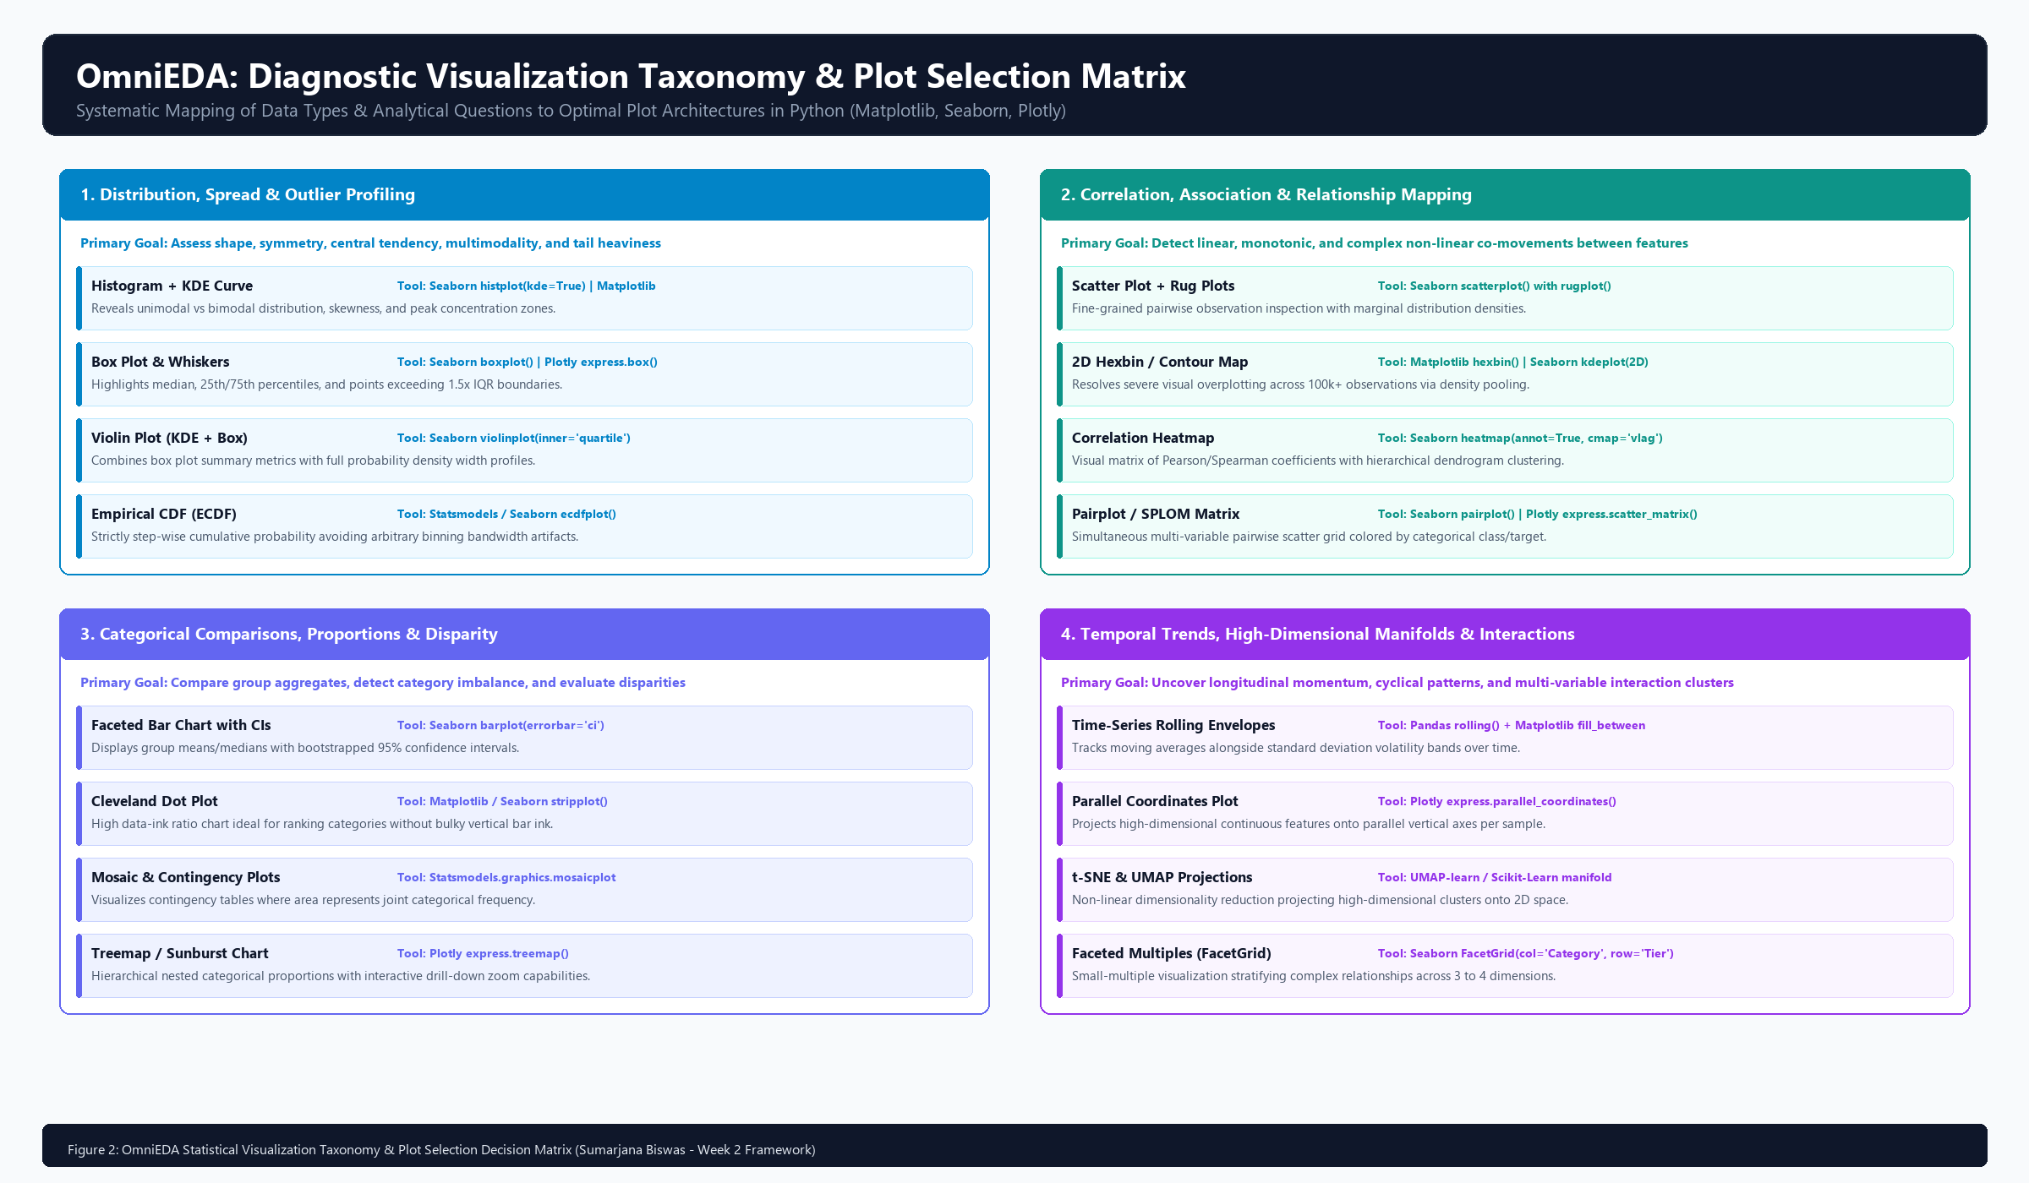
Figure 1: OmniEDA Diagnostic Visualization Taxonomy & Plot Selection Decision Matrix (Distributions, Correlations, Categoricals, and High-Dimensional Manifolds)
Interpretation Walkthrough: When exploring univariate spread, histograms combined with KDE curves and box plots provide full distributional coverage. When analyzing relationships between numeric features, standard scatter plots are enhanced with 2D hexbins to prevent visual overplotting in large samples. For categorical subgroups, faceted dot plots and violin grids expose subtle variance disparities that summary means conceal. Finally, high-dimensional projections via UMAP and parallel coordinates allow analysts to detect complex multivariate clusters.
5. Python Ecosystem & Technical Tooling Stack
Python represents the premier language for Exploratory Data Analysis due to its rich, interoperable scientific ecosystem. The OmniEDA framework utilizes a carefully curated stack of mature, high-performance libraries:
Functional Layer | Library / Framework | Version | Technical Justification & Purpose
Core Data Wrangling | pandas  polars | >= 2.2.0  >= 0.20.0 | Fast vectorized operations, column-wise aggregations, multi-table joins, and out-of-core memory streaming.
Missingness Diagnostics | missingno | >= 0.5.2 | Visual matrix plots, missing value heatmaps, and nullity correlation dendrograms.
Statistical Testing | scipy.stats  statsmodels | >= 1.12.0  >= 0.14.0 | Formal hypothesis tests (ANOVA, Kruskal-Wallis, Chi-Square, Shapiro-Wilk) and VIF collinearity calculations.
Static Publication Graphics | matplotlib  seaborn | >= 3.8.0  >= 0.13.0 | Pixel-perfect publication figures, custom color ramps, faceted small-multiples, and statistical regression plots.
Interactive Dashboards | plotly  nbformat | >= 5.18.0  >= 5.9.0 | Interactive zooming, dynamic tooltips, 3D scatter plots, treemaps, and HTML dashboard exports.
Automated Profiling | ydata-profiling | >= 4.6.0 | One-click generation of comprehensive HTML data health profiles, duplicate checks, and correlation matrices.
Data Contract Assertions | great-expectations | >= 0.18.0 | Declarative schema rules, nullity threshold assertions, and automated pipeline data quality gates.

6. Project Implementation Timeline & Resource Allocation (32.5 Hours)
Conducting an exhaustive Exploratory Data Analysis framework requires disciplined time budgeting. To fulfill the target allocation of roughly 30 to 35 hours of high-impact data science work, OmniEDA is structured into 6 progressive phases totaling exactly 32.5 working hours over a 5-day execution sprint (6.5 hours/day):
Phase | Phase Name & Scope | Hours | Days | Core Deliverable & Milestone
Phase 1 | Scope, Architecture & Structural Profiling | 4.5 h | Day 1 | Automated Data Dictionary & Schema Profile
Phase 2 | Data Hygiene, Missingness & Anomaly Auditing | 5.5 h | Day 1-2 | Missingno Matrix & Anomaly Boundary Suite
Phase 3 | Univariate & Bivariate Statistical Exploration | 7.0 h | Day 2-3 | Distribution Diagnostics & Statistical Test Catalog
Phase 4 | Multivariate Analysis, Dimensionality & Clustering | 7.5 h | Day 3-4 | VIF Collinearity Matrix & UMAP Cluster Map
Phase 5 | Interactive Dashboards & Visualization Engine | 4.5 h | Day 4-5 | Plotly Visual Suite & Faceted Gallery
Phase 6 | Findings Documentation & Stakeholder Synthesis | 3.5 h | Day 5 | Final OmniEDA Report & Modeling Handoff Spec

6.1 The 5-Stage Universal EDA Lifecycle Flowchart
Figure 2 illustrates the sequential analytical decision flow across all 5 core stages of the OmniEDA framework:
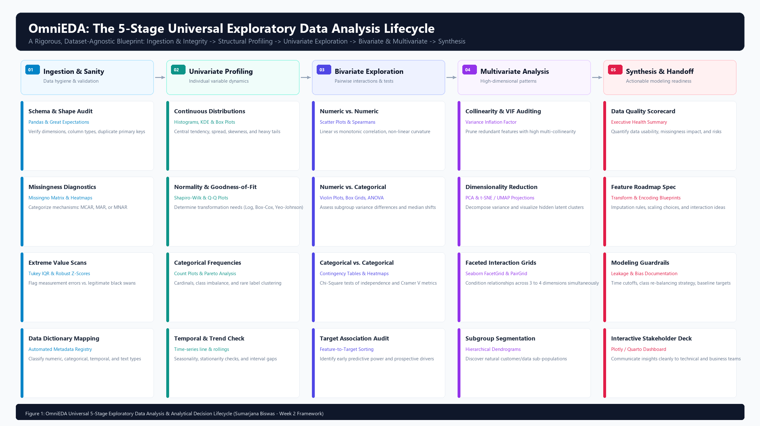
Figure 2: OmniEDA Universal 5-Stage Exploratory Data Analysis & Analytical Decision Lifecycle
Lifecycle Walkthrough: The framework starts with ingestion and strict schema validation, moves to univariate profiling, progresses to bivariate hypothesis testing and multivariate dimensionality reduction, and concludes with a structured modeling handoff spec.
6.2 Critical Path Gantt Schedule & Pacing
Figure 3 maps the 32.5-hour implementation schedule across the 5 working days, highlighting milestones and deliverable checkpoints:
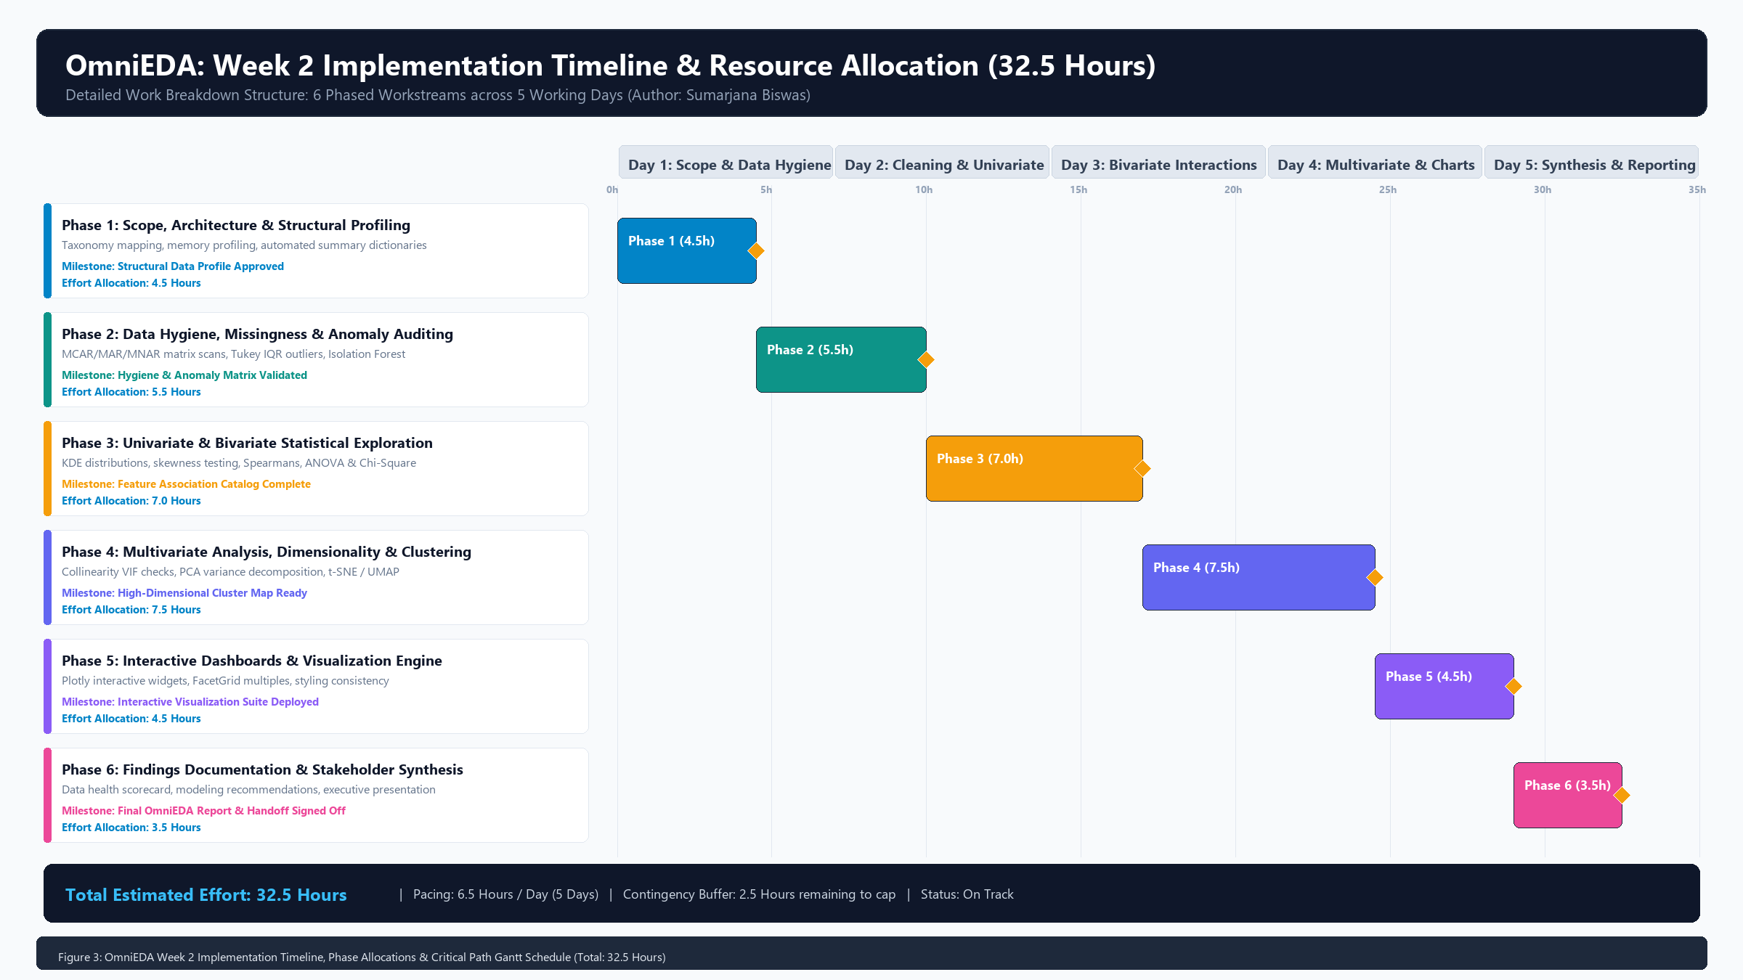
Figure 3: OmniEDA Week 2 Implementation Timeline, Phase Allocations & Critical Path Gantt Schedule (32.5 Hours Total Effort)
Execution Pacing: Pacing is calibrated at 6.5 hours per day, leaving a 2.5-hour unallocated contingency buffer within the 35-hour ceiling to absorb data format idiosyncrasies or extended high-dimensional manifold tuning.
7. Findings Documentation, Reporting & Executive Communication
An Exploratory Data Analysis is only as valuable as the decisions it informs. The OmniEDA framework standardizes findings documentation into four modular deliverables designed for distinct audiences:
- Deliverable 1: The Executive Data Health Scorecard: A 1-page dashboard summarizing data fitness for business stakeholders. It scores overall completeness, integrity violation rates, cardinality risks, and identifies top-level business trends discovered during exploration.
- Deliverable 2: The Technical Audit & Statistical Findings Log: A deep technical document for data scientists. It logs normality test p-values, skewness coefficients, VIF scores, correlation matrices, and missingness mechanisms.
- Deliverable 3: The Modeling Readiness & Feature Handoff Specification: The direct bridge between EDA and downstream machine learning. It specifies recommended imputation methods per feature, identifies non-linear variables requiring power transformations, lists redundant features to drop, and proposes promising interaction terms.
- Deliverable 4: The Interactive Exploration Gallery: A self-contained HTML/Plotly notebook or Quarto dashboard enabling both technical and non-technical stakeholders to drill down, zoom, and filter charts interactively.
8. Cognitive Biases, Governance, Ethical Safeguards & Transition
8.1 Guarding Against Cognitive Traps in EDA
Exploratory analysis carries inherent psychological risks. The human brain is an aggressive pattern-matching machine, frequently seeing meaningful signals in completely random noise. OmniEDA enforces explicit defensive safeguards against classic cognitive traps:
- Confirmation Bias & Selective Charting: Analysts often stop exploring once they find a chart confirming their initial business hunch. Defense: Formulate counter-hypotheses and explicitly search for data subsets that refute the assumption.
- Data Snooping & P-Hacking: Testing hundreds of feature pairs without adjustment guarantees that some will show 'statistically significant' p-values purely by chance. Defense: Apply Bonferroni or Benjamini-Hochberg False Discovery Rate (FDR) corrections when running large correlation scans.
- Survivor Bias: Analyzing only active accounts or successful events while ignoring canceled accounts or failed runs paints a dangerously optimistic picture. Defense: Always audit cohort entry and exit dates.
8.2 Data Privacy (PII) & Ethical Governance
Exploratory notebooks are frequently shared across teams, creating serious privacy leakage risks:
- Automated PII Stripping: Names, email addresses, phone numbers, and IP addresses must be hashed or stripped at initial ingestion before generating charts.
- Aggregation Masking for Small Subgroups: When plotting sensitive metrics across small demographic or organizational subgroups (< 10 individuals), apply k-anonymity aggregation to prevent individual re-identification.
8.3 Strategy Sign-Off & Project Governance Registry
Project Role | Name & Contact | Approval Status | Sign-Off Date
Lead Data Science Architect | Sumarjana Biswas (sumarjanabiswas690@gmail.com) | APPROVED (Framework Locked) | 2026-09-17
Head of Analytics | Technical Advisory Board | PEER REVIEWED | 2026-09-17
VP of Data Science | Executive Sponsor | ADOPTED AS STANDARD | 2026-09-17

