Лабораторная 14_1

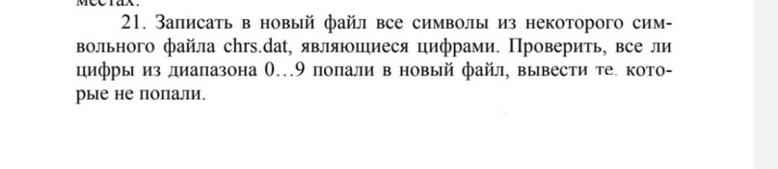

#include<fstream>

#include<iostream>

using namespace std;

int main()

{

ifstream fin("chrs1.dat");

ofstream fout("chrs2.dat");

char c;

char numbers[10] = {'0','1','2', '3', '4', '5', '6', '7', '8', '9'};

while (!fin.eof())

{

c = fin.get();

if ((c >= '0') && (c <='9'))

{

fout << c << endl;

continue;

}

}

fout.close();

fin.close();

ifstream fin2("chrs2.dat");

while (!fin2.eof())

{

c = fin2.get();

for (int i = 0; i < 10 ; i++)

{

if (numbers[i] == c)

{

numbers[i] = '-';

break;

}

}

}

cout<<"Numbers, which wasn't in file: ";

for (int i = 0; i < 10 ; i++)

{

if(numbers[i] != '-')

cout<< i<<", ";

}

system("PAUSE");

return 0;

}

