**WEEK-6**



**Exercise-1**: **Create a new React Application with the name “myfirstreact”, Run the application to print “welcome to the first session of React” as heading of that page.**

**App.js:**

function App() {

return (

<div>

<h1>Welcome to the first session of React</h1>

</div>

);}

export default App;

**OUTPUT:**

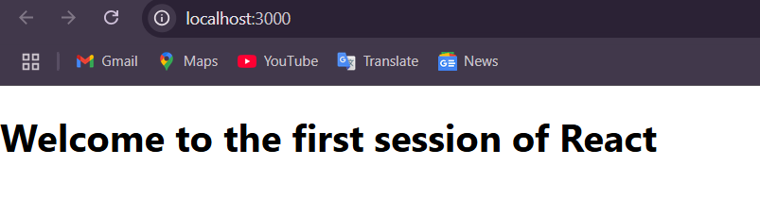

**Exercise 2: Create a react app for Student Management Portal named StudentApp and create a component named Home which will display the Message “Welcome to the Home page of Student Management Portal”. Create another component named About and display the Message “Welcome to the About page of the Student Management Portal”. Create a third component named Contact and display the Message “Welcome to the Contact page of the Student Management Portal”. Call all the three components**

**App.js:**

import React from 'react';

import Home from './components/Home';

import About from './components/about';

import Contact from './components/contact';

function App() {

  return (

    <div>

      <Home />

      <About />

      <Contact />

    </div>

  );

}

export default App;

**contact.js:**

import React from 'react';

function Contact() {

  return (

    <div>

      <h2>Welcome to the Contact page of the Student Management Portal</h2>

    </div>

  );}

export default Contact;

**about.js:**

import React from 'react';

function About() {

  return (

    <div>

      <h2>Welcome to the About page of the Student Management Portal</h2>

    </div>

  );}

export default About;

**Home.js:**

import React from 'react';

function Home() {

  return (

    <div>

      <h2>Welcome to the Home page of Student Management Portal</h2>

    </div>

  );}

export default Home;

**OUTPUT:**

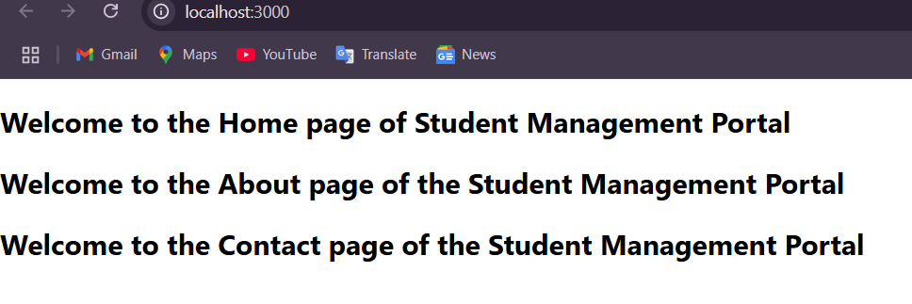

**Exercise 3: Create a react app for Student Management Portal named scorecalculatorapp and create a function component named “CalculateScore” which will accept Name, School, Total and goal in order to calculate the average score of a student and display the same.**

**App.js:**

import React from 'react';

import CalculateScore from './components/cal';

function App() {

  return (

    <div>

      <CalculateScore />

    </div>

  );}

export default App;

**cal.js:**

import React, { useState } from 'react';

import '../cal.css';

function CalculateScore() {

  const name = "Steeve";

  const school = "DNV Public School";

  const total = 284;

  const goal = 300;

  const score = ((total / goal) * 100).toFixed(2);

  return (

    <div className="score-container">

      <h1 className="title">Student Details:</h1>

      <p><span className="label name-label">Name:</span> <span className="value name-value">{name}</span></p>

      <p><span className="label school-label">School:</span> <span className="value school-value">{school}</span></p>

      <p><span className="label total-label">Total:</span> <span className="value total-value">{total} Marks</span></p>

      <p><span className="label score-label">Score:</span> <span className="value score-value">{score}%</span></p>

    </div>

  );}

export default CalculateScore;

**cal.css:**

.score-container {

  text-align: center;

  margin-top: 50px;

}

.title {

  color: brown;

  font-size: 32px;

  font-weight: bold;

}

.label {

  font-weight: bold;

  font-size: 18px;

}

.value {

  font-size: 18px;

}

.name-label {

  color: blue;

}

.name-value {

  color: slateblue;

}

.school-label {

  color: red;}

.school-value {

  color: violet;}

.total-label {

  color: maroon;}

.total-value {

  color: black;}

.score-label {

  color: green;}

.score-value {

  color: limegreen;}

**OUTPUT:**

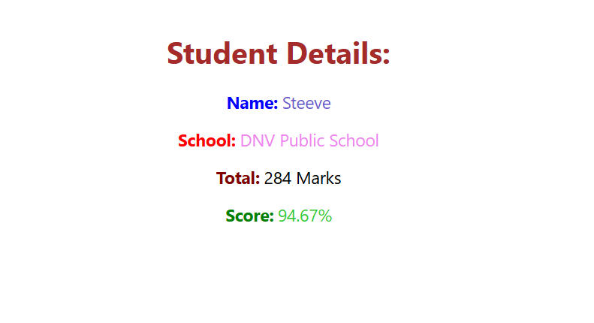

**Exercise 4: Create a new react application using *create-react-app* tool with the name as “blogapp”**

**Post.js:**

import React from 'react';

class Post extends React.Component {

  render() {

    return (

      <div style={{ border: "1px solid gray", margin: "10px", padding: "10px" }}>

        <h3>{this.props.title}</h3>

        <p>{this.props.body}</p>

      </div>

    );

  }}

export default Post;

**Posts.js:**

import React from 'react';

import Post from './Post';

class Posts extends React.Component {

constructor(props) {

super(props);

this.state = {

posts: [],

hasError: false

}; }

loadPosts() {

fetch("https://jsonplaceholder.typicode.com/posts")

.then(response => response.json())

.then(data => this.setState({ posts: data }))

.catch(error => {

console.error("Error fetching posts:", error);

this.setState({ hasError: true });

}); }

componentDidMount() {

this.loadPosts();

}

componentDidCatch(error, info) {

alert("Something went wrong while rendering posts.");

this.setState({ hasError: true });

}

render() {

if (this.state.hasError) {

return <h2>Error loading posts.</h2>;

}

return (

<div>

<h1>Blog Posts</h1>

{this.state.posts.slice(0, 10).map(post => (

<Post key={post.id} title={post.title} body={post.body} />

))}

</div>

); }}

export default Posts;

**App.js:**

import React from 'react';

import Posts from './Posts';

function App() {

  return (

    <div className="App">

      <Posts />

    </div>

  );}

export default App;

**OUTPUT:**

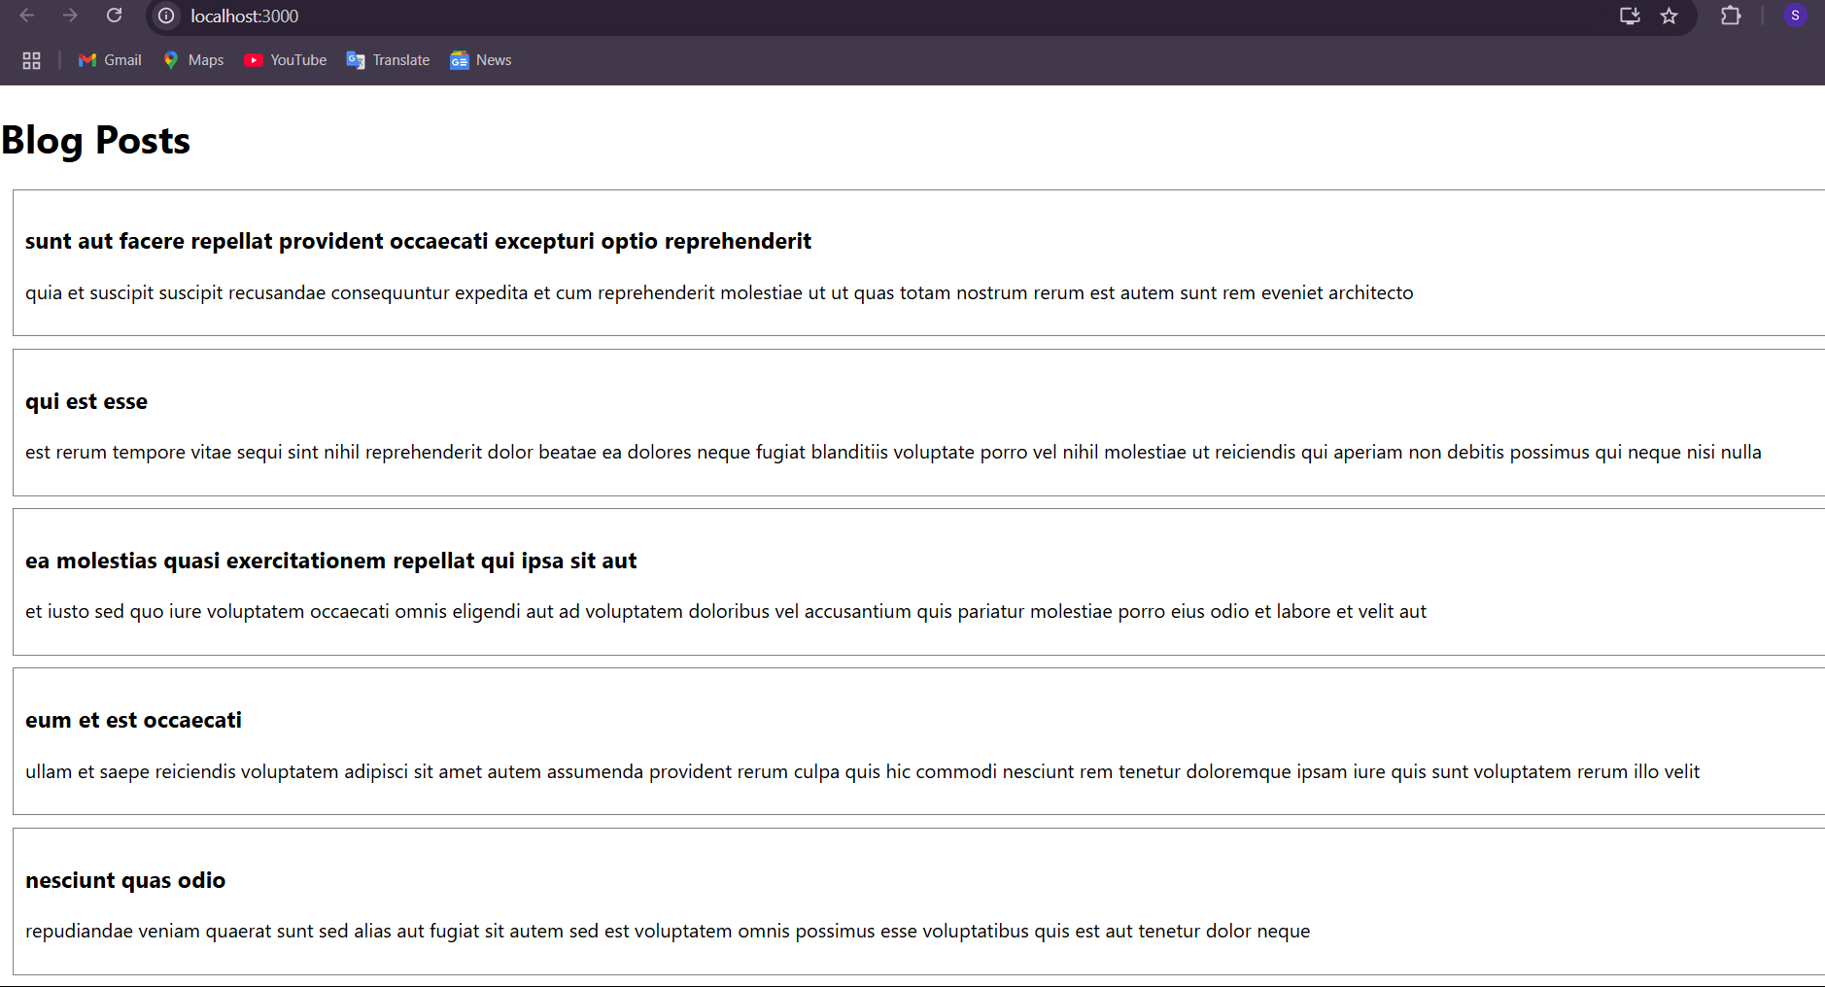

**Exercise 5: My Academy team at Cognizant want to create a dashboard containing the details of ongoing and completed cohorts. A react application is created which displays the detail of the cohorts using react component. You are assigned the task of styling these react components. Download and build the attached react application.**

**App.js:**

import React from 'react';

import CohortDetails from './cohort';

function App() {

  return (

    <div>

      <h2>Cohort Dashboard</h2>

      <CohortDetails

        name="React Bootcamp"

        duration="6 weeks"

        status="Ongoing"

        coach="Anjali"

        trainer="Suresh"

      />

      <CohortDetails

        name="Angular Fundamentals"

        duration="8 weeks"

        status="Completed"

        coach="Rahul"

        trainer="Neha"

      />

      <CohortDetails

        name="Vue.js Sprint"

        duration="4 weeks"

        status="Ongoing"

        coach="Meera"

        trainer="Kiran"

      />

    </div>

  );}

export default App;

**cohort.js:**

import React from 'react';

import styles from './cohort.module.css';

function CohortDetails({ name, duration, status, coach, trainer }) {

  const headingStyle = {

    color: status.toLowerCase() === 'ongoing' ? 'green' : 'blue',  };

  return (

    <div className={styles.box}>

      <h3 style={headingStyle}>Cohort: {name}</h3>

      <dl>

        <dt>Duration:</dt>

        <dd>{duration}</dd>

        <dt>Status:</dt>

        <dd>{status}</dd>

        <dt>Coach:</dt>

        <dd>{coach}</dd>

        <dt>Trainer:</dt>

        <dd>{trainer}</dd>

      </dl>

    </div>  );}

export default CohortDetails;

**cohort.module.css:**

.box {

  width: 300px;

  display: inline-block;

  margin: 10px;

  padding: 10px 20px;

  border: 1px solid black;

  border-radius: 10px;}

dt {

  font-weight: 500;}

**OUTPUT:**

