**WEEK-7**



**Exercise-1**: **Create a React Application named “cricketapp” with the following components: ListofPlayers,** **IndianPlayers**

**App.js:**

import React, { useState } from 'react';

import ListofPlayers from './components/ListofPlayers';

import IndianPlayers from './components/IndianPlayer';

function App() {

  const [flag, setFlag] = useState(true);

  return (

    <div className="App">

      <h1>🏏 Cricket App</h1>

      <button onClick={() => setFlag(!flag)}>Toggle View</button>

      {flag ? <ListofPlayers /> : <IndianPlayers />}

    </div>

  );}

**index.js:**

export default App;

import React from 'react';

import ReactDOM from 'react-dom/client';

import App from './App';

const root = ReactDOM.createRoot(document.getElementById('root'));

root.render(<App />);

**ListofPlayers.js:**

import React from 'react';

const ListofPlayers = () => {

  const players = [

    { name: "Virat", score: 85 },

    { name: "Rohit", score: 45 },

    { name: "Rahul", score: 78 },

    { name: "Shikhar", score: 32 },

    { name: "Hardik", score: 90 },

    { name: "Jadeja", score: 65 },

    { name: "Ashwin", score: 88 },

    { name: "Bumrah", score: 58 },

    { name: "Shami", score: 75 },

    { name: "Pant", score: 43 },

    { name: "Surya", score: 91 }

  ];

  const filteredPlayers = players.filter(player => player.score < 70); // arrow function

  return (

    <div>

      <h2>List of Players</h2>

      <ul>

        {players.map((player, index) => (

          <li key={index}>{player.name} - {player.score}</li>

        ))}

      </ul>

      <h3>Players with score below 70</h3>

      <ul>

        {filteredPlayers.map((player, index) => (

          <li key={index}>{player.name} - {player.score}</li>

        ))}

      </ul>

    </div>

  );};

export default ListofPlayers;

**IndianPlayer.js:**

import React from 'react';

const IndianPlayers = () => {

  const T20players = ["Virat", "Rohit", "Rahul", "Hardik"];

  const RanjiPlayers = ["Pujara", "Rahane", "Saha", "Sundar"];

  const allPlayers = [...T20players, ...RanjiPlayers];

  const oddTeam = allPlayers.filter((_, index) => index % 2 !== 0);

  const evenTeam = allPlayers.filter((_, index) => index % 2 === 0);

  return (

    <div>

      <h2>Even Team Players:</h2>

      <ul>

        {evenTeam.map((player, index) => (

          <li key={index}>{player}</li>

        ))}

      </ul>

      <h2>Odd Team Players:</h2>

      <ul>

        {oddTeam.map((player, index) => (

          <li key={index}>{player}</li>  ))}

      </ul>

    </div>

  );};

export default IndianPlayers;

**OUTPUT:**

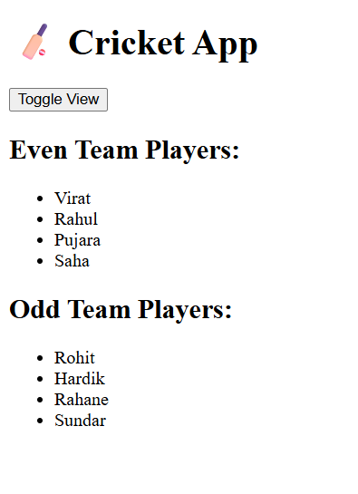

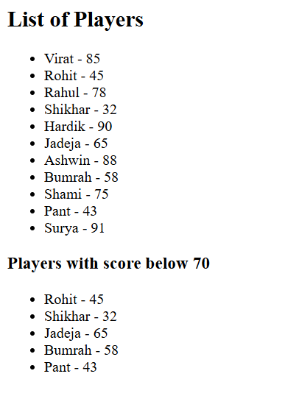

**Exercise-2**: **Create a React Application named “officespacerentalapp” which uses React JSX to create elements, attributes and renders DOM to display the page.**

**App.js:**

import React from 'react';

import './App.css';

function App() {

  const officeList = [

    {

      name: "Skyview Corporate",

      rent: 75000,

      address: "Hitech City, Hyderabad",

      image: "https://media.istockphoto.com/id/1322575582/photo/exterior-view-of-modern-apartment-building-offering-luxury-rental-units-in-silicon-valley.jpg?s=612x612&w=0&k=20&c=7ipOB2nGt7JB-rln2YM1wxQ2NI4ZZirsxSn8Ko9pk-k="

    },

    {

      name: "City Centre Workspace",

      rent: 55000,

      address: "MG Road, Bangalore",

      image: "https://images.nobroker.in/images/8a9fd3378600d74101860117f655257f/8a9fd3378600d74101860117f655257f_49756_716003_large.jpg"

    },

    {

      name: "Oceanview Towers",

      rent: 80000,

      address: "Marine Drive, Mumbai",

      image: "https://media.istockphoto.com/id/889473004/photo/walkway-leading-along-the- new-colorful-cmplex-of-apartment-buildings.jpg?s=612x612&w=0&k=20&c=Z5i9OjgYo0pLbMD4eeFtF0StrbRMaR891jYuxMLFXig="

    }

  ];

  return (

    <div className="App">

      <h1> Office Space Rental App</h1>

      {officeList.map((office, index) => (

        <div key={index} className="office-card">

          <img src={office.image} alt={office.name} />

          <h2>{office.name}</h2>

          <p><strong>Address:</strong> {office.address}</p>

          <p className={office.rent < 60000 ? 'red' : 'green'}>

            <strong>Rent:</strong> ₹{office.rent}

          </p>

        </div>

      ))}

    </div>

  );

}

export default App;

**App.css:**

.App {

  font-family: sans-serif;

  padding: 20px;

  background-color: #f9f9f9;

}

.office-card {

  background: white;

  border: 1px solid #ddd;

  padding: 16px;

  margin-bottom: 20px;

  border-radius: 8px;

  box-shadow: 2px 2px 6px rgba(0,0,0,0.1);

  max-width: 400px;

}

img {

  width: 120px;

  height: 90px;

  border-radius: 4px;

}

.red {

  color: red;

  font-weight: bold;

}

.green {

  color: green;

  font-weight: bold;

}

**OUTPUT:**

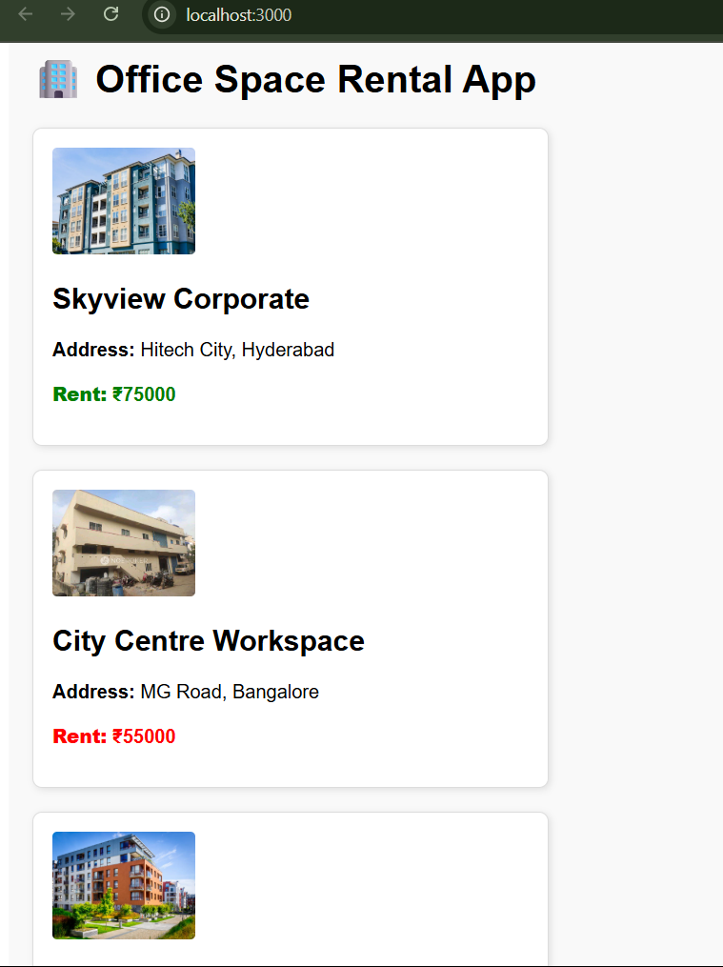

**Exercise-3**: **Create a React Application “eventexamplesapp” to handle various events of the form elements in HTML.**

**App.js:**

import React, { useState } from 'react';

import CurrencyConvertor from './components/CurrencyConverter';

function App() {

  const [count, setCount] = useState(0);

  const [message, setMessage] = useState("");

  const increment = () => {

    setCount(prev => prev + 1);

    sayHello();

  };

  const sayHello = () => {

    setMessage("Hello! This is a static message.");

  };

  const decrement = () => {

    setCount(prev => prev - 1);

  };

  const sayWelcome = (text) => {

    alert(`Message: ${text}`);

  };

  const handleClick = () => {

    alert("I was clicked");

  };

  return (

    <div className="App" style={{ padding: "20px" }}>

      <h1> Event Examples App</h1>

      <h2>Counter: {count}</h2>

      <button onClick={increment}>Increment</button>{" "}

      <button onClick={decrement}>Decrement</button>

      <p>{message}</p>

      <hr />

      <button onClick={() => sayWelcome("Welcome")}>Say Welcome</button>

      <hr />

      <button onClick={handleClick}>Click Me (Synthetic Event)</button>

      <hr />

      <CurrencyConvertor />

    </div>

  );}

export default App;

**CurrencyConvertor.js:**

import React, { useState } from 'react';

const CurrencyConvertor = () => {

  const [rupees, setRupees] = useState("");

  const [euro, setEuro] = useState(null);

  const handleChange = (e) => {

    setRupees(e.target.value);

  };

  const handleSubmit = () => {

    const value = parseFloat(rupees);

    if (!isNaN(value)) {

      const converted = value * 0.011;

      setEuro(converted.toFixed(2));

    } else {

      alert("Please enter a valid number");

    }

  };

  return (

    <div>

      <h2>💱 Currency Convertor</h2>

      <input

        type="text"

        value={rupees}

        placeholder="Enter amount in INR"

        onChange={handleChange}

      />

      <button onClick={handleSubmit}>Convert to Euro</button>

      {euro !== null && (

        <p>{rupees} INR = {euro} EUR</p>

      )}

  </div>

  );};

export default CurrencyConvertor;

**OUTPUT:**

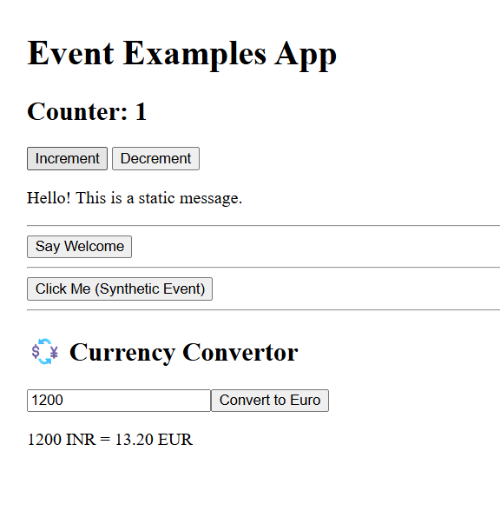

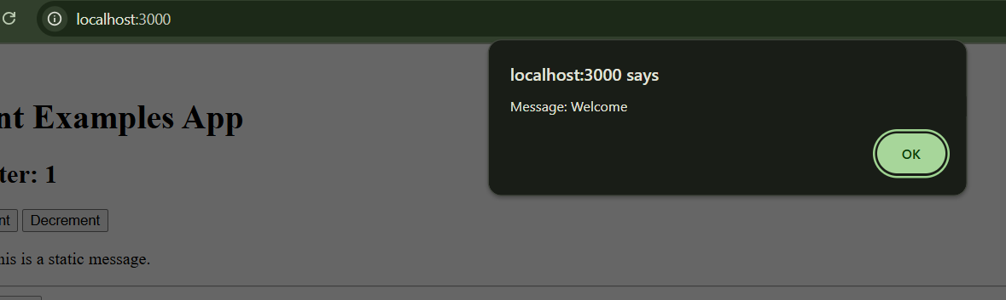

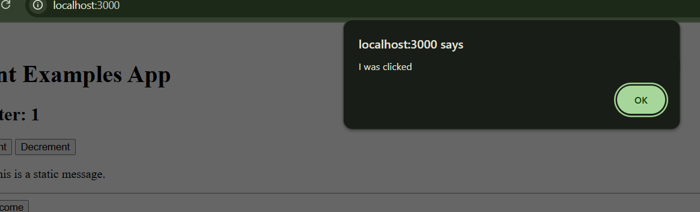

**Exercise-4**: **Create a React Application named “ticketbookingapp” where the guest user can browse the page where the flight details are displayed whereas the logged in user only can book tickets.**

**App.js:**

import React, { useState } from 'react';

import GuestPage from './components/GuestPage';

import UserPage from './components/UserPage';

function App() {

  const [isLoggedIn, setIsLoggedIn] = useState(false);

  const handleLogin = () => setIsLoggedIn(true);

  const handleLogout = () => setIsLoggedIn(false);

  return (

    <div className="App" style={{ padding: '20px' }}>

      <h1>✈️ Ticket Booking App</h1>

      {isLoggedIn ? (

        <>

          <button onClick={handleLogout}>Logout</button>

          <UserPage />

        </>

      ) : (

        <>

          <button onClick={handleLogin}>Login</button>

          <GuestPage />

        </>

      )}

    </div> );}

export default App;

**GuestPage.js:**

import React from 'react';

const GuestPage = () => {

  return (

    <div>

      <h2>🧍Guest View</h2>

      <h2>Please Signup</h2>

    </div>

  );

};

export default GuestPage;

**UserPage.js:**

import React from 'react';

const UserPage = () => {

  return (

    <div>

      <h2>👤 User View</h2>

      <h2>Welcome Back</h2>

      </div>

  );

};

export default UserPage;

**OUTPUT:**

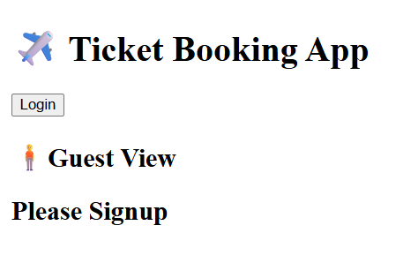

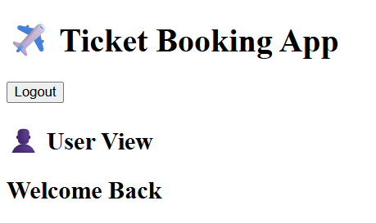

**Exercise-5**:

**Create a React App named “bloggerapp” in with 3 components.**

1. **Book Details**
2. **Blog Details**
3. **Course Details**

**App.js:**

import React, { useState } from 'react';

import BookDetails from './components/BookDetails';

import BlogDetails from './components/BlogDetails';

import CourseDetails from './components/CourseDetails';

function App() {

  const [view, setView] = useState("book");

  return (

    <div style={{ padding: '20px' }}>

      <h1>📚 Blogger App</h1>

      <button onClick={() => setView("book")}>Book Details</button>

      <button onClick={() => setView("blog")}>Blog Details</button>

      <button onClick={() => setView("course")}>Course Details</button>

      <hr />

      {view === "book" ? (

        <BookDetails />

      ) : view === "blog" ? (

        <BlogDetails />

      ) : view === "course" ? (

        <CourseDetails />

      ) : null}

    </div>

  );

}

export default App;

**BookDetails.js:**

import React from 'react';

const books = [

  { id: 1, title: "React in Action", author: "Mark T.", publisher: "Manning" },

  { id: 2, title: "Learning React", author: "Alex B.", publisher: "O'Reilly" },

  { id: 3, title: "Fullstack React", author: "Acme Inc.", publisher: "Acme Press" }

];

const BookDetails = () => {

  return (

    <div className="book-container">

      <h2>📖 Book Details</h2>

      <ul>

        {books.map((book) => (

          <li key={book.id} className="book-card">

            <p><strong>Title:</strong> {book.title}</p>

            <p><strong>Author:</strong> {book.author}</p>

            <p><strong>Publisher:</strong> {book.publisher}</p>

          </li>

        ))}

      </ul>

    </div>

  );

};

export default BookDetails;

**BlogDetails.js:**

import React from 'react';

const BlogDetails = () => {

  return (

    <div>

      <h2>📝 Blog Details</h2>

      <p>Title: Learning React</p>

      <p>Author: Sameera</p>

      <p>Posted On: July 2025</p>

    </div>

  );

};

export default BlogDetails;

**CourseDetails.js:**

import React from 'react';

const CourseDetails = () => {

  return (

    <div>

      <h2>🎓 Course Details</h2>

      <p>Course: Full Stack Web Development</p>

      <p>Instructor: Alex Doe</p>

      <p>Duration: 3 Months</p>

    </div>

  );

};

export default CourseDetails;

**OUTPUT:**

