Implementing Incident Response in DevOps Pipeline Using Open Source Tools

Sumathi Dhanasekaran  
Department of computing DevOps  
Atlantic Technological UniversityLetterkenny,Ireland  
L00187746@atu.ie

*Abstract*— The research concentrates on reducing the duration and workload dedicated to incidents which reoccur or have previous solutions. Teams gain faster problem-solving capabilities by maintaining formal records of solved incidents along with the performed actions and additional follow-up measures. This method both simplifies incident management and enables staff to apply permanent solutions to prevent future incidents. DevOps teams operate more efficiently owning to this approach thus they can dedicate their expertise to creating systems which resist failures.

Keywords— Incident Response, Automation, DevOps tools, Open-Sources, Machine Learning in DevOps, Efficiency, Reliability, Root Cause Analysis, Threat Detection

# Introduction

DevOps workflows have fast and efficient incident response mechanisms that stand as top priorities. The expansion of infrastructure and services requires organizations to possess the quick ability to identify issues, analyze and resolve them for continuous performance and high system uptime. Most early incident response strategies used to depend on manual human actions which frequently lead to delays, human error and inconsistent resolution outcomes.

Financial organizations require swift recovery above all else because system outages produce negative financial impacts along with severe damage to their reputation. When system failures occur within a few minutes across banking or stock trading and payment processing operations it can produce an expensive monetary damages and omitted transactions and dissatisfied customers. Unprompted recovery speed prevents firms from satisfying regulatory rules and litigations and losing their customer base. System downtime that extends over time creates an opportunity for market competitors to seize control leading to long-term losses in business position. Business success depends on automated incident response as an absolute necessity beyond technical requirements to protect financial stability together with regulatory compliance and client trust. [1]

Improved technologies specifically related to language processing and automation now enable rapid incident response acceleration. This paper explains how building a structured response to incidents that occur in production systems can integrate Open-Source DevOps GPT alongside with DevOps technologies. The proposed system uses automation to detect errors while assessing and resolutions therefore it decreases response time and enhances consistent reactions. Tools such as Datadog and Prometheus enable integrated logging and monitoring which support teams to search historical incidents through webhook integration while producing suitable solutions with automated response capabilities.

The integration of Open-Source GPT processing in DevOps-driven incident response systems uses artificial intelligence to provide insights and recommendations which can inform the decision-making process. GPT model operates independently to parse extensive system log data while it detects historic incident-related patterns to generate correct resolution approaches. Natural language processing technology allows the system to extract valuable information from documentation as well as existing ticket resolutions and knowledge bases to create optimal troubleshooting plans.

The integration of Open-Source DevOps GPT within DevOps pipelines enables automatic system failure response through real-time response automation which decreases the need for manual worker interactions and speeds up critical system failure resolution. The integration of DevOps GPT with monitoring tools provides users with a proactively alerting system that can identify potential problems before they turn into large-scale outages. System stability remains uninterrupted but downtime is reduced through mediations that follow pre-defined workflows which trigger automatically using playbooks. The deployment of AI-based automation systems supports both operational diversity and system scalability through minimized human mistakes and structured resolution plans based on data. The adoption of cloud and distributed systems by organizations brings DevOps-GPT into self-managing incident response systems that deliver enhanced workflow efficiency and perpetual improvement and maintain high system availability.

A Purpose and Scope

The paper explores Open-Source DevOps GPTs, e.g. Auto-GPT or Lang Chain, integration with DevOps frameworks for developing incident management systems based on artificial intelligence capabilities. Data monitoring from Datadog or Prometheus together with Open-Source DevOps GPT’s agent and its generation of optimal troubleshooting plans allows organizations to obtain quick and reliable incident resolution. AI-powered automation presents advantages for stability maintenance and downtime minimization and enables self-managing incident response workflows which leads to improved operational efficiency and high system availability. [2]

# Problem Definition

## Research hypothesis

DevOps incident response automation becomes more efficient through Open-Source DevOps GPT when integrated with its open-source capabilities allowing AI-driven error analysis as well as incident retrieval and step-by-step solution generation. An AI-powered system includes OpenAI GPT model for JSON files-based searches using MongoDB with the help of API calls guided by Open source GPT agent langChain. The implementation of this AI automation system is expected to boost system reliability by introducing reliability and downtime reduction which together will generate improved DevOps performance.

## Research Objective

To develop and implement an automated incident response system using the open-source DevOps GPT AI agent, MongoDB, and a data monitoring tool, integrating AI-driven automation for efficient incident management. An investigation was done on how the integrated platform help to analyze errors more effectively and automatically retrieves incidents, generating step-by-step solutions.

## Deployment Architecture

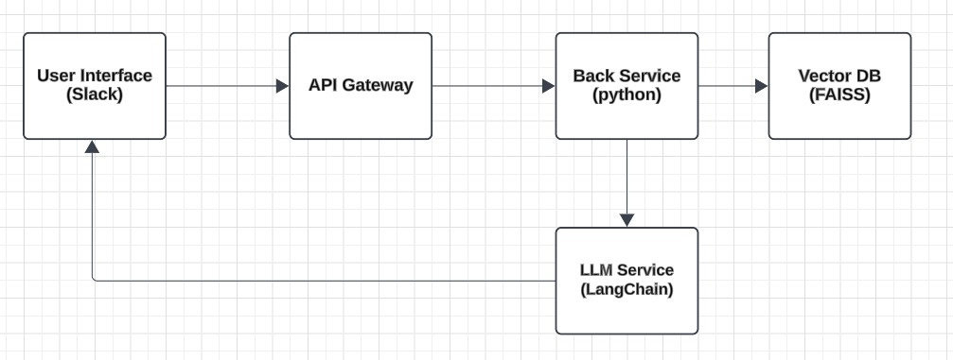

Figure

# Understanding DevOps Incident Response with Automation

DevOps teams can reduce the number of issues from becoming worse by AI-powered incident classification (e.g., using FAISS + LangChain) to provide quick solutions. Infrastructure as Code (IaC) and auto-remediation scripts operate through automated workflows to resolve incidents independently so response times decrease together with manual errors reduction.

## The role of incident response in DevOps

The response to incidents within DevOps operations ensures both system dependability and reduced outages and creates uninterrupted end-user performance. A standard DevOps environment that uses continuous integration and deployment (CI/CD) methods faces unexpected disruptions when system failures happen along with security breaches while performance bottlenecks also cause problems.

A successful incident response for effective risk management and business stability requires teams to be alert and act promptly in finding issues followed by assessment, containment and issue resolution activities to bring system functionality back online immediately. DevOps workflows achieve better incident response by employing automated system observation functions and self-healing systems that minimize the time needed for resolution (MTTR). The system resilience gets enhanced while the culture of continuous improvement develops through analysis of incident data for both prevention of future events as well as system performance optimization. [3]

## Challenges faced during manual incident handling

System reliability together with business continuity faces multiple challenges. Systems administrators must probe through multiple logs and reports as well as metrics to find the root cause of problems which slows down the resolution process. More time becomes essential for proper examination of the issue along with defining the correct solution after successfully identifying the problem. The extended response period affects the critical issues by providing solutions in rush for important incidents that create substantial operational and financial consequences. Teams face enormous operational pressure during such situations which causes communication problems and creates misunderstanding where human mistakes can also occur. The use of manual procedures can lead to variable results in addition to poor documentation methods and poor resource distribution which makes it challenging to gain insights from past events and improve future emergency procedures.

Manual incident handling creates several difficulties as it impacts risk management in a substantial way. Automation defines several key shortcomings that occur when incident teams operate without it as the incident management teams will encounter delayed responses alongside missed opportunities to maintain consistency when addressing issues and systemic breakdowns between team members. The time needed to resolve incidents extends when teams need additional time to identify problems and set priorities which increases the chances of ongoing application interruptions and disrupted business operations. Security vulnerabilities and compliance issues occur when predictive analysis and real-time monitoring systems are absent which means that potential risks may go unnoticed until they escalate into serious problems. Manual documentation creates misunderstandings which can cause information gaps that complicate the resolution process for incidents. System stability declines over time and higher costs along with damages to reputation become inevitable consequences of these inefficiencies. [4] [5]

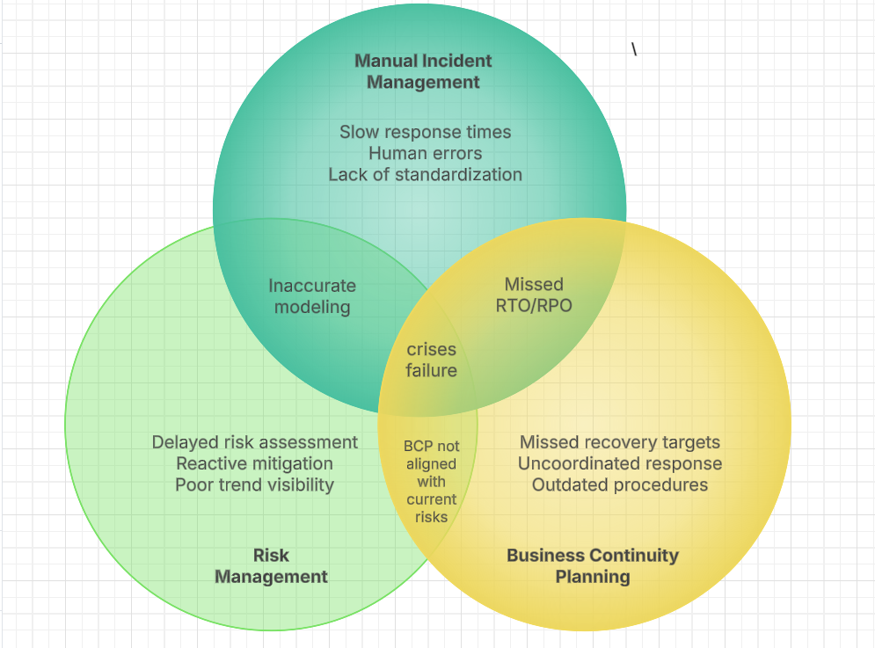

Figure

## Why automation is critical for faster recovery

The detection of production anomalies runs automated error correction programs once it identifies unexpected patterns. The reduction of system recovery times through automation allows DevOps teams to dedicate their efforts towards innovation since automated processes decrease their workloads.

# Major Domains of Incident Response Automation

## Threat Detection

Protection of production IT systems depends on continuous observation which detects both security breaches and system weaknesses as well as abnormal behavior. The detection process includes real-time system surveillance along with intrusion detection systems, security analytics solutions and endpoint detection with additional machine learning capabilities to perform fast threat identification and response. The observability solution provided by Datadog and Grafana detects anomalies in real time but Splunk together with Elastic Security (ELK Stack) and Sumo Logic excel at security event correlation and log analysis. Organizations can detect unwanted cyber-attacks as well as unauthorized access attempts or system misconfigurations early through automated systems which combine threat intelligence with behavioral analysis for the purpose of maintaining system integrity and both data security and business operations. [6] [7]

## Incident Analysis

IT incidents need investigation through incident analysis to reveal their fundamental causes together with their consequences and required actions. The identification process depends on log data and system assessments as well as network activity analysis to discover why issues occur and check whether the cause is through cyberattacks or system problems or human mistakes. The tools Splunk and Datadog unite data collection with data correlation to yield deeper analytical results. Analysts perform multiple steps by evaluating incident extent and finding affected systems before checking for active risks. Recent findings enable analysts to formulate countermeasures that they record along with lessons learned which will lead to security enhancements in the system for future incidents.

## Automated Response and Containment

The automated response and containment work to stop issues and block the malicious IPs and separate the infected endpoints while also revoking harmful credentials. Playbook-based workflows enable fast consistent incident responses that need human intervention to protect against attack impact. Incident response systems at endpoints and networks conduct automatic measures for device quarantining while removing malware infections and deploying security updates. Security policies get implemented after threat response while administrators restore systems to previous stable configurations for threat neutralization. A joint defense system is achieved through security tool integration that combines firewalls with SIEMs and SOAR platforms. Automated system implementation streamlines response operations which decreases the time needed for response while reducing issue impact to maintain resilient production operations.

## Automated Workflows and Ticketing

Automated workflows and ticketing systems efficiently minimize human effort by creating streamlined reporting structures and incident tracking for both cybersecurity and IT support teams. The technical platforms enable security teams to handle repetitive work duties including threat assessment and information acquisition that enables rapid efficient response to cyber incidents. The automated workflow system performs predefined operational procedures that start with system isolation and log acquisition following detection. Through this operation integrated ticketing systems can help to create new incident tickets and keep ticket records updated with all performed actions and findings. This not only reduces human error but also ensures consistency, improves response times, and provides a detailed audit trail for future analysis and compliance reporting.

## Post-Incident Analysis and Continuous Improvement

Post-incident analysis and continuous improvement in DevOps production IT evaluates how to respond to production incidents to boost system reliability and security through evaluation and sustained evolution. The automated forensic system generates comprehensive incident data which reveals necessary information about what is the root cause of the incident together with the routes attackers used and system-level vulnerabilities they exposed. The analysis produces complete post-incident reports to fulfill compliance requirements and facilitate information spread between development teams and operational staff. Links with outside threat intelligence resources enable the organization to monitor developing risks and establish better security collaborations with partners. The development pipeline receives information from incident feedback loops that enables adaptive learning mechanisms to enhance monitoring, detection and automated remediation methods thus improving incident response efficiency in subsequent occurrences. [8]

# Steps Involved in Incident Response Automation in DevOps Using Open Source Tools

Open-source DevOps incident response tools are cost-effective and flexible solution for managing security incidents within an organization. The tools are highly customizable, and it is easy for teams to adapt them according to their specific needs so that they can adapt to the workflows and incident response requirements. Most open-source tools also have the added advantage of having active communities contributing to them, which implies rapid updates, ongoing development, and incorporation of sophisticated features. Open-source solutions' affordability lowers the barriers in terms of financial needs, thereby making highly effective incident response capabilities accessible to even for the organisation with limited resources.

## Set Up Open-Source DevOps GPT

The fundamental setup for Incident response automation for this research is setting up Open source DevOps GPT. Tools like Auto-GPT, LangChain with GPT-4 API for a custom AI agent and [DevOps GPT by DevOps Hobbies](https://github.com/devopshobbies/devops-gpt) for experimental version of OpenAI’s latest AI model. [9]

*Tool Selection:*

LangChain API framework has been used with Auto-GPT Open AI for solving errors through automated incident response. Sentence-Transformers (all-MiniLM-L6-v2) which is a pre-trained model for dense vector embeddings is used for semantic search and retrieval of incident response.

1. *LangChain***:**

The GPT-4 API becomes more accessible through LangChain because it provides integrated tools to combine prompts and manage memory and perform retrievals. Users can create unique interaction sequences through the platform which enables their agents to access web services and store system data and retrieve documents. The platform enables better GPT-4 functionality through its integrated support for managing logical operations along with carrying out actions. Such functionality makes the technology suitable for automation work and AI applications. [10]

1. *Sentence-Transformers (all-MiniLM-L6-v2):*

all-MiniLM-L6-v2 is a brilliant AI model that converts text into numbers (called embeddings) in a way that machines understand meaning. It helps with things like:

* Searching for similar sentences (semantic search)
* Description of a related Text (clustering)

This sentence transformer works fast even on ordinary computers and knows which words are similar. [11]

## Incident Data Collection & Storage

*Database*

MongoDB is used for the research to store incident records for past incident and its resolution information retrieval. MongoDB has a schema-less architecture that enables dynamic data modeling. The indexing and aggregation features of MongoDB accelerate searches for effective incident data retrieval. With horizontal scalability and built-in replication and sharding, it can efficiently manage increasing records and is reliable and fault-tolerant. MongoDB uses the JSON-like BSON format, making integration with modern applications and APIs easy and ideal for transaction efficiency with structured incident records. [12]

JSON format of incident record in MongoDB:

{

error_message: "Application Server Crash”

root_cause: "Load Balancer went Out of memory"

solution_steps:

Array (3)

0: "Restarted application services"

1: "Increased memory allocation"

2: "Optimized background processes"

}

*Indexing*:

A text index enables full-text searches on string fields. It also assists to perform fast lookups for words or phrases in text-based fields. Without an index, MongoDB will perform a scan of the entire collection to find the match provided, which is inefficient for big data sets in MongoDB. A text index is used to speed up the search process.

*Vectorization***:**

An embedding is a numerical representation of text in a high-dimensional space. Texts similar to one another will have similar embeddings. For embedding Sentence-Transformers is used, which is a deep learning model for producing sentence embeddings.

FAISS is a library for efficient similarity search and clustering of dense vectors. FAISS (Facebook AI Similarity Search) is a library designed for efficient vector search, particularly for very large datasets.This method is useful for error log analysis, anomaly detection and debugging. [13]

## AI-Powered Incident Analysis Pipeline

The AI-based incident analysis pipeline is a smart way of using machine learning and automation to discover and respond to a security threat as it unfolds in the present time, improving the effectiveness of threat analysis.

*Error Detection:*

Real-time log monitoring is employed in the pipeline, using Prometheus, Grafana, and Datadog, to provide an ongoing view of system performance, application logs, and security events. The monitoring tools automatically sent alerts through Webhooks when it identified a possible incident or error. The webhooks acts as a way to communicate and forwards the alert data to the AI-powered analysis system that is integrated.

*GPT-Based Analysis:*

The pre-processed and converted historical incident report and log entries are translated into numerical representations (embeddings) using OpenAI’s text embeddings. FAISS (Facebook AI Similarity Search) is employed to identify historical equivalents by using vectorized embeddings of log data, error messages, and incident reports.

The purpose of the prompt was to retrieve the best resolution method, based on previous knowledge. The prompt designed was sent to an LLM (e.g. OpenAI’s GPT) to generate an explicit plan with steps to follow to reach the solution. The pipeline streamlined incident analysis and response by combining FAISS for knowledge retrieval with LangChain’s Prompt Template for AI-driven solution synthesis. [9] [13]

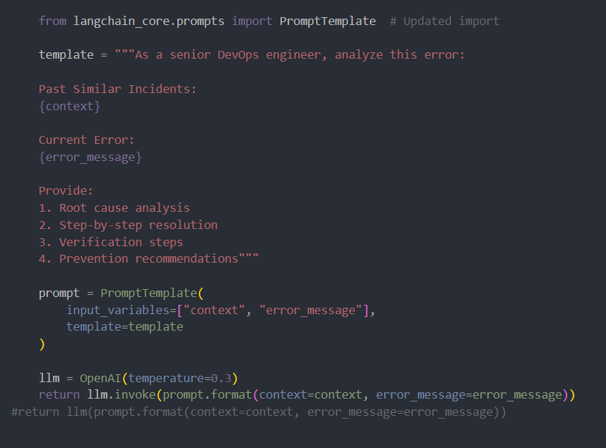

Figure LangChain prompt

*Incident Response Automation Results:*

To enable incident management team to quickly retrieve solutions for incidents, a command-line interface (CLI) tool was developed using Python Click module. This tool allows team to search for relevant past incidents and their resolutions directly from the terminal. [14] Considering “cli_tool.py” file contains the automation interface script, the query solutions looks like below.

“python cli_tool.py resolve "Application server crash"”

In order to provide a smoother incident resolution process, a Slack Bot is implemented using Slack Bolt API. When an incident was detected or queried, this bot automatically posts resolutions in dedicated Slack channels. Teams can tag the bot with an error message, and it responds with potential solutions. When an exact match is not found, the bot builds likely solution using an AI model. These updates are posted automatically to Slack improving collaboration on resulting incidents. [15]

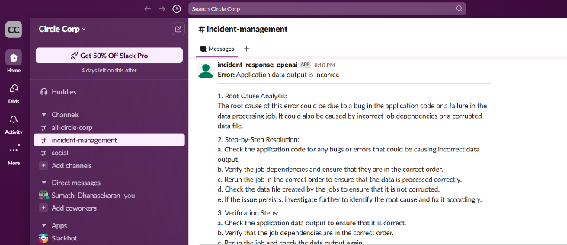

Figure Slack Integration for Automated Incident Response

# Open-Source Advantages and Limitations of Automated Incident response in devops

## No Licensing Costs

By removing dependency from proprietary SaaS platforms, we drive down licensing costs directly attributable to the use of commercial AI-driven incident management tools, typically charged on a per monitored node, log volume, or advanced automation features basis. When making clever use of open-source solutions such as FAISS, LangChain, Prometheus, and Grafana, organizations can deliver the power of an enterprise incident response solution free of rent-seeking fees. It allows for more customization, better security since data remains on-premises, and easier scaling without vendor lock-in.

## Data Portability

Data can be in a portable format, no vendor lock-in, no silos like ServiceNow etc., simply incident storage using MongoDB (self-hosted). Self-hosted MongoDB differs from closed ecosystems, which require direct access to data, and allows organizations to own, manage, and structure incident data according to their needs. Additionally, storing incidents in MongoDB also allows for cross-platform data migration, long-term archival, and compliance to be enforced, an added security measure that incident data is accessible and ready for interfacing with as infrastructure evolves.

## Long-Term Maintainability

Open-source incident response pipelines backed by AI allow organizations to maintain their systems over time while their technology matures because of their adaptable design and clear capabilities. The activity of developer communities within open-source ecosystems leads to increased continuous enhancement and security maintenance with added features. MongoDB provides its users with 40K+ GitHub repositories which contain a wealth of fixes along with plugins and extensions that organizations can use to boost database performance and conduct security optimizations as well as combine tools without complexity. [16]

The choice of open-source tools like MongoDB combined with FAISS and Auto-GPT not only cut operational expenses but simultaneously enables flexible architecture.

## Limitations:

1. *Dependency on Historical Data Quality*

The system achieves its function when the historical incident information meets the high quality and relevance. The system produces substandard solutions through artificial intelligence when it encounters inaccurate historical records that lack complete documentation of root cause analysis and solutions. The pipeline faces reliability degradation when insufficient data validation and curation procedures are used because it could accidentally spread wrong information or outdated solutions.

1. *Vector Search Latency for Large Datasets*

The performance of FAISS suffers when dealing with incident logs that exceed 100K entries because search times become longer. Real-time incident resolution can be interrupted because of the delayed responses which result from brute-force indexing methods. The required performance optimizations involve using hierarchical navigable small-world (HNSW) indexing along with sharding to sustain scalability levels that do not result in decreased speed.

# Conclusion:

Open-source DevOps tools together with GPT-based AI enable incident response automation for error examination and solution discovery and immediate time consumption on analyzing remediation actions. The proposed system built on MongoDB for incident storage and FAISS for searches and Auto-GPT for decisions makes resolution times faster while avoiding vendor lock-in.

This approach produces a fundamental change from conventional troubleshooting to advanced proactive operations which involves artificial intelligence assistance despite facing key challenges with data quality and scalability constraints. The development path will focus on LLM specialization and the integration of predictive system health assessment to establish genuine self-repair capabilities. The framework which connects AI with DevOps operations creates new possibilities for IT resilience through increased operational efficiency.

##### Acknowledgment

I would like to express my deepest gratitude to Professor Ruth Lennon for the invaluable guidance and support throughout this research. I am also thankful to Atlantic Technological University, Department of computing DevOps for providing the necessary resources.

# References

|  |  |
| --- | --- |
| [1] | C. IT, "Creating a Robust Incident Response Plan for Financial Cybersecurity," Charles IT, 30 May 2024. [Online]. Available: https://blog.charlesit.com/creating-a-robust-incident-response-plan-for-financial-cybersecurity. [Accessed 19 March 2025]. |
| [2] | S. Chinamanagonda, "Automating Incident Response in DevOps -Automated incident response mechanisms in DevOps workflows," 2023. [Online]. Available: https://researchworkx.com/index.php/jci/article/view/7/7. [Accessed 11 03 2025]. |
| [3] | A. Froehlich, "Incident response automation: What it is and how it works," TechTarget, 22 Jan 2024. [Online]. Available: https://www.techtarget.com/searchsecurity/tip/Incident-response-automation-What-it-is-and-how-it-works. [Accessed 20 March 2025]. |
| [4] | onetrust, "What’s the cost of a manual IT risk management process?". |
| [5] | D. Strait, "10 Steps for Incident Management and Business Continuity," 20 September 2022. [Online]. Available: https://www.agilityrecovery.com/article/10-steps-incident-management-and-business-continuity. [Accessed 02 March 2025]. |
| [6] | launchdarkly, "Elastic (ELK) Stack," 2024. [Online]. Available: https://launchdarkly.com/docs/eu-docs/integrations/elastic-stack. [Accessed 12 03 2025]. |
| [7] | Splunk, "Splunk Enterprise Security," [Online]. Available: https://www.splunk.com/en_us/products/enterprise-security.html. [Accessed 12 March 2025]. |
| [8] | V. Subbiah, "Post-Incident Analysis and Continuous Improvement," 2 March 2024. [Online]. Available: https://medium.com/@vinoji2005/day-35-post-incident-analysis-and-continuous-improvement-e3419be5f82b. [Accessed 27 Feb 2025]. |
| [9] | P. Lakhera, "DevOps-GPT: Automating SRE Resolutions with AI-Powered Agents and Insights," 14 Jan 2025. [Online]. Available: https://dev.to/lakhera2015/devops-gpt-automating-sre-resolutions-with-ai-powered-agents-and-insights-4621. [Accessed 20 March 2025]. |
| [10] | Restack, "Langchain Gpt-4 Tutorial," Restack, [Online]. Available: https://www.restack.io/docs/langchain-knowledge-gpt-4-tutorial-cat-ai. [Accessed 21 03 2025]. |
| [11] | Hugging face, "sentence-transformers/all-MiniLM-L6-v2," [Online]. Available: https://huggingface.co/sentence-transformers/all-MiniLM-L6-v2. [Accessed 20 March 2025]. |
| [12] | M. University, "MongoDB Manual," MongoDB University, [Online]. Available: https://www.mongodb.com/docs/manual/. [Accessed 28 02 2025]. |
| [13] | Meta, "Faiss," [Online]. Available: https://ai.meta.com/tools/faiss/. [Accessed 20 March 2025]. |
| [14] | palletsprojects, "Python Click," [Online]. Available: https://click.palletsprojects.com/en/stable/. [Accessed 20 March 2025]. |
| [15] | A. t'Kint, "Integrate OpenAI’s ChatGPT within Slack: a step-by-step approach!," 3 Feb 2023. [Online]. Available: https://medium.com/@alexandre.tkint/integrate-openais-chatgpt-within-slack-a-step-by-step-approach-bea43400d311. [Accessed 25 March 2025]. |
| [16] | V. Sergeev, "5 pros and cons of using generative AI during incident response," 06 October 2023. [Online]. Available: https://www.securitymagazine.com/articles/99984-5-pros-and-cons-of-using-generative-ai-during-incident-response. [Accessed 21 March 2025]. |

**IEEE conference templates contain guidance text for composing and formatting conference papers. Please ensure that all template text is removed from your conference paper prior to submission to the conference.**