***📽️ Movie Data Analysis Project Documentation***

# *Project Overview*

The goal of this project is to analyze a dataset of movies to uncover insights into the factors that influence movie success. This includes examining trends in genres, revenue, ratings and release years.

# *Dataset*

**Source**: Movie Metadata

**Key Columns**:

- Movie Titles  
- Director Names  
- Duration  
- Languages  
- Country  
- Title Year  
- Actors Names  
- Content Rating  
- Budget  
- Gross

- Genres  
- imdb_score  
- Movies imdb_link  
- Plot Keywords  
- Number of Voted Users  
- Number of Users for Reviews  
- Face Number in Poster  
- Movies Facebook Likes  
- Aspect Ratio  
- Cast Total Facebook Likes

- Director Facebook Likes  
- Actors Facebook Likes  
- Number of Critic for Reviews

# *Tools Used*

- Microsoft Excel  
- Power BI

# *Steps Followed*

- Cleaned data in Excel (e.g.: removed blanks and duplicates, formatted columns)  
- Used Excel formulas for basic analysis  
- Imported cleaned data into Power BI

-Built dashboards using charts, slicers, and KPIs

# *Key Insights*

- Number of movies were highest in 2014.  
- Crime Thriller and Drama are the most common genres.  
- The number of votes is more indicative of popularity than average rating alone.  
- US is consistently produced high-grossing films.

- Kingkong is the highest imdb scored movie

# *Screenshot*

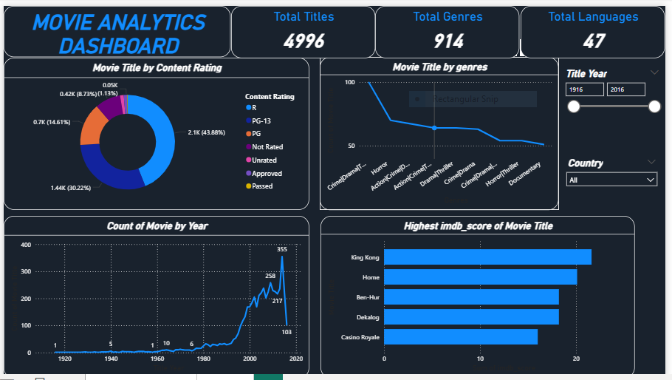

# *Files Included*

- movie_metadata_cleaned.xlsx - Cleaned data and basic analysis

- Visual Moviedata.pbix - Power BI Dashboard

- ‘README.md’ - Project Description

# *How to Use*

- Open movie_metadata_cleaned.xlsx to view the cleaned data

- Open Visual Moviedata.pbix in Power BI Desktop to explore the visuals