**Analyzing Neighborhoods in Mumbai**

# Coursera – IBM Capstone Project

*Starting a Café business in Mumbai*

By: Sumedh

July 2020

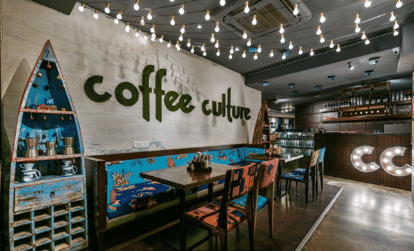

**Introduction**

Being a metropolitan city, Mumbai has seen a boom in cafes and restaurants over the past decade. Now the need is to identify places where these business ventures will in fact work and to expand this market well beyond its current borders.

**Business Problem**

The objective of this capstone project is to analyze and select the best locations in the city of Mumbai, India to open a new cafe. Using data science methodology and machine learning techniques like clustering, this project aims to provide solutions to answer the business question: In the city of Mumbai, India, if a person is looking to open a new cafe, where would you recommend that they open it?

**Target Audience of this project**

This project is particularly aimed at people/companies in the business line of cafes who either want to expand their business or start up fresh.

**Data**

To solve the problem, we will need the following data:

• List of neighborhoods in Mumbai.

• Latitude and longitude coordinates of those neighborhoods. This is required in order to plot the map and also to get the venue data.

• Venue data, particularly data related to cafes. We will use this data to perform clustering on the neighborhoods.

Sources of data and methods to extract them

<https://en.wikipedia.org/wiki/Administrative_divisions_of_Mumbai>

Using this in conjunction to the FourSquare API to form the data and do the analysis accordingly.