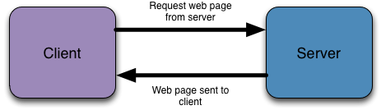
In order to deliver dynamic content we need to extend the abilities of the web server so that it can do more than merely send static web pages in response to client requests. The common gateway interface (CGI) provides a mechanism to do this.
When serving static web pages the server is normally asked for a file that has a .htm or .htmlextension e.g. http://mywebsite.com/index.html. If we wish to serve a dynamic page the extension would be different, for example .cgi or .php.
If a request comes in with one of these extensions the web server knows to pass the request to the CGI which then interprets it correctly and executes the script in the particular scripting language.
Once the script has finished executing the CGI then passes the output back to the web server to be delivered as a response to the client request. The diagram demonstrates this:
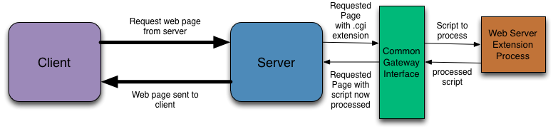

Localhost Server
Normally server-side scripts form part of a dynamic website which is stored on some remote web server. You would edit your pages on your computer and then upload them to the server via a FTP program. Which is inconvenient so we use localhost.
Software’s required are:
XAMMP
SQL Connector
To install connector use : pip install mysql-connector-python
- pip install pymysql

Path to python:
'C:\\Users\\sumed\\AppData\\Local\\Programs\\Python\\Python36-32'
We need to mention this path in at top our script.
code for that:-
>>> import os
>>> import sys
>>> os.path.dirname(sys.executable)
First Code to show hello world:-
#!"C:\\Users\\sumed\\AppData\\Local\\Programs\\Python\\Python36-32\\Python.exe" //add additional python.exe to execute the file because we can not execute the folder

import cgi

def htmltop():
print("""Content-type:text/html\n\n
<!DOCTYPE html>
<html>
<head lang="en">
<meta charset = "utf-8">
<title>First Script</title>
</head>
<body>
""")

def htmltail():
print("""</body>
</html>""")

if __name__=='__main__':
try:
htmltop()
print("Hello World") /*write here so that everyhing come in between body tags*/
htmltail()
except:
cgi.print_exception()

Note:
validating your form easier. Generally validation of a form is a two step process
- Client-side validation with JavaScript
- Server-side validation with your scripting language

Our form has the following action attribute:
1 | <form method="post" action="processname.cgi">
This means that the processname.cgi script is supposed to handle the submitted form data. We will need to create the script.

Field storage
To access the data submitted by the form in our script we will need to make use of the FieldStorage() function available in the cgi module of Python.
For example, we would assign the data from the form to a Python variable in the following way:
1 | formData = cgi.FieldStorage()
The variable formData now contains every piece of data submitted by the form.

Getting individual values
Clear we will need to access the individual submitted values - in this case the actual submitted name. Python has a function we can use for this purpose as well. It is called getvalue().
In order to use the getvalue() function you need to know the name of the html form component you wish to retrieve data from. Our form had the following components:
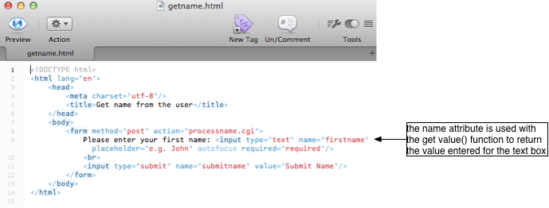
If we know the name of the component we can then use the formData variable in conduction with the getvalue() function to retrieve the data stored:
1  2 | formData = cgi.FieldStorage()  firstName = formData.getvalue('firstname')
Once the data is in a Python variable you can treat it like any other variable you have created previously.
In addition, any data that is submitted via a form can be processed by a server-side script and then stored in the database.

MySQL
The database management system that we use with our server-side scripts is called MySQL.
One important feature is access control: you must have an appropriate username and password to access the contents of particular databases. This prevents unauthorised access to content, unlike SQLite which does not have this functionality

Accessing the MySQL server
There are a few different methods of accessing MySQL:
- Python scripts
- The command line
- By using a web application called PHPMyAdmin
We will be mainly interacting with MySQL using Python scripts as access to the command line and PHPMyAdmin varies depending on whether you are using XAMPP or another server-side set-up.
If you are using a XAMPP installation then you will need the following to log into the server:
- Host Name: localhost
- User Name: root
- Password: there is no password
- create database exampledb;
The person entity can be defined as:
- person(personid, firstname, lastname
Q. What is use of cursor??
Ans: Cursor might used for retrieving data row by row basis.its act like a loopingstatement(ie while or for loop). A cursor can be viewed as a pointer to one row in a set of rows

Code for database connectivity:
def connectDB():
#establish connection with database
db = conn.connect(host="localhost",user="root", password='')
cursor =db.cursor()
return db,cursor

def createDB(db,cursor):
#create database
sql ="create database exampledb"
cursor.execute(sql)
db.commit()

def createEntity(db,cursor):
#use created database
sql ="use exampledb"
cursor.execute(sql)
#create simple entity
sql = '''create table person
(personid int not null auto_increment,
firstname varchar(20) not null,
lastname varchar(20) not null,
primary key(personid))'''
cursor.execute(sql)
db.commit()

if __name__=='__main__':
try:
htmltop()
db,cursor =connectDB()
createDB(db,cursor)
createEntity(db,cursor)
#close connection
cursor.close()
htmltail()
except:
cgi.print_exception()
There are two ways of accomplishing this:
- Writing each individual SQL INSERT statement and sending them to the MySQL server via a Python script
- Creating a form which will allow us to enter the data and then processing the form with another Python script

Insert data: above template is common in all file i.e first.cgi file
def connectDB():
#establish connection with database
db = conn.connect(host="localhost",user="root", password='',db='exampledb')
# this ‘db’ is extra attribute to state name of table
cursor =db.cursor()
return db,cursor

def createPersonlist():
#create list
people = []
# add persons in list
people.append(["Adam","Warlock"])
people.append(["Andy","Ramse"])
people.append(["Robert","Sane"])
return people

def insertPerson(db,cursor,people):
for each in people:
sql = "insert into person(firstname,lastname) values('{0}', '{1}')".format(each[0],each[1])
cursor.execute(sql)
db.commit()
# to display the result :
def connectDB():
#establish connection with database
db = conn.connect(host="localhost",user="root", password='',db='exampledb')
cursor =db.cursor()
return db,cursor

def selectPerson(db,cursor):
sql = "select * from person"
cursor.execute(sql)
#fetch the result
people = cursor.fetchall()
return people

def displaypeople(people):
print("<table border ='1'>")
print("<tr>")
print("<th>ID</th>")
print("<th>Name</th>")
print("<th>Lastname</th>")
print("</tr>")
for each in people:
print("<tr>")
print("<td>{}</td>".format(each[0]))
print("<td>{}</td>".format(each[1]))
print("<td>{}</td>".format(each[2]))
print("</tr>")
print("<table>")

if __name__=='__main__':
try:
htmltop()
db,cursor =connectDB()
people =selectPerson(db,cursor)
cursor.close()
displaypeople(people)
htmltail()
except:
cgi.print_exception()

HTML form components
Forms usually contain several questions and whilst many will require written responses in a text box others may use:
- Drop-down menus
- Check boxes
- Radio buttons

Drop-down menus
Drop-down menus allow you to select a single value for a list of values. They are generally used instead of radio buttons when there are too many options to fit comfortably on screen. In HTML a drop down menu might be written as follows:
1  2  3  4  5 | <select name="mymenu">  <option value="1">Option One</option>  <option value="2">Option Two</option>  <option value="3">Option Three</option>  </select>
Notice three things:
- That the drop down menu has a name
- That each option has a unique value
- That each option has some text to represent the value

A drop down menu can either be created statically, like the one above, or dynamically. In a static menu the options are hard coded into the HTML and can only change if the HTML itself is altered. In a dynamic menu the options are generated from values stored in the database - so it can update itself to reflect changes made to the database.
Radio buttons can also be created either statically or dynamically
Check boxes can also be created either statically or dynamically.

