WEEK 1 DATA SCIENCE PROJECT PLAN

Student Performance Prediction and
Early Academic Risk Detection Using Data Science
A Strategic Planning Report for a Python-Based Data Science Project

Student Name | Sumedh Bodke
Course / Internship | Data Science Internship
Project Stage | Planning and Strategy
Estimated Effort | 33 Hours
Technology Focus | Python and Data Science

This document outlines the complete planning and strategy design
for the Week 1 internship task. No implementation or model training has been performed.

Table of Contents
1. Project Background and Motivation
2. Problem Statement
3. Project Objectives
4. Project Scope
5. Data Science Methodology
6. Strategic Workflow Diagram
7. Proposed Data Strategy
8. Model Development Strategy
9. Evaluation Strategy
10. Project Architecture Diagram
11. Timeline and Work Allocation
12. Tools and Technologies
13. Expected Outcomes and Benefits
14. Challenges and Mitigation
15. Project Success Criteria
16. Conclusion

1. Project Background and Motivation
Many educational institutions collect large amounts of routine academic data — attendance percentages, internal assessment scores, assignment submission records, previous examination results, and participation indicators. When examined one record at a time, these values rarely reveal a clear picture. Taken together, however, they often form patterns that point toward students who are quietly falling behind.
Teachers and academic advisors already try to notice these patterns through personal observation and periodic reviews. The difficulty is scale. In a class of forty or fifty students, and especially across multiple courses, it becomes hard to track every combination of declining attendance, incomplete assignments, and dropping internal marks. By the time a final examination score confirms the problem, the opportunity for timely support has often passed.
The motivation for this project is therefore practical. An early-warning system that processes historical academic and engagement data could help faculty identify students who may benefit from additional attention. The system is not intended to replace teachers, issue automatic disciplinary decisions, or declare any student a failure. It is meant only as a decision-support tool that surfaces patterns for human review.
Python is a natural choice for this work. Its mature libraries for data cleaning, statistical exploration, machine learning, and visualization allow a complete data-science workflow to be planned and later implemented within a single environment. The project therefore also serves as a realistic example of how a full data-science lifecycle can be designed from problem definition through responsible reporting.
The primary users of the eventual system would be faculty members, academic coordinators, and student-support staff. They would receive risk indicators and performance predictions that they could interpret alongside their own knowledge of each student.

2. Problem Statement
Academic performance is shaped by many interacting factors. A single examination score at the end of a term does not capture the gradual decline that may have been visible weeks earlier in attendance, assignment completion, or internal assessments. Institutions therefore need a more continuous way of recognizing students who are at academic risk.
This project addresses that need through a planning exercise. The central question guiding the work is:
How can historical academic and engagement information be analyzed using Python to predict future performance and identify students who may require additional academic support?
The answer will not be a finished production system. Instead, the plan will define the data requirements, cleaning rules, exploratory questions, candidate models, evaluation criteria, and responsible-use guidelines that would allow such a system to be built later.

3. Project Objectives
The following objectives define what the planning phase aims to achieve:
- Identify the academic and engagement variables most likely to carry predictive signal for student performance.
- Design a reproducible data-preparation process that handles missing values, inconsistent records, duplicates, and unsuitable fields.
- Plan an exploratory analysis that reveals distributions, relationships, group differences, and potential outliers.
- Define feature-engineering steps that convert raw records into academically meaningful indicators.
- Select candidate regression and classification approaches suitable for performance prediction and risk-group identification.
- Establish a validation and evaluation strategy that uses appropriate metrics and avoids optimistic bias.
- Produce interpretation guidelines so that model outputs can be turned into plain-language insights for faculty.
- Document limitations, privacy considerations, and responsible-use rules so that predictions remain decision-support rather than final judgments.

4. Project Scope

4.1 In Scope
- Planning the collection or acquisition of historical student academic and engagement data.
- Data-quality checks, cleaning rules, transformation steps, and exploratory analysis design.
- Feature selection and feature-engineering ideas based on academically meaningful variables.
- Development planning for both regression (score prediction) and classification (risk categories).
- Model-validation design, comparison criteria, error-analysis approach, and interpretation methods.
- Chart and summary-report structure, plus outline of a possible future dashboard layer.
- Documentation of assumptions, limitations, and responsible-use considerations.

4.2 Out of Scope
- Automatic disciplinary action or academic decisions based solely on model output.
- Psychological diagnosis or inference of sensitive personal characteristics.
- Real-time surveillance of student activity.
- Any claim that historical patterns guarantee future examination results.
- Deployment into a live institutional student-management system during this planning phase.
- Collection of personally identifiable information that is not required for the analytical objective.

5. Data Science Methodology
The project follows a staged data-science process. Each stage has a clear purpose and produces a concrete deliverable. The stages are sequential in plan but iterative in practice: findings from later stages may require returning to earlier ones.
Stage | What Will Be Done | Deliverable
1. Problem Definition | Translate the academic need into measurable prediction and risk goals. Define target variable, users, assumptions, and acceptable error levels. | Written problem statement, success criteria, and user list.
2. Data Collection | Plan acquisition of historical academic records and engagement indicators. Document sources, frequency, ownership, permissions, and expected schema. | Data dictionary and acquisition plan.
3. Data Understanding | Inspect column types, distributions, missingness, duplicates, unusual values, and possible leakage before any modeling. | Data-profile report and leakage checklist.
4. Data Cleaning | Handle missing values with context-appropriate methods, reconcile duplicates, standardize formats, validate ranges, and document every transformation. | Cleaning rules document and cleaned dataset (later stage).
5. Exploratory Data Analysis | Use summary statistics and visualizations to study performance distributions, relationships, group differences, trends, and outliers. | EDA notebook outline and key visual plan.
6. Feature Engineering | Construct indicators such as attendance rate, assessment average, recent performance trend, submission consistency, and aggregated engagement measures. | Feature catalogue and transformation plan.
7. Model Selection | For continuous scores evaluate regression models; for risk categories evaluate classification models (Logistic Regression, Decision Tree, Random Forest, Gradient Boosting). | Candidate-model list with justification.
8. Training & Validation | Separate training and testing data, apply cross-validation on the training portion, keep the final test set untouched until final evaluation. | Validation design and train/test protocol.
9. Evaluation | Select metrics based on the task (MAE/RMSE/R² for regression; Precision/Recall/F1/Confusion Matrix for classification) and perform error analysis. | Evaluation protocol and metric definitions.
10. Interpretation | Identify influential features, inspect misclassifications, compare model behaviour, and convert technical outputs into educator-friendly explanations. | Interpretation guidelines and feature-importance plan.
11. Reporting | Prepare charts, key findings, limitations, recommendations, and a clear description of responsible use. | Final planning report and presentation structure.

6. Strategic Workflow Diagram
The diagram below shows the planned sequence of work. Although drawn as a linear flow, the process is intended to be iterative: results from evaluation or interpretation may send the team back to feature engineering or even data cleaning.
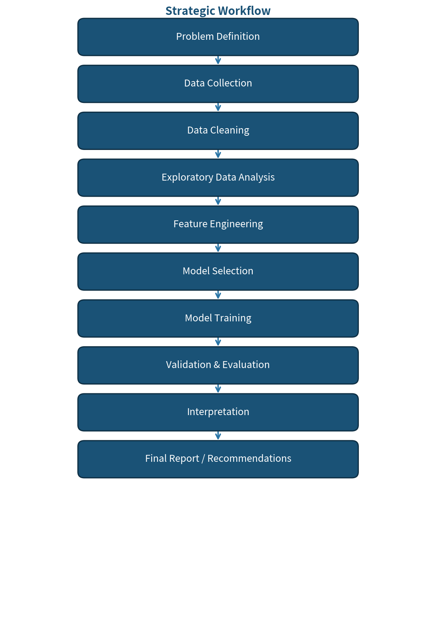
Figure 1. Strategic Workflow for the Student Performance Prediction Project

7. Proposed Data Strategy
Because this is a planning exercise, no real student data will be collected or processed in Week 1. The strategy below describes the kinds of information that would be required and the quality issues that must be anticipated.
Data Category | Example Variables | Planned Use
Academic history | Previous marks, internal assessment scores, examination results | Target construction and historical performance context
Attendance | Attendance percentage, absence count, late arrivals | Engagement and consistency indicator
Assignment / assessment activity | Assignment scores, submission rate, quiz performance | Continuous learning indicators
Learning activity | Study hours or platform activity (only where legitimately available) | Potential explanatory features
Course context | Subject, semester, credit weight, assessment type | Contextual segmentation and stratified analysis

Before any analysis begins, the data plan must address several quality and ethical concerns:
- Missing values — profile missingness by column and by student; choose imputation or exclusion rules that reflect the academic meaning of the field.
- Duplicate records — detect and reconcile repeated student–course entries so that no observation is counted twice.
- Incorrect values — validate ranges (attendance cannot exceed 100 %, marks cannot be negative) and correct or flag anomalies.
- Data leakage — ensure that no information that would only be known after the prediction point (for example, final exam scores) enters the feature set.
- Privacy — prefer anonymized student identifiers, collect only the minimum fields required, and restrict access to authorized users.
- Bias — examine whether the available data systematically under-represents certain groups of students and document any limitations that result.
- Anonymization — replace direct identifiers with opaque codes before any modeling work begins.

8. Model Development Strategy
Two complementary prediction tasks are planned. Neither will be trained during Week 1; the descriptions below define the modelling approach that later implementation stages would follow.

8.1 Regression Track
The target is a continuous performance measure such as a final course score or an overall grade-point value. Suitable candidate models include ordinary linear regression (as a transparent baseline), regularized linear models, decision trees, random forests, and gradient-boosting regressors. The baseline linear model will be established first so that any improvement offered by more complex algorithms can be measured honestly.

8.2 Classification Track
Students will be assigned to predefined risk categories (for example, low, moderate, or high academic risk) according to an agreed institutional rule. Candidate classifiers include logistic regression, decision trees, random forests, and gradient-boosting classifiers. Again, a simple logistic-regression baseline will be fitted first.
Across both tracks the following principles will guide development:
- Create a simple baseline before advanced models so that improvement can be measured honestly.
- Compare interpretable models with stronger ensemble methods rather than assuming complexity is always better.
- Use scikit-learn pipelines so that preprocessing steps and model training remain consistent and free of leakage.
- Apply cross-validation on the training data and keep a final held-out test set untouched until the last evaluation.
- Inspect feature importance or other interpretation techniques to understand the main drivers of predictions.
- Record model assumptions, parameter choices, evaluation results, and limitations for reproducibility.

9. Evaluation Strategy
Evaluation metrics will be chosen according to the nature of each task. Overall accuracy alone is insufficient, especially when the high-risk class is expected to be smaller than the low-risk class.
Task | Primary Metrics | Purpose
Regression | MAE, RMSE, R² | Shows average absolute error, sensitivity to larger errors, and proportion of variance explained.
Classification | Precision, Recall, F1-score, Confusion Matrix | Shows how accurately risk groups are identified and the trade-off between missed alerts and false alerts.
Overall quality | Cross-validation results, error analysis, stability checks | Reduces the chance of selecting a model that performs well only on one particular data split.

For an early-warning application, recall on the higher-risk group deserves special attention. Missing a student who genuinely needs support may be more consequential than generating an extra review case that later proves unnecessary. The final decision threshold will therefore be chosen in consultation with intended faculty users rather than selected solely for maximum overall accuracy.

10. Project Architecture Diagram
The architecture diagram shows how data would flow from institutional sources through Python processing layers to final faculty-facing insights. All components remain at the planning stage; none have been implemented.
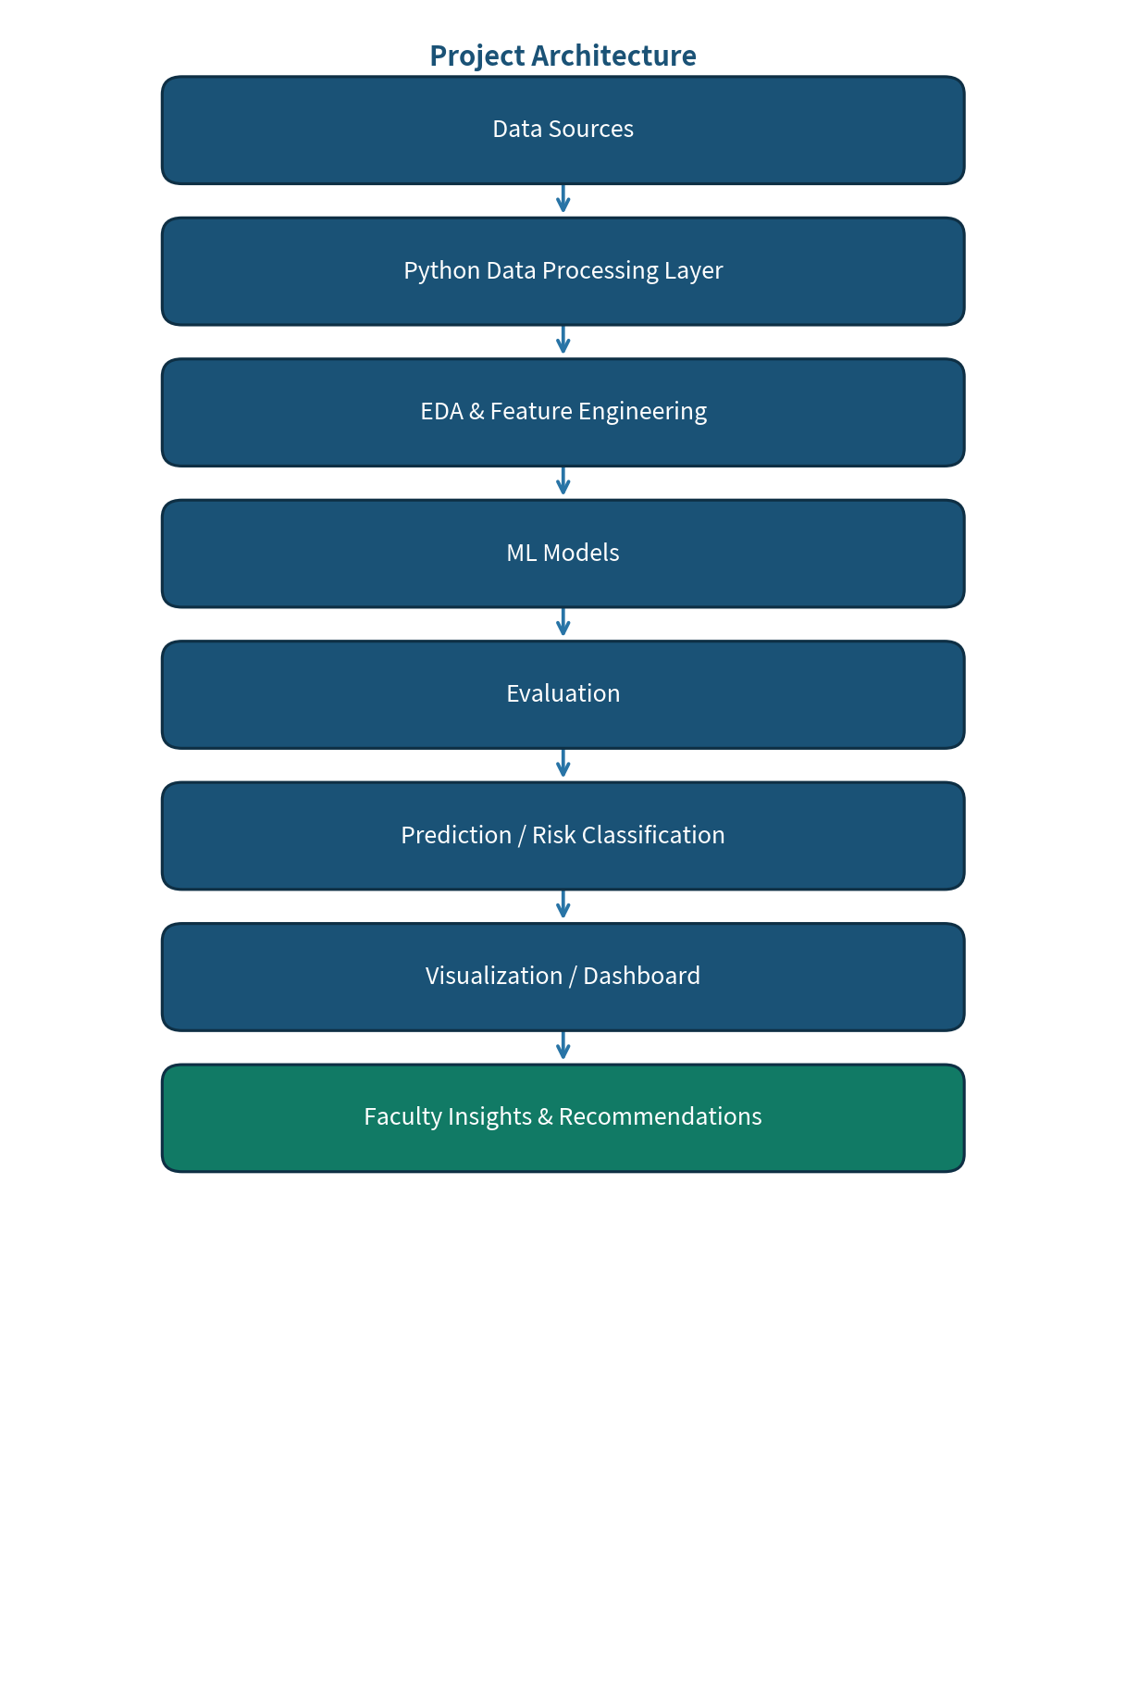
Figure 2. Planned Project Architecture

11. Timeline and Work Allocation
The total planned effort for Week 1 is 33 hours. The allocation below balances problem framing, data strategy, modelling design, and documentation.
Activity | Hours | Main Deliverable
Problem definition and research | 3 | Problem statement, users, assumptions
Data source and collection planning | 4 | Data dictionary and acquisition plan
Data cleaning strategy | 4 | Quality rules and preprocessing plan
Exploratory analysis planning | 4 | EDA questions and visualization plan
Feature engineering design | 3 | Candidate features and transformations
Model selection and training plan | 4 | Candidate models and baseline design
Evaluation and validation strategy | 3 | Metrics, validation design, error analysis
Visualization and reporting design | 3 | Charts, insights, reporting structure
Documentation and final review | 5 | Completed report and project plan
TOTAL | 33 | Week 1 planned effort

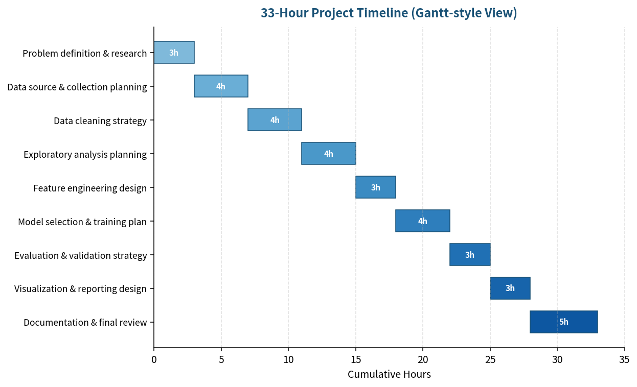
Figure 3. 33-Hour Timeline (Gantt-style View)

12. Tools and Technologies
The following tools and libraries form the planned technology stack. All are free, widely used in academic and industry data-science work, and well documented.
Tool / Library | Planned Role | Reason for Selection
Python | Core programming language | Strong ecosystem for data analysis and machine learning
Pandas | Data manipulation and cleaning | Efficient tabular data operations
NumPy | Numerical computation | Array operations and numerical foundations
Matplotlib / Seaborn | Visualization | Clear statistical and exploratory charts
Scikit-learn | Preprocessing, modeling, validation | Consistent tools for classical machine learning
Jupyter Notebook | Interactive development and documentation | Supports iterative analysis and literate programming
VS Code | Code editing and debugging | Lightweight, extensible editor with good Python support
Git / GitHub | Version control | Tracks project changes and supports reproducibility
Streamlit (optional) | Future interactive dashboard | Simple way to expose insights through a web interface

13. Expected Outcomes and Benefits
If the project proceeds from planning into implementation, the following outcomes are expected. All wording remains future-oriented because no models have yet been trained and no real dataset has been processed.
- A documented, reproducible data-science workflow tailored to the academic-risk problem.
- A cleaned and analysis-ready dataset once historical records become available.
- Exploratory findings that highlight important relationships and performance patterns.
- One or more validated models for continuous performance prediction and/or academic-risk classification.
- Identification of the features that most strongly influence the predictions.
- Visual summaries that communicate results without requiring technical expertise.
- Faculty decision-support insights that can guide targeted academic interventions.
- A foundation on which a future interactive dashboard could be built.
- Clear documentation of limitations, privacy safeguards, and responsible-use conditions.

14. Challenges and Mitigation
Several practical and ethical risks must be anticipated. The table below lists the main challenges, the associated risk, and the mitigation strategy planned for each.
Challenge | Risk | Mitigation Strategy
Missing or inconsistent records | Unreliable features and biased analysis | Profile missingness, validate ranges, document rules, and apply context-appropriate imputation or exclusion.
Class imbalance | Weak detection of the minority high-risk group | Use appropriate metrics, class weighting, or resampling only where justified by the data.
Data leakage | Artificially high test performance | Review feature timing carefully and keep any future information out of the training inputs.
Overfitting | Poor performance on unseen students | Use proper train/test separation, cross-validation, regularization, and model comparison.
Biased or incomplete data | Unfair or misleading predictions | Check subgroup performance where feasible and document limitations before any deployment discussion.
Low interpretability | Users may distrust or misuse results | Prefer understandable models when accuracy is comparable; add interpretation techniques for complex models.
Privacy concerns | Unnecessary exposure of student information | Minimize personal data, anonymize identifiers, restrict access, and define responsible-use rules.

15. Project Success Criteria
The planning phase will be considered successful when the following criteria are met:
- The problem, target variable, intended users, and project boundaries are explicitly defined.
- The planned data pipeline covers collection, quality checks, cleaning, exploration, and preparation.
- The modelling plan includes a baseline, multiple candidate approaches, and justified evaluation metrics.
- The proposed validation method reduces the risk of misleading performance estimates.
- Results will be communicated through clear visualizations and plain-language interpretation.
- The final approach acknowledges privacy, bias, leakage, and other responsible-use risks.
- The project can be reproduced and extended using documented Python tools and version control.

16. Conclusion
This Week 1 plan establishes a structured foundation for a Python-based data-science project focused on student performance prediction and early academic-risk detection. The proposed approach begins with a clearly defined problem and moves systematically through data strategy, quality management, exploratory analysis, feature engineering, modelling, validation, interpretation, and reporting. A realistic 33-hour work allocation keeps the planning phase itself manageable while still covering every essential design decision.
The most important principle guiding the work is that a useful data-science project is not simply a model that achieves a high numeric score. It must use appropriate data, avoid leakage, communicate uncertainty, consider fairness and privacy, and produce information that a real user—such as a faculty member—can understand and act upon. These principles will shape every later technical stage if the project proceeds from planning into implementation.
By completing this planning document, the internship task of Week 1 is fulfilled: a complete, coherent strategy now exists that can guide subsequent data collection, analysis, and model development.

— End of Week 1 Project Plan —

