WEEK 2 EDA AND VISUALIZATION
FRAMEWORK
Exploratory Data Analysis and Visualization Framework Design
A strategic, dataset-independent framework for Python-based analysis

Field | Details
Prepared For | Week 2 Data Science Internship Task
Student | Sumedh Bodke
Project Context | Student Performance Prediction and Early Academic Risk Detection
Task Focus | EDA Planning, Visualization Strategy and Reporting
Estimated Effort | 33 Hours

Table of Contents
1. Introduction to Exploratory Data Analysis
2. Purpose and Analytical Questions
3. Potential Data Types and Dataset Structure
4. Data Quality Assessment
5. Univariate Analysis
6. Bivariate Analysis
7. Multivariate Analysis
8. Missing Data Strategy
9. Outlier Detection and Treatment
10. Visualization Strategy
11. Plot Selection Framework
12. Python Tools and Libraries
13. EDA Workflow Diagram
14. Reporting and Documentation Plan
15. Timeline and Work Allocation
16. Expected Outcomes
17. Challenges and Mitigation
18. Evaluation and Quality Criteria
19. Conclusion

1. Introduction to Exploratory Data Analysis
Exploratory Data Analysis (EDA) is the stage of a data science project where the analyst learns what the data actually contains before attempting to build predictive models. It combines numerical summaries, visual inspection, data-quality checks, and relationship analysis. The purpose is not simply to produce attractive charts; it is to uncover structure, detect errors, test assumptions, and generate questions that guide the later modeling process.
For the proposed student-performance project, EDA would be used to understand how variables such as attendance, previous marks, assessment scores, assignment activity, and other legitimate learning indicators relate to academic outcomes. Because Week 2 does not provide a dataset, this report defines a reusable framework that can be applied once the dataset is available.

2. Purpose and Analytical Questions
The EDA stage will be organized around questions instead of a random collection of charts. Examples include:
- What variables are available, how are they measured, and which are likely to be relevant to the target outcome?
- How are numeric variables distributed, and are there extreme values or unusual clusters?
- Do attendance and assessment measures show visible relationships with performance?
- Does performance vary meaningfully across course, semester, or other non-sensitive categories?
- Are any variables strongly correlated or redundant?
- Are missing values concentrated in particular columns or groups?
- Could any variable accidentally reveal information that would not be available at prediction time (data leakage)?

3. Potential Data Types and Dataset Structure
The framework anticipates a mixed-type dataset. The type of each variable will determine both the appropriate summary statistics and the appropriate visual treatment.
Data Type | Examples | Recommended First Checks
Numerical - continuous | Marks, attendance rate, study hours | Range, mean, median, standard deviation, histogram, box plot
Numerical - discrete | Absence count, assignment count | Frequency, min/max, value counts, bar chart
Categorical - nominal | Course, department, assessment type | Unique values, frequency table, count plot
Categorical - ordinal | Risk level, performance band | Category order, counts, grouped comparisons
Datetime | Assessment date, submission date | Time range, missing dates, trend over time
Boolean | Submitted/not submitted, pass/fail | Class balance and frequency
Identifier | Student ID or record ID | Uniqueness, duplicates; usually excluded from modeling

4. Data Quality Assessment
Before interpreting patterns, a quality audit will establish whether the dataset is suitable for analysis. The audit should be reproducible and recorded in a data-quality log.
- Load the data using pandas and inspect shape, column names, data types, and sample records.
- Calculate missing-value counts and percentages for every variable.
- Check duplicate rows and duplicate identifiers.
- Validate ranges, units, date formats, category spelling, and impossible values.
- Identify constant or near-constant columns and columns with very high cardinality.
- Check whether the target variable is correctly defined and whether predictors contain future information.
- Document each cleaning decision and the reason for making it.

5. Univariate Analysis
Univariate analysis studies one variable at a time. It is the first detailed inspection after basic data validation.
Variable Type | Techniques | Questions Answered
Numeric | Mean, median, quartiles, standard deviation, histogram, density plot, box plot | What is typical? How spread out is the variable? Are there extreme observations?
Categorical | Frequency table, count plot, percentage distribution | Which categories dominate? Are some categories too rare?
Datetime | Time range, counts by period, line chart | Is data continuous over time? Are there gaps or bursts?
Boolean | Counts and percentages | Is the class distribution reasonable?

6. Bivariate Analysis
Bivariate analysis examines the relationship between two variables. The plot and statistic should be chosen according to the pair of variable types.
Variable Pair | Techniques | Typical Interpretation
Numeric vs Numeric | Scatter plot, correlation coefficient | Direction, strength, non-linearity, clusters
Numeric vs Category | Box plot, violin plot, grouped summary | Differences in distribution between groups
Category vs Category | Contingency table, count plot, stacked bar | Association and composition
Time vs Numeric | Line chart, rolling summary | Trend, seasonality, sudden changes

7. Multivariate Analysis
Multivariate analysis considers several variables together. It is useful for identifying interactions, redundancy, and patterns that are not visible from one pair at a time.
- Correlation heatmaps for groups of numeric variables.
- Pair plots for a carefully selected subset of variables rather than every available column.
- Grouped summaries to compare outcomes across two or more relevant categories.
- Feature-to-target comparisons after controlling for obvious confounding factors where appropriate.
- Optional dimensionality-reduction visuals such as PCA for high-dimensional exploratory inspection, clearly labeled as exploratory rather than causal evidence.

8. Missing Data Strategy
Missing values will be treated as an analytical issue, not merely a formatting problem. The treatment will depend on why information is missing, how much is missing, and whether missingness itself carries useful information.
- Measure missingness by column and, where useful, by group or time period.
- Distinguish between genuine missing values and placeholder values such as 0, -1, or text tokens.
- Use median or other robust imputation for suitable numeric fields when justified.
- Use mode or an explicit unknown category for suitable categorical fields.
- Consider removing variables only when their information content is insufficient or their missingness is excessive.
- Never impute using information from the test set when the eventual project moves into predictive modeling.
- Document the percentage of values changed and the chosen method.

9. Outlier Detection and Treatment
Outliers may represent measurement errors, rare but valid observations, or changes in the underlying process. The plan therefore avoids automatically deleting extreme values.
Method | Use | Action Guideline
IQR rule | Simple numeric screening | Flag observations outside a chosen IQR boundary and inspect context.
Z-score | Approximately symmetric numeric data | Use as a screening measure, not as automatic proof of bad data.
Box plot | Visual comparison | Compare spread and extreme observations across groups.
Domain rules | Known valid ranges | Check whether a value is physically or logically possible.
Robust statistics | Skewed data or heavy tails | Prefer median and IQR when mean/std are distorted.
Potential treatments include correcting obvious entry errors, keeping legitimate extreme cases, applying transformations such as log scaling to highly skewed variables, or using robust models. Every treatment should be justified in the analysis notes.

10. Visualization Strategy
Visualization will be treated as a communication and reasoning tool. Each chart should answer a specific question, include informative labels, and avoid decorative complexity.
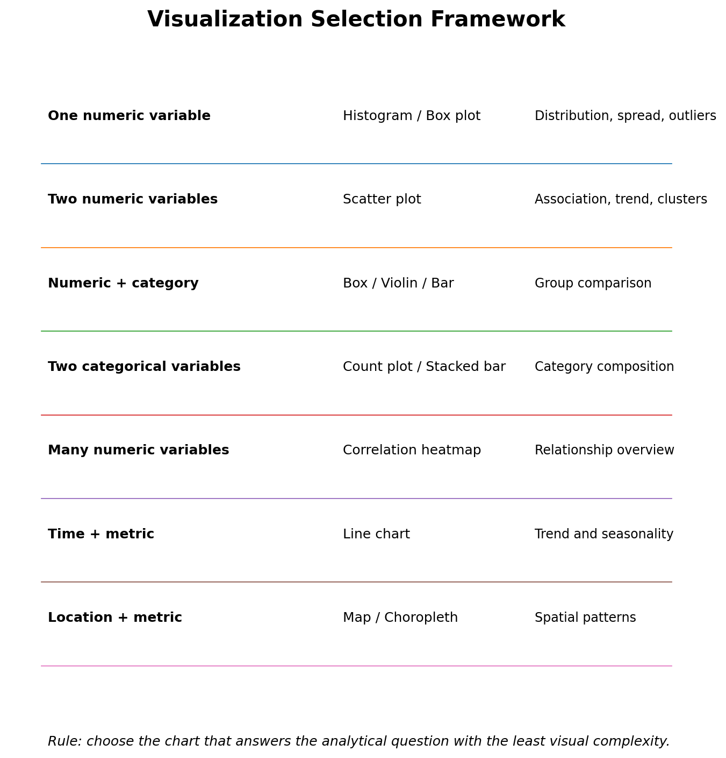

11. Plot Selection Framework
Plot / Chart | Primary Purpose | Best Used For | Important Caution
Histogram | Distribution shape | Single numeric variable | Bin choice can change the visual story
Box plot | Spread and outliers | Numeric variable across groups | Does not show the full distribution
Violin plot | Distribution comparison | Numeric vs category | Can be harder to read with small samples
Bar / Count plot | Category frequency or aggregated value | Categorical variables | Do not imply continuous trends
Scatter plot | Relationship between numeric variables | Two numeric variables | Overplotting can hide dense regions
Line chart | Change over time | Datetime + numeric measure | Use only when order is meaningful
Heatmap | Matrix-style relationship overview | Correlation or cross-tabulation | Color intensity needs a clear scale
Pair plot | Small multivariate overview | Selected numeric variables | Can become cluttered for many variables
Stacked bar | Composition across groups | Two categorical variables | Too many categories reduce readability

12. Python Tools and Libraries
Library / Tool | Role in EDA | Planned Contribution
pandas | Data loading and manipulation | Read files, profile columns, filter records, aggregate summaries, handle missing data
NumPy | Numerical operations | Arrays, mathematical functions, conditional transformations
Matplotlib | Core plotting | Fine-grained control over figures and publication-ready charts
Seaborn | Statistical visualization | Convenient distribution, relationship, and categorical plots
Plotly | Interactive visualization | Interactive charts for presentations or future dashboards
Jupyter Notebook | Analysis workspace | Combines code, narrative, outputs, and observations
VS Code | Development environment | Organize reusable scripts and notebooks
Git / GitHub | Version control | Track EDA changes, documentation, and reproducibility

13. EDA Workflow Diagram
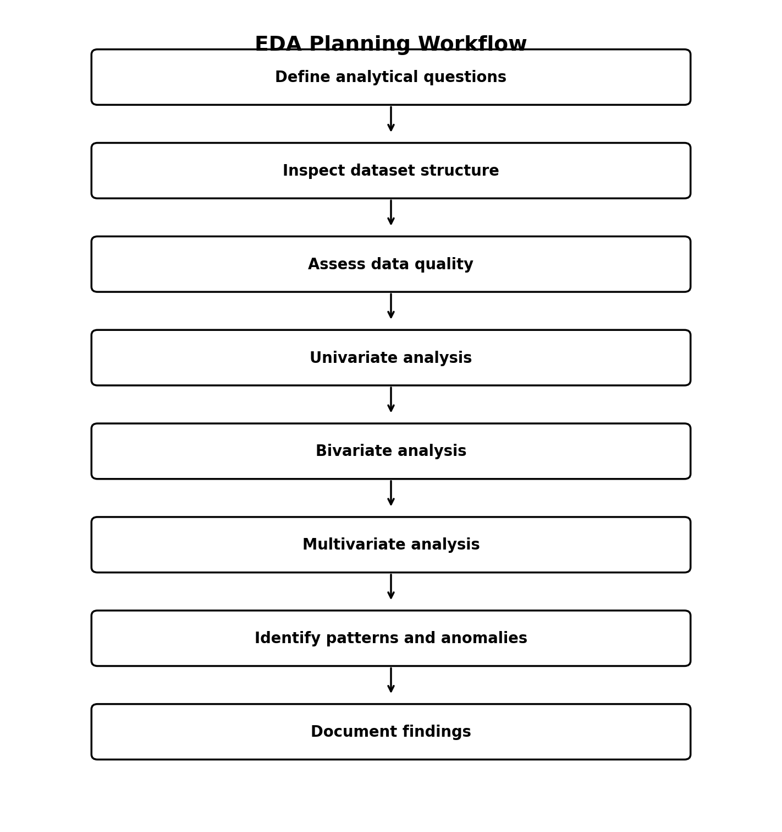
The workflow is iterative: an unusual pattern discovered during visualization may require a return to data validation or cleaning before the analysis continues.

14. Reporting and Documentation Plan
The EDA output should be documented so another analyst can understand what was inspected, what was changed, and why each conclusion was reached.
Report Section | Contents | Output
Executive Summary | Main findings, important data-quality notes, major implications | Short management-friendly overview
Dataset Overview | Rows, columns, variable types, source and assumptions | Data dictionary and structure table
Data Quality | Missingness, duplicates, invalid values, outliers | Quality summary and action log
Univariate Findings | Important distributions and category patterns | Annotated charts with observations
Bivariate Findings | Key relationships and comparisons | Scatter/box/count/line plots with interpretation
Multivariate Findings | Correlation, interactions, grouped patterns | Heatmap, selected pair plots, grouped charts
Interpretation | What patterns could mean and what they do not prove | Evidence-based narrative
Limitations | Sampling bias, missingness, data leakage, measurement issues | Limitations and caution notes
Next Steps | Feature candidates and modeling implications | Transition plan for technical phase
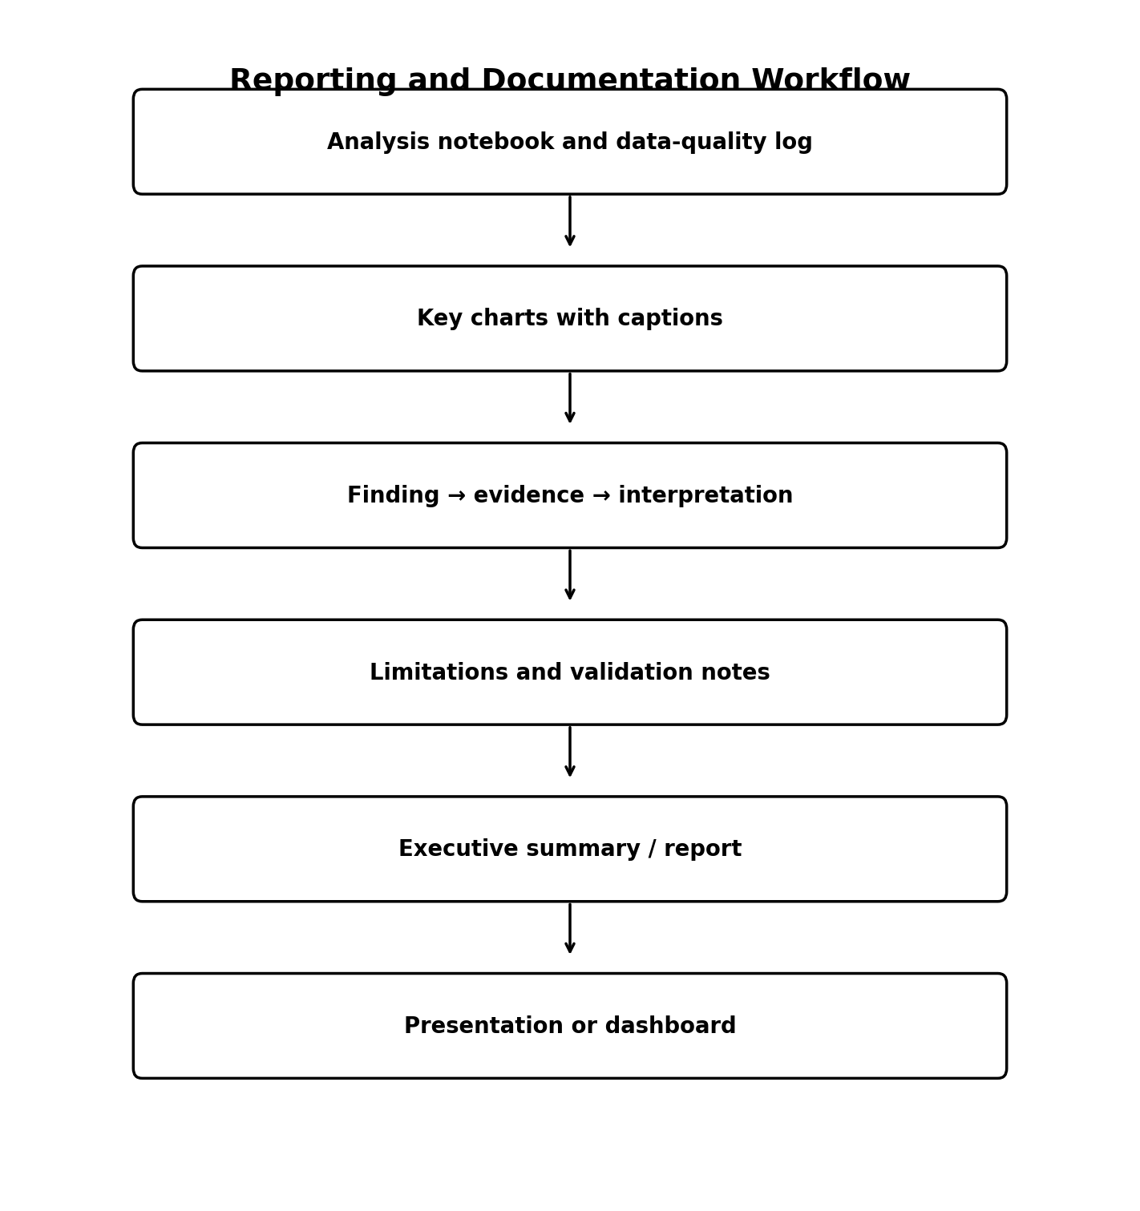

15. Timeline and Work Allocation - 33 Hours
Activity | Hours | Main Deliverable
EDA planning and analytical questions | 3 | Question bank and EDA checklist
Dataset structure and data-type framework | 3 | Variable-type classification template
Data-quality assessment planning | 4 | Missingness, duplicate, validity and leakage checks
Univariate analysis design | 4 | Distribution and category analysis plan
Bivariate and multivariate analysis design | 5 | Relationship and interaction analysis plan
Missing-data and outlier strategy | 3 | Decision rules and documentation template
Visualization strategy design | 4 | Plot selection matrix and chart standards
Reporting/documentation framework | 4 | Finding-to-evidence reporting template
TOTAL | 33 | Week 2 planned effort

16. Expected Outcomes
- A reusable EDA checklist that can be applied to the selected dataset in the technical phase.
- A clear process for profiling data types, quality issues, distributions, relationships, and outliers.
- A visualization framework that connects plot type to analytical question rather than using charts arbitrarily.
- A consistent standard for chart titles, axis labels, units, legends, and concise interpretation.
- A reporting structure that preserves evidence, assumptions, limitations, and decisions.
- A stronger foundation for feature engineering and model selection in later weeks.

17. Challenges and Mitigation
Challenge | Potential Effect | Mitigation Strategy
Too many variables | EDA becomes cluttered and repetitive | Prioritize questions, group variables by theme, and use targeted plots
Missing values | Biased summaries or loss of records | Measure missingness, investigate cause, document treatment
Outliers | Distorted statistics or false conclusions | Combine domain checks, robust statistics, and visual review
Misleading charts | Wrong interpretation | Use appropriate scales, labels, baselines, and honest annotations
Correlation mistaken for causation | Unsupported conclusions | Use cautious language and distinguish association from cause
Data leakage | Unrealistically strong later models | Audit timestamps and feature availability during EDA
Irrelevant visualization | Wasted analysis time | Require each chart to answer a defined question

18. Evaluation and Quality Criteria
The Week 2 framework will be considered successful when it demonstrates the following:
- EDA steps are ordered logically and explain the purpose of each activity.
- Univariate, bivariate, and multivariate techniques are covered with appropriate examples.
- Missing-value and outlier strategies distinguish detection from automatic removal.
- Visualization choices are tied to variable types and analytical questions.
- Python libraries are identified with clear roles rather than being listed without explanation.
- Findings will be documented with evidence, interpretation, limitations, and next steps.
- The framework can be adapted to different datasets without depending on a particular file or schema.

19. Conclusion
This Week 2 framework establishes how exploratory analysis will be performed before predictive modeling begins. The emphasis is on disciplined investigation: first understand the structure and quality of the dataset, then examine individual variables, relationships, and multivariate patterns, and finally communicate the findings through carefully selected visualizations. The approach is deliberately dataset-independent so it can be adapted when actual student-performance data becomes available.
A successful EDA process should reduce uncertainty rather than simply increase the number of charts. By recording data-quality decisions, selecting visuals according to analytical questions, and documenting findings with evidence and limitations, the project will be better prepared for feature engineering, model development, and later evaluation.

