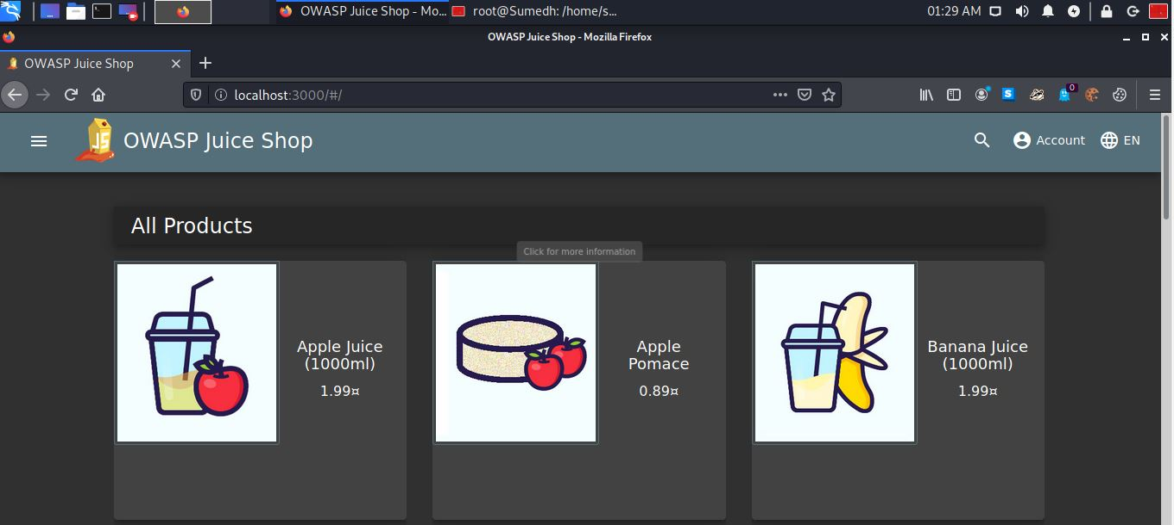
Figure 1: index of juice-shop

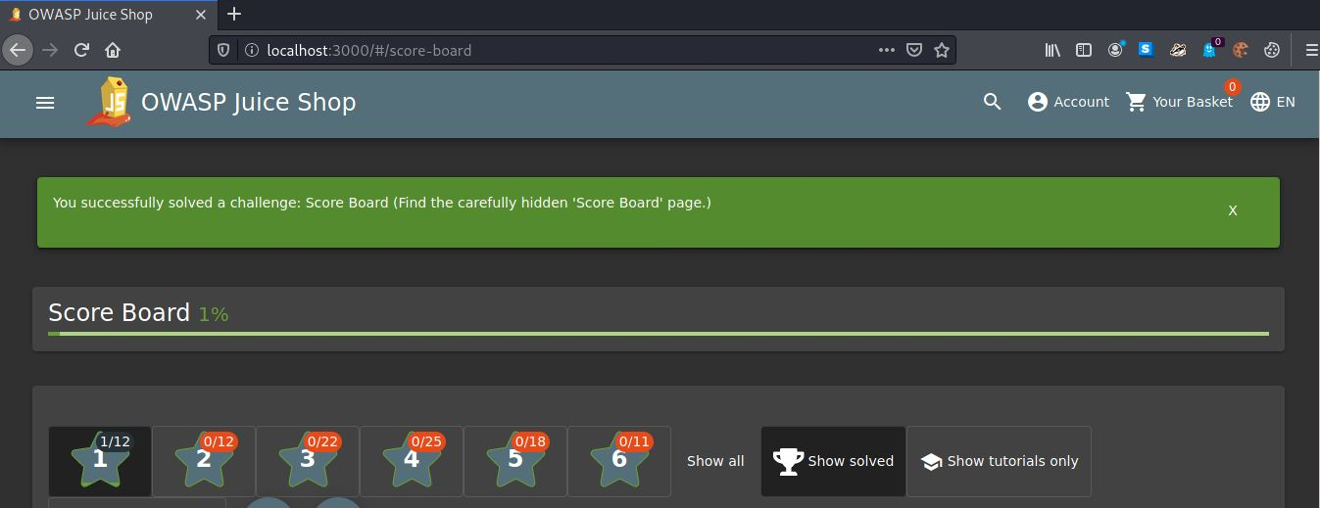
Figure 2: score-board

Figure 3: Task01 : To find admin-section
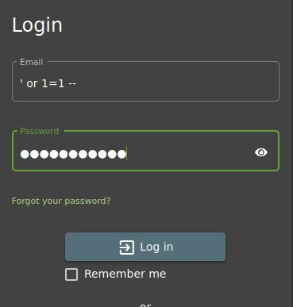
Figure 4: SQL-injection
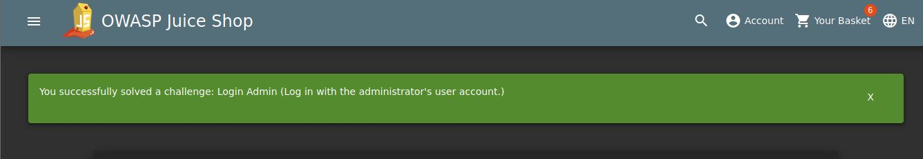
Figure 5: successfully broken via SQL injection.

Still, we don’t know the password of the admin. But from the token we can get the information.
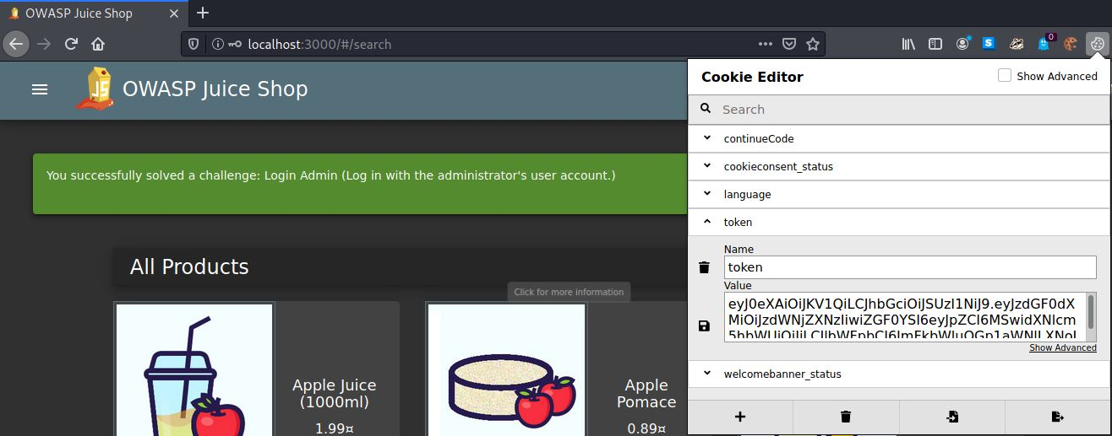
Figure 6: admin token.
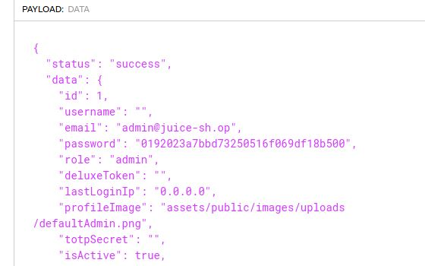
Figure 7: information extracted from token.

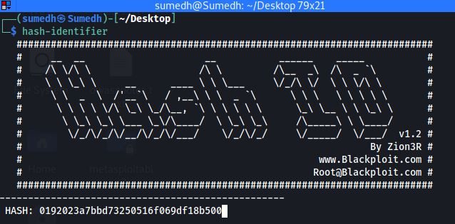
Figure 8: checking the hash value
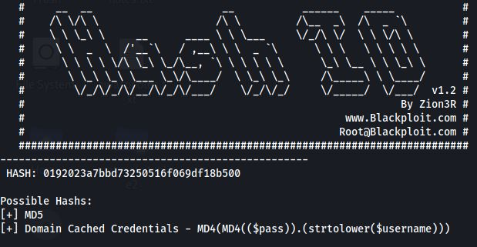
Figure 9: Hash-value: MD5
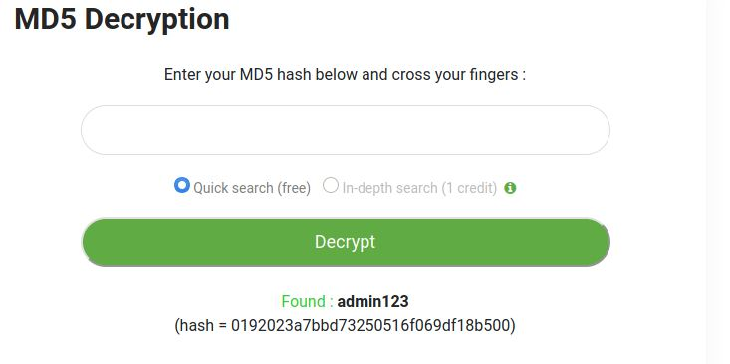
Figure 10: Password decrypted.
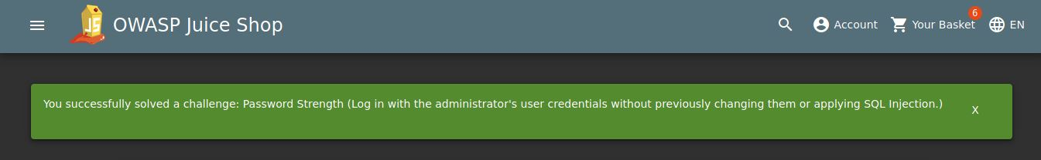
Figure 11: Successfully solved challenge

