**Cloud Computing Optimization**

**Problem Statement**

Cloud computing mainly deals with offering Infrastructure as a service,Platforms as a service and Internet as a service inside its own virtualized Infrastructure. Allocation of resources to servers in a cloud environment across different data centres which gives a optimized solution by increasing the company profits and decreasing the bandwidth consumption is difficult. This project aims at finding a optimized solution to select data centers of a company/firm in the most efficient way

**Discussion**

Consider a company having having lots of data centers with virtual machine to offer resources for cloud computing. Lets assume that at one of the data centers request arises for storage capacity of 6000GB.It has many possibilities to serve this from the options given below:

Datacentre1 can offer 5000GB which is at a distance of 700miles.

Datacentre2 can offer 8000GB which is at a distance of 600miles.

Datacentre3 can offer 4000GB which is at a distance of 900miles.

Datacentre4 can offer 3000GB which is at a distance of 300miles.

The PSO comes into picture to select the best possible datacenter to request storage capacity from. The fitness equation considered in this scenario is

Distance – distance*(offering capacity/required capacity )

The aim of particles is to minimize this function. As the ideal value of this will be zero when offering capacity = required capacity.

The values of cognitive and social components are calculated to find the velocity and hence next position of the particle.

The following equations of swarm particle optimizations are used

x(t+1) = x(t) + v(t+1)

v(t+1) = w*v(t) + c1*r1*(pBest(t) - x(t)) + c2*r2*(gBest(t) - x(t))

(Gandhi, 2014)

The swarm size, iterations and other parameters are in a separate class. After running the iterations for 200 times with 10 particles the output is displayed below. It represents the location of particle after every iteration. These values are plotted to observe a swarm i e point of convergence of these particles which gives the optimum solution.

Output

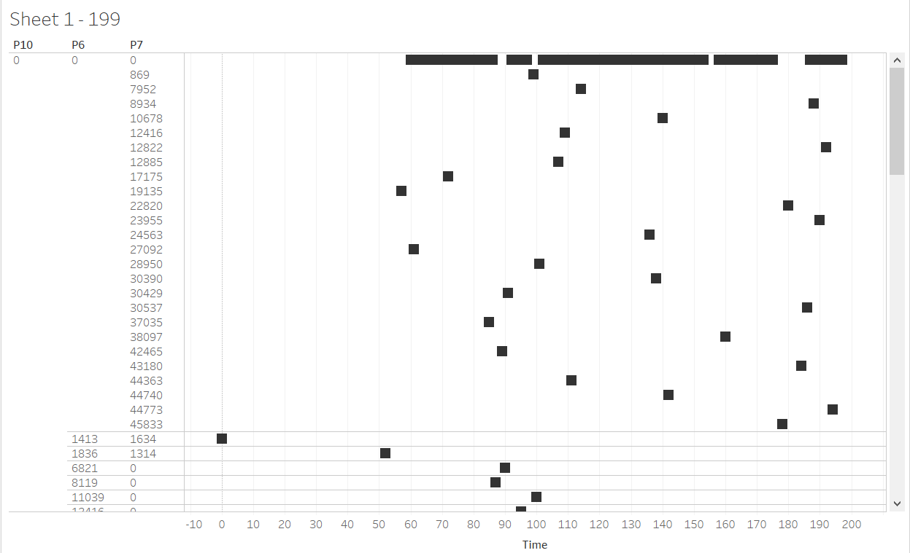

Input Constants

**int** ***SWARM_SIZE*** = 20;

**int** ***MAX_ITERATION*** = 50;

**int** ***PROBLEM_DIMENSION*** = 2;

**double** ***C1*** = 2.0;

**double** ***C2*** = 2.0;

**int** ***requirement*** = 2000;

Output values

SERVER id:0 SERVER offering:500 Server Distance from hub:553

SERVER id:1 SERVER offering:600 Server Distance from hub:769

SERVER id:2 SERVER offering:700 Server Distance from hub:1152

SERVER id:3 SERVER offering:800 Server Distance from hub:651

SERVER id:4 SERVER offering:900 Server Distance from hub:1762

SERVER id:5 SERVER offering:1000 Server Distance from hub:1292

SERVER id:6 SERVER offering:1100 Server Distance from hub:2504

SERVER id:7 SERVER offering:1200 Server Distance from hub:3120

SERVER id:8 SERVER offering:1300 Server Distance from hub:483

SERVER id:9 SERVER offering:1400 Server Distance from hub:1874

SERVER id:10 SERVER offering:1500 Server Distance from hub:1234

SERVER id:11 SERVER offering:1600 Server Distance from hub:1828

SERVER id:12 SERVER offering:1700 Server Distance from hub:1023

SERVER id:13 SERVER offering:1800 Server Distance from hub:2085

SERVER id:14 SERVER offering:1900 Server Distance from hub:1200

SERVER id:15 SERVER offering:2000 Server Distance from hub:2364

SERVER id:16 SERVER offering:2100 Server Distance from hub:1427

SERVER id:17 SERVER offering:2200 Server Distance from hub:1484

SERVER id:18 SERVER offering:2300 Server Distance from hub:2396

SERVER id:19 SERVER offering:2400 Server Distance from hub:538

**Best Server Chosen:15** after 50 iterations