**Software Design Specification for Ecommerce**

**Table of Contents**

1. **Introduction** 
   1. **Project Overview**
   2. **Definitions**
   3. **References**
2. **Design Considerations**
3. **Use Case Diagrams**
   1. **Admin Role**
   2. **User Role**
4. **High Level Architecture**

**1.0 Introduction**

**1.1 Project Overview**

The project aims at building an e-commerce platform which will be useful mainly for mid-sized retailers to set up their business. Any retailer who wants to set up his store has to register an account. After creating his account, he should create different sections and departments of his choice and add the products of his store corresponding to the department. He will be able to upload the images for the corresponding products. After creation of store, the store details will be stored in a server and any user can access the store by accessing the website URL and searching the store by location. User will be able to place an order by adding items to cart.

In this way, any user can access the website URL search for stores based on the location and select a store of their choice and place an order.

* 1. **Definitions**

**Admin** - He is the retailer who wants to set up the store. His main function is adding various departments and uploading products. After uploading the products, he can browse his store and make sure that all items are uploaded. Each admin can set up only one store. He can also browse the website by searching for any other store by entering the store’s location.

**User** - The user is the one who uses the website to find a required store and buy the products. He can look at his previous orders. Search the store by entering the store state name. He can also the create a same order containing products from different stores.

* 1. **References**

<http://docs.spring.io/spring/docs/current/spring-framework-reference/htmlsingle/>

<https://www.tutorialspoint.com/spring/spring_web_mvc_framework.htm>

<https://vrtoonjava.wordpress.com/2012/06/17/part-3-dao-and-service-layer/>

<https://api.genmymodel.com/>

<https://www.youtube.com/watch?v=wuRDaN_7xq8>

<http://stackoverflow.com/>

**2.0 Design Considerations**

I have used Six tables as entities and a separate relationship tables to map the relationship tables between them.

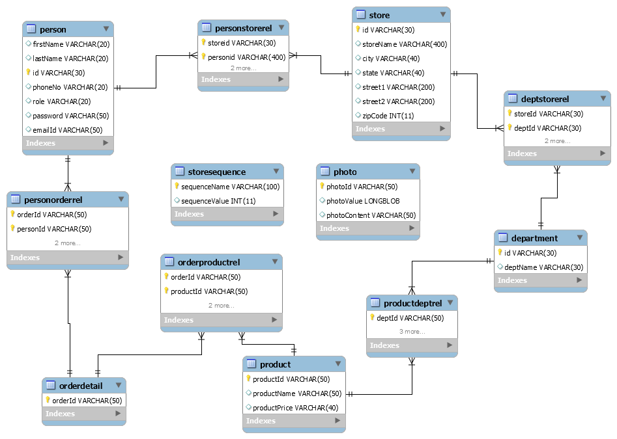

MVC pattern is used. There are different layers like service layer, Data access Object layer to facilitate separation of business logic and data access logic. MySQL is used and a spring bean will be used to establish connection to the database. The connection url and database name are specified as the properties of the Spring bean initialized. The Model layer will be handled by hibernate to manage operations associated with the database. JSPs are integrated with JQuery and bootstrap for front end development. The project is developed using Spring Tool Suite which gives a built in framework for standard MVC Spring project.CSS blueprint classes are also used for UI

**3.0 Use Case Diagrams**

**3.1 Admin Role**

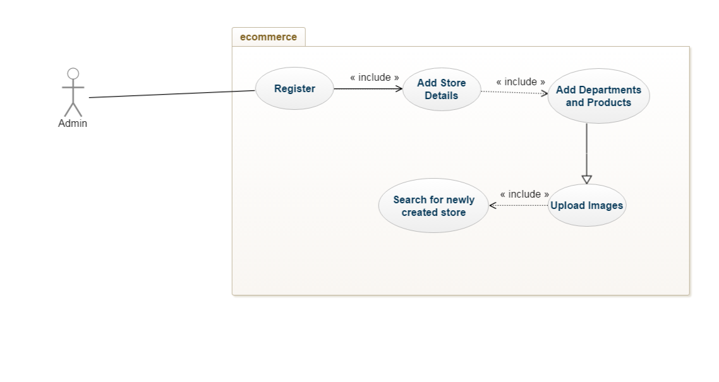

**3.2 User Role**

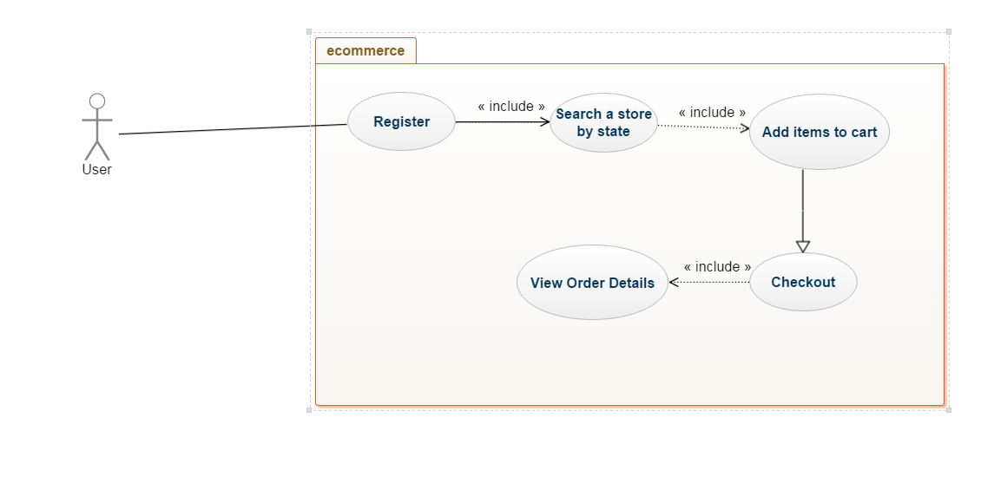

**4.0 High Level Architecture**

Controller Bean

Service Bean

Dao Bean

Sessionfactory Bean