AI-Based Safety Perception Mapping System for Women Using Sentiment Analysis of Crowdsourced Text Data
Sufia Sayyed, Sharmila Udaiyar, Kartik Gore, Shivam Deshmukh, Sumeet Gupta, Madhvi Saxena, Savita Vibhute
Vishwakarma University, Pune
sufiaa.sayyed@gmail.com, sharmilaudaiyar@gmail.com,

Abstract
The safety of women in public spaces continues to be a critical issue, especially in public spaces, as existing safety applications have been based on reactive safety mechanisms, including SOS and emergency response systems. However, there is a lack of perception-based information, which can be a valuable tool in decision-making before entering a particular space for women. This paper proposes a safety perception mapping system using AI, which analyzes crowdsourced textual experiences to provide preventive safety insights. The system provides users with the opportunity to submit anonymous feedback on their experiences at a particular space using a web-based interface. The feedback is processed using Natural Language Processing techniques such as text cleaning, tokenization, and removal of stop words. TF-IDF is then applied to the feedback. The sentiment in the feedback is classified as positive, neutral, or negative, which corresponds to safe, moderate, and unsafe conditions. This classification is done using a Logistic Regression model. The results are then visualized in a map based on the feedback provided. Unlike existing safety applications, which use crime statistics and GPS, the system focuses on community-based intelligence. The system has been successful in proving the effectiveness of AI in providing safety applications, which can be a shift towards proactive safety.

Keywords: Sentiment Analysis, Public Safety, Natural Language Processing (NLP), Machine Learning, Text Classification, Safety Perception, Crowdsourced Feedback, Logistic Regression, TF-IDF Vectorization, Data Visualization, Risk Assessment, Predictive Analytics.

- Introduction
Women’s safety in public spaces is one of the major issues in India, particularly in growing cities. According to the National Crime Records Bureau (NCRB) 2022 report, the total number of crimes against women reported was 445,256. This is an increase of 4% compared to the previous year, averaging almost 51 cases every hour [1]. Further insights from the 2025 National Annual Report and Index on Women's Safety (NARI), conducted from a survey of 12,770 women from 31 cities across the country, indicate that the overall safety score for the country is a mere 65%. In addition to this, 40% of women have stated that they felt that they were not safe [2]. When it comes to harassment, it has been stated that 7% of women have felt that they have been harassed at some point of time while at public spaces, with almost two-thirds of these cases not being reported. When it comes to cities like Pune, the poor infrastructure has been one of the biggest reasons why women have felt unsafe. This is reflected in the crime rate of 66.4 cases per lakh of women's population [3].
Despite these alarming statistics, the current safety solutions are ineffective in collecting perception-based information. Women's experiences are scattered across social media platforms, helplines, and other mediums. This leads to the loss of valuable information related to safety. Current safety solutions are limited to only reacting to situations that arise. For example, current safety apps provide SOS services that are only utilized during emergency situations. According to research, only a small percentage of such incidents are reported. In addition to this, it has been stated that close to 70% of women who are living in urban spaces try to avoid traveling at night. This again highlights the importance of awareness systems rather than purely reactive solutions [3].
Community participation is essential in filling this gap. Women’s live experiences can offer in-depth, localized information on safety conditions, including environmental and social determinants of safety perceptions. With the advent of Artificial Intelligence and Natural Language Processing (NLP) technology, it has become possible to analyze unstructured textual information. Techniques like TF-IDF vectorization and machine learning algorithms, such as Logistic Regression, can be employed to extract sentiment and safety patterns from a massive volume of user feedback in the form of text, converting it into quantitative safety information [4].
Experience-driven safety intelligence systems have the potential of being a game-changer, as they have the potential of changing the focus from safety responses to preventive awareness. This will empower the user through the provision of a visual representation of the data, as presented through safety maps [3]. This paper proposes an AI-based safety perception mapping system that analyzes women’s textual experiences and generates location-based safety insights.

Problem Statement
Even though there is a significant increase in the number of applications for women's safety, existing applications are mostly based on reactive technologies such as SOS messages, location sharing, and emergency response services. These applications are heavily dependent on immediate responses and interventions, which may not be effective due to certain limitations such as response time, connectivity, and the ability to send emergency messages during critical situations [5]. Another major problem with the current solutions is the absence of mechanisms to utilize the safety perception data collected from the experiences of women. For example, the feelings of insecurity while moving to public spaces like dark streets, lonely routes, and unsafe transportation modes are subjective and are not documented effectively [6]. These perceptions can play a crucial role in the preventive aspects of safety solutions.
A further issue with current solutions is that public complaints related to safety issues are mostly unstructured and distributed over various platforms [7]. This issue leads to inefficiencies in identifying patterns and potential risks, which is a major limitation of current safety solutions. Furthermore, there is a clear lack of AI-based analysis techniques that can aid in processing textual safety experiences. Most of the existing applications fail to utilize Natural Language Processing (NLP) and machine learning to identify meaningful patterns and sentiments within the experiences shared by users [7]. Lastly, the existing applications have no perception-based safety mapping techniques that can aggregate experiences shared by users to produce safety insights for specific geographical locations [5]. Hence, proactive decisions and preventive safety awareness remain limited.

Objectives of the Proposed System
The AI-Based Safety Perception Mapping System for Women is a system that attempts to provide users with meaningful information on safety. The system is expected to provide safety-related feedback from users via a web interface, where users, especially women, can provide location-based safety information and share their experiences. The textual data provided to the system will be analyzed to obtain information through Natural Language Processing techniques such as text processing and TF-IDF vectorization. The system will use machine learning to classify the sentiment of the safety-related information provided to it by users, which includes Positive, Neutral, and Negative, representing Safe, Moderate, and Unsafe conditions, to determine the safety perception of a particular area. The system will also use its ability to provide users with information on the safety of different areas through the experiences of users and assign different levels of risk to those areas. The system will provide users with safety-related information via an interactive interface, including color-coded maps, to enable users to easily understand safety levels. The system will provide data-driven and preventive safety awareness, enabling users to make informed decisions based on user experiences, as opposed to relying on emergency response mechanisms.

- Literature Survey

  - Existing Research Work
- Pawar et al. (2024) proposed a framework for quantitative sentiment analysis for women’s safety in their research. This framework was proposed by utilizing Natural Language Processing methods such as TF-IDF and Bag-of-Words, as well as machine learning methods such as Support Vector Machine and Logistic Regression. This framework was trained on a dataset containing 10,000 tweets, and an accuracy of 85.2% and an F1-score of 82% were obtained, along with a negative sentiment of 68% in post-incident tweets [8].
- A framework for evaluating women’s safety in urban regions was proposed by R. Mano Ranjini et al. (2025). This framework is based on various data sources such as crime statistics, CCTV, and Twitter data, and is based on machine learning algorithms such as Random Forest and K-NN, with an accuracy of 87.26% in testing and 92.5% in training, with 1,200 spatial grids, and Dijkstra’s algorithm for route recommendations. This shows that data from various sources is useful in this field of research [9].
- A Twitter-based sentiment analysis system was proposed by Gokulakrishnan et al. (2022), in which a combination of machine learning and deep learning algorithms such as Support Vector Machine, Random Forest, and Long Short-Term Memory was applied to analyze 50,000 tweets and detect trends and geographical differences in sentiment, with F1 scores of 84% (SVM), 86% (RF), and 89% (LSTM). This system shows promising performance in high-volume sentiment classification and trend detection [10].
- P. Sharma and A. Jain (2023) proposed a sentiment classification model using TextBlob and Logistic Regression for analyzing women’s safety-related tweets. The system processed 5,000 posts, achieving 78.5% precision and 76% recall, and mapped negative sentiment regions as unsafe zones. The approach provides an interpretable method for identifying areas of concern using sentiment polarity [11].
- A research conducted by Kumar et al. (2019) studied the perception of safety for women in Indian cities using machine learning algorithms on Twitter data. In this research, TF-IDF features and classifiers like SVM and NB were used. The accuracy of the results was found to be up to 84.3% and 81% for SVM and NB, respectively. In this research, it was found that 92% of the sentiments in metropolitan regions were negative [7].
- Gargiulo et al. (2020) proposed a qualitative GIS-based safety perception mapping system by incorporating environmental factors such as lighting, visibility, and vegetation. The study revealed that environmental factors contribute to almost 70% of the safety perception. The system also produced a safety index ranging from 0 to 1. The research also focuses on the role of environmental factors in safety perception [12].
- S. Prerana et al. (2025) carried out a review on the application of machine learning and deep learning in detecting harassment and abusive content on social media platforms. The research focuses on the application of BERT, which achieves a recall rate of 92% on a dataset of 20,000 posts. The research has also shown the role of deep learning in detecting harmful content and improving cyber safety [13].
- S. Chen et al. (2024) proposed a system for evaluating safety perception in urban environments by using street-view images. The proposed system, which utilizes CNN and ResNet architectures, obtained an accuracy of 76.4% and revealed a negative correlation between greenery and safety perception at -0.32. The system effectively detects environmental characteristics that affect safety perception [14].
- In a proposed study by Torra et al. (2022) on the analysis of the SafetiPin crowdsourced safety mapping platform through GIS-based survey methods, it was revealed that about 65% of the locations were considered to be in an unsafe state. The proposed system emphasizes crowdsourced data collection and community involvement [15].
- S. Verma et al. (2020) proposed a spatio-temporal machine learning model for evaluating the safety of women in public buses through 1,500 recorded crimes. The proposed model obtained an accuracy of 80.2% in detecting crime hotspots. The proposed system focuses on structured crime data and statistical modeling [16].
- Trang Le (2022) conducted a critical study on crowdsourced safety mapping platforms like SafetiPin, analyzing 500 mapped data points. The study found that 72% of entries reflected exclusion bias, indicating challenges in representation and inclusivity. It highlights the importance of equitable participation in safety mapping systems [17].
- Ranjitha et al. (2022) applied supervised machine learning algorithms such as Support Vector Machine, Naive Bayes, and Random Forest to analyze 25,000 tweets related to women’s safety in India. The SVM model achieved 88.1% accuracy, demonstrating strong classification performance. The study provides insights into public opinion trends at scale [18].
- V. Prerana and K. Rao (2025) proposed an AI-based threat detection system using computer vision and deep learning techniques such as YOLO for posture and motion analysis. The system achieved 92% accuracy in posture detection and operates in real time at 95 frames per second. It is effective in detecting abnormal or dangerous situations [19].
- N. R. Wagh and S. R. Sutar (2023) developed a multimodal deep learning framework combining text, image, audio, and video data for emotion recognition. The system achieved 95.3% accuracy, outperforming unimodal models that achieved around 85%. The approach improves overall prediction performance through data fusion [20].
- Shenoy et al. (2021) proposed a GIS-based framework for crime analysis and women’s safety monitoring. The system achieved 85% recall in identifying crime hotspots and integrates volunteer networks and crime data for improved safety management. The framework supports data-driven decision-making [21].
- Dolly Daga (2021) proposed the Suraksha smartwatch system, which uses GPS and motion sensors to detect emergencies and send alerts. The system achieved 100% alert delivery efficiency, ensuring reliable communication during critical situations. It is effective for personal safety and immediate response [22].
- Mandapati et al. (2015) developed the I Safe mobile application, which includes features such as SOS alerts, GPS tracking, and fake call generation. The system achieved 95% success in alert triggering, making it reliable for emergency situations. It enhances individual safety through quick response mechanisms [23].
- Kavitha et al. (2023) proposed an integrated safety device using GPS and GSM technologies for automatic alert generation. The system demonstrated 98% reliability in alert transmission, ensuring timely communication during emergencies. It provides strong hardware-based safety support [24].
- Prafulla et al. (2023) presented a conceptual study on AI-based women’s safety solutions, including predictive policing and chatbot systems. The research highlights the potential of Artificial Intelligence in improving safety awareness and response mechanisms [25].
- Akram et al. (2019) proposed an IoT-based safety device incorporating fingerprint authentication, GPS tracking, and shock detection mechanisms. The system achieved 90% detection accuracy, providing an effective personal safety solution. It integrates multiple technologies for enhanced security [26].
  - Research Gap Analysis
Despite all the progress achieved in the domain of women’s safety technologies, there are some key issues that need to be covered by existing literature:

- Reactive emergency focus only: Most of the existing technologies are developed to be used in emergency situations, incorporating features like SOS messaging, GPS location tracking, etc. These systems are activated after a potential threat has been detected and do not provide any form of warning about safety before entering a potentially dangerous location. These systems do not provide any form of preventive awareness that can be used for informed decision-making before entering a potentially dangerous location [19, 21, 22, 24, 26].
- No AI/NLP sentiment analysis of textual experiences: Although there are several studies that use various forms of sentiment analysis for safety perception systems, these studies are based on social media data such as Twitter posts that represent general public feelings rather than specific personal experiences. These systems do not use any form of user-submitted stories describing real-life experiences in potentially dangerous situations [7, 10, 11, 13, 18].
- Lack of crowdsourced perception mapping: The existing systems that use GIS mapping and survey methods focus on the collection of manually gathered data such as interview and questionnaire data. Although the information gathered from such methods is useful and provides a clear insight into the problem domain, it lacks automation and does not incorporate the dynamic crowdsourced textual feedback that can update the real-time safety perceptions [12, 15, 16, 17].
- Infrastructure and crime data dependency: Most of the existing systems for evaluating safety incorporate data from various sources such as crime data, CCTV installation, and environmental factors such as street view images. Although these factors contribute to the evaluation of safety, the subjective feeling of security that an individual experiences is not represented by the system [9, 14, 21].
- Hardware/IoT limitations: Most of the systems proposed for the evaluation of safety incorporate hardware such as wearable gadgets and IoT for the evaluation of safety. The proposed systems require users to carry hardware that may not function properly at all times. This makes the system impractical for implementation compared to software-based systems [22, 24, 26].
- No risk aggregation based on locations: Though many studies are carried out on sentiment classification using text data, the results are limited to determining the polarity of the given text, i.e., positive, negative, and neutral. The results are not further processed to obtain meaningful safety scores and risk levels for particular locations [7, 8, 10, 11, 13].
- Privacy-invasive tracking: The studies that involve GPS tracking and real-time monitoring are not privacy-friendly and may cause concern for the users. The users may be discouraged from providing feedback due to the fear of being tracked and their personal data being misused. Contrary to this, anonymous text-based feedback systems are not yet explored to their maximum potential [21, 22, 23, 26].
- Cyber vs. physical safety disconnect: The studies carried out are mainly to identify online harassment and abusive language detection on social media platforms. They are helpful in improving cyber safety, but there is a huge gap in translating the insights obtained from digital safety to physical safety in real-time locations [13].
- Manual/Qualitative Analysis: Significant research in the existing literature depends upon the analysis of survey results, interviews, and qualitative GIS inputs. These methods are time-consuming and hard to scale up for large data sets. The absence of automated machine learning methods prevents these from becoming real-time data analysis systems [12, 15, 17].
- Conceptual AI without Implementation: Some research in the existing literature discusses the possible applications of Artificial Intelligence in making the world a better place for females. These applications may include predictive policing and intelligent systems. However, these research studies are purely conceptual and do not provide practical implementations or experimental results. The absence of practical models prevents these from becoming applicable in real-world situations [25].
- Visual/Image Data Dominance: Some advanced systems in the existing literature are based upon computer vision methods involving images and videos to assess safety conditions. These methods are limited in scope as they fail to consider contextual information available in narratives. For instance, “dark isolated road” or “unsafe at night” provides a greater depth of information compared to available visual data [14, 19, 20].
- No community-driven prevention: The existing systems were developed keeping authorities in mind. They provide features like crime detection, monitoring, response strategies, etc. There is no active community-driven user contribution to share experiences or contribute to safety awareness. This absence of community-driven user contribution prevents the creation of collective intelligence to aid preventive safety decisions [9, 16, 21].

Table 1 presents an overview of existing women’s safety systems with respect to the proposed system based on certain parameters, i.e., approach, data source, AI used, and output. From the table, it is evident that existing systems are mostly reactive, limited with respect to the data source, and offer limited outputs, i.e., alerts or hotspots, with certain privacy issues. In the proposed system, crowdsourced textual feedback is used, machine learning is applied for sentiment analysis, location-wise safety scores are generated, anonymity is maintained, and finally, a perception-based solution for safety mapping is offered.

Feature | Existing Systems | Proposed System
Safety Approach | Reactive systems focusing on SOS alerts and post-incident response [19, 21-24, 26] | Preventive approach based on safety perception mapping
Data Source | Social media data (10K–50K tweets), crime records (~1.5K incidents), street imagery [16, 18, 20] | Crowdsourced user-submitted textual experiences
AI Analysis | Limited models such as TextBlob (~78% precision), SVM/RF/LSTM (82–89% F1), and manual GIS-based analysis [15, 17, 19] | TF-IDF based feature extraction with Logistic Regression classification
Text Processing | Basic TF-IDF/Bag-of-Words applied mainly on social media text [16] | Complete pipeline including cleaning, tokenization, TF-IDF, and multi-class classification
Output Format | Alerts, SMS notifications, crime hotspots, and safety indices [17, 18, 20] | Color-coded safety perception maps (Green, Yellow, Red)
Location Risk Scoring | Limited or absent; basic crime grid analysis (~87% accuracy) [21] | Aggregated safety scores (safe, moderate, unsafe) per location
Anonymity / Privacy | Often involves GPS tracking, raising privacy concerns [22] | Fully anonymous system with no personal data tracking
Community Participation | Minimal; primarily based on official or top-down data sources [21] | Active crowdsourced participation from users
Scalability | Hardware-dependent systems or manual surveys [16, 20] | Web-based system with automated data aggregation and scalability
India Context | Limited regional focus (e.g., selected cities or datasets) [23] | Designed for broader urban India applicability with real-user validation

Table 1. Comparison of Existing Systems and Proposed System

- Proposed Methodology
The proposed system is designed as a structured pipeline for the analysis of user feedback in textual form and mapping it to significant safety information. This includes various stages for data collection, preprocessing, feature extraction, sentiment classification, and safety mapping to transform textual data into understandable safety information.
The overall architecture of the system is illustrated in Figure 1. The system accepts textual safety feedback along with corresponding location details through a web-based interface. The input data is then transmitted to the backend server, where it goes through a series of processing steps. The dataset that has been collected comprises a total of approximately 1,111 feedback entries, spread over a total of 18 locations. Since the input data is inherently unstructured and varies in format, it is first standardized using Natural Language Processing techniques.
Following preprocessing, the textual data is transformed into numerical representation (feature matrix) using Term Frequency-Inverse Document Frequency (TF-IDF) vectorization [27]. These feature vectors are then used as input to a Logistic Regression model for sentiment classification. The predicted sentiment is subsequently mapped to a safety category and aggregated at the location level to generate a final safety perception. The results are then visualized through a map-based interface for user interpretation.
Figure 1 illustrates the architecture of the proposed AI-based safety perception mapping system, highlighting the sequential flow of data from user input to final visualization. The architecture integrates data acquisition, preprocessing, TF-IDF-based feature extraction, sentiment classification using Logistic Regression, and location-based aggregation to generate safety perception insights.
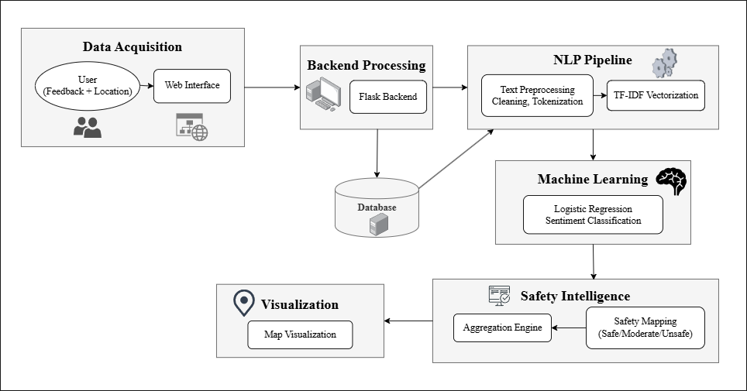

Figure 1. Overall System Architecture of the Proposed System
  - Data Collection
Safety-related data is collected through user-submitted feedback using a web-based interface. Each user provides a textual description of their experience along with the associated location. The dataset contains 1,111 entries, collected from diverse environments such as public spaces, transportation routes, and institutional areas. Each data instance consists of a location identifier and a corresponding textual feedback description. For a given location $L_{i}$, multiple feedback entries may exist, forming a set of size ${[k}_{i}]$. This enables the system to capture collective safety perception by aggregating multiple user experiences associated with the same location.
  - Data Preprocessing
The collected textual data is unstructured in nature and may be accompanied by noise in the form of punctuation symbols, special characters, and redundant words. Hence, preprocessing is done to improve the quality of the data and ensure consistency in all the input data. Firstly, text cleaning is done to remove unwanted symbols and irrelevant characters in the data. The text is converted to lowercase to ensure uniformity in the data. The process of removing stop words is also applied to remove frequently occurring words that do not significantly contribute to the meaning of the text. Finally, tokenization is applied to divide the text into individual words, as each word is the fundamental unit of analysis in this process [28].

5.3 NLP Processing and Sentiment Classification
Once this preprocessing step is complete, the clean textual data is now converted into numerical form using the TF-IDF Vectorizer. In this step, a feature matrix is created has a dimensionality of approximately $[N×V]$, where $N$ represents the number of feedback entries and $V$ represents the total vocabulary size. This approach allows for the weighting of words based on their importance in each specific feedback entry as well as the entire dataset as a whole. Words that are more closely associated with safety perception, such as words that convey a feeling of risk or discomfort, are given a higher level of significance in the feature space. These features are now input into a supervised machine learning algorithm for classification. The system uses a Logistic Regression classification technique for sentiment classification due to its ability to handle high-dimensional sparse data and its computational efficiency [29]. The Logistic Regression classification technique classifies the input into three different classes: Positive, Neutral, and Negative. The class that the system predicts represents the level of safety that the input feedback is perceiving.

5.4 Safety Score Generation

The predicted sentiment labels are then mapped to the corresponding safety categories, where positive sentiment is related to safe conditions, neutral sentiment relates to moderate safety, and negative sentiment relates to unsafe conditions. For each location, several feedback entries are aggregated to derive a final safety perception, where a location with $[k]$ feedback entries, where $[nₚ]$ denotes the number of positive predictions, $[nₙ]$ denotes the number of negative predictions, and $[nᵤ]$ denotes the number of neutral predictions, the final safety classification is derived based on the dominant sentiment. The aggregation of several feedback entries ensures that the final safety perception is derived based on the collective experiences of the users, hence eliminating bias.

5.5 Visualization of Safety Perception
Once calculated, safety levels are combined with geographical data and presented through a map interface. Each location is marked, and the marker's color signifies the associated safety level. Green color represents a safe zone, yellow represents moderate safety, and red represents a location of concern. The visualization provides an idea of safety perception at different locations. At the same time, it also helps the user interpret the safety conditions effectively. The combination of user feedback and visualization at different geographic locations helps in better decision-making and enhances the level of awareness.

- System Implementation
The proposed system employs a modular architecture, encompassing a web-based frontend, a Flask-based backend, and a machine learning element designed for sentiment-driven safety analysis. This architecture is structured as a pipeline, wherein user input is transmitted via HTTP requests, processed by a natural language processing module, and subsequently classified implementing a pre-trained model. The resulting output is then correlated with safety levels and presented for user comprehension.
6.1 Frontend Development
The frontend is implemented using HTML, CSS, and JavaScript. The frontend enables the users to provide feedback about their safety by giving specific details about the location and explaining their experiences. The frontend interacts with the backend using asynchronous HTTP requests and displays the predicted sentiment and corresponding safety levels. A map-based visualization is used to display safety levels for different locations. The marker colors indicate the level of safety. Green color markers are used to depict safe regions, yellow to depict moderate safety, and red to depict unsafe regions.
6.2 Backend Development
The backend is implemented using the Python programming language with the Flask framework. The backend is an interface for interaction between the frontend and the machine learning model. It provides RESTful endpoints for the client requests. After user input is received, the backend undertakes the preprocessing steps such as text normalization, tokenization, and removal of stop words. The text is then converted into a numerical form using a pre-trained vectorizer and fed into the classification model. Based on the sentiment, a corresponding level of safety is determined. In addition, the backend undertakes tasks related to data handling, processing of coordinates, and data preparation for displaying on a map. Finally, it sends structured data related to the prediction results back to the frontend for display.
6.3 Machine Learning Model
The proposed system utilizes a supervised machine learning algorithm for sentiment classification of textual data, and for this purpose, a Logistic Regression model has been chosen. Machine learning models require numerical data as input, and hence, textual data is converted into numerical form using Term Frequency-Inverse Document Frequency (TF-IDF) Vectorizer. The proposed system uses a Logistic Regression classifier as it performs effectively in linear text classification tasks. It also has low computational complexity and can efficiently operate in high-dimensional sparse space. The model classifies data into three classes: Positive, Neutral, and Negative, which map to Safe, Moderate, and Unsafe conditions in this classifier.
The model is trained offline using the preprocessed data and labels. Once deployed, the model performs real-time prediction using the new user input data without requiring any further training. For efficient deployment, the model and the TF-IDF vectorizer are serialized and saved as pickle files for efficient loading during deployment. The structured approach supports scalability and allows integration of more advanced models in future developments.
Table 2 illustrates the performance evaluation of the model. The table indicates the overall effectiveness of the classification approach. The metrics used in the evaluation process are accuracy, precision, recall, and F1 score. The metrics reflect the reliability of the model in classifying the safety-related textual feedback into the appropriate sentiments.

Metric | Value
Accuracy | 87%
Precision | 83%
Recall | 82%
F1 Score | 82%
Table 2. Model Performance Metrics

Results and System Interface
The results of the proposed system show that it can effectively analyze user safety feedback and transform it into useful safety information. For instance, the proposed system can effectively classify user input text into positive, neutral, and negative sentiment, which can be transformed into safe, moderate, and unsafe levels, respectively. The proposed system is capable of displaying the results in an interactive web interface, which users can utilize to understand safety levels in different areas.

Figure 2 below represents the Safety Feedback Submission Interface, which users can utilize to submit their safety feedback by describing the location and safety experience. The proposed interface is user-friendly, which may encourage the user to provide their safety feedback in detail.

Figure 3 below shows the Safety Perception Map Visualization, which shows different locations in the form of color-coded markers, where green represents safe locations, yellow represents moderate safety, and red represents unsafe locations. This form of visualization enables the user to interpret the safety levels in an effective manner.

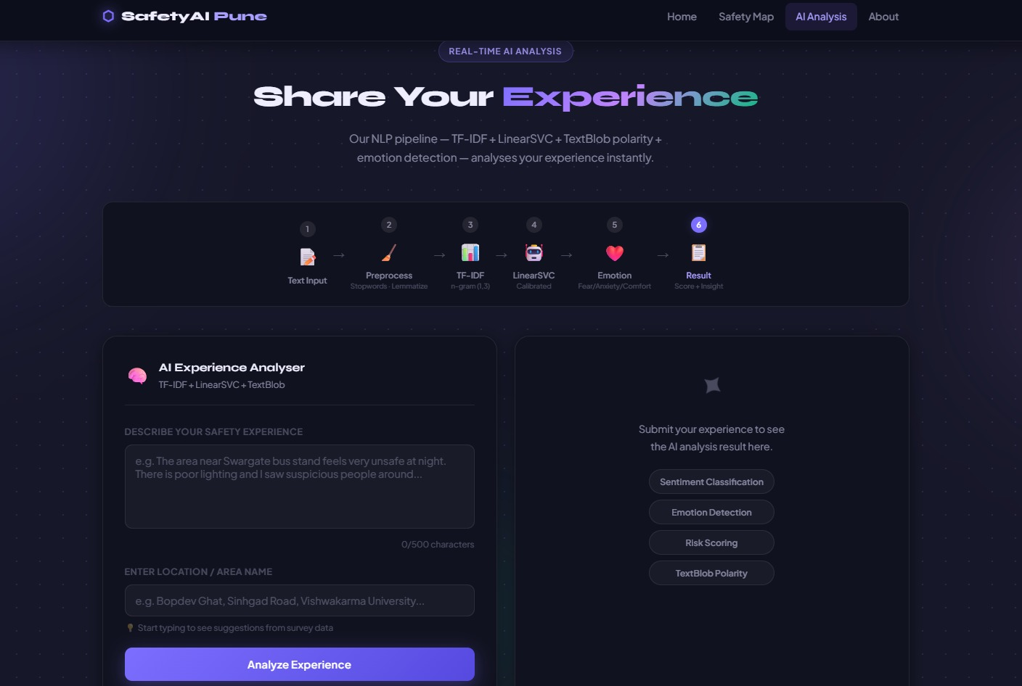

Figure 2. Safety Feedback Submission Interface

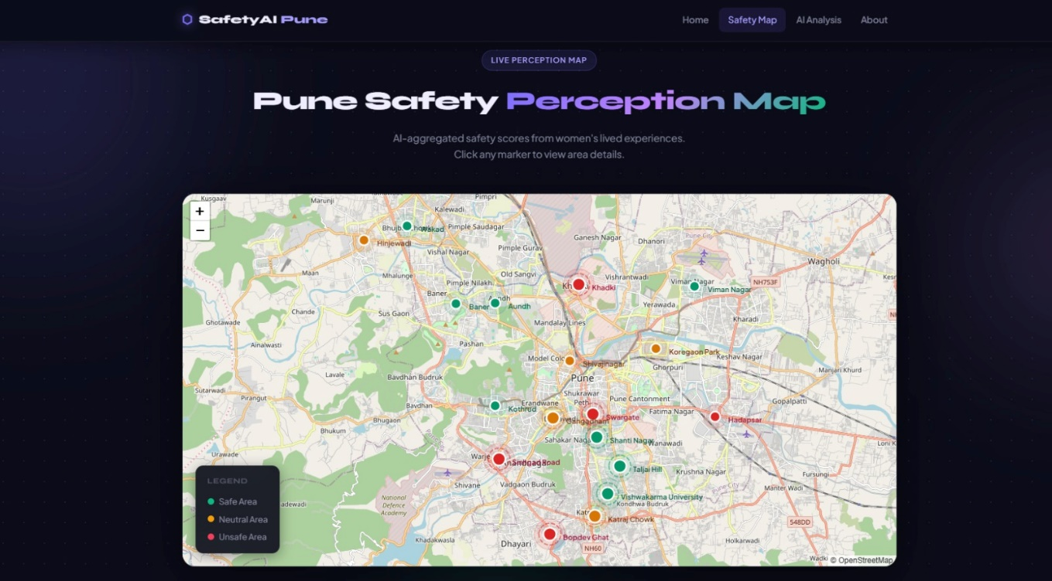

Figure 3. Safety Perception Map Visualization
Table 3 below represents a sample of feedback, sentiment, and the corresponding predicted levels of risk. It represents how efficiently the model can detect unsafe locations such as those with poor illumination, harassment, and isolation, as well as safe locations, as described by the user.

Feedback | Sentiment | Risk Level
The place is very unsafe at night and many incidents happen | Negative | Unsafe
Poor lighting and harassment issues make it unsafe to go alone | Negative | Unsafe
Generally safe environment but some outsiders enter without restriction | Neutral | Moderate
Okay during the day but lighting issues make evenings uncomfortable | Neutral | Moderate
Safe area with active community and well-maintained surroundings | Positive | Safe
Very isolated area with lack of police presence and feels unsafe | Negative | Unsafe

Table 3. Example Feedback Analysis

Discussion
The system offers significant value to its users by allowing them to derive information from individual experiences, which are then used as a form of collective intelligence for providing safer experiences. By analyzing feedback from other users, an individual is able to analyze awareness about the safety perception of a particular location. This eliminates the need for them to rely on official reports or alerts, as they are able to derive information on how safe or unsafe a location may be.

Another significant feature of this system is its ability to allow users to share their experiences anonymously. This is particularly important, as many incidents related to safety are often not reported by individuals due to personal, social, or legal concerns. By allowing them to do so, not only does it increase the overall data being collected, but it also becomes a more reliable source of information for analyzing safety perceptions.

The system also facilitates a community-based approach to building awareness about safety. In this regard, every contribution made by a user adds to the overall database that can be of useful to other users. Ultimately, this leads to a collective knowledge base where the understanding of safety-related concepts is constantly being improved by adding more information to the data base. Such a collaborative approach would also increase trust among users and would encourage them to take a more active part in promoting awareness about public safety.

The system also facilitates informed decision-making by providing clear and simple indicators of safety. In this regard, the system uses a sentiment-based classification approach where the safety level of a particular location can be visually represented on a map. Such an approach would enable users to make more informed decisions about the routes to be taken while traveling or the timing of their visits to a particular location.

Future Scope
The proposed system of safety perception mapping could be further improved and modified for better scalability and usability. One of the significant improvements that can be made is to transform the existing system from a web application to a cross-platform mobile application using frameworks like React Native and Flutter. This will allow the users to give their feedback and access the safety maps in real-time during their journeys. Moreover, the system would be able to automatically identify the areas using location services and provide users with immediate safety information. Furthermore, the system would be able to notify users of increasing safety risk levels for frequently visited places such as college campuses or daily commutes to cities such as Pune.

Another major feature that is improved in this model is the inclusion of advanced multilingual Natural Language Processing capabilities. In the future, it is also possible to make use of advanced models like mBERT (Multilingual BERT) or XLM-R (Cross-lingual RoBERTa) in handling multilingual text data like Hindi, Marathi, and other regional language variants. Also, TF-IDF vocabularies specific to India can be used to enhance sentiment detection capabilities with words like “eve-teasing” or “isolated area.” This would allow the system to receive input from a larger user base, including the vast percentage of non-English speakers, thereby improving the quality of the dataset.

The system can also be extended to include large-scale data from other sources, which may help improve the accuracy and reliability of the predictions generated by the system. For instance, large-scale data can be obtained from publicly available sources such as NCRB Crime Records, SafetiPin Safety Audits, or municipal complaints, and can be combined with user perception data to form hybrid safety scores. Techniques such as weighted ensemble models can be employed to effectively utilize such large-scale data. Moreover, federated learning can be used to allow training on multiple institutions, thereby keeping user data private, which can extend the system to large-scale data with over 100,000 entries. Associations with women’s safety organizations or NGOs can further assist in collecting high-quality, verified data for fine-tuning the models, thereby converting the system into a comprehensive, large-scale safety intelligence system.

Conclusion
The aim of this paper is to fill an existing gap in the system for women’s safety by proposing an artificial intelligence-based system for mapping safety perceptions using crowdsourced textual experiences. The system will utilize a Python Flask back-end with TF-IDF vectorization and logistic regression to analyze crowdsourced feedback, which will then allow it to generate insights on safety. This system will be trained on actual survey feedback from 1,111 real data points, which will allow it to generate insights on safety patterns at different places based on actual user experiences.

The performance of the proposed model shows the efficiency of the model in processing real-time textual data, where the model shows 87% accuracy, 83% precision, 82% recall, and 82% F1-score. This indicates that the system is able to effectively classify safety perception from the user narrative. The output obtained is further visualized through an easy-to-understand safety map, which is very useful for the users. The safety map helps users visualize the safety level of a particular area, allowing them to take appropriate decisions with regard to movement.

Unlike traditional safety applications that focus on reactive emergency responses, this proposed system focuses on preventive and community-centric awareness. This is because it leverages user experiences that are often not reported through anonymous user contributions and transforms them into valuable insights. This paper demonstrates the potential of machine learning and crowdsourced data in developing safety solutions that are scalable and respect user privacy. This paper provides a strong foundation for experience-centric safety analysis and contributes to improving safety awareness among people using smart and intelligent technologies.

- References

- https://sprf.in/crimes-against-women-in-india-trends-challenges-and-policy-responses/
- https://www.shankariasparliament.com/current-affairs/national-annual-report-and-index-on-womens-safety-nari-2025
- https://www.gktoday.in/national-annual-report-and-index-on-womens-safety-2025/
- Prasad, G. N., Mohan, S. P., Shamshuddin, S. T., Anil, V. P., & Vijay, P. V. (2024, April). Women Safety Analysis based on Twitter (Machine Learning). In 2024 MIT Art, Design and Technology School of Computing International Conference (MITADTSoCiCon) (pp. 1-5). IEEE.
- Pawar, S. S., Roy, R., Sawant, K. V., Singh, R. B., & Navale, M. RescueNow: Real-time SOS and Predictive Women's Safety System.
- Matthewson, G., Kalms, N., Berry, J., & Bawden, G. (2023). Streets after dark: The experiences of women, girls and gender-diverse people. In Everyday Streets: Inclusive approaches to understanding and designing streets (pp. 89-104). UCL Press.
- Kumar, D., & Aggarwal, S. (2019, February). Analysis of women safety in indian cities using machine learning on tweets. In 2019 Amity International Conference on Artificial Intelligence (AICAI) (pp. 159-162). IEEE.
- Patil, Harshali. (2025). Quantitative Sentiment Analysis of Women's Safety Using Twitter Data: An NLP Approach. Journal of Information Systems Engineering and Management. 10. 133-145. 10.52783/jisem.v10i34s.5783.
- Ranjini, M., Vignesh Muruga, M., & Krithick, R. (2025). Evaluating Women Safety in Urban Areas Using Machine Learning. International Journal of Advanced Research in Science, Communication and Technology International Open-Access, Double-Blind, Peer-Reviewed, Refereed, Multidisciplinary Online Journal, 5(3). https://doi.org/10.48175/IJARSCT-26351
- Gokulakrishnan, S., Reddy, C. A., & Anudeep, P. V. S. (2022). MACHINE LEARNING OF TWITTER FEEDS AND WOMEN SAFETY IN INDIAN CITIES. Computing Technology Research Journal, 1(1), 12-13.
- https://ijsrem.com/download/machine-learning-for-womens-safety-based-on-analysis-of-tweets/
- Gargiulo, I., Garcia, X., Benages-Albert, M., Martinez, J., Pfeffer, K., & Vall-Casas, P. (2020). Women’s safety perception assessment in an urban stream corridor: Developing a safety map based on qualitative GIS. Landscape and Urban Planning, 198, 103779. https://doi.org/10.1016/j.landurbplan.2020.103779
- https://www.ijraset.com/fileserve.php?FID=24023https://www.ijraset.com/fileserve.php?FID=24023
- Chen, S., Lin, S., Yao, Y., & Zhou, X. (2024). Urban Public Space Safety Perception and the Influence of the Built Environment from a Female Perspective: Combining Street View Data and Deep Learning. Land, 13(12), 2108. https://doi.org/10.3390/land13122108
- Torrao, G., Htait, A., & Wong, S. H. S. (2024). Perceptions of Women’s Safety in Transient Environments and the Potential Role of AI in Enhancing Safety: An Inclusive Mobility Study in India. Sustainability, 16(19), 8631. https://doi.org/10.3390/su16198631
- Verma, M., Rodeja, N., Manoj, M., & Verma, A. (2020). Young Women’s Perception of Safety in Public Buses: A Study of Two Indian Cities (Ahmedabad and Bangalore). Transportation Research Procedia, 48, 3254–3263. https://doi.org/10.1016/j.trpro.2020.08.151
- Le, T. (2022). Crowdsourcing Women’s Experiences of Space: Empowerment, (In)Visibility, and Exclusions – A Critical Reading of Safetipin Map. Platform: Journal of Media and Communication, 43–55. https://doi.org/10.46580/p62073
- Ranjitha, & Nayak, P. (n.d.). Sentiment Classification on Women Safety across Indian Cities Based on Twitter Data using NLP and Machine Learning. Retrieved March 25, 2026, from https://ijirt.org/publishedpaper/IJIRT156041_PAPER.pdf
- Rao, P. (2025). AI-Driven Women Safety Analytics: A Proactive Threat Detection System. International Journal of Creative Research Thoughts (IJCRT) Www.ijcrt.org C177, 13(5), 2320–2882. https://www.ijcrt.org/papers/IJCRT2505246.pdf
- https://www.researchgate.net/publication/373458222
- M. V. Shenoy, S. Sridhar, G. Salaka, A. Gupta and R. Gupta, "A Holistic Framework for Crime Prevention, Response, and Analysis With Emphasis on Women Safety Using Technology and Societal Participation," in IEEE Access, vol. 9, pp. 66188-66207, 2021, doi: 10.1109/ACCESS.2021.3076016
- Daga, D., Saikia, H., Bhattacharjee, S., & Saha, B. (2021). A Conceptual Design Approach for Women Safety Through Better Communication Design. International Journal of Electronics Engineering and Applications, IX(III), 01. https://doi.org/10.30696/ijeea.ix.iii.2021.01-11
- Sridhar Mandapati, Pamidi, S., & Ambati, S. (2015). A Mobile Based Women Safety Application (I Safe Apps). 17(1), 29–34. https://doi.org/10.9790/0661-17112934
- Kavitha Gokulprasanth, J., & Ajith Kumar. (2023). Intelligent Safety System For Women Security. 11, 2320–2882. https://ijcrt.org/papers/IJCRT2305890.pdf
- Artificial-Intelligence_-A-Smart-and-Empowering-Approach-to-Womens-Safety(2023) Scribd. https://www.scribd.com/document/799151380/Artificial-Intelligence-A-Smart-and-Empowering-Approach-to-Womens-Safety
- Wasim Akram, Mohit Jain, C. Sweetlin Hemalatha, Design of a Smart Safety Device for Women using IoT, Procedia Computer Science,Volume 165, 2019 Pages 656-662, ISSN 1877-0509, https://doi.org/10.1016/j.procs.2020.01.060.
- Salton, G., & Buckley, C. (1988). Term-weighting approaches in automatic text retrieval. Information processing & management, 24(5), 513-523.
- Bird, S., Klein, E., & Loper, E. (2009). Natural language processing with Python: analyzing text with the natural language toolkit. " O'Reilly Media, Inc.".
- Hosmer Jr, D. W., Lemeshow, S., & Sturdivant, R. X. (2013). Applied logistic regression. John Wiley & Sons.

