use('my-db')

// remove if collection exists

db.students.drop();

// create collection

db.createCollection('students', {

validator: {

$jsonSchema: {

bsonType: 'object',

required: ['home_address', 'phone'],

properties: {

name: {

bsonType: 'string',

},

home_address: {

bsonType: 'object',

properties: {

street: { bsonType: 'string' },

city: { bsonType: 'string' },

state: { bsonType: 'string' },

zipcode: { bsonType: 'int' }

}

},

phone: {

bsonType: 'number',

minimum: 1000000000,

maximum: 9999999999

}

}

}

}

});

// create indexes

db.students.createIndex( { "home_address.zipcode": 1}, { name: "zipcode_index" } )

db.students.createIndex( { "phone": 1}, { name: "phone_index", unique: true } )

// insert 10 students

var states = ['MH', 'NY', 'IL', 'UK']

var cities = ['Mumbai', 'NYC', 'Chicago', 'London']

var streets = ['444 Flower Street', '221 Baker Street', '325 W Adams Blvd', '85 Park Street']

var zips = [10007, 10040, 90007, 12029, 90009]

var names = ['Sumeet', 'Lukas', 'Guru', 'Robin', 'Marshall', 'Lily', 'Chandler', 'Joey', 'Monica', 'Rachel']

for (i = 1; i <= 10; i=i+1){

city_st = Math.floor(Math.random()*4)

db.students.insertOne({

name: names[i-1],

home_address: {

street: streets[Math.floor(Math.random()*4)],

city: cities[city_st],

state: states[city_st],

zipcode: zips[Math.floor(Math.random()*5)]

},

phone: Math.floor(Math.random()*(9999999999 - 1000000000 + 1) + 1000000000)

})

}

**5. What indexes do you recommend?**

* Indexes on Zipcode and Phone (since we anticipate searches to be done through these)

**6. Create indexes**

// create indexes

db.students.createIndex( { "home_address.zipcode": 1}, { name: "zipcode_index" } )

db.students.createIndex( { "phone": 1}, { name: "phone_index", unique: true } )

**7. Run Search Queries**

* db.students.find({phone: {$gt: 4329902221}})
* db.students.find({'home_address.zipcode': 10003})
* db.students.find({phone: {$gt: 3503333333}}).explain("executionStats")
* db.students.find({'home_address.zipcode': 90007}).explain("executionStats")

**8. And proof that indexes are being used**

* Before adding indexes :
* 8424379448
* db.students.find({phone: 8424379448})
  + 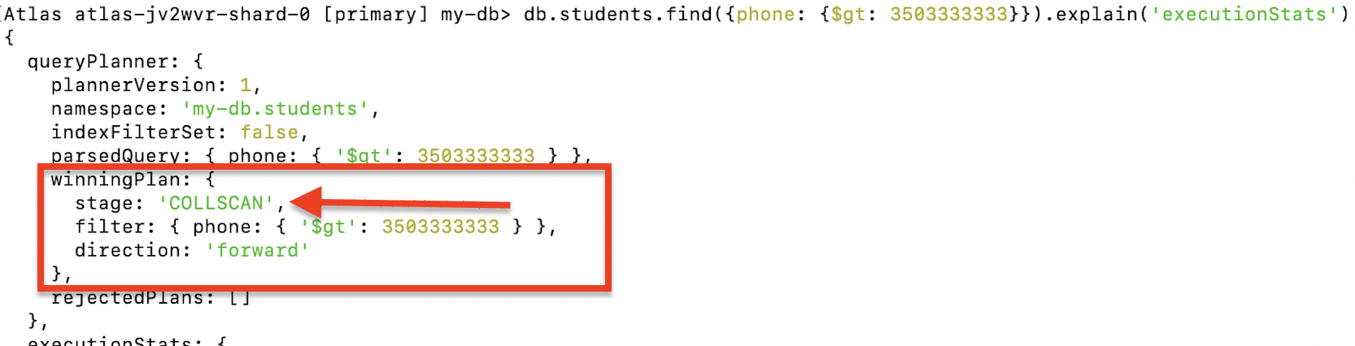
* 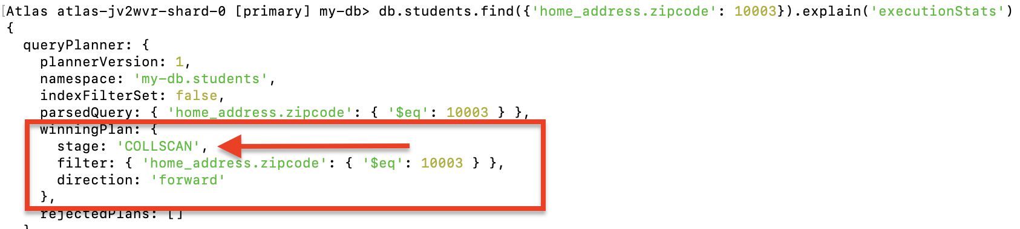
* AFTER adding indexes :
  + 
   