Q1

db.widgetSales.aggregate([

{

$group: {

_id: {

$dateToString: { format:"%Y-%m", date: "$date" }

},

monthlySales: {$sum: {$multiply: ["$unitPrice", "$quantity"]}}

}},

{$out: "widgetSalesMonthlyAgg"}

]);

Q2

// The example of a query

db.orders.find(

{productName: "Steel beam"},

{productName: 1, status: 1,_id:0}

)

// Creating index

db.orders.createIndex({productName: 1, status:1})

// Index size is 40960 kb

db.orders.totalIndexSize()

// Since all queries are indexed, it is the fastest index.

//So, when we execute the query, it takes all information from the index in the RAM without going to the main memory

db.orders.find(

{productName: "Steel beam"},

{productName: 1, status: 1,_id:0}

).explain("executionStats")

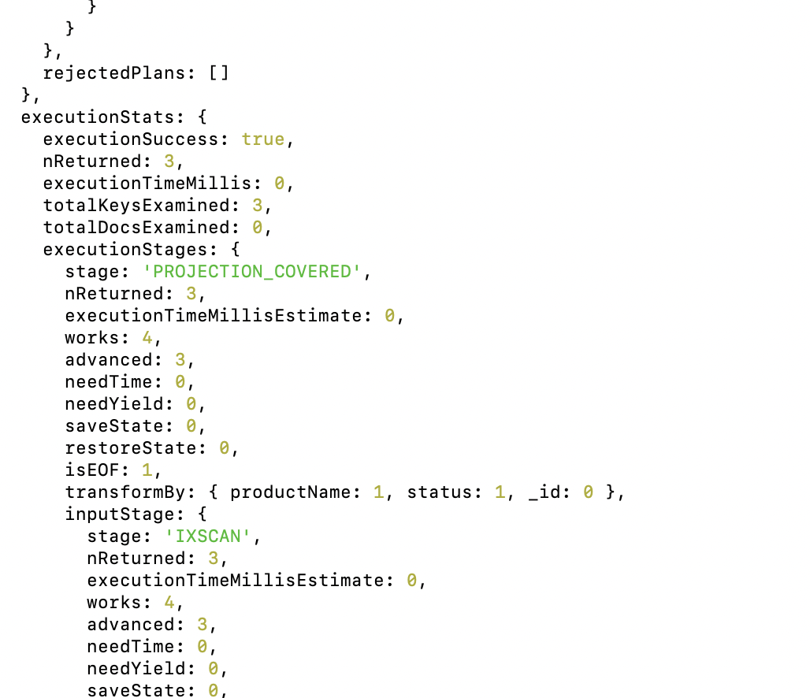

Q3

